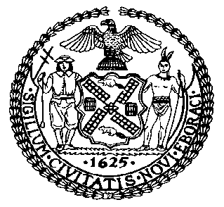 | The Council of the City of New York  Finance Division  Latonia McKinney, Director  Fiscal Impact Statement  Proposed Intro. No: 1429-A  Committee: Housing and Buildings
Title: A Local Law to amend the New York city building code, in relation to requiring pre-shift safety meetings for workers at construction sites | Sponsors: Council Members Ferreras-Copeland, Crowley, Rose, Reynoso, Levin, Espinal, Cornegy, Richards, Menchaca, Chin, Kallos and Rosenthal
Summary of Legislation: Proposed Intro. 1429-A would require that workers at major construction sites take part in a safety meeting and receive task-specific instructions at the beginning of every shift (before the worker commences any construction or demolition work), including specific safety concerns or risks associated with fulfilling such tasks and activities. In addition, the bill would require a recordkeeping of all pre-shift safety meetings be maintained and kept at each construction site.

Effective Date: This local law would take effect 180 days after it becomes law, except that the Commissioner of the Department of Buildings may take such actions as are necessary for its implementation, including the promulgation of rules, prior to such effective date.
Fiscal Year In Which Full Fiscal Impact Anticipated: Fiscal 2019
Fiscal Impact Statement:

 | Effective FY18 | FY Succeeding Effective FY19 | Full Fiscal Impact FY19
Revenues | $0 | $0 | $0
Expenditures | $0 | $0 | $0
Net | $0 | $0 | $0

Impact on Revenues: It is estimated that there would be no impact on revenues resulting from the enactment of this legislation.
Impact on Expenditures: It is anticipated that there would be no impact on expenditures resulting from the enactment of this legislation because existing resources would be used by DOB and non-City entities to implement the provisions of this local law.
Source of Funds To Cover Estimated Costs: Not applicable.

Source of Information: New York City Council Finance Division

Estimate Prepared by: Sarah Gastelum, Principal Financial Analyst

Estimated Reviewed by: Eric Bernstein, Counsel

Legislative History: This legislation was introduced to the full Council on January 18, 2017, as Intro. No. 1429 and was referred to the Committee on Housing and Buildings (Committee). A hearing was held by the Committee on January 31, 2017, and the bill was laid over. The legislation was subsequently amended, and the amended version, Proposed Intro. 1429-A, will be considered by the Committee on October 16, 2017. Following a successful Committee vote, the bill will be submitted to the full Council for a vote on October 17, 2017.

Date Prepared: October 11, 2017

