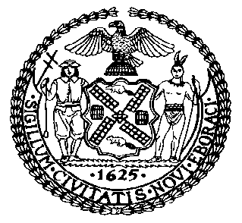 | The Council of the City of New York  Finance Division  Latonia McKinney, Director  Fiscal Impact Statement  Proposed Intro. No: 1783-A  Committee: Housing and Buildings
Title: A Local Law to amend the administrative code of the city of New York, in relation to excluding cooperatives from the housing portal | Sponsors: By Council Members Levine, Kallos, Cornegy, Rosenthal, Rivera, Rodriguez, Cohen, Chin, Yeger and Louis
Summary of Legislation: Proposed Int. No. 1783-A would amend Local Law 64 of 2018 so that dwelling units in certain buildings that are incorporated as cooperatives are exempt from the requirements of the housing portal. Under the bill, the definition of an affordable unit would exclude units owned in the form of shares in cooperatives incorporated under Articles II, IV, V, or XI of the Private Housing Finance Law. As a result, these cooperatives, including properties under the Mitchell-Lama Housing Program, Limited Dividend Housing Companies, Redevelopment Companies, and HDFC cooperatives, would not be required to market available units through the housing portal.

Effective Date: This local law would take effect immediately.

Fiscal Year In Which Full Fiscal Impact Anticipated: Fiscal 2022
Fiscal Impact Statement:

 | Effective FY21 | FY Succeeding Effective FY22 | Full Fiscal Impact FY22
Revenues | $0 | $0 | $0
Expenditures | $0 | $0 | $0
Net | $0 | $0 | $0

Impact on Revenues: It is estimated that there would be no impact on revenues resulting from the enactment of this legislation.

Impact on Expenditures: It is anticipated that there would be no impact on expenditures resulting from the enactment of this legislation because existing resources would be used by HPD to implement the provisions of this local law.
Source of Funds To Cover Estimated Costs: N/A

Source of Information: New York City Council Finance Division

Estimate Prepared by: Sarah Gastelum, Principal Financial Analyst

Estimated Reviewed by: Chima Obichere, Unit Head
Noah Brick, Assistant Counsel

Legislative History: This legislation was introduced to the full Council as Int. No. 1783 on October 30, 2019 and was referred to the Committee on Housing and Buildings (Committee). A hearing was held by the Committee on January 13, 2020, and the bill was laid over. The legislation was subsequently amended and the amended version, Proposed Intro. No. 1783-A, will be considered by the Committee on July 28, 2020. Following a successful vote by the Committee, Proposed Intro. No. 1783-A will be submitted to the full Council for a vote on July 28, 2020.

Date Prepared: July 21, 2020

