Committee on Technology
Irene Byhovsky, Legislative Counsel
Charles Kim, Legislative Policy Analyst
John Russell, Financial Unit Head
Florentine Kabore, Financial Analyst
Nicholas Montalbano, Data Analyst

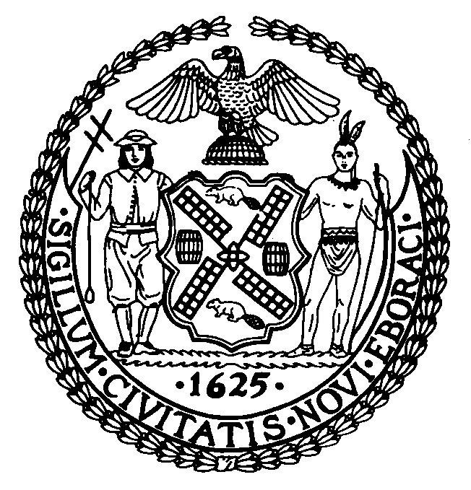

THE COUNCIL

Committee Report of the Infrastructure Division
Jeffrey Baker, Legislative Director
Terzah Nasser, First Deputy Director, Infrastructure

COMMITTEE ON TECHNOLOGY
Hon. Robert F. Holden, Chair

May 12, 2021

INT. NO. 1755-A: By Council Members Holden, Gjonaj, Louis, Rosenthal and Riley

TITLE: A Local Law in relation to an assessment of the 311 service request intake map

I. Introduction

On Wednesday, May 12, 2021 the Committee on Technology, chaired by Council Member Robert Holden, held a hearing to consider Int. No. 1755-A, A Local Law in relation to an assessment of the 311 service request intake map. The Committee previously heard the original version of the bill, Int. No. 1755, on September 8, 2020. More information on Int. No. 1755-A and materials from the previous hearing can be accessed online at https://go.usa.gov/xHA9N.
II. Background

New York City 3-1-1 (“NYC311” or “3-1-1”) is a Citywide customer service program that provides New York City residents, businesses and visitors with access to non-emergency government services and information. The NYC311 Customer Service Center was previously housed within the Mayor’s Office of Operations (“MOO”), but now is housed within the Department of Information, Technology and Telecommunications (“DoITT” or the “the Department”).
NYC311 is available 24 hours a day, seven days a week via multiple channels, including telephone, website (“311 Online”), mobile application, and social media. According to the NYC Open Data Portal, from May 11, 2020 to May 10, 2021 NYC311 received a total of 2.78 million service requests. These service requests were organized according to the following categories known as channel types, which indicate how the service request was submitted: “Online” means the service request was submitted through the 311 mobile app; “Phone” means the service request was submitted by a 311 call center agent on behalf of a customer; “Unknown” means NYC311 were unable to determine the source channel type of the service request; and “Other” means the service request was submitted by another city agency or source. Of those requests, 39% or 1.075 million came from the “Online” channel type; 31% or 856,426 came from the “Phone” channel type; 20% or 568,747 came from a “Mobile” channel type; and 10% or 283,204 came from the “Unknown” channel type. Fifty-eight service requests, or less than one percent of total NYC311 service requests, came from the “Other” channel type.
Both the 311 website and the 311 mobile applications have an interactive map functionality or address lookup option. However, these mapping functionalities do not assist the user well. For example, it is impossible to select a location on the mobile application unless the exact address is known.
III. ANALYSIS OF INT. NO. 1755-A
The legislation would require the DoITT to conduct an assessment of the interactive map accessible through the 311 website or mobile device application that is used for the intake of 311 service requests and complaints, in order to determine the feasibility of improving the location accuracy of the 311 intake map. The Department would also be required to submit a report of the results of the assessment to the Council. The bill would take effect immediately and be repealed upon the submission of the report.
Update
On Wednesday, May 12, 2021, the Committee adopted Int. No. 1755-A by a vote of five in the affirmative, zero in the negative, and zero abstentions.

Int. No. 1755-A

By Council Members Holden, Gjonaj, Louis, Rosenthal and Riley

A Local Law in relation to an assessment of the 311 service request intake map

Be it enacted by the Council as follows:

Section 1. Assessment of 311 service request intake map. a. Definitions. For the purposes of this section, the following terms have the following meanings:
311 service request intake map. The term “311 service request intake map” means an interactive map accessible through any website or mobile device application used by the 311 customer service center for the intake of 311 requests for service or complaints.
Department. The term “department” means the department of information technology and telecommunications.
b. The department shall conduct an assessment of the 311 service request intake map to determine the feasibility of improving the location accuracy of the 311 service request intake map.
c. No later than one year after the effective date of this local law, the department shall submit to the council a report of the results of the assessment conducted pursuant to subdivision b of this section.
§ 2. This local law takes effect immediately and is deemed repealed upon the submission of the report required pursuant to subdivision c of section 1 of this local law.

MHL/IB
LS #11606
5/4/2021 1:45pm

The Official Website of the City of New York, NYC311, https://portal.311.nyc.gov (last accessed May 11, 2021).
NYC DoITT, About, https://www1.nyc.gov/site/doitt/about/who-we-are.page (last accessed May 11, 2021).
Mayor’s Office of Operations, Mayor’s Preliminary Management Report, January 2020, p.125, https://www1.nyc.gov/assets/operations/downloads/pdf/pmmr2020/2020_pmmr.pdf.
NYC OpenData, 311 Service Requests from 2010 to Present, May 10, 2021, https://data.cityofnewyork.us/Social-Services/311-Service-Requests-from-2010-to-Present/erm2-nwe9.
Id.
Id; The 311 Service Request Data Dictionary posted on the cited NYC311 Open Data page is from 2018 and does not include a definition for the “Mobile” channel type.
Id.
Id.

