THE COUNCIL OF THE CITY OF NEW YORK
RESOLUTION NO. 379

Resolution approving with modifications the decision of the City Planning Commission on Application No. N 210349 ZRK, for an amendment of the text of the Zoning Resolution (L.U. No. 111).

By Council Members Salamanca and Riley

WHEREAS, Angelina Gatto Trust filed an application pursuant to Section 201 of the New York City Charter, for an amendment of the text of the Zoning Resolution of the City of New York, modifying Article XII, Chapter 3 (Special Mixed Use District) for the purpose of establishing a new Special Mixed Use District (MX-25) and modifying APPENDIX F for the purpose of establishing a Mandatory Inclusionary Housing area, which in conjunction with the related action would facilitate the construction of a nine-story mixed-use development containing 48 dwelling units, 13 of which would be permanently affordable, along with ground-floor commercial space, at 153-157 Ninth Street and 124 Eighth Street, in the Gowanus neighborhood of Brooklyn, Community District 6 (ULURP No. N 210349 ZRK) (the “Application”);

WHEREAS, the City Planning Commission filed with the Council on September 9, its decision dated September 7, 2022 (the “Decision”), on the Application;

WHEREAS, the Application is related to applications C 210348 ZMK (L.U. No. 110), a zoning map amendment to change an M2-1 zoning district to an M1-4/R7A zoning district and C 210350 ZSK (L.U. No. 112), a special permit to waive residential off-street parking to facilitate affordable housing;

WHEREAS, the Decision is subject to review and action by the Council pursuant to Section 197-d of the City Charter;

WHEREAS, upon due notice, the Council held a public hearing on the Decision and Application on September 22, 2022;

WHEREAS, the Council has considered the land use implications and other policy issues relating to the Decision and Application; and

WHEREAS, the Council has considered the relevant environmental issues, including the Negative Declaration issued April 25th, 2022 (CEQR No. 22DCP091K) which includes an (E) designation to avoid the potential for significant adverse impacts related to hazardous materials, air quality, and noise impacts (E-670) (the “Negative Declaration”).

RESOLVED:

The Council finds that the action described herein will have no significant impact on the environment as set forth in the (E) Designation (E-670) and Negative Declaration.

Pursuant to Sections 197-d and 200 of the City Charter and on the basis of the Decision and Application, and based on the environmental determination and consideration described in the report, N 210349 ZRK, incorporated by reference herein, and the record before the Council, the Council approves the Decision of the City Planning Commission with the following modification.

Matter double struck out is old, deleted by the City Council;
Matter double-underlined is new, added by the City Council;
Matter underlined is new, to be added;
Matter struck out is to be deleted;
Matter within # # is defined in Section 12-10;
* * * indicates where unchanged text appears in the Zoning Resolution

ARTICLE XII
SPECIAL PURPOSE DISTRICTS

Chapter 3
Special Mixed Use District
* * *

123-60
SPECIAL BULK REGULATIONS

* * *

123-63
Maximum Floor Area Ratio and Lot Coverage Requirements for Zoning Lots Containing Only Residential Buildings in R6, R7, R8 and R9 Districts

* * *

#Special Mixed Use District# | Designated #Residence District#
MX-1 – Community District 1, The Bronx | R6A R7D
* * *
MX 23 – Community District , Queens | R7A
MX 25 - Community District 6, Brooklyn | R7A R6B

* * *

123-90
SPECIAL MIXED USE DISTRICTS SPECIFIED

* * *

#Special Mixed Use District# - 25 [date of adoption]
Gowanus, Brooklyn

The #Special Mixed Use District# - 25 is established in Gowanus in Brooklyn as indicated on the #zoning maps#.

* * *

APPENDIX F

Inclusionary Housing Designated Areas and Mandatory Inclusionary Housing Areas

* * *

BROOKLYN

* * *

Brooklyn Community District 6

* * *

Map 1 – (12/9/21) [date of adoption]

[EXISTING MAP]

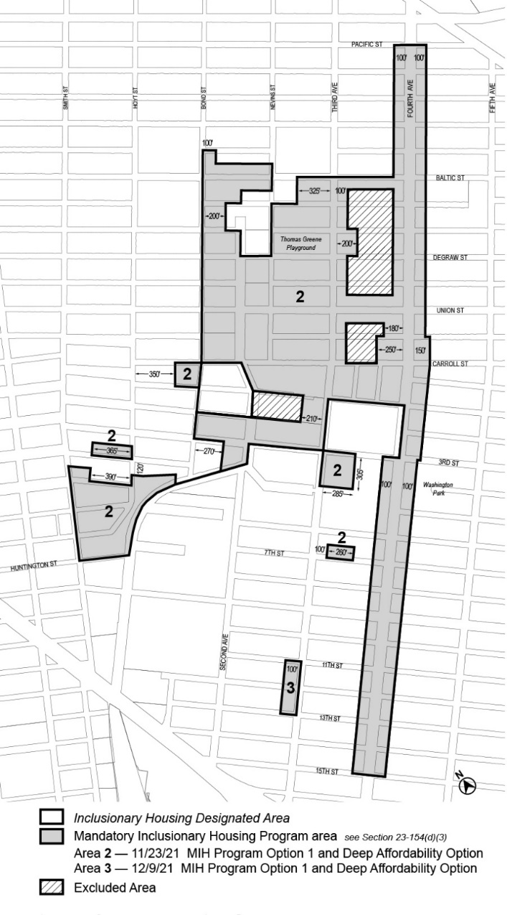

[PROPOSED MAP]
[reflective of proposed Council modification]

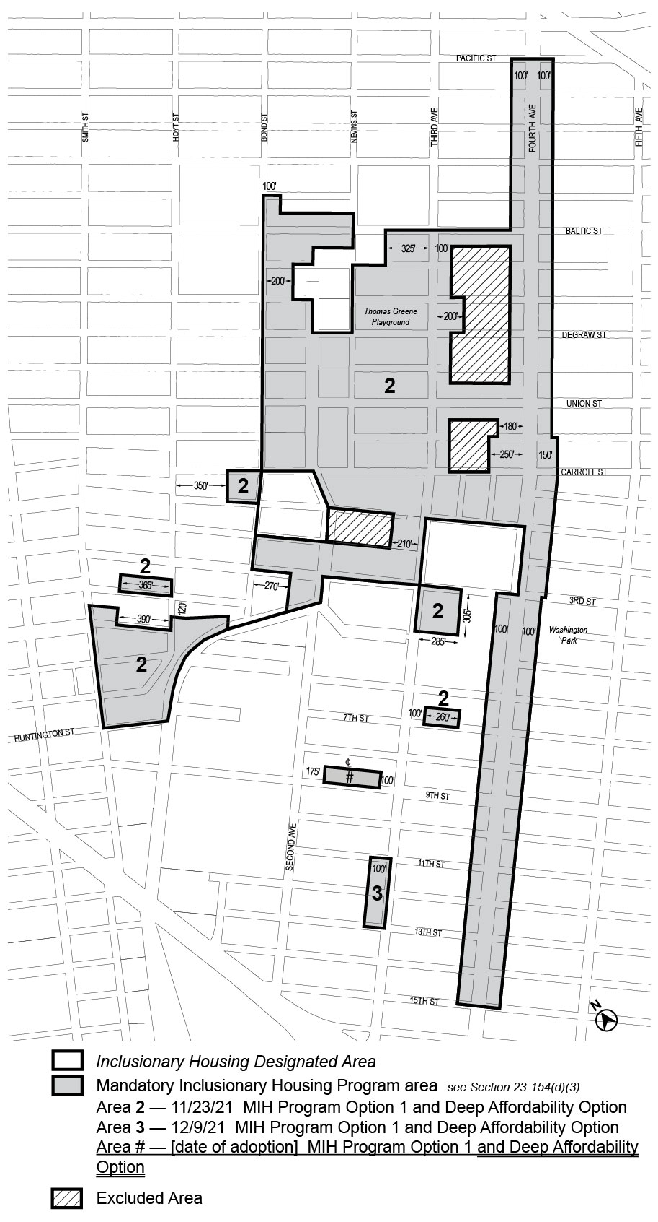

Portion of Community District 6, Brooklyn

* * *

Adopted.

Office of the City Clerk, }
The City of New York, } ss.:

I hereby certify that the foregoing is a true copy of a Resolution passed by The Council of The City of New York on __________, 2022, on file in this office.

.....................................................
City Clerk, Clerk of The Council

