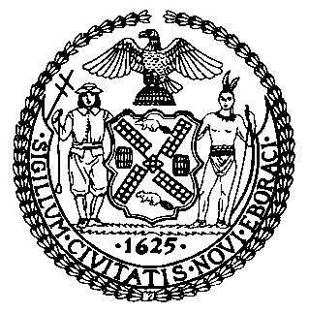 | The Council of the City of New York  Finance Division  Tanisha S. Edwards, Esq., Chief Financial Officer, and Deputy Chief of Staff to the Speaker  Fiscal Impact Statement  Proposed Intro. No: 56-A  Committee: Mental Health
Title: A Local Law to amend the administrative code of the city of New York, in relation to establishing a nightlife opioid antagonist program | Sponsor(S): By Council Members Ossé, Powers, Hanif, Hudson, Nurse, Salamanca, Cabán, Restler, Joseph, Farías, Gutiérrez, Schulman, Dinowitz, Louis, Moya, Williams, Krishnan, Bottcher, Stevens, Sanchez, Lee, Hanks, Menin, Narcisse, Won, Abreu, Velázquez, De La Rosa, Feliz, Rivera, Riley, Richardson Jordan, Gennaro, Brannan, Ayala, Marte, Avilés, and Carr
Summary of Legislation: The proposed legislation would the Department of Health and Mental Hygiene (DOHMH) to create the Nightlife Opioid Antagonist Program to help prevent opioid overdoses in nightlife establishments. The program would permit nightlife establishments in the City to request and retain up to five opioid antagonist kits at a time, free of charge, to keep on premises for administration to patrons, staff or individuals on the premises experiencing an opioid overdose. This bill would also require DOHMH to offer free resources and training to staff of participating nightlife establishments on the administration of opioid antagonists.

Effective Date: This local law takes effect 120 days after it becomes law.

Fiscal Year In Which Full Fiscal Impact Anticipated: Fiscal 2024

Fiscal Impact Statement:

 | Effective FY23 | FY Succeeding Effective FY24 | Full Fiscal Impact FY24
Revenues | $0 | $0 | $0
Expenditures | $0 | $0 | $0
Net | $0 | $0 | $0

Impact on Revenues: It is anticipated that this legislation would not affect revenues.

Impact on Expenditures: It is anticipated that there would be no impact on expenditures resulting from the enactment of Proposed Intro. 56-A because DOHMH would utilize existing resources to fulfill the requirements.

Source of Funds To Cover Estimated Costs: N/A
Source of Information: New York City Council Finance Division
Mayor’s Office of Management and Budget
Estimate Prepared By: Crilhien R. Francisco, Unit Head, NYC Council Finance Division

Estimate Reviewed By: Eisha Wright, Deputy Director, NYC Council Finance Division
Jonathan Rosenberg, Managing Deputy Director, NYC Council Finance Division
Legislative History: The legislation was introduced to the full Council on February 24, 2022, as Intro. 56 and referred to the Committee on Mental Health. The legislation was considered by the Committee on Mental Health and the Committee on State and Federal Legislation at a hearing held on April 21, 2022, and was subsequently amended, and the amended version Proposed Intro. 56-A will be considered by the Committee on Mental Health on September 13, 2022. Upon successful vote by the Committee on Mental Health, Proposed Intro. No. 56-A will be submitted to the full Council for a vote on September 14, 2022.
Date Prepared: August 5, 2022

