THE COUNCIL OF THE CITY OF NEW YORK
RESOLUTION NO. 790

Resolution approving the decision of the City Planning Commission on Application No. N 180262 ZRX, for an amendment of the text of the Zoning Resolution (L.U. No. 349).

By Council Members Salamanca and Moya

WHEREAS, the City Planning Commission filed with the Council on February 1, 2019 its decision dated January 30, 2019 (the "Decision"), on the application submitted by 2712 Radcliff Yates Realty, LLC, pursuant to Section 201 of the New York City Charter, for an amendment of the text of the Zoning Resolution of the City of New York, modifying Appendix F for the purpose of establishing a Mandatory Inclusionary Housing Area, utilizing MIH Option 1 with approximately eight permanent affordable units and MIH Option 2 with nine permanent affordable units, which in conjunction with the related action would facilitate the development of a new nine-story plus cellar mixed-use building with approximately 30 dwelling units and ground floor office space at 2712 Williamsbridge Road and 2721 Colden Avenue in the Allerton neighborhood of Bronx, Community District 11, (Application No. N 180262 ZRX), (the "Application");

WHEREAS, the Application is related to application C 180261 ZMX (L.U. No. 348), a Zoning Map amendment to change a C8-1 zoning district to an R7A and R7A/C2-3 district;

WHEREAS, the Decision is subject to review and action by the Council pursuant to Section 197-d(b)(1) of the City Charter;
WHEREAS, upon due notice, the Council held a public hearing on the Decision and Application on February 14, 2019;

WHEREAS, the Council has considered the land use implications and other policy issues relating to the Decision and Application; and

WHEREAS, the Council has considered the relevant environmental issues, including the Revised Negative Declaration issued January 30, 2019, which supersedes the Negative Declaration issued August 31, 2018, and Revised Environmental Assessment Statement issued January 25, 2019 (CEQR No. 18DCP071X) which include an (E) designation to avoid the potential for significant adverse impacts related to hazardous materials and air quality (the “E” Designation (E-498)).

RESOLVED:

The Council finds that the action described herein will have no significant impact on the environment as set forth in the (E) Designation (E-498) and Revised Negative Declaration.

Pursuant to Sections 197-d and 200 of the City Charter and on the basis of the Decision and Application, and based on the environmental determination and consideration described in the report, N 180262 ZRX, incorporated by reference herein, and the record before the Council, the Council approves the Decision of the City Planning Commission.

Matter underlined is new, to be added;
Matter struck out is to be deleted;
Matter within # # is defined in Section 12-10;
* * * indicates where unchanged text appears in the Zoning Resolution.

* * *

APPENDIX F
Inclusionary Housing Designated Areas and Mandatory Inclusionary Housing Areas

* * *

THE BRONX

* * *

Bronx Community District 11

* * *
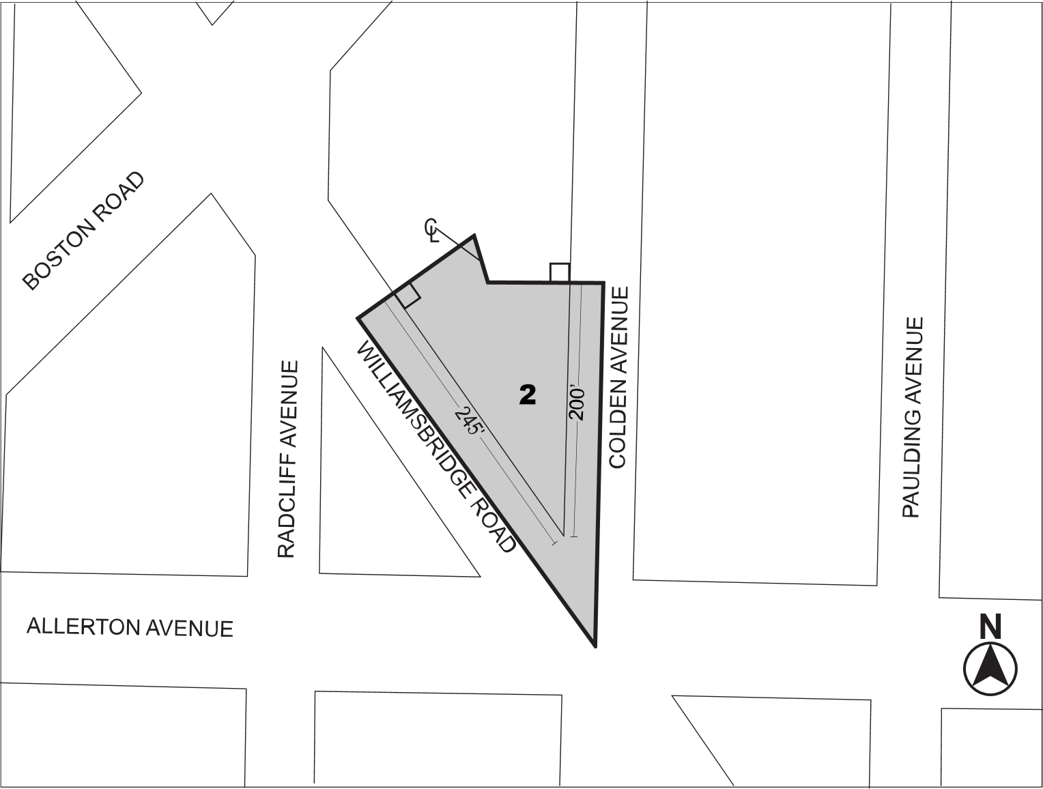
Mandatory Inclusionary Housing Program Area see Section 23-154(d)(3)
Area 2 [date of adoption] — MIH Program Option 1 and Option 2

Portion of Community District 11, The Bronx

* * *

Adopted.

Office of the City Clerk, }
The City of New York, } ss.:

I hereby certify that the foregoing is a true copy of a Resolution passed by The Council of The City of New York on March 13, 2019, on file in this office.

.....…….........................................
City Clerk, Clerk of The Council

