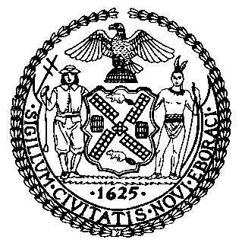 | The Council of the City of New York  Finance Division  Latonia McKinney, Director  Fiscal Impact Statement  Proposed Intro. No.: 878-A  Committee: Women
Title: A Local Law to amend the administrative code of the city of New York, in relation to requiring lactation rooms in certain city spaces | Sponsors: Council Members Cornegy, Cumbo, Koslowitz, Powers, Rivera, Ayala, Constantinides, Kallos, Rosenthal, Ampry-Samuel, Lander, and Adams
Summary of Legislation: Proposed Intro. 878-A would require the Department of Correction (DOC) and the New York City Police Department (NYPD) to make lactation rooms available in City jail facilities that accept visitors and police precincts, where practicable and upon request, in a publicly-accessible and non-secure area, to individuals receiving on-site services. Furthermore, Proposed Intro. 878-A would require DOC and NYPD to submit to the Speaker of the City Council a report by August 1, 2019, listing all City jails and precincts where the agencies have determined that it is not practicable to make a lactation room available in accordance with this legislation. Subsequently, the agencies would be required to submit annual reports detailing any plans to improve access to or provide for lactation rooms.
Effective Date: This local law would take effect 90 days after it becomes law.

Fiscal Year in Which Full Fiscal Impact Anticipated: Fiscal 2020
Fiscal Impact Statement:

 | Effective FY19 | FY Succeeding Effective FY20 | Full Fiscal Impact FY20
Revenues | $0 | $0 | $0
Expenditures | $0 | $0 | $0
Net | $0 | $0 | $0

Impact on Revenues: It is estimated that there would be no impact on revenues resulting from the enactment of this legislation.
Impact on Expenditures: It is anticipated that this legislation would have no impact on expenditures as DOC and NYPD can use existing resources to implement the requirements of this legislation.
Source of Funds to Cover Estimated Costs: N/A
Source of Information: New York City Council Finance Division
Estimate Prepared by: Daniel Kroop, Financial Analyst
Estimate Reviewed by: Regina Poreda Ryan, Deputy Director
Rebecca Chasan, Counsel
Legislative History: This legislation was introduced to the Council on May 9, 2018 as Intro. 878 and was referred to the Committee on Women. The legislation was considered by the Committee on Women and the Committee on Governmental Operations at a joint hearing on June 19, 2018, and the bill was laid over. The legislation was subsequently amended, and the amended version, Proposed Intro. 878-A, will be voted on by the Committee on Women on October 15, 2018. Upon successful vote by the Committee, Proposed Intro. 878-A will be submitted to the full Council for a vote on October 17, 2018.
Date Prepared: October 12, 2018

