THE COUNCIL OF THE CITY OF NEW YORK
RESOLUTION NO. 1253

Resolution approving with modifications the decision of the City Planning Commission on Application No. N 190266 ZRQ, for an amendment of the text of the Zoning Resolution (Preconsidered L.U. No. 605).

By Council Members Salamanca and Moya

WHEREAS, Mega Realty Holding, LLC and Pancyprian Association, Inc., filed an application pursuant to Section 201 of the New York City Charter, for an amendment of the text of the Zoning Resolution of the City of New York, modifying Appendix F for the purpose of establishing a Mandatory Inclusionary Housing area, which in conjunction with the related actions would facilitate the construction of an eight-story mixed-use building at 22-60 46th Street in Astoria, Queens, Community District 1 (Application No. N 190266 ZRQ), (the “Application”);

WHEREAS, the City Planning Commission filed with the Council on January 10, 2020 its decision dated January 8, 2020 (the “Decision”), on the Application;

WHEREAS, the Application is related to application C 190267 ZMQ (Pre. L.U. No. 604), a zoning map amendment from R4 and M1-1 to R4, R4/C2-3, R6A, and R6A/C2-3;

WHEREAS, the Decision is subject to review and action by the Council pursuant to Section 197-d of the City Charter;

WHEREAS, upon due notice, the Council held a public hearing on the Decision and Application on January 14, 2020;

WHEREAS, the Council has considered the land use implications and other policy issues relating to the Decision and Application; and

WHEREAS, the Council has considered the relevant environmental issues, including the negative declaration issued August 26th, 2019 (CEQR No. 19DCP145Q), which includes an (E) designation to avoid the potential for significant adverse impacts related to air quality and hazardous materials (E-549) (the “Negative Declaration”).

RESOLVED:

The Council finds that the action described herein will have no significant impact on the environment as set forth in the (E) Designation (E-549) and Negative Declaration.

Pursuant to Section 200 of the City Charter and on the basis of the Decision and Application, and based on the environmental determination and consideration described in the report, N 190266 ZRQ, incorporated by reference herein, and the record before the Council, the Council approves the Decision of the City Planning Commission with the following modifications:

Matter underlined is new, to be added;
Matter struck out is to be deleted;
Matter double struck out is old, deleted by the City Council;
Matter double-underlined is new, added by the City Council
Matter within # # is defined in Section 12-10;
* * * indicates where unchanged text appears in the Zoning Resolution

APPENDIX F
Inclusionary Housing Designated Areas and Mandatory Inclusionary Housing Areas

* * *

QUEENS

* * *

Queens Community District 1

* * *

Map 7 – [date of adoption]

[PROPOSED MAP]

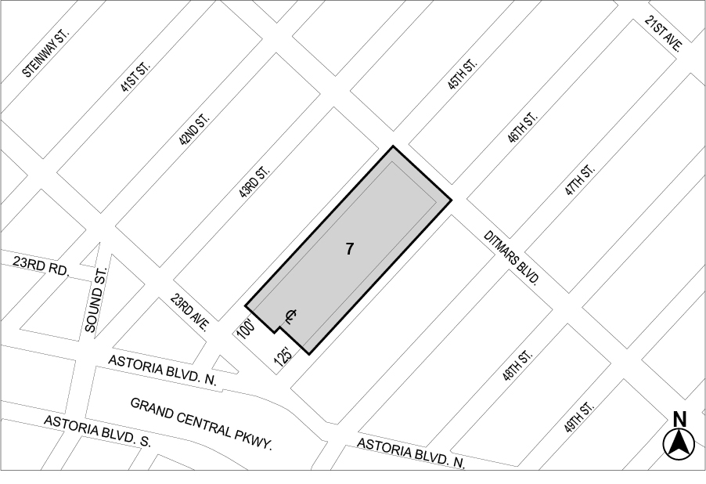

Mandatory Inclusionary Housing area (see Section 23-154(d)(3))
Area 7 ─ [date of adoption], MIH Program Option 2 and Workforce Option 1
Portion of Community District 1, Borough of Queens

* * *

Adopted.

Office of the City Clerk, }
The City of New York, } ss.:

I hereby certify that the foregoing is a true copy of a Resolution passed by The Council of The City of New York on February 11, 2020, on file in this office.

.....................................................
City Clerk, Clerk of The Council

