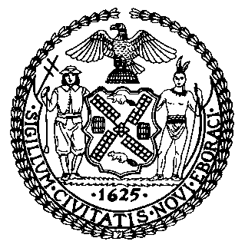 | The Council of the City of New York  Finance Division  Latonia Mckinney, Director  Fiscal Impact Statement  Proposed Int. No. 1852-A  Committee: Fire and Emergency Management
Title: A Local Law to amend the New York city fire code, in relation to fire safety at film production locations and to providing the fire department and local firehouses with information about field conditions at film production locations | Sponsors: Council Member Cornegy, Borelli, Powers, Koslowitz, Cabrera, Kallos, Holden and Ayala
Summary of Legislation: Proposed Int. No. 1852-A would require that the Fire Department and the Mayor’s Office of Media and Entertainment (“MOME”) to establish protocols that enable inter-agency information sharing regarding film production activities authorized by a permit obtained from MOME. The protocols would provide the Fire Department with real time access to all permit information, require local firehouses be notified when certain film permits are issued, and enable firefighters to receive detailed information on production location conditions, including alterations. The bill would also require that prior to a permit being issued for rigging or production activities, the applicable building be clear of certain safety violations issued by the Department of Buildings or Fire Department. Finally, the bill would require that at film production locations, means of egress are maintained, portable fire extinguishers are present, and the location is maintained free of accumulated flammable waste.
Effective Date: This local law would take effect 120 days after the bill becomes law.
Fiscal Year In Which Full Fiscal Impact Anticipated: Fiscal 2022
Fiscal Impact Statement:

 | Effective FY22 | FY Succeeding  Effective FY23 | Full Fiscal  Impact FY22
Revenues (+) | $0 | $0 | $0
Expenditures (-) | $0 | $0 | $0
Net | $0 | $0 | $0

Impact on Revenues: It is anticipated that there would be no impact on revenues resulting from the enactment of this legislation.
Impact on Expenditures: It is anticipated that the legislation would not affect expenditures by the Mayor’s Office of Media and Entertainment or the Fire Department, because both agencies could comply with its requirements using existing resources.
Source of Funds To Cover Estimated Costs: N/A
Source of Information: The Fire Department of New York
The Mayor’s Office of City Legislative Affairs

Estimate Prepared by: Jack Kern, Financial Analyst

Estimate Reviewed by: Regina Poreda Ryan, Deputy Director
Eisha Wright, Unit Head
Noah Brick, Assistant Counsel

Legislative History: This legislation was introduced to the Council on January 23, 2020 as Intro. No. 1852 and was referred to the Committee on Fire and Emergency Management (Committee). The Committee heard the legislation on October 19, 2020 and the bill was laid over. The legislation was subsequently amended and the amended version, Proposed Int. No. 1852-A, will be considered by the Committee at a hearing on February 25, 2021. Upon successful vote by the Committee, Proposed Int. No. 1852-A will be submitted to the full Council for a vote on February 25, 2021.

Date Prepared: February 22, 2021

