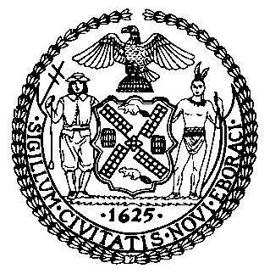 | The Council of the City of New York  Finance Division  Latonia Mckinney, Director  Fiscal Impact Statement  Proposed Intro. No: 1236-A  Committee: Criminal Justice
Title: A Local Law to amend the administrative code of the city of New York, in relation to requiring the department of correction to report on information regarding sick call and clinic production and share such information with correctional health services, and to repeal section 9-108 of the administrative code of the city of New York, relating to health services for incarcerated individuals | Sponsors: By Council Members Powers, Rivera, Kallos, Cumbo and Levin
Summary of Legislation: Proposed Intro. No. 1236-A would require the Department of Correction to report on information regarding sick call and clinic production and repeal section 9-108 of the administrative code, relative to health services for incarcerated individuals and replace it with a new section defining relevant terms for reporting purposes.

Effective Date: This local law would take effect 365 days after it becomes law.

Fiscal Year In Which Full Fiscal Impact Anticipated: Fiscal 2022
Fiscal Impact Statement:

 | Effective FY21 | FY Succeeding Effective FY22 | Full Fiscal Impact FY22
Revenues | $0 | $0 | $0
Expenditures | $0 | $0 | $0
Net | $0 | $0 | $0

Impact on Revenues: It is anticipated that there would be no impact on revenues resulting from the enactment of this legislation.
Impact on Expenditures: It is anticipated that there would be no impact on expenditures resulting from the enactment of this legislation because the Department of Correction could use existing resources to implement the requirements of this legislation.
Source of Funds To Cover Estimated Costs: N/A
Source of Information: New York City Department of Correction
Estimate Prepared by: Peter Butler, Financial Analyst
Estimate Reviewed by: Eisha Wright, Unit Head, Finance Division
Regina Poreda Ryan, Deputy Director, Finance Division
Noah Brick, Assistant Counsel, Finance Division

Legislative History: This legislation was introduced by the City Council as Intro. 1236 on November 14, 2018 and was referred to the Committee on Criminal Justice. A joint hearing was held by the Committee on Criminal Justice, the Committee on Mental Health, Disabilities and Addiction, and the Committee on Hospitals on November 15, 2018, and the bill was laid over. The legislation was amended, and the amended verions, Proposed Intro. 1236-A, will be voted on by the Committee on Criminal Justice at a hearing on June 13, 2019. Upon a successful vote by the Committee on Criminal Justice, Proposed Intro. 1236-A will be submitted to the Council for a vote on June 13, 2019.
Date Prepared: June 10, 2019

