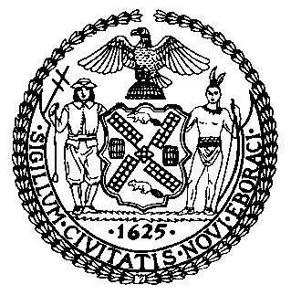 | The Council of the City of New York  Finance Division  Latonia Mckinney, Director  Fiscal Impact Statement  Proposed Intro. No: 1590-A  Committee: Mental Health
Title: A Local Law to amend the administrative code of the city of New York, in relation to requiring correctional health services to report information to the attorney of record for individuals in the custody of the department of correction who are diagnosed with serious mental illness | Sponsors: Council Member Chin, the Speaker (Council Member Johnson), and Council Members Levin, Powers, Rosenthal, Brannan, Ampry-Samuel, Kallos and Ayala
Summary of Legislation: This bill would require correctional health services to provide defense attorneys information about their client’s mental health diagnosis within five days of obtaining voluntary consent to share health information, and updated medical condition letters within five days prior to a calendared court appearance.
Effective Date: This local law would take effect 120 days after it becomes law.
Fiscal Year In Which Full Fiscal Impact Anticipated: Fiscal 2021
Fiscal Impact Statement:
 | Effective FY20 | FY Succeeding Effective FY21 | Full Fiscal Impact FY21
Revenues | $0 | $0 | $0
Expenditures | $0 | $0 | $0
Net | $0 | $0 | $0
Impact on Revenues: It is anticipated that there would be no impact on revenues resulting from the enactment of this legislation.
Impact on Expenditures: It is anticipated that there would be no impact on expenditures resulting from the enactment of this legislation because the relevant City agencies would utilize existing resources to fulfill the requirements of this legislation.
Source of Funds To Cover Estimated Costs: N/A
Source of Information: New York City Council Finance Division
Department of Health and Mental Hygiene
Estimate Prepared By: Lauren Hunt, Financial Analyst
Estimate Reviewed By: Nathan Toth, Deputy Director
Crilhien R. Francisco, Unit Head
Noah Brick, Assistant Counsel
Legislative History: This legislation was introduced to the Council as Int. No. 1590 on June 13, 2019 and was referred to the Committee on Mental Health, Disabilities and Addiction. A hearing was held jointly by Committee on Mental Health, Disabilities and Addiction and the Committee on Criminal Justice on June 17, 2019 and the bill was laid over. The legislation was subsequently amended and the amended version, Proposed Int. 1590-A, will be voted on by the Committee on Mental Health, Disabilities and Addiction at a hearing on October 16, 2019. Upon a successful Committee vote, Proposed Intro. No. 1590-A will be submitted to the full Council for a vote on October 17, 2019.
Date Prepared: October 15, 2019

