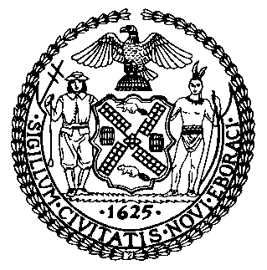 | The Council of the City of New York  Finance Division  Latonia McKinney, Director  Fiscal Impact Statement  Proposed Intro. No: 1635-A  Committee: Housing and Buildings
Title: A Local Law to amend the administrative code of the city of New York, in relation to the display of artwork on temporary protective structures on construction sites | Sponsors: Council Members Cumbo, Brannan and Kallos
Summary of Legislation: Proposed Intro. No. 1635-A would require the Department of Cultural Affairs (DCLA) to establish a program to solicit works of art from the public for display on temporary protective structures at construction sites. DCLA, in consultation with the Department of Buildings (DOB), would be required to biennially approve at least 40 such works of art, as well as 10 received through solicitation by other offices or agencies. Additionally, owners of properties where a temporary protective structure is installed would be required to display artwork, either selected from among the 40 approved works, or selecting a site-specific artwork, on such temporary protective structure. The bill requires that every two years no fewer than 100 project sites owned by the City, or receiving capital funding from the City or an agency, particiate in this program and establishes an opt out for certain property owners who elect not to participate in this program.

Effective Date: This local law would take effect September 1, 2023

Fiscal Year In Which Full Fiscal Impact Anticipated: Fiscal 2024
Fiscal Impact Statement:
 | Effective FY23 | FY Succeeding Effective FY24 | Full Fiscal Impact FY24
Revenues | $0 | $0 | $0
Expenditures | $1,759,167 | $2,111,000 | $2,111,000
Net | $1,759,167 | $2,111,000 | $2,111,000
Impact on Revenues: It is estimated that there would be no impact on revenues resulting from the enactment of this legislation.

Impact on Expenditures: It is estimated that the enactment of this legislation would result in increased City-tax levy expenditures of approximately $2.1 million annually, beginning in Fiscal 2024. However, in Fiscal 2023, the prorated cost of this legislation would be approximately $1.8 million. The above estimates include annual Personal Services (PS) costs of $511,000, including fringe benefits, associated with four headcount positions and Other Than Personal Services (OTPS) costs of $1.6 million associated with the cost of materials and equipment related to the display of the 50 pieces of art as required by this legislation annually.
Source of Funds to Cover Estimated Costs: General Fund
Source of Information: New York City Council Finance Division
Mayor’s Office of Legislative Affairs
Estimate Prepared by: John Basile, Senior Financial Analyst

Estimate Reviewed by: Chima Obichere, Unit Head
Noah Brick, Assistant Counsel
Legislative History: This legislation was first introduced to the Council as Intro. No. 1635 on July 23, 2019 and referred to the Committee on Housing and Buildings (Committee). A hearing was held by the Committee on May 4, 2021 and the bill was laid over. The legislation was subsequently amended and the amended version, Proposed Intro. No. 1635-A, will be considered by the Committee on November 22, 2021. Upon a successful vote by the Committee, Proposed Intro. No. 1635-A will be submitted to the full Council for a vote on November 23, 2021.
Date Prepared: November 18, 2021

