Committee on General Welfare
Aminta Kilawan, Senior Legislative Counsel
David Romero, Legislative Counsel
Julia Haramis, Principal Financial Analyst
Rose Martinez, Assistant Deputy Director
Anne Driscoll, Data Analyst

Committee on Aging
Christopher Pepe, Senior Legislative Counsel
Chloë Rivera, Senior Policy Analyst
Austrid Chan, Financial Analyst

Subcommittee on Senior Centers and Food Insecurity
Christopher Pepe, Senior Legislative Counsel
Rose Martinez, Assistant Deputy Director

THE COUNCIL OF THE CITY OF NEW YORK

Committee Report and Briefing Paper of the Human Services Division
Andrea Vazquez, Legislative Director
Smita Deshmukh, Deputy Director

Committee on General Welfare
Hon. Diana Ayala, Chair

Committee on Aging

Hon. Crystal Hudson, Chair

Subcommittee on Senior Centers and Food Insecurity
Hon. Darlene Mealy, Chair

April 19, 2023

Oversight: Food Insecurity in New York City

INT. NO. 945: By Council Members Hudson, Brewer, Lee, Gutiérrez, Cabán, Yeger, Louis, Richardson Jordan, Abreu, Hanif, Farías, De La Rosa, Schulman, Holden, Riley and Ung

TITLE: A Local Law to amend the administrative code of the city of New York, in relation to establishing a technical support program for older adults

Introduction
On April 19, 2023, the Committee on General Welfare, chaired by Deputy Speaker Diana Ayala, the Committee on Aging, chaired by Council Member Crystal Hudson, and the Subcommittee on Senior Centers and Food Insecurity, chaired by Council Member Darlene Mealy, will conduct an oversight hearing to examine food insecurity in New York City. Representatives from the Human Resources Administration (HRA), the Department for the Aging (NYC Aging), anti-hunger advocates, emergency food providers, and other interested parties were invited to testify.
Background
Poverty Levels in NYC
Some of the primary causes for domestic hunger and food insecurity include poverty, unemployment, lack of affordable housing, high healthcare costs, and lack of access to the Supplemental Nutrition Assistance Program (SNAP). Lack of neighborhood access to affordable and nutritious food also contributes to hunger and food insecurity. Numerous studies have shown that hunger and food insecurity are prevalent among children, college students, the elderly, minority groups and undocumented immigrants.
According to a 2023 report by the Poverty Tracker Research Group at Columbia University, 18% of adults and 15% of children in New York City lived in poverty in 2021. Before the COVID-19 pandemic, nearly 1 in 5 New York City adults (or 1.2 million people) lived in poverty. The poverty rate in New York City has remained relatively steady since 1980, at around 20%, exceeding both national (11.6%) and state (13.9%) levels. But according to the latest New York City Government Poverty Measure Report (NYCgov poverty measure), 40.8% of New York City residents were living at or near poverty in 2019. The NYCgov poverty measure was developed in response to the shortfalls of the Census Bureau’s official measure, which does not accurately reflect other factors related to poverty, such as Earned Income Tax Credit, SNAP benefits, housing subsidies, health care, transportation and childcare costs.
Food Insecurity
Nationally, according to data from the United States Department of Agriculture (USDA), in 2021, 13.5 million Americans lived in food-insecure households, meaning at some point during the year they had difficulty providing enough food for all household members due to a lack of resources or insufficient money for food. While the prevalence of food insecurity for all households remained the same for most householders, food insecurity increased significantly from 2020 for households with no children, especially women living alone and elderly people living alone.
According to the NYC Mayor’s Office of Food Policy 2022 Food Metrics Annual Report, an estimated 1.2 million (14.6%) New York City residents were food insecure. The Bronx has the highest rate at 19.7%, followed by Brooklyn at 15.5%, Manhattan at 13.6%, Queens at 12.1% and Staten Island at 10.1%. New York City’s residents make up 50% of all food insecure people living in New York State. According to Feeding America, the nation’s leading hunger-relief organization, 1 in 10 New Yorkers, or 1,882,580 people, struggle with hunger, and of them 596,060 are children. Nearly 1.2 million New Yorkers were food insecure even before the COVID-19 pandemic, with more than 185 million missing meals across the five boroughs, also known as “The Meal Gap.” Additionally, average meal costs in New York County are estimated to be $6.31, almost twice as high as the national average, $3.25. In New York, high food prices can make circumstances even more difficult for food-insecure households.
The Supplemental Nutrition Assistance Program (SNAP)
SNAP, formerly known as the Food Stamp Program, is the cornerstone of the nation’s safety net and nutrition assistance programs, providing assistance to millions of eligible low-income people. Benefit levels for SNAP are based on criteria including, but not limited to, household size and income levels. Prior to the pandemic, SNAP households received an average of $240 a month. From April 2020 through February 2023, SNAP benefits increased temporarily due to COVID-19 legislation. However, upon the expiration of emergency allotments in 2023, it is estimated that SNAP benefits will decrease to $182 per month per person, or $6.00 per person per day.
SNAP provides assistance to recipients by offering monthly electronic benefits that can be used to purchase food at authorized stores. According to research, spending by SNAP households “multiplies” throughout the national economy, as businesses supplying food and their employees have additional funds to make purchases of their own. SNAP can also help lift people out of poverty. SNAP benefits lifted at least 2.9 million people out of poverty in 2020.

The preceding graph illustrates the number of New York City residents enrolled in SNAP over the past ten years. Since 2012, the number of SNAP recipients has trended downward, peaking at 1,906,610 in December 2012 and then declining to a ten-year low point in February 2020 at 1,481,257 recipients. Notably, February 2020 was the last full month before the full onset of the COVID-19 pandemic, after which enrollment quickly spiked, hitting 1,705,337 recipients in September 2020. Since the onset of the pandemic, the enrollment levels have fluctuated somewhat, as Federal and State changes to program rules, unemployment, and other economic factors influenced enrollment levels. Even with the waning impact of the pandemic, SNAP enrollment levels have not returned to those seen pre-pandemic, and the highest level of enrollment since the start of the pandemic was met in January 2023, which saw 1,767,422 recipients.
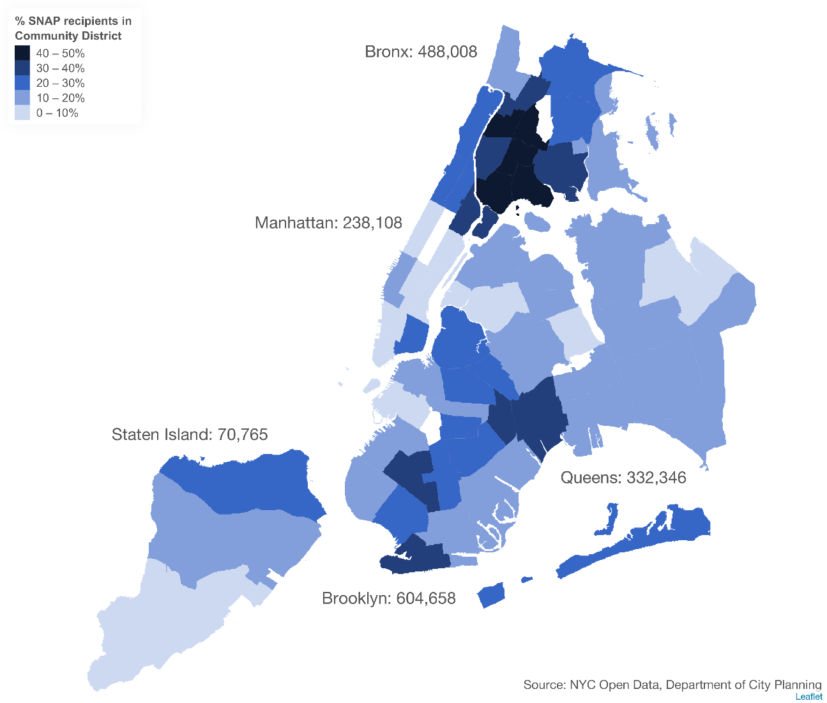
The preceding map illustrates the percentage of SNAP recipients located in each of the City’s 59 Community Districts, as of December 2022. The full data, by Community District, is included in Appendix A at the end of this report. The five Community Districts with the highest percentage of residents on SNAP, each with over 40%, are all located in the Bronx. Eight Community Districts have a percentage of residents on SNAP between 30 and 40%, with three in the Bronx, four in Brooklyn, and one in Manhattan. Overall, as of December 2022, approximately 20% of all New York City residents were enrolled in SNAP.

Able-Bodied Adults without Dependents (ABAWD)
While SNAP is intended to ensure that no one should fear going hungry, SNAP rules require all recipients to meet certain work requirements unless they are exempt because of age or disability or another specific reason. Federal law limits able-bodied adults without dependents (ABAWDs) eligibility to receive SNAP benefits to 3 months in 3 years if they do not meet certain work requirements. To be eligible beyond the time limit, ABAWDs are required to either work or participate in an educational or training program for at least 80 hours per month, or comply with the requirements of a particular work program. In addition to some other general exemptions, adults are exempt from this provision if they are: (1) under 18 or 50 years of age or older, (2) responsible for the care of a child or incapacitated household member, (3) medically certified as physically or mentally unfit for employment, (4) pregnant, or (5) already exempt from the general SNAP work requirement.
States may seek permission to temporarily waive the ABAWD time limit for people living in areas with an unemployment rate above 10% or for those in an area with insufficient jobs. In 2014, New York City became the final social services district in New York State to accept this “ABAWD waiver,” in addition to 43 other states that had accepted the waiver. According to HRA, “in addition to providing federal assistance to address hunger, this policy change provides an economic benefit when this federal assistance is spent in neighborhoods in all five boroughs and averts unnecessary fair hearings resulting from hard-to-administer rules that have applied in the absence of this waiver.”
The Biden Administration announced the COVID-19 federal Public Health Emergency declaration will end on May 11, 2023. Many states that qualified for a state-wide waiver due to high unemployment rates during the pandemic have already become ineligible for these waivers, and more states are likely to follow. With the public health emergency officially ending in May, SNAP recipients will lose their SNAP benefits in October 2023 unless they live in a waived area or fall under other exemptions. New York State has been operating under a state-wide ABAWD waiver since September 2020. New York’s State-wide waiver will end on February 29, 2024.
Emergency Food Assistance Program/Community Food Connection
HRA’s Community Food Connection (CFC), formerly the Emergency Food Assistance Program (EFAP), administers funding and coordinates the distribution of shelf-stable food to more than 500 food pantries and community kitchens citywide. Reports from the end of 2022 show that food pantries had served 7,315,960 individuals and community kitchens had served 795,751 meals in New York City. CFC also provides administrative support to cover utilities, equipment, office supplies, and personnel to a food provider (food pantries and community kitchens) with the aim to improve the nutritional status of low-income New Yorkers.
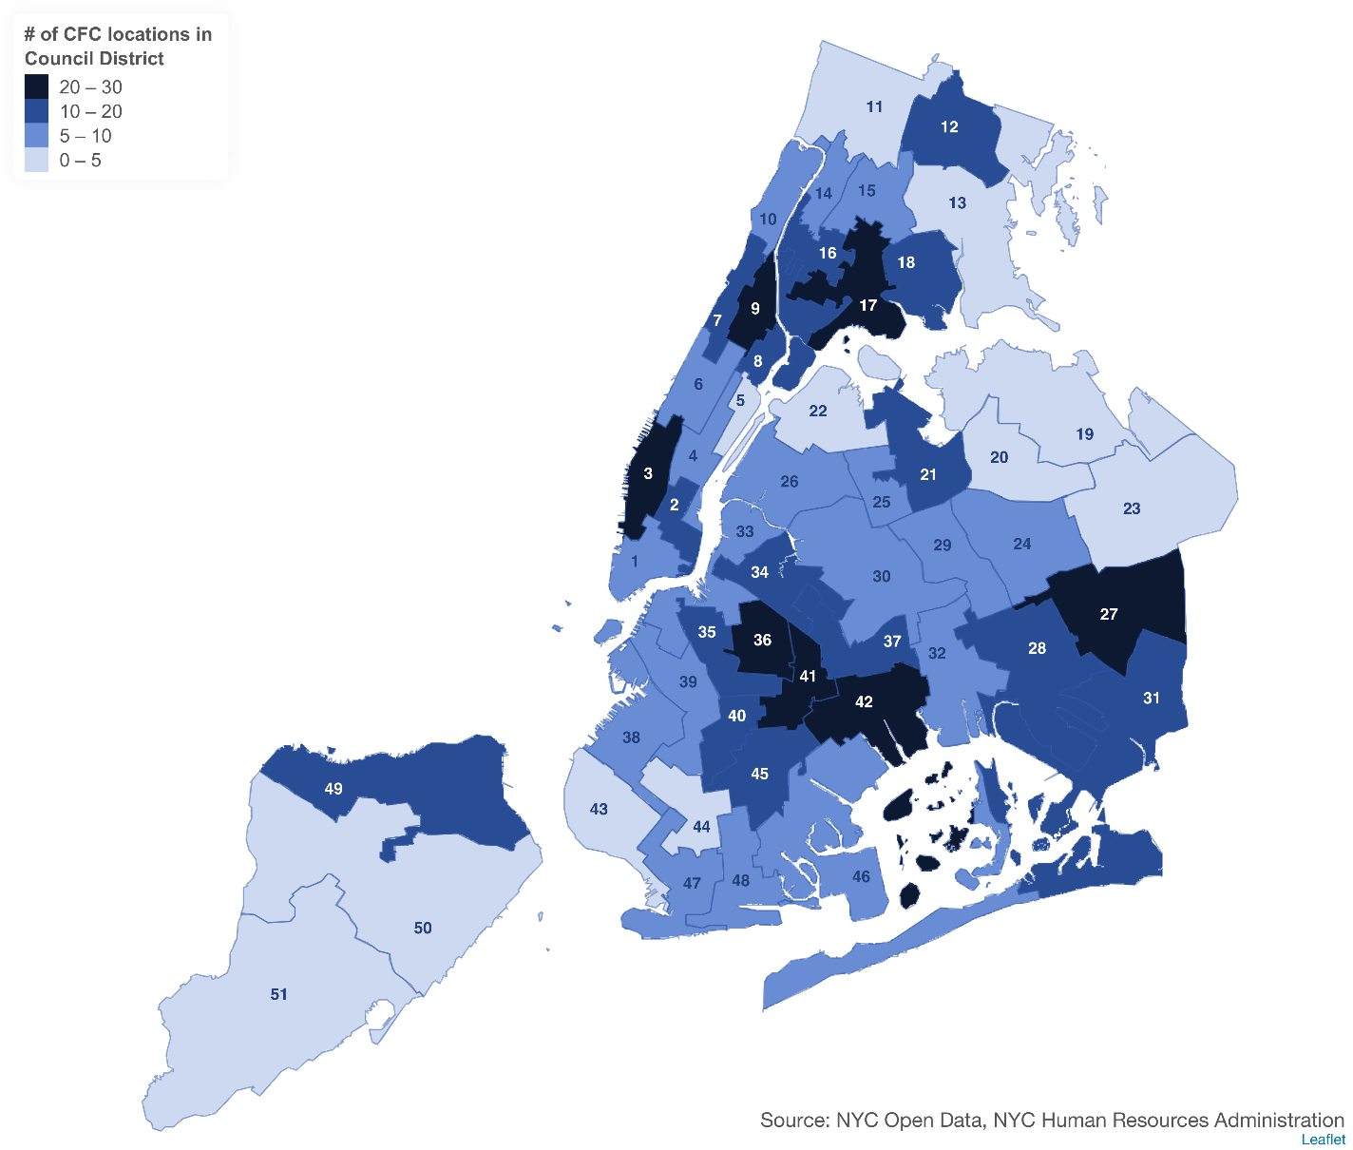
The preceding map illustrates the concentration of emergency food providers enrolled in CFC across the City’s 51 City Council Districts. As of March 6, 2023, there were 559 providers, of which 479 were food pantries and 80 were soup kitchens.
Emergency food assistance is an essential service that is often used to supplement SNAP benefits, since SNAP benefits supply, on average, approximately two weeks’ worth of food for most households. In FY 2022, CFC distributed 17,755,087 pounds of shelf stable and frozen foods. The City’s Pandemic Food Reserved Emergency Distribution (PFRED) program distributed 55,551,690 pounds of food, including fresh fruits and vegetables, as well as culturally relevant food.
According to a Food Bank for New York City survey in early 2018, 80% of food pantries and soup kitchens in NYC had seen elevated traffic and 40% reported the number of visitors increased by more than half. Nearly half of food pantries and soup kitchens have an operating budget of under $25,000. Before the pandemic, over half of soup kitchens and food pantries reported running out of food and 29% reported turning people away because of lack of food.
Food Insecurity and Older Adults

Prior to the pandemic, one in 10 older New Yorkers reported food insecurity, but a 2021 study by Food Bank for New York City found that number to have increased to one-in-five. Among households with persons aged 65 and older, the rate of food insecurity was below the national average, at 7.1%. However, for households with persons aged 65 and older living alone, the rate of food insecurity was slightly higher at 9.5%, representing a 1.2% increase from 2020. According to a study published by United Neighborhood Houses, among NYC residents aged 60 and older, older adults of color are five to six times more likely than their white counterparts to experience food insecurity.
At least one in six older New Yorkers is a SNAP recipient. In fact, the Council estimates that one in four older New Yorkers uses SNAP benefits. The average number of monthly SNAP recipients aged 65 or older in New York was 368,224 in 2022. Unfortunately, advocates estimate that almost 200,000 older adults in New York State may be eligible for SNAP benefits, but are not receiving such benefits.
A report from the New York State Comptroller predicts that food insecurity may be on the rise across the state because of the lapse in pandemic SNAP supports coinciding with rapid inflation and rising prices. Paired with the rising cost of food, which climbed nearly 10% in 2022 and is predicted to surge an additional 7% in 2023, expiration of emergency allotments stand to thrust many SNAP recipients into food insecurity, including many older New Yorkers. The expiration will impact nearly 41 million SNAP recipients nationally, with the average recipient likely to lose 90 dollars per month in benefits. In New York State, 2.9 million households are enrolled in SNAP and lost the EA as of March 1, 2023. This recent change stands to disproportionately impact older adults.
Older Adult Centers
Until the COVID-19 pandemic, older adult centers (“OACs”) funded by NYC Aging served almost 30,000 individuals daily at nearly 250 sites citywide. There are now more than 300 OACs and affiliated sites operating in the five boroughs. OACs “are spaces of community, of learning, of supports, of health and well-being, and spaces where people can build a life of meaning and purpose.” OACs play a vital role in meal provision for older adults, offering “healthy and nutritious” meals at no cost that strive to be representative of the communities served by each OAC. According to NYC Aging, meals served at OACs are certified by registered dietitians to ensure they are nutritious and meet dietary guidelines and standards. Some centers also offer breakfast, dinner and grab-and-go options. Centers also host workshops and trainings on nutrition and healthy cooking to help older adults make decisions regarding their health and diet.
Prior to the pandemic, many older adults relied on OAC meals for more than half of their daily nutritional intake. In June 2021, OACs received guidance from DOHMH to reopen for in-person programming, including meals. Since then, over 2.7 million congregate and grab-and-go meals have been served at OACs. On March 21, 2022, NYC Aging notified providers that OAC capacity restrictions were lifted and programming could resume at 100% capacity.
In addition, some OACs provide case assistance services where staff can provide information on benefits or entitlements, such as food assistance through the Supplemental Nutrition Assistance Program (SNAP). Centers may also refer older adults to benefits access and assistance programs or to NYC Aging’s Aging Connect service.
In its FY 2024 Budget Preliminary Budget Response, the Council called on the Administration to increase NYC Aging’s budget by $51 million to support older adult centers. This additional funding would largely be used to cover an inflation cost adjustment for congregate meals. The meals portion of the funding reflects a 23.2% inflation adjustment based on extensive surveys conducted by advocates.

NYC Aging’s Home Delivered Meals Program
To help combat older adult food insecurity, NYC Aging offers older adults a variety of ways in which to receive meals. Those who are unable to attend older adult centers can receive meals through NYC Aging’s Home Delivered Meals (“HDM”) program, so long as they meet certain qualifications, discussed in more detail below.
The Older Americans Act (OAA) Nutrition Program was signed into law in 1972, establishing the first federal program to improve the food security of older adults. The OAA Senior Nutrition Program administered by the U.S. Department of Health and Human Services’ Administration for Community Living (ACL) continues to fund local agencies and organizations that help older adults aged 60 and over access healthy meals and other resources, including meals delivered directly to their homes. NYC Aging operates the Home Delivered Meals (HDM) program through a network of contracted (and subcontracted) community-based organizations (“providers”) and commercial caterers. To receive home-delivered meals, an older adult must receive authorization from an NYC-Aging-funded case management organization following an assessment. Older adults with a disability or diminished mobility that makes it difficult for them to shop for food or prepare their meals are eligible for the HDM program. Nonprofit providers, which include four settlement houses who are lead contractors, deliver a daily nutritious meal five days a week to these homebound older adults while ensuring that HDM participants receive case management, regular in-person wellness checks, and contact from drivers who are trained on how to work with older adults.
In FY 2023, $3 million was allocated through the Council’s discretionary funding to purchase 44 HDM vans to extend the coverage of the HDM program. For FY 2024, the Council is calling on the Administration to continue funding HDM vans by adding $5 million to NYC Aging’s Capital Plan.
HDM providers have been impacted by rising raw food and transportation costs due to inflation and supply chain shortages. Raw food costs have risen by at least 7% since 2021. To help address this, the FY 2023 Budget included additional funding to support increased contract reimbursement rates for the HDM program, with $2.3 million added for FY 2022 and $9.4 million added for FY 2023 and beyond – to bring rates up to $11.78 per meal. However, recent high inflation has concerned HDM providers. In its FY 2024 Preliminary Budget Response, the Council called on the Administration to add $18 million to NYC Aging’s budget for its HDM program: $14 million for inflation costs and $4 million to fund weekend and holiday meals, which the City currently does not cover. The $14 million in funding reflects a 27% inflation adjustment, based on extensive surveys conducted by advocates for HDMs. Additional meals funding would also provide community-based providers the flexibility to provide raises for kitchen staff, delivery drivers, kitchen inspections, and health and safety mandates.
The Council also called on the Administration to restore and baseline $6.2 million to support the continued transition of GetFood Recovery Meals clients to NYC Aging’s baselined Home Delivered Meals (HDMs) program. The GetFood Recovery Meals program was an emergency program created during the COVID-19 pandemic that ended in June 2022. Previously, $8.8 million for the transition was baselined while $6.2 million in onetime funding was added in FY 2023. NYC Aging has previously estimated that approximately 3,000 older adults would need to be transferred from this program due to its expiration.
Funding for Food Programs in HRA’s Budget
The FY 2024 Preliminary Plan includes $51.3 million in FY 2023 for CFC, increasing to $54.1 million in Fiscal 2024, decreasing to $21.5 million in FY 2025 and then to $20.9 million in FY 2026. The decline between FY 2024 and the outyears is largely because the Administration added $30 million in funding in the FY 2023 Executive Plan for just FY 2023 and FY 2024. The FY 2024 Preliminary Plan also includes $1.75 million in FY 2023 for the Mayor’s Office for Food Policy (MOFP), increasing to $2.1 million in FY 2024, decreasing to $1.1 million in FY 2025 and then to $438,899 in FY 2026.
SNAP Benefits are provided through an Electronic Benefits Transfer (EBT) system, with monthly amounts automatically added by the State to EBT credit cards that recipients can use to purchase permissible food items at participating retailers. HRA screens clients for eligibility and assists them with enrolling and recertifying benefits at the agency’s client service centers and through its online platform, ACCESS HRA. HRA’s budget does not include the value of SNAP benefits to recipients residing in New York City as that is part of the State budget and the State applies those payments. The Fiscal 2024 Preliminary Plan includes a budget of $73.6 million and 1,302 positions for SNAP administration in Fiscal 2023 and in the outyears.
Funding for Food Programs in NYC Aging’s Budget
The Fiscal 2024 Preliminary Plan includes $60.1 million for home delivered meals (HDMs) in Fiscal 2024. Notably, the Fiscal 2023 Executive Plan added $8.8 million in Fiscal 2023 and in the outyears for HDMs to increase the number of older adults served. The Fiscal 2024 Preliminary Plan also includes $231 million to support congregate meals and other activities at older adult centers (OACs). As shown in the Fiscal 2023 Preliminary Mayor’s Management Report, OACs served 1,578,423 meals in the first four months of Fiscal 2023, compared to 623,974 meals in the same period in Fiscal 2022, an increase of 153 percent. HDMs and congregate meals providers have raised concerns over recent inflation and the adequacy of the budget.
The Council’s FY 2024 Preliminary Budget Response
In the FY 2024 Preliminary Budget Response, the Council included five proposals that relate to food programs funded through HRA and NYC Aging’s budgets.
For many years, the Council has called on HRA to expand the food items offered under its emergency food assistance program, now known as CFC, and in FY 2023, HRA revamped the program with a new contracted vendor and a wider variety of food options, including fresh fruits and vegetables. In FY 2023, the Council called on the Administration to increase the baseline budget for CFC and it increased the budget by $30 million, but just for FYs 2023 and 2024. In the FY 2024 Preliminary Budget Response, the Council called on the Administration to increase and baseline the budget for CFC to $60 million. That would increase the budget in FY 2024 by $6 million, and by approximately $39 million in FY 2025 and in the outyears. Additionally, the Council called on CFC to engage in an outreach and education campaign to ensure smaller, community-based providers, especially those who have begun operating since the onset of the pandemic, are enrolled in the program, and adequately supported so that they are able to continue serving their communities.
Older adults represent the fastest-growing age cohort in the City, yet one-in-ten is food insecure and one-in-four use SNAP. The first FY 2024 Preliminary Budget Response proposal relating to NYC Aging’s budget relates to HDMs. HDMs provide an essential nutrition safety net for older adults and the Council calls on the Administration to add $18 million to NYC Aging’s budget for its HDM program: $14 million for inflation costs and $4 million to fund weekend and holiday meals. Second, the Council calls on the Administration to increase NYC Aging’s budget by $51 million to support older adult centers. This additional funding should be used to cover an inflation cost adjustment for congregate meals of $46 million and the remaining $5 million should be dedicated to support marketing efforts for older adult centers to encourage older adults to return to their local centers following the isolation experienced during the COVID-19 pandemic.
Third, the Council calls on the Administration to restore and baseline $6.2 million to support the continued transition of GetFood Recovery Meals clients to NYC Aging’s baselined HDMs program. The GetFood Recovery Meals program was an emergency home-delivered meal program created during the COVID-19 pandemic that ended in June 2022. Finally, the Council calls on the Administration to continue funding HDMs vans by adding $5 million to NYC Aging’s Capital Plan. In FY 2023, $3 million was allocated through the Council’s discretionary funding to purchase 44 HDMs vans to extend the coverage of HDMs. Van availability and replacements are crucial for providers to continue to provide this critical service in a timely manner.
FY 2023 Council Discretionary Food Funding

Council Discretionary Food Funding
Program Area and Initiative Name | FY 2023
Food Initiatives
Food Pantries | $7,260,000
Access to Healthy Food and Nutritional Education | $2,133,750
Food Access and Benefits | $1,500,000
Subtotal | $10,893,750
Senior Services Initiatives
Senior Centers, Programs, and Enhancements | $500,000
Total | $11,393,750

For many years, the Council has provided direct support to community-based organizations that administer a range of food assistance programs across the City, including food pantries, soup kitchens, farmers markets, nutrition education and outreach, and social services benefits support. Council discretionary funding explicitly designated to food programs in FY 2023 is listed, by initiative, in the preceding table. In addition, congregate meals and other feeding programs may be included under the various services supported for a wide range of older adult service providers funded under the Council’s $32.2 million Senior Services initiative portfolio, as well as through Local and Speaker's funds.
For FY 2023, the Council’s designations to food programs total $11.4 million and are further detailed below.
- Food Pantries – Funding totals $7.3 million, with $1 million allocated to support 25 DOE-based school food and hygiene pantries and $6.3 million allocated by the borough delegations to community-based emergency food providers. Over 300 community-based organizations are funded, across all boroughs, to provide food pantry and soup kitchen services in every Council district.
- Access to Healthy Food and Nutritional Education – Funding totals $2.1 million to support programs that expand access to healthy food and improve understanding of nutrition and wholesome food choices, while engaging communities to make positive changes related to food and lifestyle to improve health outcomes. Efforts include farmers markets, urban farms, community gardens, programs to expand the use of SNAP benefits for healthier, less processed food, and educational workshops and training programs.
- Food Access and Benefits – Funding totals $1.5 million to support technical assistance for tax return preparation for low-income City residents; SNAP and emergency food assistance benefits education and outreach; and SNAP eligibility screening, application, and recertification assistance.
- Senior Services – The Council allocated $500,000 to CityMeals on Wheels under the Senior Centers, Programs, and Enhancements initiative for emergency food deliveries for homebound elderly individuals.

Bill Analysis – Int. 945
This bill would require the Department for the Aging and the Department of Information Technology and Telecommunications to develop a technical support program to serve older adults. This bill would take effect immediately.
Conclusion
At today’s hearing, the Committees will seek an overview of how the Administration is addressing food insecurity in New York City. The Committees will additionally seek information about SNAP administration and any inefficiencies that can be alleviated in the SNAP application and recertification process. The Committees will also seek an update on emergency food assistance programs including CFC. In addition, the Committees would like to learn how food insecurity has uniquely impacted older adults in New York City and ways in which the Administration has responded to meet their needs.

Appendix A

SNAP Recipients, by Community District, as of December 2022
Community District (CD) | 2020 Population | December 2022 SNAP Recipients | CD SNAP Recipients as % of Population
B01 | 100,929 | 46,445 | 46%
B02 | 54,454 | 23,422 | 43%
B03 | 93,755 | 44,444 | 47%
B04 | 150,436 | 58,250 | 39%
B05 | 132,584 | 56,013 | 42%
B06 | 89,216 | 41,128 | 46%
B07 | 146,813 | 49,917 | 34%
B08 | 106,924 | 19,124 | 18%
B09 | 188,249 | 57,760 | 31%
B10 | 130,763 | 21,290 | 16%
B11 | 119,666 | 27,454 | 23%
B12 | 163,489 | 42,761 | 26%
K01 | 204,125 | 51,822 | 25%
K02 | 130,021 | 14,218 | 11%
K03 | 174,960 | 45,079 | 26%
K04 | 120,747 | 24,171 | 20%
K05 | 200,293 | 66,755 | 33%
K06 | 113,933 | 10,766 | 9%
K07 | 133,230 | 23,035 | 17%
K08 | 108,259 | 20,005 | 18%
K09 | 102,000 | 21,790 | 21%
K10 | 136,071 | 19,733 | 15%
K11 | 198,870 | 41,181 | 21%
K12 | 205,377 | 65,401 | 32%
K13 | 108,905 | 34,255 | 31%
K14 | 164,568 | 33,901 | 21%
K15 | 169,632 | 31,232 | 18%
K16 | 98,506 | 37,538 | 38%
K17 | 162,446 | 33,186 | 20%
K18 | 204,095 | 30,590 | 15%
M01 | 78,390 | 2,025 | 3%
M02 | 92,445 | 3,010 | 3%
M03 | 163,141 | 38,800 | 24%
M04 | 131,351 | 13,519 | 10%
M05 | 63,600 | 4,361 | 7%
M06 | 155,614 | 5,653 | 4%
M07 | 222,129 | 17,222 | 8%
Community District (CD) | 2020 Population | December 2022 SNAP Recipients | CD SNAP Recipients as % of Population
M08 | 231,983 | 6,535 | 3%
M09 | 110,458 | 23,014 | 21%
M10 | 130,440 | 31,560 | 24%
M11 | 125,771 | 43,752 | 35%
M12 | 180,206 | 48,657 | 27%
Q01 | 196,803 | 25,025 | 13%
Q02 | 137,981 | 11,702 | 8%
Q03 | 179,134 | 25,599 | 14%
Q04 | 181,025 | 28,395 | 16%
Q05 | 178,178 | 20,893 | 12%
Q06 | 120,955 | 11,912 | 10%
Q07 | 269,587 | 33,616 | 12%
Q08 | 161,402 | 20,839 | 13%
Q09 | 152,839 | 25,344 | 17%
Q10 | 129,411 | 18,326 | 14%
Q11 | 122,211 | 9,243 | 8%
Q12 | 256,278 | 48,453 | 19%
Q13 | 199,218 | 22,648 | 11%
Q14 | 124,173 | 30,351 | 24%
S01 | 189,663 | 39,923 | 21%
S02 | 140,795 | 17,783 | 13%
S03 | 164,723 | 13,059 | 8%
Total | 8,803,220 | 1,733,885 | 20%
Key:
% of SNAP recipient over 40%
% of SNAP recipient is 30-39%
Source: NYC Open Data, “Borough/Community District Report - SNAP Population”, see: https://data.cityofnewyork.us/Social-Services/Borough-Community-District-Report-SNAP-Population/jye8-4d7.

Int. No. 945

By Council Members Hudson, Brewer, Lee, Gutiérrez, Cabán, Yeger, Louis, Richardson Jordan, Abreu, Hanif, Farías, De La Rosa, Schulman, Holden, Riley and Ung

A Local Law to amend the administrative code of the city of New York, in relation to establishing a technical support program for older adults

Be it enacted by the Council as follows:

Section 1. Chapter 2 of title 21 of the administrative code of the city of New York is amended by adding a new section 21-210 to read as follows:
§ 21-210 Technical support program for older adults. a. By no later than December 1, 2024, the commissioner, in collaboration with the commissioner of information technology and telecommunications and any relevant stakeholders deemed necessary by the mayor, shall develop a technical support program to serve older adults. Such program shall be offered at no cost and shall, at minimum, include the following:
1. Providing technical support related to the use of computers to the extent possible;
2. Providing technical support related to the use of phones;
3. Accessing and navigating telehealth services; and
4. Providing contact information for the technical support team associated with the device.
b. The program established pursuant to subdivision a of this section shall be made available in all designated citywide languages as defined in section 23-1101.
§ 2. This local law takes effect immediately.

IB
LS #9254, 9435 and 10816
1/5/2023

National Coalition for the Homeless, “Hunger and Food Insecurity,” (Nov. 2011), available at http://www.nationalhomeless.org/factsheets/hunger.html (last visited Apr. 5, 2023).
Id.
The State of Poverty and Disadvantage in New York City, Vol. 5 (Winter 2023), Poverty Tracker and Columbia University Center on Poverty and Social Policy, and Robinhood (last visited Apr. 4, 2023) available at, https://www.robinhood.org/wp-content/themes/robinhood/images/poverty-tracker/pdfs/POVERTY_TRACKER_REPORT38.pdf, (last visited Apr. 6, 2023)
The State of Poverty and Disadvantage in New York City, Vol. 3 (Winter 2023), Poverty Tracker and Columbia University Center on Poverty and Social Policy, and Robinhood (last visited Apr. 4, 2023) available at, https://static1.squarespace.com/static/610831a16c95260dbd68934a/t/6113f3b27a11e63e811521a9/1628697527573/POVERTY_TRACKER_REPORT25.pdf
United States Census Bureau, “Quick Facts” available at https://www.census.gov/quickfacts/fact/table/NY/IPE120221#IPE120221 (last visited Arp. 4, 2023).
New York City Mayor’s Office for Economic Opportunity, “New York City Government Poverty Measure, 2019, An Annual report from the Office of the Mayor,” available at https://www.nyc.gov/assets/opportunity/pdf/21_poverty_measure_report.pdf (last visited Apr. 4, 2023)
New York City Government Poverty Measure, supra note 6.
United States Department of Agriculture, “Household Food Security in the United States in 2021” (September 2022) at 6. available at https://www.ers.usda.gov/webdocs/publications/104656/err-309.pdf?v=3913.5 (last visited Apr. 4, 2023)
Id. at 3.
NYC Food Policy, “Food Metrics Report 2022 ” at 8, available at https://www.nyc.gov/assets/foodpolicy/downloads/pdf/Food%20Metrics%20Report%20FY%202022_FINAL.pdf (last visited Apr. 4, 2023)
Id.
Food Bank for New York City, “Fast Facts,” available at https://www.foodbanknyc.org/research-reports/ (last visited Apr. 6, 2023).
Feeding America, “What Hunger Looks Like in New York,” available at https://www.feedingamerica.org/hunger-in-america/new-york (last visited Apr. 4, 2023). Data from Feeding America’s Map the Meal Gap 2020 study.
Food Bank for New York City, “Fast Facts,” available at https://www.foodbanknyc.org/research-reports/#lqd-1649893215163-8614facb-f189 (last visited, Apr. 6, 2023)
Feeding America “Map of the Meal Gap 2022”, (July 2022) available at https://www.feedingamerica.org/sites/default/files/2022-09/Map%20the%20Meal%20Gap%202022%20Report_0.pdf?s_src=W234REFER&s_referrer=https%3A%2F%2Fmap.feedingamerica.org%2F&s_channel=https%3A%2F%2Fmap.feedingamerica.org%2F&s_subsrc=https%3A%2F%2Fwww.feedingamerica.org%2Fresearch%2Fmap-the-meal-gap%2Foverall-executive-summary%3F_ga%3D2.171176544.1371052009.1680805257-1849911243.1680805257 (last visited Apr. 6, 2023).
Id.
Center on Budget and Policy and Policy Priorities, “SNAP is Effective and Efficient,” available at http://www.cbpp.org/research/snap-is-effective-and-efficient (last visited Apr. 6, 2023).
Office of Temporary and Disability Assistance, “Supplemental Nutrition Assistance Program (SNAP)” available at https://otda.ny.gov/programs/snap/ /(last visited Apr. 6, 2023).
Center on Budget and Policy and Policy Priorities, “A Quick Guide to SNAP Eligibility and Benefits,” available at http://www.cbpp.org/research/a-quick-guide-to-snap-eligibility-and-benefits (last visited Apr. 6, 2023).
Id.
Id.
Office of Temporary and Disability Assistance, “Supplemental Nutrition Assistance Program (SNAP)” available at https://otda.ny.gov/programs/snap/ /(last visited Apr. 4, 2023).
United States Department of Agriculture, “Quantifying the Impact of SNAP benefits on the U.S. Economy and Jobs,” (July 2019) available at https://www.ers.usda.gov/amber-waves/2019/july/quantifying-the-impact-of-snap-benefits-on-the-us-economy-and-jobs/ (last visited Apr. 4, 2023).
United States Census Bureau, “The Supplemental Poverty Measure: 2022.” available at The Supplemental Poverty Measure: 2020 (census.gov) (last visited Apr. 4, 2023).
HRA Monthly Fact Sheets on the HRA Program Facts and Reports webpage report SNAP enrollment levels, see: https://www.nyc.gov/site/hra/about/facts.page.
NYC Open Data, "Borough/Community District Report - SNAP Population", see: https://data.cityofnewyork.us/Social-Services/Borough-Community-District-Report-SNAP-Population/jye8-4d7
United States Department of Agriculture, Food and Nutrition Service, Supplemental Nutrition Assistance Program (SNAP) – Able-Bodied Adults Without Dependents (ABAWDs) available at http://www.fns.usda.gov/snap/able-bodied-adults-without-dependents-abawds (last visited Apr. 5, 2023).
Id.
Id.
ABAWDs, supra note 28.
Id.
Testimony of Steven Banks, Commissioner, Human Resources Administration, before the Committee on General Welfare, New York City Council, Fiscal Year 2015 Executive Budget Hearing (May 19, 2014) available at https://www.nyc.gov/assets/hra/downloads/pdf/news/testimonies/2014/may_2014/HRA_Executive_Budget_Testimony_2015.pdf
Id.
Center on Budget and Policy Priorities, “Timeline: Understanding the Impact of the End of the Public Health Emergency and COVID-19 Waivers on SNAP Households,” (Mar. 15, 2023) available at https://www.cbpp.org/research/food-assistance/understanding-the-impact-of-the-end-of-the-public-health-emergency-and (last visited Apr. 6, 2023)
Id.
Id.
Supplemental Nutrition Assistance Program, “FAQ” available at https://otda.ny.gov/programs/snap/qanda.asp#why-abawd
Id.
NYC Human Resources Administration, SNAP Benefits & Food Program, available at https://www.nyc.gov/site/hra/help/food-assistance.page (last visited Apr. 5, 2023).
Community Food Connections, Open Data (Feb. 16, 2023) available at https://data.cityofnewyork.us/Social-Services/Community-Food-Connection-CFC-/mpqk-skis (last visited Apr. 6, 2023)
Feed NYC, “Resources”, available at https://feednyc.org/resources (last visited Apr. 6, 2023).
Human Resources Administration, “NYC Food Pantries and Community Kitchens”, as of March 6, 2023, see: https://www.nyc.gov/assets/hra/downloads/pdf/services/efap/CFC_ACTIVE.pdf.
Food Bank for New York City, “Hunger Cannot Afford to Be Hidden,” Nov. 2019, available at https://fbnyc.wpenginepowered.com/wp-content/uploads/Hunger-Cannot-Afford-to-Be-Hidden-2019-Research-Report_Food-Bank-For-New-York-City-11.25.19.pdf (last visited Apr. 6, 2023).
Food Metrics Report 2022, supra note 10.
Id.
Food Bank for NYC, “Reflections of Hunger,” Nov. 2018, available at https://www.foodbanknyc.org/state-of-hunger-in-nyc-new-data-from-food-bank-for-new-york-city/ (last visited Apr. 6, 2023).
Id.
Id.
Food Bank for New York City, Fighting More Than Covid-19: Unmasking the State of Hunger in NYC During a Pandemic (Jun. 2020), available at https://www.foodbanknyc.org/wp-content/uploads/Fighting-More-Than-Covid-19_Research-Report_Food-Bank-For-New-York-City_6.09.20_web.pdf.
Aisha Coleman-Jensen, et al., Household Food Security in the United States in 2021, Economic Research Service, U.S. Department of Agriculture (Sept. 2022), available at https://www.ers.usda.gov/webdocs/publications/104656/err-309.pdf?v=9010.9.
Id.
Irene Lew, Settlement Houses on the Frontlines of Alleviating Food Insecurity, United Neighborhood Houses (Oct. 2022), available at https://uploads.prod01.oregon.platform-os.com/instances/542/assets/(FINAL)%20105%20-%20Food%20Insecurity%20Report%20-%20AS%20%20.pdf?updated=1664983862.
Food Research & Action Center, New York: SNAP Matters for Seniors, https://frac.org/wp-content/uploads/senior_facts_NY.pdf (updated Feb. 2019).
New York City Council, “Response to the Fiscal 2024 Preliminary Budget and Preliminary Mayor’s Management Report”, see: https://council.nyc.gov/wp-content/uploads/sites/54/2023/04/Fiscal-2024-Preliminary-Budget-Response-Final-1.pdf.
NYC Mayor’s Office of Food Policy, Food Metrics Report 2022 1, 10 (Dec. 2022), https://www.nyc.gov/assets/foodpolicy/downloads/pdf/Food%20Metrics%20Report%20FY%202022_FINAL.pdf.
Hunger Solutions New York, SNAP & Seniors Professional Network, https://hungersolutionsny.org/federal-nutrition-programs/snap/snap-and-seniors/ (last visited Dec. 8, 2022).
New York State Comptroller Thomas DiNapoli, New Yorkers in Need: Food Insecurity and Nutritional Assistance Programs (Mar. 2023), https://www.osc.state.ny.us/files/reports/pdf/new-yorkers-in-need-food-insecurity.pdf.
Stratman, Josephine, More than 1.5 million in NYC facing hunger, shortages with March 1 end of pandemic-era SNAP benefits, N.Y. Daily News (Feb. 28, 2023, 4:10 PM), https://www.nydailynews.com/new-york/ny-pandemic-grocery-help-snap-ending-20230228-tjkci34u55cdvdsdx6wqwcsmja-story.html.
Id.
Id.
Goshgarian, Mark, New York’s seniors, low-income families prepare for end of SNAP emergency benefit, Spectrum Local News (Feb. 1, 2023, 10:24AM), https://spectrumlocalnews.com/nys/buffalo/news/2023/02/01/new-york-s-seniors--low-income-families-prepare-for-end-of-snap-emergency-benefit.
Office of Comptroller Thomas P. DiNapoli, Congregate Meal Services for the Elderly, Jan. 2018, available at http://osc.state.ny.us/audits/allaudits/093018/sga-2018-16n5.pdf at p. 1.
DFTA, “Older Adult Centers,” available at http://www1.nyc.gov/site/dfta/services/senior-centers.page.
Id.
United Neighborhood Houses, “Response to DFTA’s Older Adult Center (formerly Senior Centers) Concept Paper,” available at https://bklyner.s3.us-east-1.amazonaws.com/bklyner/wp-content/uploads/2020/10/Older-Adult-Center-Concept-Paper-Feedback-UNH-Oct-20201.pdf at p. 2.
Supra note 19.
Id.
Id.
Id.
LiveOn-NY, Testimony before the New York City Council Committee on Aging (Sep. 21, 2021), available at https://static1.squarespace.com/static/562a3197e4b0493d4ffd3105/t/6148c0f6993f891460db6af6/1632157942506/LiveOn+NY+Aging+Testimony+FINAL+9.20.21.pdf (last visited Dec. 8, 2022).
Testimony of DFTA Comm’r Lorraine Cortés-Vázquez before the N.Y.C. Council Cmt’e on Aging and Subcmt’e on Senior Centers and Food Insecurity (Apr. 6, 2022).
DFTA Email to Providers, Subject: DFTA Contract Providers - Updated DOHMH Guidance: Capacity Limits, Mar. 21, 2022.
See e.g. BronxWorks, Older Adult Centers, https://bronxworks.org/our-services/services-for-older-adults/older-adult-centers/ (last visited Dec. 8, 2022).
Id.
Supra note 9.
Id.
Id.
In-Home Services, NYC Department for the Aging, available at https://www1.nyc.gov/site/dfta/services/in-home-services.page; see also Free Meals Delivered Directly to NYC Seniors Through Senior Centers and DFTA, EastNewYork, Mar. 31, 2020, available at https://eastnewyork.com/free-meals-delivered-directly-to-nyc-seniors-through-senior-centers-and-dfta/.
U.S. Dep’t of Agriculture, OAA Nutrition Programs Fact Sheet, available at https://acl.gov/sites/default/files/news%202017-03/OAA-Nutrition_Programs_Fact_Sheet.pdf
Id.
United Neighborhood Houses, “Investing in Home Delivered Meals for Older Adults in New York City” (May 2022), available at https://uploads.prod01.oregon.platform-os.com/instances/542/assets/HDM%20Brief%20-%20Final.pdf?updated=1654025329 (last visited Dec. 8, 2022).
Id.
Id.
Id.
Supra note 9.
Id.
Id.
Id.
LiveOn-NY, Adopted FY 2023 City Budget Recap, https://www.liveon-ny.org/news/2022/4/12/fy23-city-budget-recap (last visited Dec. 8, 2022).
Supra note 9.
Id.
Id.
Id.
Id.
Id.
Supra note 9.
Id.
NYC Aging, Fiscal 2024 Preliminary Budget Hearing Testimony, see: https://legistar.council.nyc.gov/LegislationDetail.aspx?ID=6028024&GUID=8663C62A-20E0-4CD5-8ED2-5B9A1E0D3DAE&Options=&Search=
Fiscal 2023 Preliminary Mayor’s Management Report, see: https://www.nyc.gov/assets/operations/downloads/pdf/pmmr2023/2023_pmmr.pdf.
New York City Council, “Response to the Fiscal 2024 Preliminary Budget and Preliminary Mayor’s Management Report”, see: https://council.nyc.gov/wp-content/uploads/sites/54/2023/04/Fiscal-2024-Preliminary-Budget-Response-Final-1.pdf.
On file with New York City Council Finance Division.

