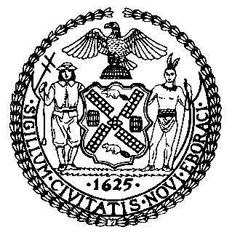 | The Council of the City of New York  Finance Division  Latonia McKinney, Director  Fiscal Impact Statement  Int. No: 1042-A  Committee: Parks and Recreation
Title: A Local Law to amend the administrative code of the city of New York, in relation to distributing excess automated external defibrillators from youth baseball and softball to other sports. | Sponsor(s): By Council Members Matteo, Levine, Grodenchik, Yeger, Holden, Moya and Gjonaj

Summary of Legislation: Proposed Intro. 1042-A would require the Department of Citywide Administrative Services (DCAS) and the Department of Parks and Recreation (DPR) to distribute excess automated external defibrillators from youth baseball and softball to any other youth league at no cost to such youth league.

Effective Date: This local law would take effect on January 1, 2020.

Fiscal Year In Which Full Fiscal Impact Anticipated: Fiscal 2021

Fiscal Impact Statement:

 | Effective FY20 | FY Succeeding  Effective FY21 | Full Fiscal  Impact FY21
Revenues | $0 | $0 | $0
Expenditures | $0 | $0 | $0
Net | $0 | $0 | $0

Impact on Revenues: It is estimated that there would be no impact on revenues as a result of this legislation.

Impact on Expenditures: It is anticipated that there would be no impact on expenses resulting from the enactment of this legislation because DCAS and DPR would use existing resources to implement the requirements of this legislation.

Source of Funds To Cover Estimated Costs: N/A

Source of Information: New York City Council Finance Division

Estimate Prepared By: Monika Bujak Legislative Financial Analyst
Mayor’s Office of Legislative Affairs

Estimate Reviewed By: Chima Obichere, Unit Head
Nathan Toth, Deputy Director
Rebecca Chasan, Senior Counsel

Legislative History: This legislation was introduced to the full Council as Intro. No. 1042 on July 18, 2018 and was referred to the Committee on Health. On November 14, 2018, Intro. No. 1042 was re-referred to the Committee on Parks and Recreation (Committee). A hearing was held by the Committee on February 7, 2019, and the legislation was laid over. The legislation was subsequently amended and the amended version, Proposed Intro. No. 1042-A, will be considered by the Committee on June 26, 2019. Upon a successful vote by the Committee, Proposed Intro. No. 1042-A will be submitted to the full Council for a vote on June 26, 2019.

Date Prepared: June 20, 2019.2019.

