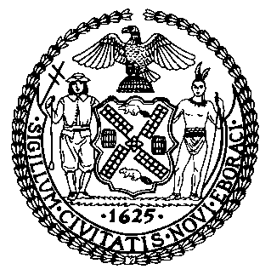 | The Council of the City of New York  Finance Division  Latonia Mckinney, Director  Fiscal Impact Statement  Proposed Int. No. 1261-A  Committee: Public Safety
Title: A Local Law to amend the New York city charter, in relation to requiring educational outreach within the office of prevention of hate crimes | Sponsors: By Council Members Deutsch, Richards, Levine, Vallone, Eugene, Menchaca, Moya, Ampry-Samuel, Cabrera, Gibson, Levin, Lancman, Rodriguez and Kallos
Summary of Legislation: Proposed Int. No. 1261-A would require the Office for the Prevention of Hate Crimes to conduct educational outreach and trainings, and the development of a K-12 curriculum addressing hate crime issues, in consultation with the Department of Education.
Effective Date: This local law takes effect on the same date as a local law for the year 2019 amending the New York city charter, relating to creating the office for the prevention of hate crimes, as proposed in introduction number 1234 for the year 2018, takes effect.
Fiscal Year In Which Full Fiscal Impact Anticipated: Fiscal 2021
Fiscal Impact Statement:

 | Effective FY20 | FY Succeeding  Effective FY21 | Full Fiscal  Impact FY21
Revenues (+) | $0 | $0 | $0
Expenditures (-) | ($204,000) | ($306,000) | ($306,000)
Net | ($204,000) | ($306,000) | ($306,000)

Impact on Revenues: It is anticipated that there would be no impact on revenues resulting from the enactment of this legislation.
Impact on Expenditures: It is anticipated that the Office of the Mayor would hire three Education Coordinators to provide education outreach. The fiscal impact of this legislation includes budgeting for personal services, other than personal services, and fringe benefits. The fiscal impact would be prorated at $204,000 for Fiscal 2020 and the full fiscal impact would be $306,000 in Fiscal 2021 and the following years.
Source of Funds To Cover Estimated Costs: General Fund
Source of Information: New York City Council Finance Division
Estimate Prepared by: Nevin Singh, Financial Analyst

Estimate Reviewed by: Regina Poreda Ryan, Deputy Director
Eisha Wright, Unit Head
Stephanie Ruiz, Assistant Counsel
Legislative History: This legislation was considered at a hearing of the Committee on Public Safety (“Committee”) as a Preconsidered Int. on November 19, 2018, and the legislation was laid over. This legislation was introduced by the Council as Int. No. 1261 on November 28, 2018, and referred to the Committee. The bill was subsequently amended and the amended legislation, Proposed Int. No. 1261-A, will be considered by the Committee on January 22, 2019. Upon a successful vote by the Committee, Proposed Int. No. 1261-A will be submitted to the full Council for a vote on January 24, 2019.
Date Prepared: January 18, 2018

