THE COUNCIL OF THE CITY OF NEW YORK
RESOLUTION NO. 1777

Resolution approving the decision of the City Planning Commission on Application No. N 210279 ZRK, for an amendment of the text of the Zoning Resolution (L.U. No. 876).

By Council Members Salamanca and Moya

WHEREAS, 130 St. Felix Street, LLC, filed an application pursuant to Section 201 of the New York City Charter, for an amendment of the text of the Zoning Resolution of the City of New York, modifying provisions of Article X, Chapter 1 (Special Downtown Brooklyn District) and modifying APPENDIX F for the purpose of establishing a Mandatory Inclusionary Housing area, which in conjunction with the related action would facilitate the construction of a 23-story, approximately 147,000-square-foot mixed-use residential and community facility building with approximately 120 dwelling units at 130 St. Felix Street (Block 2111, Lot 40) in the Downtown Brooklyn neighborhood of Brooklyn Community District 2 (ULURP No. N 210279 ZRK), (the “Application”);

WHEREAS, the City Planning Commission filed with the Council on September 24, 2021, its decision dated September 22, 2021 (the "Decision") on the Application;

WHEREAS, the Application is related to applications C 210278 ZMK (L.U. No. 875), a zoning map amendment to change a portion of a C6-1 zoning district to C6-4 and C6-6 zoning districts within the Special Downtown Brooklyn District (SDBD); C 210280 ZSK (L.U. No. 877), a special permit pursuant to Zoning Resolution (ZR) Section 74-533 to waive required residential parking to facilitate affordable housing; and C 210281 ZSK (L.U. No. 878), a special permit pursuant to Zoning Resolution (ZR) Section 101-82 to modify bulk regulations;

WHEREAS, the Decision is subject to review and action by the Council pursuant to Section 197-d of the City Charter;

WHEREAS, upon due notice, the Council held a public hearing on the Decision and Application on October 5, 2021;

WHEREAS, the Council has considered the land use implications and other policy issues relating to the Decision and Application; and

WHEREAS, the Council has considered the relevant environmental issues, including the Negative Declaration issued May 3rd, 2021 (CEQR No. 21DCP083K), which includes an (E) designation to avoid the potential for significant adverse impacts related to hazardous materials, air quality, and noise (E-616) (the “Negative Declaration”).

RESOLVED:

The Council finds that the action described herein will have no significant impact on the environment as set forth in the (E) Designations (E-616) and Negative Declaration.

Pursuant to Sections 197-d and 200 of the City Charter and on the basis of the Decision and Application, and based on the environmental determination and consideration described in the report, N 210279 ZRK, incorporated by reference herein, and the record before the Council, the Council approves the Decision of the City Planning Commission.

Matter underlined is new, to be added;
Matter struck out is to be deleted;
Matter within # # is defined in Section 12-10;
* * * indicates where unchanged text appears in the Zoning Resolution.

ARTICLE X
SPECIAL PURPOSE DISTRICTS

Chapter 1
Special Downtown Brooklyn District

* * *

101-20
SPECIAL BULK REGULATIONS

* * *

101-21
Special Floor Area and Lot Coverage Regulations

* * *

(d) In C6-6 Districts

In C6-6 Districts, the maximum permitted #floor area ratio# for #commercial# or #community facility uses# shall be 15.0, and the maximum #residential# #floor area ratio# shall be 9.0. However, in #Mandatory Inclusionary Housing areas# mapped after [date of adoption], the maximum #residential# #floor area ratio# shall be 12.0. No #floor area# bonuses shall be permitted.

* * *
101-80
SPECIAL PERMITS
* * *

101-82
Modification of Bulk Regulations for Certain Buildings on Irregular Sites

In C6-9 Districts within the #Special Downtown Brooklyn District#, mapped after March 13, 2019, and in C6-4 and C6-6 Districts within the #Special Downtown Brooklyn District#, mapped after [date of adoption], for #developments# or #enlargements# on irregular sites, the City Planning Commission may modify underlying #bulk# regulations, other than #floor area ratio#, provided that no Use Group 5 #use# shall be permitted in any portion of the #building# receiving such modifications, and:

(a) there are physical conditions, including irregularity, narrowness or shallowness of lot shape or size that create practical difficulties in complying with the #bulk# regulations and would adversely affect the #building# configuration or site plan;

(b) the practical difficulties of developing on the #zoning lot# have not been created by the owner or by a predecessor in title;

(c) the proposed modifications are limited to the minimum needed to relieve such difficulties;

(d) the proposed modifications will not unduly obstruct access of light and air to adjoining properties or #streets#; and

(e) the proposed scale and placement of the #development# or #enlargement# relates harmoniously with the surrounding area.

The Commission may prescribe additional conditions and safeguards to minimize adverse effects on the character of the surrounding area and to improve the quality of the site configuration.

* * *

APPENDIX F
Inclusionary Housing Designated Areas and Mandatory Inclusionary Housing Areas

* * *

BROOKLYN
* * *

Brooklyn Community District 2
* * *
Map 8 – (9/26/18)[date of adoption]

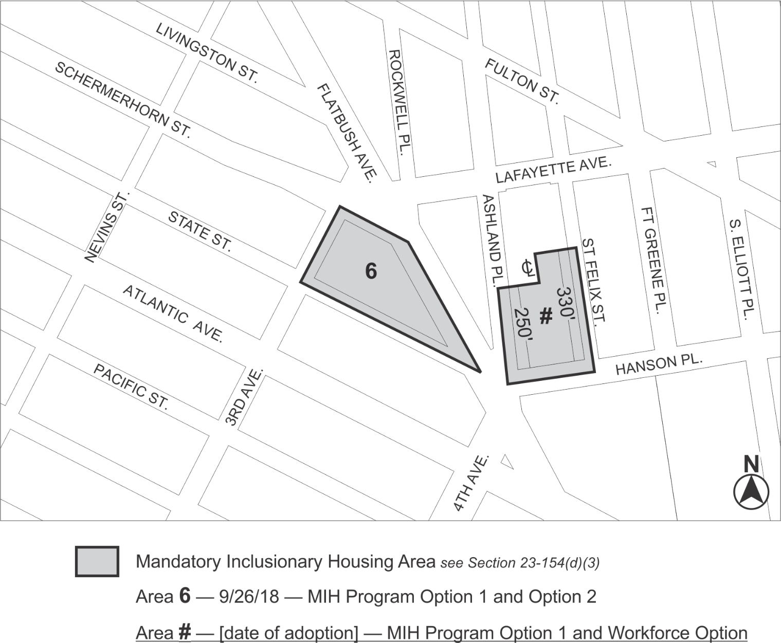

Portion of Community District 2, Brooklyn

* * *

Adopted.

Office of the City Clerk,}
The City of New York,} ss.:
I hereby certify that the foregoing is a true copy of a Resolution passed by The Council of The City of New York on October 21, 2021, on file in this office.

.....................................................
City Clerk, Clerk of The Council

