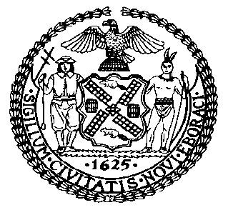 | The Council of the City of New York  Finance Division  Latonia McKinney, Director  Fiscal Impact Statement  Proposed Intro. No: 1853-A  Committee: Housing and Buildings
Title: A Local Law in relation to requiring the department of buildings to report on the safety and feasibility of authorizing building exterior wall examinations by unmanned aircraft systems | Sponsors: Council Members Cornegy, Kallos, Vallone, Rosenthal, Brannan, Ayala, Louis and Chin
Summary of Legislation: Proposed Intro. No. 1853-A would require the Department of Buildings to study the safety and feasibility of conducting building façade inspections using unmanned aircraft systems (i.e. “drones”) and submit the findings of such study to the Mayor and the Speaker of the Council by October 31, 2021.
Effective Date: This local law would take effect immediately.
Fiscal Year In Which Full Fiscal Impact Anticipated: Fiscal 2022
Fiscal Impact Statement:

 | Effective FY21 | FY Succeeding Effective FY22 | Full Fiscal Impact FY22
Revenues | $0 | $0 | $0
Expenditures | $0 | $0 | $0
Net | $0 | $0 | $0
Impact on Expenditures: It is estimated that there would be no impact on revenues resulting from the enactment of this legislation.
Impact on Expenditures: It is anticipated that there would be no impact on expenditures resulting from the enactment of this legislation because the Department of Buildings would use existing resources to implement the provisions of this local law.
Source of Funds To Cover Estimated Costs: Not applicable.

Source of Information: New York City Council Finance Division
NYC Department of Buildings

Estimate Prepared by: Luke Zangerle, Legislative Financial Analyst

Estimated Reviewed by: Chima Obichere, Unit Head
Noah Brick, Assistant Counsel

Legislative History: This legislation was introduced to the full Council on January 23, 2020 as Intro. No. 1853 and was referred to the Committee on Housing and Buildings. A hearing was held by the Committee on Housing and Buildings on January 27, 2020 and the bill was laid over. The legislation was subsequently amended, and the amended version, Proposed Intro. 1853-A, will be considered by the Committee on Housing and Buildings on September 16, 2020. Following a successful Committee vote, the bill will be submitted to the full Council for a vote on September 16, 2020.

Date Prepared: September 14, 2020

