Committee on Governmental Operations
Daniel Collins, Senior Legislative Counsel
Elizabeth Kronk, Senior Policy Analyst
Emily Forgione, Senior Policy Analyst
Sebastian Bacchi, Financial Analyst

Committee on Technology
Irene Byhovsky, Legislative Counsel
Charles Kim, Policy Analyst
Florentine Kabore, Financial Analyst

Data Operations Staff
Ben Witte, Data Scientist
Julia Fredenburg, Data Visualization Specialist



THE COUNCIL OF THE CITY OF NEW YORK

Briefing Paper and Committee Report of the Governmental Affairs Division & Infrastructure Division
Jeffrey Baker, Legislative Director
Rachel Cordero, Deputy Director, Governmental Affairs Division
Terzah Nasser, Deputy Director, Infrastructure Division

COMMITTEE ON GOVERNMENTAL OPERATIONS
Hon. Fernando Cabrera, Chair

COMMITTEE ON TECHNOLOGY
Hon. Robert Holden, Chair

January 21, 2020

Oversight – 311

Int. No. 62: By Council Members Cornegy, Brannan and Holden

Title: A Local Law to amend the administrative code of the city of New York, in relation to requiring that the 311 website, app, and phone line allow for persons to request snow and ice removal on pedestrian bridges and that those reports be routed to the appropriate agency

Administrative Code: Adds a new section 23-304

Int. No. 462: By Council Member Dromm

Title: A Local Law to amend the New York city charter, in relation to requiring the 311 call center to log complaints about locations without street addresses

Charter: Amends section 15

Proposed Int. No. 1420-B: By Council Members Matteo and Holden

Title: A Local Law in relation to requiring a study and report on unsubstantiated 311 complaints

Proposed Int. No. 1525-A: By Council Members Koo and Cabrera

Title: A Local Law to amend the administrative code of the city of New York, in relation to conducting 311 customer satisfaction surveys in designated citywide languages

Administrative Code: Adds a new section 23-304

Int. No. 1830: By Council Member Ayala

Title: A Local Law to amend the administrative code of the city of New York, in relation to publication of 311 service level agreements

Administrative Code: Adds a new section 23-304

Proposed Int. No. 1832-A: By Council Members Cabrera, Louis, Brannan and Kallos

Title: A Local Law to amend the administrative code of the city of New York, in relation to requiring 311 to notify each agency when a request for service or complaint has not been closed within the number of days specified by such agency’s service level agreement

Administrative Code: Adds a new section 23-304

Introduction
On January 21, 2020, the Committee on Governmental Operations, chaired by Council Member Fernando Cabrera, jointly with the Committee on Technology, chaired by Council Member Robert Holden, will hold a joint oversight hearing on New York City 311 (“311”). The Committees will hear the following legislation: Int. 62, sponsored by Council Member Robert Cornegy, Jr., in relation to requiring that the 311 website, app, and phone line allow for persons to request snow and ice removal on pedestrian bridges and that those reports be routed to the appropriate agency; Int. 462, sponsored by Council Member Daniel Dromm, in relation to requiring the 311 call center to log complaints about locations without street addresses; Proposed Int. 1420-B, sponsored by Council Member Steven Matteo and Holden, in relation to requiring a study and report on unsubstantiated 311 complaints; Proposed Int. 1525-A sponsored by Council Member Peter A. Koo, in relation to conducting 311 customer satisfaction surveys in designated citywide languages; Proposed Int. 1832-A, sponsored by Council Member Fernando Cabrera, in relation to requiring 311 to notify each agency when a request for service or complaint has not been closed within the number of days specified by such agency’s service level agreement; and Int. 1830, sponsored by Council Member Diana Ayala, in relation to publication of 311 service level agreements. Those expected to testify include representatives from 311, the Mayor’s Office of Operations (“MOO”) and other interested members of the public.
This hearing is a follow-up to two previous oversight hearings regarding 311, the first on January 17, 2019 (Committees on Governmental Operations and Technology) regarding 311 customer experience and operations, and the second on February 4, 2019 (Governmental Operations alone) regarding agency responsiveness to 311 service requests.

Background

311 overview
New York City 311 is a citywide program providing non-emergency government services to New York City residents, businesses and visitors. The 311 Customer Service Center is housed within MOO. The Department of Information Technology & Telecommunications (“DoITT”), the agency responsible for providing information technology, infrastructure and telecommunications services to City agencies, boards and offices, provides technological services and general services support for 311.
The 311 customer service center was first launched in 2003 as a call center. Prior to its establishment by former Mayor Michael Bloomberg, the City relied on approximately 40 agency help lines and a general mayoral phone line, almost all of which were folded into the 311 call center.
Today, 311 is available 24 hours a day, seven days a week via multiple channels. In Fiscal Year 2019, 311 received more than 42 million inquires. More than 20 million contacts were made via 311 online and almost 20 million via telephone. Eighty percent of calls were answered within 30 seconds. The average wait time to speak to a representative after 311’s initial recorded message was 26 seconds, which is a two-second decrease from the Fiscal Year 2018 28-second average, but still an eight-second increase from Fiscal Year 2017.
By comparison, contacting 311 via mobile app or text was less widely adopted in Fiscal Year 2019. About 2.2 million inquiries were made via the 311 mobile app, and about 253,000 were made via text messaging at 311-NYC(692) and 311 TTY at 212-504-4115. Information and assistance are available via the web-based calling application Skype (username: “NYC311”) or using a video relay service available at 212-New-York (212-639-9675). The 311 service is also on Facebook and Twitter.

Agency service level agreements
A customer contact with 311 generally generates either a service request, when the customer is seeking a City agency to take an action, or an informational request, when the customer has a question regarding a City service. There are datasets for both types of requests on the City’s Open Data portal. Once a customer makes a complaint or request, a unique number is generated which is shared with the customer and can be used to track the resolution of the case. Service requests are submitted to appropriate City agencies, based on complaint type.
Service level agreements (“SLAs”) between 311 and city agencies outline the timeframe in which an agency is expected to respond to a particular service request. Some SLAs are as short as an hour while others can span several days, depending on the severity of the threat to public safety. As discussed below, 311 communicates this information to customers so they have an expectation for when the service request will be fulfilled.
However, 311 is unable to follow an agency’s workflow for each request. It relies on each agency to document a clear resolution for each request and mark each request as closed. During the Council’s February hearing, the Departments of Environmental Protection (“DEP”), Buildings (“DOB”), Finance (“DOF”), Health and Mental Hygiene (“DOHMH”), Transportation (“DOT”) and Housing Preservation and Development (“HPD”), and the Taxi and Limousine Commission (“TLC”), each testified to how they prioritize and respond to disparate requests relayed by 311. Each agency has numerous complaint types, each with an assigned response time. For example, DEP has 123 unique complaint types, DOB has nearly 100 and HPD has more than 150. Agencies testified that the majority of service requests are responded to within the time provided in their SLAs. However, not all are responded to in a timely fashion. For example, DOF reported that 67 percent of its requests were closed within the SLA time in Fiscal Year 2018. DOHMH reported that it responded to rodent complaints within its 10-business day SLA target 81 percent of the time.
Currently, service level requests are not publicly disclosed. Additionally, according to correspondence with the Mayor’s Office, 311 does not currently send agencies notifications when they are beyond their SLA time for any request, or if a request is not closed.
Both 311 representatives and members of the public can look up the status of a request if they have the corresponding service request number, and can see the SLA deadline for that request. Tracking service requests is possible through 311’s website and smartphone application for iOS and Android. The following is a screenshot (Figure No. 1) of what members of the public would see online, with the SLA complaint type and “SLA remaining days” highlighted:
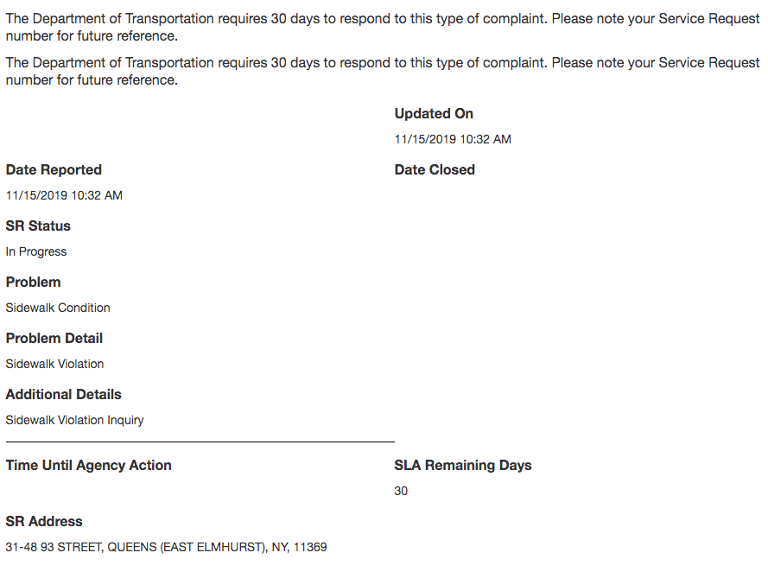
Figure No. 1
Agencies testified to Speaker Corey Johnson in February that they would close requests when they are complete. However, given that 311 relies on agencies to close requests within their SLAs, it is not clear what either 311 or a member of the public could do if an agency has not timely closed a service request. Governmental Operations Committee Chair Cabrera asked 311 if it had interest in creating an alert system to notify an agency when a customer complaint has not been noted as closed on the 311 system within the time specified by such agency’s SLA. Joseph R. Morrisroe, 311’s Executive Director, said, “it’s something we could take a look at with agencies and see what it would take to do, [and] what the value of that would be.”

Agency responsiveness to 311 complaints
Figure No. 2 below shows the ten City agencies with the most service requests overall, out of 2.3 million service requests in 2019 as compared to requests received in 2018:
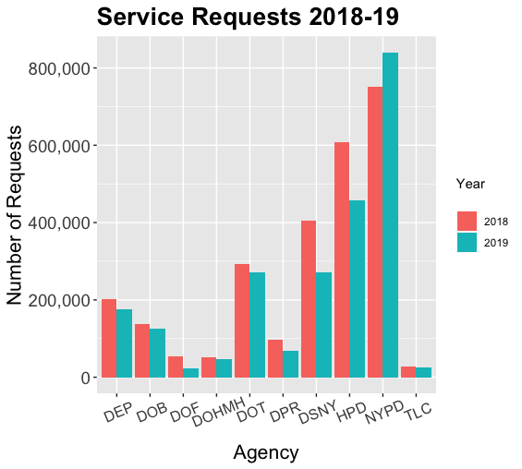
Figure No. 2
With the exception of the NYPD, most agencies either experienced no change or a decrease in the volume of service requests compared to the previous year.
Figure No. 3 shows the top ten complaint types from that same poll of service request data from 2019:
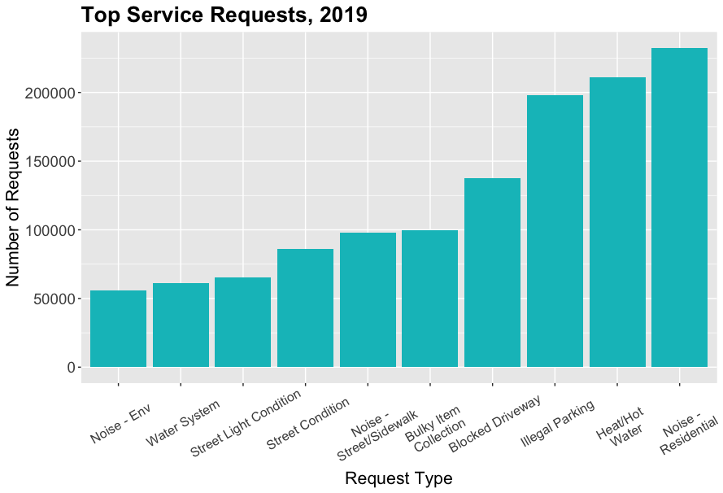
Figure No. 3
These requests remain largely consistent with 2018 data, as parking, noise and heat and hot water continue to be most common concerns for New Yorkers. Figure No. 4 shows the ten complaint types with the longest resolution times:
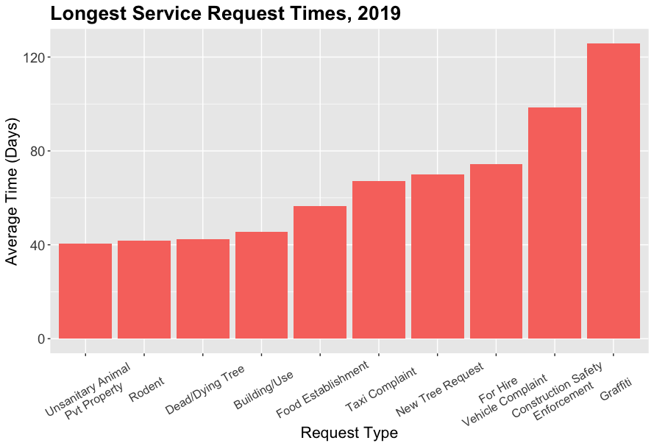
Figure No. 4
While ‘Dead/Dying Tree’ requests are addressed, on average, in approximately one-third of the time it took in 2018, this list otherwise remains largely unchanged from previous years. Complaints that require significant investigation or communication with property owners inevitably require time to address. One positive change, however, is the response time to resolve rodent complaints. In 2018, due to data-entry practices, rodent-related service requests were often completed in a negative timeframe (i.e. were marked closed hours or even days before the request was opened). It appears this issue has been addressed, and response times more accurately reflect the time between a service request entry and actual closure of this request. By addressing this data-entry issue, raised in past Committee oversight, DOHMH has improved the quality of their 311 data.
Looking beyond the requests with the longest time to resolve, some requests took significantly more or less time to resolve, as compared to 2018. Significant decreases may be the result of a lower volume of requests, but further clarity is necessary. Figure No. 5 illustrates the service requests that have changed the most since last year:
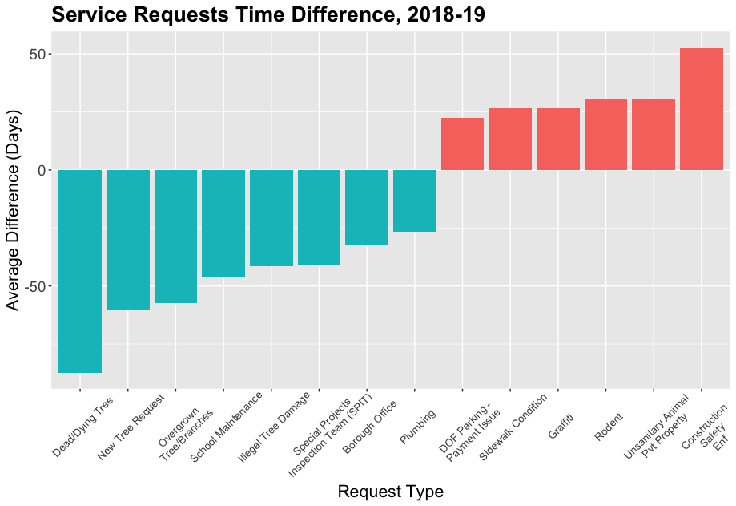
Figure No. 5
As discussed above, 311 relies on each agency to document a clear resolution for each request and mark each request as closed. However, a 2018 Council analysis of 311 requests on the City’s Open Data portal found that this process has significant room for error, and that 311 service request data lacked sufficient nuance to allow both the public and agencies to understand if requests are being addressed appropriately and in a timely manner. For example, the Council found that certain agencies, including TLC and DOHMH, did not describe how, if at all, it actually resolved complaints. Other agencies, including DOT and DOF, used ambiguous responses in place of concrete resolution descriptions that would aid the public in knowing if a complaint was in fact resolved. Other agencies reported inaccurate response times or reported response times that were misleading. For example, DOHMH reported that all lead-related complaints were addressed within 24 hours because resolution involved mailing a lead testing kit, not confirming the results of any resulting lead test. Similarly, TLC marked complaints closed even when the only resolution was a promise to contact the complainant.
In February 2019, Speaker Johnson expressed frustration with agencies’ differing approaches to reporting their responses to 311 complaints and suggested an interagency working group to improve such reporting.
Data from 2019 suggests that little has improved in regards to response quality. Few agencies saw significant positive improvement, and several even showed decreased quality, with more complaints containing ambiguous resolution descriptions, such as “see notes,” or simply closed with “unknown” statuses. Below is a visualization of 2018 (Figure No. 6) and 2019 (Figure No. 7) resolution descriptions from the top ten City agencies with the most service requests overall.
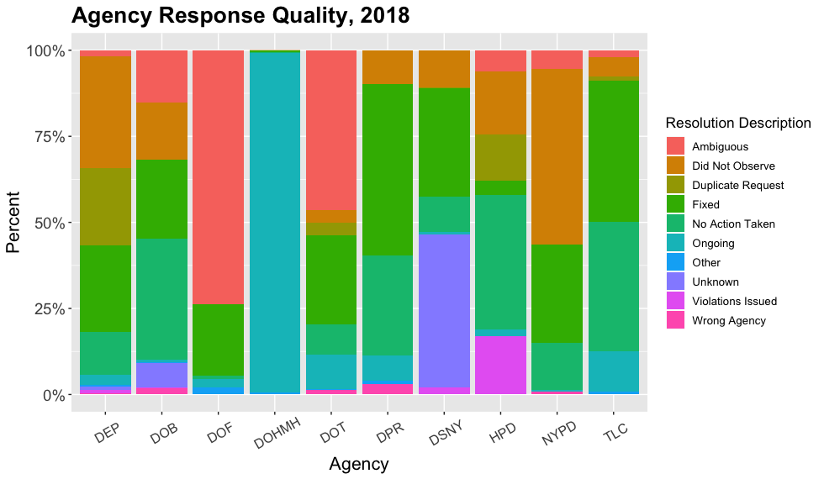
Figure No. 6
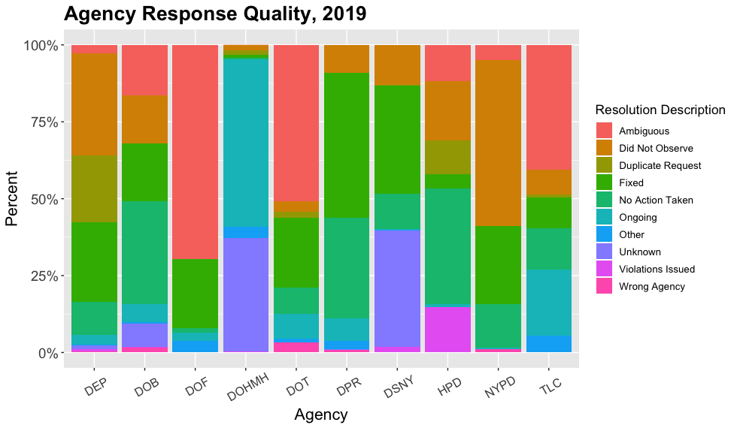
Figure No. 7

Technology upgrades
As discussed above, the 311 website and mobile app can be used to look up the status of an individual request. As of the Council’s January 2019 oversight hearing, only the mobile app could track multiple service requests at one time for a customer, and then only if those requests were submitted through the app. Neither the website nor the telephone system allowed for similar tracking. Accordingly, New Yorkers could not sign in and view all the service requests they made in one convenient place.
Improvements to customers’ interface have been hampered by 311’s outdated 2002-era technology. DoITT led an effort to deliver a new customer relationship management platform (“CRM”) to replace 311’s existing 16-year-old system. In April 2015, DoITT issued a request for services to create a new platform where users could create 311 accounts that allow tracking requests and receiving updates on complaints. The City awarded IBM a $24 million contract in February 2017 for a contract term from March 1, 2017 to August 31, 2019. Per the contract, IMB’s Watson, a high-tech computing system with machine-learning capability, would support a new CRM that will be constructed for multiple communications channels. The Council was told that, once completed, the new system will be more flexible and customer-oriented. The new system was also anticipated to be more stable, even under a high volume of requests. According to 311, many of these changes will not be visible to the public, but a customer will be able to build and maintain their own account in the CRM. The new system went live mid-2019.

Language access
To improve access to City government information and services, the Council passed Local Law 30 of 2017, which requires that covered agencies provide language access services for ten designated citywide languages. Specifically, section 23-1101 of the Administrative Code defines the designated languages as the top six limited English proficiency languages spoken by the New York City population based on U.S. Census data, plus an additional four languages based on language data collected the City’s Department of Education. These languages are currently Spanish, Chinese (Mandarin and Cantonese), Russian, Bengali, Haitian Creole, Korean, Arabic, French, Urdu and Polish.
Pursuant to Local Law 30, members of the public can submit language access complaints and requests through 311. Language access complaints refer to instances in which an individual stated that they did not receive access to information services because of a language barrier and requests for additional language services regarding, for example, a need for interpretation at a facility or agency service, or a need for material that should be translated into additional languages. The Mayor’s Office of Immigrant Affairs (“MOIA”) and MOO annually report how many such complaints each agency receives and how such complaints were resolved.
Local Law 30 also required every covered agency to develop and implement an agency-specific language access plan to describe how language access services will be provided. These plans must be updated at least every three years and published on the agency’s website. These plans are also compiled by MOIA and MOO annually.
According to its updated language access plan, published in June 2019, 311 offers telephonic interpretation and translation services in more than 175 languages, including the 10 languages required by Local Law 30. Translation is also provided in more than 100 languages on 311’s website.
Callers are informed about the availability of interpretation services through the 311 call pickup recording, which transfers them to a telephonic interpreter if they choose. However, the recording offers pre-recorded announcements in only six languages, not all 10 of the citywide languages: Spanish, Mandarin, Russian, Cantonese, Korean and Haitian Creole. According to 311’s Language Access Plan, more than 94 percent of limited English proficient (“LEP”) callers request interpretation services in Spanish, Mandarin, Russian, or Cantonese, with the other six percent requesting other languages. Of the approximately 20 million calls received in 2017, 639,521 calls, or approximately three percent, required interpretation services. Language Line, 311’s telephonic interpretation vendor, provided assistance in 93 different languages.
According to its plan, 311 call center operators are trained on how to interact with a caller who does not speak English, and how to handle a call when they are unable to readily identify a caller’s language. When operators are unable to identify a caller’s language, they will connect with a vendor, Language Line, and request to speak with someone who is skilled in language identification.
Despite this training, there have been persistent reports that 311 operators do not always appropriately identify the language a caller is speaking. At a Committee on Governmental Operations hearing in October 2018, advocates, including the Chinese American Planning Council, Asian American Federation, the New York Immigration Coalition and India Home, testified that they knew of incidents where LEP New Yorkers were unable to lodge a 311 complaint because they could not access the appropriate interpreter for the language that they spoke. India Home returned to the Governmental Operations and Technology committees’ joint hearing in January 2019 to testify about this issue.
In advance of its January 2019 oversight hearing, Council staff tested 311’s language access procedures. The automated system by which callers may select one of six pre-recorded languages did not appear to communicate with 311’s human operator system. The call was transferred to an operator who answered in English and did not appear to know that the caller previously selected a non-English language. When a caller spoke a language other than the six pre-recorded languages, the call was also transferred to a human operator, who answered in English and then attempted to identify the language the caller needed. In both cases, a 311 operator first had to make a best guess of the caller’s language and then transfer the caller to a Language Line interpreter. If the 311 operator guessed incorrectly, or could not understand the caller’s language, Language Line staff would figure out the correct language and eventually connect the caller to an appropriate interpreter. The process took time, and only the most determined callers were likely to remain on the line before getting frustrated and disconnecting. For example, Speaker Johnson said he had an Armenian-speaking staffer who took 17 minutes to be connected to a proper translator.
During the January 2019 oversight hearing, 311 Executive Director Morrisroe said 311 would make solving the issues raised by advocates and the Council a priority. He also blamed 311’s outdated system for failing to note for 311’s human operators when a caller had selected one of the six non-English languages.
Nearly a year later, 311’s system still directs callers who select one of the six non-English touchtone languages to an English-speaking operator who then attempts to link them to an appropriate interpreter. According to 311, the operator is now informed when a language was selected, however, Korean and Mandarin testers for news website The City reportedly found that only on some calls did the operator see that a language was selected and connect the callers to appropriate interpreters. Responding to criticism that it only offers six of the 10 citywide languages as touchtone options, 311 argues that its legal obligations under Local Law 30 are satisfied because callers can access all 10 languages, and many more, via Language Line interpreters operators connect them with.

Satisfaction surveys
During the Council’s January 2019 oversight hearing, 311 testified that it conducts an annual, 25-question customer satisfaction survey through a vendor. 311 conducts four additional in-house surveys using a Likert scale, which is a type of rating scale used to capture more nuanced responses to questions than the simple binary “yes” or “no.” These surveys were conducted entirely in English, with results showing generally high levels of customer satisfaction with 311 service. In Fiscal Year 2019, 311 reported that a customer satisfaction survey of 765 callers conducted by CFI Group, Inc. gave 311 a “composite score of 84,” which is reportedly “on par with the best performers in the private sector.”
However, Council Member Koo, then-chair of the Council Committee on Technology, expressed some skepticism towards the results of 311’s surveys, contending that a survey that does not capture the feedback and criticism of non-English users would not accurately represent the customer satisfaction of all 311 users. In response, 311 Executive Director Morrisroe said 311 could look at how it can expand its survey capability to languages other than English.

Anonymous complaint harassment
While 311 is intended to be a way for New Yorkers to request agencies to address legitimate complaints, there is concern that it occasionally has been used as a tool for harassment, whereby a caller makes repeated, anonymous, unsubstantiated complaints against a private property. Such abuse is not only detrimental to the subject of the anonymous complaints, but also a drain on City resources that could be used to respond to valid complaints.
Between 2006 and 2014, the Staten Island Borough President’s district office recorded more than 50 reports of 311 harassment, including one homeowner who was the subject of nine anonymous complaints about various conditions in and around his home in 2013, five of which were made over just two days, and seven of which were deemed baseless upon inspection. Local elected officials believed these repeated anonymous calls were the result of neighbor-versus-neighbor disputes. In 2017, a Bronx homeowner reported that he had received 68 summonses for conditions in and around his home over the past two years, all arising from anonymous calls to 311. Local State Assembly Member Michael Benedetto said that 66 of the 68 complaints were dismissed. That case also appeared to involve a neighbor-versus-neighbor dispute.
There has also been reported 311 harassment against businesses. In 2012, D’Amico, a coffee and specialty food store in Carroll Gardens, Brooklyn, was the subject of repeated anonymous complaints over the smell of roasting coffee beans coming from their shop. The caller then began calling the Fire Department, which could have diverted important City resources away from responding to true emergencies.
The Council passed Local Law 70 of 2017 to require DoITT to create a notification system whereby business owners can be informed of any 311 complaints lodged against them. Participation is voluntary. Business owners can sign up to receive notifications via text message or email. Such notifications must be made available in the ten designated citywide languages.

Issues and Concerns
Nearly a year after the Council’s last oversight hearing, the Committees are interested to hear what progress 311 has made to address several concerns raised in 2019. Among other topics, the Committees are interested in the steps that have been taken to ensure that agencies respond to service requests in a timely manner and clearly document how such requests are addressed. The Committees are interested in the progress made in updating 311’s outdated technology, and seek to understand how 311’s new system will increase functionality and responsiveness for customers. Additionally, the Committees expect updates on the steps 311 has taken to improve language access. The Committees will also seek input from 311 and interested members of the public on proposed legislation.

Legislative Analysis

Int. No. 62

Int. No. 62 (Cornegy Jr.) would allow individuals who access the 311 website, app and phone line to be able to request that snow and ice be cleared from pedestrian bridges.

Int. No. 462

Int. No. 462 (Dromm) would prohibit staff at the 311 customer service call center from declining to enter complaints or requests for service into their database for the purposes of forwarding to the appropriate agency to respond on account of the customer failing to provide an address or other location recognized by the database utilized by 311. In such instances, 311 would be required to enter the location, whether it is an unrecognized address, intersection, or other location, into the “notes” section of the database entry, which is intended to allow the responding agency to identify the location to which the caller or texter is referring.

Proposed Int. No. 1420-B

Proposed Int. No. 1420-B (Matteo) would require MOO to study and file a report on the number of unsubstantiated 311 complaints made against private properties, the number and types of notices of violation issued to a property that was previously visited and resulted in an unsubstantiated complaint in the prior year, the frequency of, and reasons for, visiting a property more than once a year, the disposition of violations unrelated to the original 311 complaint, and whether the complaint was made anonymously. The information would be disaggregated by borough, council district and community district.

Proposed Int. No. 1525-A

Proposed Int. No. 1525-A (Koo) would require the 311 customer service center to conduct at least five annual customer satisfaction surveys. The bill would require each customer satisfaction survey conducted in relation to 311 user experience to be offered, in addition to English, in ten designated citywide languages, as determined based on United States census data and New York City Department of Education data. The bill would require MOO to submit an annual report containing the results of any such survey, disaggregated by the language in which the survey was conducted.

Int. No. 1830

Int. No. 1830 (Ayala) would require 311 to maintain on its website each service level agreement it has with agencies. Service level agreements set forth the number of days within which each agency will respond to and close a request for service or complaint.

Proposed Int. No. 1832-A

Proposed Int. No. 1832-A (Cabrera) would require 311 to notify each agency when a customer’s request for service or complaint has not been closed within the number of days specified by such agency’s service level agreement.
Int. No. 62

By Council Members Cornegy, Brannan and Holden

A Local Law to amend the administrative code of the city of New York, in relation to requiring that the 311 website, app, and phone line allow for persons to request snow and ice removal on pedestrian bridges and that those reports be routed to the appropriate agency

Be it enacted by the Council as follows:

Section 1. Chapter 3 of title 23 of the administrative code of the city of New York is amended by adding a new section 23-304 to read as follows:
§ 23-304. Reporting snow and ice conditions on pedestrian bridges. The department of information technology and telecommunications shall create a mechanism for persons using the 311 app, 311 website, and 311 phone line to report snow and ice conditions on pedestrian bridges, and for those reports to be routed to the appropriate agency.
§ 2. This local law takes effect 120 days after it becomes law, except that the commissioner of information technology and telecommunications shall take all actions necessary for its implementation, including the promulgation of rules, prior to such effective date.

[ADW/MHL]
LS #3146
1/17/18

[This Page is Intentionally Left Blank]

Int. No. 462

By Council Member Dromm

A Local Law to amend the New York city charter, in relation to requiring the 311 call center to log complaints about locations without street addresses

Be it enacted by the Council as follows:

Section 1. Section 15 of the New York city charter is amended by adding a new subdivision l to read as follows:
l. No call or text received by 311 that would be entered into the 311 computer system if it included a specific address or other location contained within any address or location database utilized by the 311 shall fail to be so entered on account of such address or other location not being included in any such database. Where a call or text is received by 311 that does not include a specific address or other location contained within any address or location database utilized by 311, such call or text shall be treated for the purposes of entering it into the 311 computer system as if it did include such an address or specific location, except that the location shall be manually noted by the 311 representative in the notes section of any associated entry in the computer system. For the purposes of this subdivision, “311” means the 311 citizen service center.
§ 2. This local law takes effect 90 days after it becomes law.
DSS/JJD
LS 3916/Int. 785-2015
LS 1101
1/3/2018

[This Page is Intentionally Left Blank]

Proposed Int. No. 1420-B

By Council Members Matteo and Holden

A Local Law in relation to requiring a study and report on unsubstantiated 311 complaints

Be it enacted by the Council as follows:

Section 1. Reporting on 311 complaints. a. Definitions. For the purposes of this section the following terms have the following meanings:
Unsubstantiated complaint. The term “unsubstantiated complaint” means a complaint for which there is not enough evidence for an enforcement official from the responding agency or department to determine whether or not the reported incident occurred.
b. No later than December 1, 2020, the mayor’s office of operations shall complete a study on 311 complaints received on or after February 1, 2013, and shall prepare and file with the mayor and the council, and post on its website, a report disclosing the following:
1. The number and types of unsubstantiated complaints made against private properties;
2. The number and types of notices of violation issued to a property that was previously visited and resulted in an unsubstantiated complaint in the prior 12 months;
3. The number of, and reasons for, visits by the responding agency or department to any property or dwelling that received more than one visit from an enforcement official in the previous 12 months;
4. The number, types and dispositions of violations unrelated to the underlying complaint that prompted a visit from an enforcement official to the property; and
5. Whether any reported complaints were made anonymously or in the name of the complainant.
c. All the information reported pursuant to subdivision b of this local law shall be disaggregated by borough, council district and community district.
§ 2. This local law takes effect immediately and expires and is deemed repealed on February 1, 2021.

JG
LS # 7628
12/17/19 11:00 a.m.

Proposed Int. No. 1525-A

By Council Members Koo and Cabrera

A Local Law to amend the administrative code of the city of New York, in relation to conducting 311 customer satisfaction surveys in designated citywide languages

Be it enacted by the Council as follows:

Section 1. Chapter 3 of title 23 of the administrative code of the city of New York is amended by adding a new section 23-304 to read as follows:
§ 23-304 Customer satisfaction survey. a. Definitions. As used in this section, the following terms have the following meanings:
Customer satisfaction survey. The term “customer satisfaction survey” means a survey used to evaluate the experiences of individuals who contact the 311 customer service center and to determine the overall level of satisfaction with 311 service.
Designated citywide languages. The term “designated citywide languages” has the same meaning as used in section 23-1101.
b. The 311 customer service center shall annually conduct at least five customer satisfaction surveys.
c. Every customer satisfaction survey administered by the 311 customer service center or by an entity contracting with the city to conduct such customer satisfaction survey shall be made available in all designated citywide languages.
d. No later than July 1 of each year, the mayor’s office of operations shall issue a report to the speaker of the council and the mayor including the results of each survey required by subdivision b of this section, disaggregated by the language in which such survey was conducted.
§ 2. This local law takes effect 90 days after it becomes law.

AS/dfc
LS # 9782
12/10/19 6:34 p.m.

Int. No. 1830

By Council Member Ayala

A Local Law to amend the administrative code of the city of New York, in relation to publication of 311 service level agreements

Be it enacted by the Council as follows:

Section 1. Chapter 3 of title 23 of the administrative code of the city of New York is amended by adding a new section 23-304 to read as follows:
§ 23-304 Service level agreements. The 311 customer service center shall maintain on its website each service level agreement between each agency and the 311 customer service center, which shall set forth the number of days within which each agency will respond to and close a request for service or complaint referred by the 311 customer service center to each agency.
§ 2. This local law takes effect 30 days after it becomes law.

DFC
LS #10237
12/13/19 4:38 p.m.

[This Page is Intentionally Left Blank]

Proposed Int. No. 1832-A

By Council Members Cabrera, Louis, Brannan and Kallos

A Local Law to amend the administrative code of the city of New York, in relation to requiring 311 to notify each agency when a request for service or complaint has not been closed within the number of days specified by such agency’s service level agreement

Be it enacted by the Council as follows:

Section 1. Chapter 3 of title 23 of the administrative code of the city of New York is amended by adding a new section 23-304 to read as follows:
§ 23-304 Notification to agencies. The 311 customer service center shall notify the applicable agency when a customer’s request for service or complaint referred by the 311 customer service center to such agency has not been closed within the number of days specified by such agency’s service level agreement. For purposes of this section, the term “service level agreement” means an agreement between an agency and the 311 customer service center which sets forth the number of days within which such agency will respond to and close a request for service or complaint referred by the 311 customer service center to such agency.
§ 2. This local law takes effect 1 year after it becomes law.

DFC
LS #9975
12/23/19 3:56 p.m.

The Official Website of the City of New York, NYC311, https://portal.311.nyc.gov (last accessed Dec. 9, 2019).
NYC Mayor’s Office of Operations, Mission, https://www1.nyc.gov/site/operations/about/about.page (last accessed Dec. 9, 2019).
NYC Information Technology & Telecommunications, Who We Are, https://www1.nyc.gov/site/doitt/about/who-we-are.page (last accessed Dec. 9, 2019).
Testimony of 311 Exec. Dir. Joseph R. Morrisroe before the Committees on Governmental Operations and Technology, New York City Council, (Jan. 17, 2019), available at https://legistar.council.nyc.gov/LegislationDetail.aspx?ID=3723063&GUID=82CF9499-67A5-48FB-BAF1-2E230611B69B&Options=&Search.
Committee Report, Committees on Governmental Operations and Technology, New York City Council, (Jan. 17, 2019), at page 2, available at https://legistar.council.nyc.gov/LegislationDetail.aspx?ID=3723063&GUID=82CF9499-67A5-48FB-BAF1-2E230611B69B&Options=&Search.
New York City Budget Office, Fiscal Brief: 311 Customer Service Center: More Calls and a Growing Budget, April 2008, p. 1-2, available at http://www.ibo.nyc.ny.us/iboreports/311Apr08.pdf. Examples of entities not incorporated into 311 are areas of New York City operated by certain authorities, such as the New York City Housing Authority, the Battery Park City Authority and the Roosevelt Island Operating Corporation. See Rachel Holliday Smith, What’s the 311? Stranded in New York’s Service Hotline Deserts, The City (Apr. 24, 2019), https://thecity.nyc/2019/04/whats-the-311-stranded-in-n-y-s-service-hotline-deserts.html.
Mayor’s Office of Operations, Mayor’s Management Report (Sept. 2019) at 134, available at https://www1.nyc.gov/assets/operations/downloads/pdf/mmr2018/311.pdf.
Id. at 143-44.
Id. 144.
Id.
Id.
See Mayor’s Office of Operations, Mayor’s Management Report, 311 Customer Service Center, (2018) at 143, available at https://www1.nyc.gov/assets/operations/downloads/pdf/mmr2019/2019_mmr.pdf.
Id.
Id. at 143.
Id. at 143-44.
Jan. 17, 2019 Committee Report, supra note 5 at 2.
See NYC OpenData, 311 Service Requests from 2010 to present, https://data.cityofnewyork.us/Social-Services/311-Service-Requests-from-2010-to-Present/erm2-nwe9 (last accessed Dec. 10, 2019); NYC OpenData, 311 Call Center Inquiry, https://data.cityofnewyork.us/City-Government/311-Call-Center-Inquiry/tdd6-3ysr (last accessed Dec. 10, 2019).
Committee Report, Committee on Governmental Operations, New York City Council, (Feb. 4, 2019), at page 4, available at https://nyc.legistar.com/LegislationDetail.aspx?ID=3840384&GUID=0F7E3CF0-3DB1-49D3-8280-63036A475EE7&Options=&Search.
Id.
Testimony of 311 Exec. Dir. Joseph R. Morrisroe before the Committee on Governmental Operations, New York City Council, (Feb. 4, 2019), available at https://legistar.council.nyc.gov/LegislationDetail.aspx?ID=3541118&GUID=B2312F00-2894-40AC-9DEF-A54C44F9FCBC&Options=&Search.
Id.
Id.
See generally Feb. 4 testimony, supra note 20; Andrew Millman, In Second 311 Oversight Hearing, City Council Examines Agency Responsiveness, Gotham Gazette (Feb. 10, 2019), https://www.gothamgazette.com/city/8271-in-second-311-oversight-hearing-council-examines-agency-responsiveness.
Feb. 4 testimony, supra note 20.
See id.
Id.
Id.
Nov. 19, 2019 email correspondence with the Mayor’s Office of City Legislative Affairs, on file with Governmental Operations Committee staff.
See The Official Website of the City of New York, NYC311 Look Up Service Requests, https://portal.311.nyc.gov/check-status (last accessed Dec. 9, 2019).
See id.; The Official Website of the City of New York, NYC311 Mobile App, https://portal.311.nyc.gov/article/?kanumber=KA-01025 (last accessed Dec. 15, 2019).
Testimony before the Committee on Governmental Operations, New York City Council, (Feb. 4, 2019), hearing transcript at page 29, available at https://legistar.council.nyc.gov/LegislationDetail.aspx?ID=3541118&GUID=B2312F00-2894-40AC-9DEF-A54C44F9FCBC&Options=&Search.
Id. at pages 52-53. TLC Asst. Commissioner Mark Lee said he understands that the new 311 system could have new functionality that more easily allows for the checking of aging complaints that have not been resolved. Id. at 53.
311 OpenData sets, supra note 17. The Council’s data team did an analysis of 311 operations using this OpenData information. New York City Council, 311 Services, https://council.nyc.gov/data/311-services/ (last accessed Dec. 10, 2019); New York City Council, Are City Agencies Responding to 311?, https://council.nyc.gov/data/311-agency/ (last accessed Dec. 10, 2019).
See generally Feb. 4, 2019 Committee Report, supra note 18.
Id. at 7-8, 9-10.
Id. at 8, 10. DOF testified that vague responses may be due to the sensitive nature of DOF service requests and that direct responses to complainants provide more specific information. Millman, supra note 23.
For example, as discussed above and since rectified, DOHMH data showed that 20 percent of rodent complaints were listed as resolved on a date before the complaint was filed, an error the DOHMH commissioner said may have been due to multiple complaints being filed for the same location and the resolution date reflecting the response to the first such complaint. Id.
Feb. 4, 2019 Committee Report, supra note 18 at 10; Millman, supra note 23.
Feb. 4, 2019 Committee Report, supra note 18 at 10; Rich Calder, The city’s 311 system is a complete mess, N.Y. Post (Feb. 4, 2019), https://nypost.com/2019/02/04/the-citys-311-system-is-a-complete-mess/; Zak Kostro, City’s 311 help line is ignoring you?, The Riverdale Press (Mar. 16, 2019), https://riverdalepress.com/stories/citys-311-help-line-is-ignoring-you,68356.
Millman, supra note 23.
Jan. 17, 2019 Committee Report, supra note 5 at 3.
Id.
Id. at 2-3. Former Mayor Bloomberg previously attempted to revamp 311 by approving a $10 million contact with Montreal-based company CGI, however Comptroller Scott Stringer stated that the contract needed to be re-bid, citing concerns about the planning and scope of the project, as well as costs. Id. at 6 (citing Annie Karni, Bloomberg Gave 311 Contract Worth $10M to Company Behind Obamacare Rollout, N.Y. Daily News (Jan. 24, 2014), https://www.nydailynews.com/news/politics/exclusive-bloomberg-gave-311-contract-worth-10m-cgi-article-1.1590916; Annie Karni, Co. That Botched HealthCare.gov Loses $10 Million New York City Contract, N.Y. Daily News (Feb. 5, 2014), https://www.nydailynews.com/new-york/healthcare-gov-loses-10m-nyc-contract-article-1.1602569).
Id. at 3; Testimony of Joseph Morrisroe, supra note 4.
Jan. 17, 2019 Committee Report, supra note 5 at 7 (Citing DoITT Request for Systems Integration Services for 311 Customer Service Management System Replacement and Re-Architecture Project, April 28, 2015, available at https://www1.nyc.gov/assets/doitt/downloads/pdf/311-rfs.pdf; Matthew Flamm, City’s 311 Hotline is Getting Some Help of Its Own, Crain’s N.Y. Bus. (April 30, 2015), https://www.crainsnewyork.com/article/20150430/TECHNOLOGY/150429832/city-s-311-hotline-is-getting-some-help-of-its-own; Task Order Number 1426-001A, NYC 311 CSMS Replacement and Re-Architecture for Department of Information Technology and Telecommunications, found at: https://www.scribd.com/document/342938208/NTP-and-NYC-311-IBM-Task-Order-1426-001A-signed-Redacted-v2?secret_password=RtVgjUFEdELXT1pukn65; Matthew Flamm, IBM's Watson will soon answer your 311 calls, Crain’s N.Y. Bus. (Jan. 11, 2017), https://www.crainsnewyork.com/article/20170112/TECHNOLOGY/170119941/ibm-s-watson-will-soon-answer-your-311-calls-as-part-of-a-24-million-upgrade-to-the-system).
Id.
Id. at 7-8.
Id. 4.
Id.
Testimony of Joseph Morrisroe, supra note 4.
See Testimony of DoITT Commissioner Samir Saini before the Committees on Governmental Operations and Technology, New York City Council, (Jan. 17, 2019), hearing transcript at page 45, available at https://legistar.council.nyc.gov/LegislationDetail.aspx?ID=3723063&GUID=82CF9499-67A5-48FB-BAF1-2E230611B69B&Options=&Search; Andrew Millman, City's 311 Upgrade Set for Mid-Year Launch, Gotham Gazette (Jan. 25, 2019), https://www.gothamgazette.com/city/8225-city-s-311-upgrade-set-for-mid-year-launch.
Mayor’s Office of Immigrant Affairs and Mayor’s Office of Operations, Local Law 30 Report, June 28, 2019 at PDF page 3, available at https://www1.nyc.gov/assets/immigrants/downloads/pdf/Local_Law_30.pdf (311 Language Access Plan).
N.Y.C. Admin. Code § 23-1101.
Local Law 30 Report 2019, supra note 52 at PDF pages 3, 19-23.
N.Y.C. Admin. Code § 23-301(b). Local Law 30 Report 2019, supra note 52 at PDF page 6.
Id.
See Charter § 15(c)(5); Local Law 30 Report 2019, supra note 52 at PDF page 6.
N.Y.C. Admin. Code § 23-1102(b).
N.Y.C. Admin. Code § 23-1102(d).
See Local Law 30 Report 2019, supra note 52 beginning at PDF page 30.
New York City 311 Customer Service Center, Language Access Plan, June 28, 2019, at 31, available at https://www1.nyc.gov/assets/immigrants/downloads/pdf/Local_Law_30.pdf.
Id. at 32.
Id. at 35.
See id. at 33-34.
Id. at 31.
Id.
Id. at 32.
Id. at 35.
Id.
Testimony before the Committee on Governmental Operations, New York City Council, (Oct. 25, 2018), available at https://legistar.council.nyc.gov/LegislationDetail.aspx?ID=3698345&GUID=D53B67F7-5F3F-47C5-B753-EC74797E5072&Options=&Search; Gabriel Sandoval, 311 Tone deaf on language options for non-native English speakers, The City (Dec. 16, 2019), https://thecity.nyc/2019/12/311-tone-deaf-on-language-options-for-non-english-speakers.html.
Testimony before the Committee on Governmental Operations, New York City Council, (Jan. 17, 2019), available at https://legistar.council.nyc.gov/MeetingDetail.aspx?ID=668221&GUID=0F82BE58-10B4-4F58-98A1-28215D28C10F&Options=info&Search=.
See Millman, supra note 51.
Id.
Id.; Jan. 17, 2019 hearing transcript, supra note 51 at 35-39 (exchange with Speaker Johnson).
Id. at 40-41.
Sandoval, supra note 70.
Id.
Id.
Testimony of Joseph Morrisroe, supra note 4.
Id.
Saul McLeod, Likert Scale, Simply Psychology (2008), available at https://www.simplypsychology.org/likert-scale.html.
2019 Mayor’s Management Report, supra note 7 at 144.
Millman, supra note 51; Jan. 17, 2019 hearing transcript, supra note 51 at 100 (exchange between Chair Koo and 311 Exec. Dir. Morrisroe).
Id. at 100-101.
Anna Sanders, New City Council bill targets 311 'harassment,’ Metro, (Mar. 20, 2014), https://www.metro.us/local/new-york-city-looks-to-end-harassment-via-311-complaint-hotline/tmWncs---b47PDHLFQBMqs.
Id.
Jessica Moore, Bronx Man Claims Neighbor Is Using 311 Complaint Hotline to Harass Him, CBS N.Y. (Aug. 10, 2017), https://newyork.cbslocal.com/2017/08/10/311-complaint-harassment/.
Id.
Id.
Katia Kelly, ‘D’Amico To Anonymous 311 Caller In New Message: Stop Calling DEP And Fire Department,’ Pardon Me For Asking (blog) (April 20, 2012), https://pardonmeforasking.blogspot.com/2012/04/damico-to-anonymous-311-caller-in-new.html.
Id.
N.Y.C. Admin. Code § 23-303.
Id.
Id.

