THE COUNCIL OF THE CITY OF NEW YORK
RESOLUTION NO. 878

Resolution approving the decision of the City Planning Commission on Application No. N 190162 ZRK, for an amendment of the text of the Zoning Resolution (Preconsidered L.U. No. 388).

By Council Members Salamanca, Jr. and Moya

WHEREAS, the City Planning Commission filed with the Council on March 29, 2019 its decision dated March 27, 2019 (the "Decision"), on the application submitted by the New York City Department of Housing Preservation and Development and DTF Atlantic, LLC, pursuant to Section 201 of the New York City Charter, for an amendment of the text of the Zoning Resolution of the City of New York, modifying APPENDIX F for the purpose of establishing a Mandatory Inclusionary Housing area utilizing Option 1, which in conjunction with the related actions would facilitate the development of a new 14-story building containing approximately 235 units of affordable housing plus one superintendent’s unit, as well as ground-floor retail and community facility space at 1921 Atlantic Avenue in the Bedford Stuyvesant neighborhood of Brooklyn, Community District 3, (Application No. N 190162 ZRK), (the "Application");

WHEREAS, the Application is related to applications C 190160 HAK (Pre. L.U. No. 386), an Urban Development Action Area Project (UDAAP) designation, project approval and disposition of City-owned property; C 190161 ZMK (Pre. L.U. No. 387), a zoning map amendment to eliminate an MX-10 Special District, change the underlying M1-1/R7D zoning district to an R8A zoning district, and establish a C2-4 commercial overlay; and C 190163 HUK (Pre. L.U. No. 389), a first amendment to the Saratoga Square Urban Renewal Plan (URP);

WHEREAS, the Decision is subject to review and action by the Council pursuant to Section 197-d(b)(1) of the City Charter;

WHEREAS, upon due notice, the Council held a public hearing on the Decision and Application on April 2, 2019;

WHEREAS, the Council has considered the land use implications and other policy issues relating to the Decision and Application; and

WHEREAS, the Council has considered the relevant environmental issues, including the negative declaration issued on November 9, 2018 (CEQR No. 18HPD104K) (the “Negative Declaration”).

RESOLVED:

The Council finds that the action described herein will have no significant impact on the environment as set forth in the Negative Declaration.

Pursuant to Sections 197-d and 200 of the City Charter and on the basis of the Decision and Application, and based on the environmental determination and consideration described in the report, N 190162 ZRK, incorporated by reference herein, and the record before the Council, the Council approves the Decision of the City Planning Commission.

Matter underlined is new, to be added;
Matter struck out is to be deleted;
Matter within # # is defined in Section 12-10;
* * * indicates where unchanged text appears in the Zoning Resolution

* * *

APPENDIX F

Inclusionary Housing Designated Areas and Mandatory Inclusionary Housing Areas

* * *

BROOKLYN

* * *

Brooklyn Community District 3

* * *

Map 2 – [date of adoption]
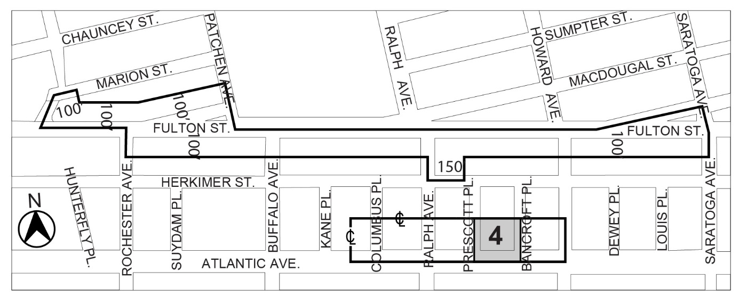

Inclusionary Housing designated area

Mandatory Inclusionary Housing Program Area see Section 23-154 (d) (3)

Area 4 [date of adoption] – MIH Program Option 1

Portion of Community District 3, Borough of Brooklyn

* * *

Adopted.

Office of the City Clerk, }
The City of New York, } ss.:

I hereby certify that the foregoing is a true copy of a Resolution passed by The Council of The City of New York on May 8, 2019, on file in this office.

.....................................................
City Clerk, Clerk of The Council

