THE COUNCIL OF THE CITY OF NEW YORK
RESOLUTION NO. 708

Resolution approving with modifications the decision of the City Planning Commission on Application No. N 180487 ZRK (L.U. No. 274), for an amendment of the Zoning Resolution of the City of New York, modifying Appendix F for the purpose of establishing a Mandatory Inclusionary Housing area, Community District 16, Borough of Brooklyn.

By Council Members Salamanca and Moya

WHEREAS, the City Planning Commission filed with the Council on November 2, 2018 its decision dated October 31, 2018 (the "Decision"), pursuant to Section 201 of the New York City Charter, regarding an application submitted by Brownsville Livonia Associates, LLC, for an amendment of the text of the Zoning Resolution of the City of New York, modifying Appendix F for the purpose of establishing a Mandatory Inclusionary Housing area, which in conjunction with the related actions would facilitate the development of seven eight- and nine-story mixed-use buildings with approximately 724 units of affordable housing in the Brownsville neighborhood of Brooklyn, Community District 16, (Application No. N 180487 ZRK) (the "Application");

WHEREAS, the Application is related to applications C 180485 HAK (L.U. No. 272), a Urban Development Action Area designation, project approval (UDAAP), and disposition of City-owned property to a developer selected by HPD. The UDAAP portion of this action was withdrawn prior to the City Planning Commission decision; C 180486 PCK (L.U. No. 273), a site selection and acquisition by the Department of Parks and Recreation (DPR) for a new community garden; C 180488 ZSK (L.U. No. 275), a zoning special permit pursuant to Section 74-743 of the Zoning Resolution (ZR) to allow bulk modifications within a large scale general development (LSGD), including lot coverage, distance between buildings modifications, and height and setback; C 180489 ZMK (L.U. No. 276), a zoning map amendment to rezone a portion of the project area from R6 to R7-2 and R7-2/C2-4; and C 180490 ZSK (L.U. No. 277), a zoning special permit pursuant to ZR 74-532 to waive the existing parking requirement within the LSGD of accessory off-street parking spaces;

WHEREAS, the Decision is subject to review and action by the Council pursuant to Section 197-d(b)(1) of the City Charter;
WHEREAS, upon due notice, the Council held a public hearing on the Decision and Application on November 15, 2018;

WHEREAS, the Council has considered the land use implications and other policy issues relating to the Decision and Application; and

WHEREAS, the Council has considered the relevant environmental issues, including the negative declaration issued June 25, 2018 (CEQR No. 18DCP101K), which includes an (E) designation to avoid the potential for significant adverse impacts related to hazardous materials, air quality, and noise on the development sites Block 3589, Lot 21 (Development Site A); Block 3574, Lot 1 (Development Site B); Block 3588, Lots 27, 32, 33, 34, 35, 36 (Development Site C); Block 3573, Lot 1 (Development Site D); Block 3587, Lots 1 and 27 (Development Site E); Block 3602, Lot 12 (Development Site F); and Block 3560, Lot 1 (Development Site G) (E-485) (the “Negative Declaration”).

RESOLVED:

The Council finds that the action described herein will have no significant impact on the environment as set forth in the (E) Designation (E-485) and Negative Declaration.

Pursuant to Section 200 of the City Charter and on the basis of the Decision and Application, and based on the environmental determination and consideration described in the report, N 180487 ZRK, incorporated by reference herein, and the record before the Council, the Council approves the Decision of the City Planning Commission with the following modifications.

Matter underlined is new, to be added;
Matter struck out is to be deleted;
Matter within # # is defined in Section 12-10;
Matter double struck out is old, deleted by the City Council;
Matter double-underlined is new, added by the City Council
* * * indicates where unchanged text appears in the Zoning Resolution.

* * *

APPENDIX F
Inclusionary Housing Designated Areas and Mandatory Inclusionary Housing Areas

* * *
Brooklyn

* * *

Brooklyn Community District 16

* * *

Map 4 – [date of adoption]

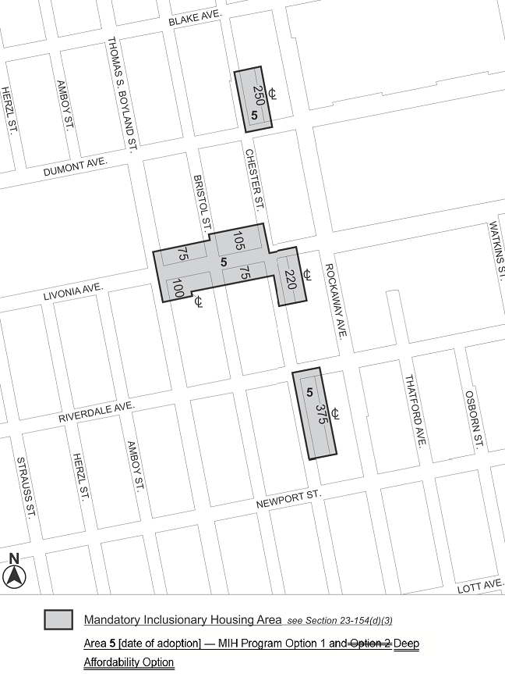

Portion of Community District 16, Brooklyn

* * *
Adopted.

Office of the City Clerk, }
The City of New York, } ss.:

I hereby certify that the foregoing is a true copy of a Resolution passed by The Council of The City of New York on December 20, 2018, on file in this office.

.....……......................................... City Clerk, Clerk of The Council

