Committee on Public Safety:
Daniel Ades, Senior Counsel
Casie Addison, Senior Policy Analyst
Nevin Singh, Financial Analyst

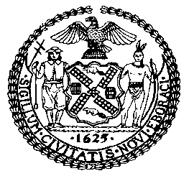

THE COUNCIL OF THE CITY OF NEW YORK
BRIEIFING PAPER AND COMMITTEE REPORT OF THE
JUSTICE DIVISION
Jeffrey Baker, Legislative Director
Brian Crow, Deputy Director, Justice Division

COMMITTEE ON PUBLIC SAFETY
Hon. Donovan Richards, Chair

Oversight: The NYPD’s Neighborhood Coordination Officers

December 10, 2018

- INTRODUCTION
On December 10, 2018, the Committee on Public Safety, chaired by Council Member Donovan Richards, will hold an oversight hearing regarding the New York City Police Department’s (NYPD) neighborhood coordination officers. Those expected to testify include representatives of the NYPD and various advocates, stakeholders, and members of the public.

- BACKGROUND
The United States Department of Justice created the Office of Community Oriented Policing Services (COPS) in 1994 to support “the concept that trust and mutual respect between police and the communities they serve is critical to public safety.” COPS defines community policing as “a philosophy that promotes organizational strategies that support the systematic use of partnerships and problem-solving techniques to proactively address the immediate conditions that give rise to public safety issues such as crime, social disorder, and fear of crime.”
The emphasis on community partnerships is echoed by many other practitioners and researchers, including the authors of a 2014 systematic review of 25 studies on community policing. The meta-analysis states that community policing “emphasizes community involvement in crime prevention efforts, in contrast to the focus of traditional policing on law enforcement and order maintenance.” But the term “community policing,” has been interpreted in various and sometimes contradictory ways. Community policing may include the concept that minor quality-of-life offenses can lead to social disorder and major crimes. George L. Kelling, one of the two social scientists who first used the term “broken windows” as a policing theory, considers it a tactic of community policing. According to Kelling, community policing emphasizes neighborhood problems by analyzing “crime incidents as not isolated events” rather symptoms of underlying causes that can be addressed with community policing focused on “anticipat[ing] security breakdowns and crime opportunities and interfere with their progression.” However, it can be argued that broken windows policing was implemented in New York as highly aggressive form of enforcement that contradicts the basic premise of community policing that it should build trust between the police and the community.
In contrast to these broad interpretations of policing strategy, community policing has also sometimes been understood more narrowly to refer to specific programs instituted by police departments to build relationships with communities, including midnight basketball games and community meetings. These approaches have been criticized as merely superficial tactics, in contrast to an overall philosophy that informs all the work of a police department. Critics attribute this confusion to the ambiguity of community policing’s mission, resulting in many practitioners seeming “unsure of who to serve and how to serve them.” Approaches range from ardent neighborhood advocacy to aggressive street crime suppression.” Indeed, even Kelling has commented that his theory of broken windows policing was misinterpreted to justify Stop, Question and Frisk Tactics that are not supported by his theory.
Several jurisdictions around the nation have implemented aspects of community policing. Its widespread popularity can be attributed to the creation of COPS, which has invested $14 billion in community policing since 1994. Due to the lack of consistency in defining and implementing community policing, many stakeholders have found that evaluating its effectiveness is extremely difficult. However, findings suggest that community policing has positive effects on citizen satisfaction, perceptions of disorder, and police legitimacy, but limited effects on crime and fear of crime.
- COMMUNITY POLICING IN NEW YORK CITY
The first community policing pilot project in New York City, the Community Patrol Officer Program (CPOP), was launched in 1984 in one precinct in Brooklyn and eventually expanded to all precincts by 1988. Each precinct was divided into ten beats, with one officer assigned to each beat as a walking patrol officer. In 1990, the Vera Institute of Justice found that CPOP improved police-community relationships, created opportunities for officers to solve neighborhood problems that improved quality of life, but did not have a statistically significant impact on crimes such as robberies and burglaries.
Community leaders gave strong positive assessments of the program, and officers reported that the most valuable features of CPOP were: 1) it gave them a deeper understanding of the community, 2) it allowed them to follow through in addressing the community’s problems, and 3) it elicited significant support from residents and community leaders. Sergeants remarked that CPOP officers quickly became the recipients of information normally not shared with the police, and attributed this success to the trust built up by patrol officers known personally by the residents. Since then, police commissioners have made significant amendments to the department’s community policing strategies, at times adding programs or abandoning the practice as a whole.
- NYPD’S NEIGHBORHOOD COORDINATING OFFICERS
In 2015, the NYPD began implementing “Neighborhood Policing” a “comprehensive crime-fighting strategy built on communication and collaboration between local police officers and community residents”. The departments Neighborhood Policing model divides precincts into four or five fully-staffed sectors that correspond to the neighborhoods boundaries. To increase familiarity with local residents and problems, the same officers are assigned to the same neighborhoods on the same shifts. Radio dispatchers, supervisors, and sector officers are tasked with maintaining “sector integrity”, by ensuring sector officers and cars do not go outside of their assigned sectors unless a precinct-wide emergency occurs. A key element of Neighborhood Policing is providing sector officers with off-radio time to engage with community members to identify local problems and work toward solutions.
Neighborhood Coordinating Officers (NCOs) support sector officers, serving as liaisons between the police department and the community. Using “creative techniques and adaptive skills”, NCOs are responsible for attending community meetings with community leaders such as clergy members, visiting schools, and following up on previous incidents to familiarize themselves with residents and their problems. According to the department, NCOs provide a new dimension of crime-fighting as they serve as “adjuncts” to local detective squads, “responding swiftly to breaking incidents and developing leads and evidence that might have been missed under the old patrol model.”
As of December 2018, there are over 700 Neighborhood Coordinating Officers in precincts across the City. Each precinct’s neighborhood policing program is staffed by a supervisor and an average of six to ten NCOs. Two officers are assigned to one sector of the precinct, and one officer to any housing developments within the precinct. The map on page 7 depicts the total number of NCOs per precinct.
In July 2018, the department announced the expansion of Neighborhood Policing to six of the twelve Transit Districts citywide. The NCO officers are assigned to: Transit District 30, which covers a big portion of Brooklyn; Transit District 12, covering several stations along the 2,5, and 6 trains; Transit District 3 covering Manhattan and Bronx stations along the 1, 2,3,A,B,C, and D trains; Transit District 4 covers Manhattan stations along the 4, 5, 6, 7, B, D, F, M, E, J, Z, L, Q, N, R, W, and S lines; Transit District 20 covers Queens stations along the 7, E, M, R, F, G, J, Z, N, and W lines.; and Transit District 32 covers Brooklyn stations along the 2, 3, 4, 5, B, D, N, Q, R, and S lines. The map on page 8 depicts the segments of the transit system that have been assigned NCOs.
Number of Neighborhood Coordinating Officers per Precinct as of December 2018
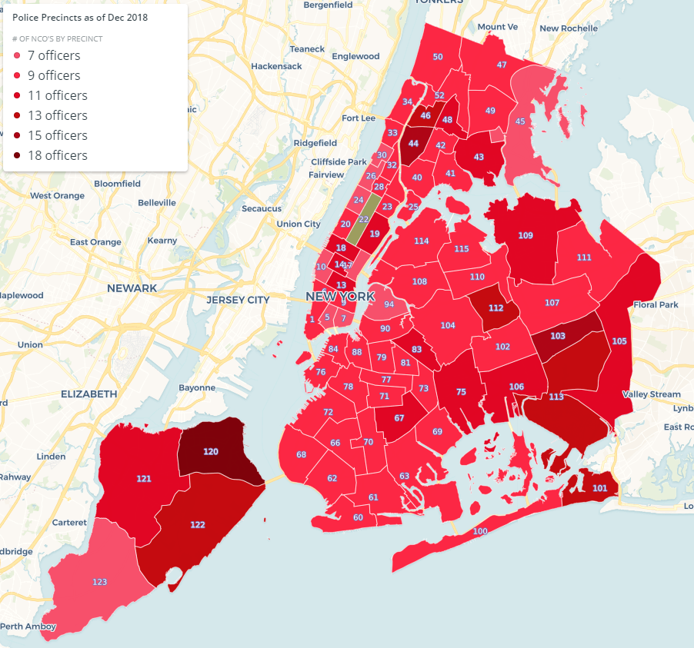
Source: NYPD
Transit District Assignments of Neighborhood Coordinating Officers
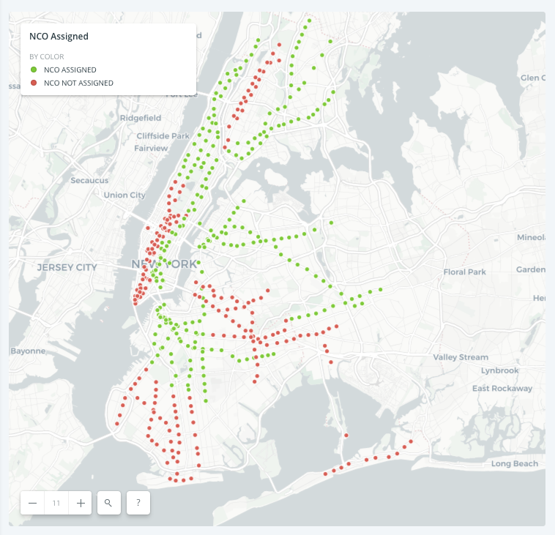
Source: NYPD
- ISSUES & CONCERNS
The recent shift away from broken windows policing as defined by aggressive low level enforcement is a welcome development amongst poor and minority communities that have endured the majority of the collateral consequences resulting from that policing strategy. A major question underlying this hearing is whether the NCO program is sufficiently tailored to the goal of rebuilding trust in the communities in which it has been eroded over the course of several mayoral administrations. For example, on the NYPD web page promoting the NCO program, a video featuring two NCOs tells the story of their arrest of a person who was wearing the same shoes as the perpetrator of a robbery committed the day before based on their review of the surveillance footage from the robbery. Nothing in this story suggests that their specific familiarity or trust built within the community contributed to the arrest. Indeed, the story demonstrates what appears to be a good example of traditional police work: reviewing video footage to identify a suspect, conducting a canvas, and making an arrest. Promoting this example as the purpose of the NCO program only raises questions about what the goals of the program are and whether NCOs are in effect patrol officers who do not respond to sector calls.
The program itself presents administrative challenges for the NYPD, which has long focused on crime reduction metrics in order to determine success. Because the work of NCOs is not based on arrest numbers or other traditional enforcement measures, it is difficult to determine how to define successful NCO operations. In addition, concerns about high turnover rate within the NCO program may undermine the goal of developing trust between individual officers and the community. For example, the 101st precinct in Far Rockaway had 15 different NCOs in the first 21 months of the program.
This hearing will focus on the precise goals of the NCO program, and whether the assignment of NCOs throughout the city and the responsibilities outlined for them is consistent with these goals. The hearing will also address challenges in the expansion of the NCO program and ways the Council can assist in developing positive relationships between communities and the NYPD.

Office of Community Oriented Policing Services (COPS), U.S. Department of Justice, “Community Policing Defined,” August 5, 2012. available at https://ric-zai-inc.com/Publications/cops-p157-pub.pdf
Id.
Gill, C. et el., “Community-Oriented Policing to Reduce Crime, Disorder and Fear and Increase Satisfaction and Legitimacy Among Citizens: A Systematic Review,” Journal of Experimental Criminology (2014) 10:399-428, at 400. available at https://www.researchgate.net/publication/272011608_Community-oriented_policing_to_reduce_crime_disorder_and_fear_and_increase_satisfaction_and_legitimacy_among_citizens_a_systematic_review/download
Kelling, G.L. et el., “Keeping Americans Safe: Best Practices to Improve Community Policing and to Protect the Public,” Goldwater Institute Policy Report, February 16, 2011, at 1. available at http://www.freedomsphoenix.com/Uploads/023/Media/Policy_Report_FINAL.pdf
Id. at 9.
Patterson, Supra note 5.
Patterson, Supra note 5.
Patterson, Supra note 5.
“How a Theory of Crime was Born and Went Terribly Wrong”, available at: https://www.npr.org/2016/11/01/500104506/broken-windows-policing-and-the-origins-of-stop-and-frisk-and-how-it-went-wrong
Skogan, W. et el., (Ed.), “Fairness and Effectiveness in Policing: The Evidence,” National Research Council, 2004.seve
Gill, Supra note 3 at 400.
Id. at 423.
McElroy, J. et el., “CPOP: The Research: An Evaluative Study of the New York City Community Patrol Officer Program,” Vera Institute of Justice, 1990 available at https://storage.googleapis.com/vera-web-assets/downloads/Publications/cpop-the-research-an-evaluative-study-of-the-new-york-city-community-patrol-officer-program/legacy_downloads/1211.pdf
McElroy, J. et el., “CPOP: The Research: An Evaluative Study of the New York City Community Patrol Officer Program,” Vera Institute of Justice, 1990 available at https://storage.googleapis.com/vera-web-assets/downloads/Publications/cpop-the-research-an-evaluative-study-of-the-new-york-city-community-patrol-officer-program/legacy_downloads/1211.pdf
Id. at 20.
Id.
NYPD “Neighborhood Policing” available at https://www1.nyc.gov/site/nypd/bureaus/patrol/neighborhood-coordination-officers.page
Id.
NYPD “Neighborhood Policing” available at https://www1.nyc.gov/site/nypd/bureaus/patrol/neighborhood-coordination-officers.page
NYPD “Neighborhood Policing” available at https://www1.nyc.gov/site/nypd/bureaus/patrol/neighborhood-coordination-officers.page
NYPD “Neighborhood Policing” available at https://www1.nyc.gov/site/nypd/bureaus/patrol/neighborhood-coordination-officers.page
NYPD “Neighborhood Policing” available at https://www1.nyc.gov/site/nypd/bureaus/patrol/neighborhood-coordination-officers.page
NYPD “Neighborhood Policing” available at https://www1.nyc.gov/site/nypd/bureaus/patrol/neighborhood-coordination-officers.page
https://www1.nyc.gov/site/nypd/bureaus/patrol/neighborhood-coordination-officers.page
The Official Website of the New York City Police Department “NYPd Expands Neighborhood Polcing to Four More Transit Districts Citywide” July 26, 2018 available at https://www1.nyc.gov/site/nypd/news/p0726a/nypd-expands-neighborhood-policing-four-more-transit-districts-citywide#/0
The Official Website of the New York City Police Department “Transit: Getting to Know Your Neighborhood Coordination Officers” available at https://www1.nyc.gov/site/nypd/bureaus/transit-housing/transit.page
The Official Website of the New York City Police Department “Transit: Getting to Know Your Neighborhood Coordination Officers” available at https://www1.nyc.gov/site/nypd/bureaus/transit-housing/transit.page
https://www1.nyc.gov/site/nypd/bureaus/patrol/neighborhood-coordination-officers.page
https://www.dnainfo.com/new-york/20170406/central-harlem/nypd-neighborhood-policing-nco-community-police-department/

