Oversight Hearing:

Toilet Paper, Soap, Paper Towels

Council Member Eva Moskowitz - Chair, Council Education Committee

Sample entries from the Craigslist-Cole Hardware
"Wishlists for Schools and Non-Profits" website:

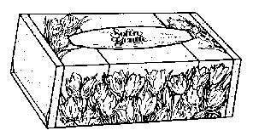
Wishlist Title: East Harlem Teaching Fellow

- Risa Schneider, P.S. 155, NY
- I am a new teacher. This year I will be teaching 3rd grade at P.S. 155 on 117th Street between First and Second Avenues. This is a "new" class in that there are four 3rd grade classes instead of three this year, so I'm not really "inheriting" many books and supplies from any predecessors. I would like to provide my students with a safe, comfortable, and friendly classroom environment that will inspire their best learning. Any help that can be provided would be much appreciated.
- TISSUE_FACIAL_SOFT`NGNTL GEORGIA_PACIFIC_-_FORT_HOWARD 40117 $0.891 10

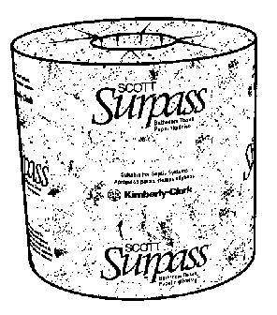
Wishlist Title: Francis Lewis School

  - Annamarie Tromp , P.S. 79, Whitestone
  - We are in desperate need of supplies. The teachers need to make copies for the students of particular work and we have no paper. Our school has over 1,000 students with supplies running very low. Funds are extremely low for NYC public schools and the children are suffering. Our students are our number one priority. They are our future and they cannot learn without books and paper. We appreciate any help that we can get to enhance the education of our stars of the future. Thank you.
  - entry last updated on 04/18/04
  - TISSUE_TOILET_TRAD_CS96 KIMBERLY_CLARK 02122 $40.491 2
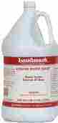
Wishlist Title: East New York Teaching Fellow

- Natalie Alexis Thomas, P.S. 224 Hale A Woodruff, East New York
- I am currently a fourth grade teacher in an often overlookd low income urban area in New York City area. This will be my second year as a teacher. I believe that all students in NYC deserve to learn in a comfortable and safe environment where they are actively engaged in a rich, challenging, and multicultural curriculum. My wish is to provide a rich learning environment for the students.
- entry last updated on 08/27/03
- SOAP_HAND_LIQ_GL_LNDMRK LUNDMARK_WAX_COMPANY 3255G01-2 $7.461 1

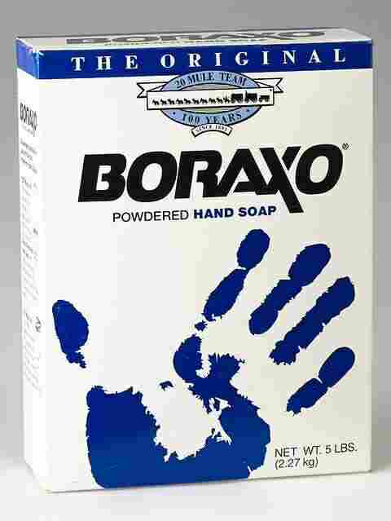
Wishlist Title: UFT

- Hubert Gordon, CJHS 145, Bronx NY
- The UFT is committed to the quality education of children in the South Bronx and other areas in New York City.
- entry last updated on 10/24/03
- SOAP_HAND_BORAXO_5LB LAGASSE_BROTHERS DIA_02203 $6.741 10

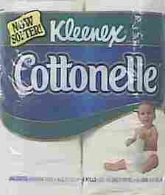
Wishlist Title: Environmental Studies

- Robin Cornelison, P.S. 220 Mott Haven Village School, Bronx NY
- I will be implimenting in my kindergarten class an environmental program throughout the year. We will be studying the rainforest, recycling and several other issues that deal with the rainforest.
- entry last updated on 08/27/03
- TISSUE_BATH_COTONEL_4PK KIMBERLY-CLARK_CORP. 64534-00 $1.611 2

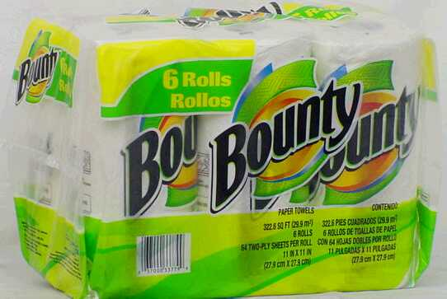
Wishlist Title: I.S. 174 Science Department

- Lynne K. LaRochelle, I.S. 147 - Eugene T. Maleska School, Bronx
- Thank you for donating your valuable time and money to urban education! It is people like you that make me believe that it is possible to change our world for the better. About the school: one of the largest middle schools in NYC with about 1500 students in attendance 2002-2003. The seventh grade alone had 400 students last year. About me: I am a 7th grade Physical Science teacher. I believe that students learn science best through hands-on activities and projects that allow them to explore a topic independently. I strive to put tools and materials in the hands of students as often as possible, but am often limited by the cost of even seemingly inexpensive items. Last year I taught 180 students, so even the cheapest activities had to be done in groups in order to conserve materials such as aluminum foil, plastic cups and plates, etc.
- entry last updated on 08/27/03
- TOWEL_PAPER_BOUNTY_6PK PROCTER_ _GAMBLE 33779 $6.291 3
Wishlist Title: Special Ed in the Bronx
- Anna Rivera, PS 188X @ 34, Bronx NY
- Hi! We are a special ed pre-school class in need of your help!! Our classroom caters to youngsters with autism in a part of the Bronx where parents are not financially flourishing. We have many needs in order to reach the students in their own individual difficulties, so having the basic necessities is a huge help. Thank you in advance for your donations!!! :-D
- entry last updated on 08/27/03
- TOWEL_PAPER_BOUNTY_6PK PROCTER_ _GAMBLE 33779 $6.291 2
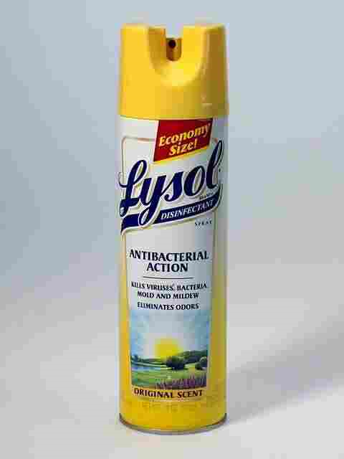
Wishlist Title: Kindergarten Classroom
- E Maureen Olson, P.S. 157X, Hartsdale
- I will be teaching Kindergarten for the first time. Many of the children come to the school with an attitude of hopelessness about life. I want to give the kids a vision that I hope they will internalize. The vision relates to the fact that life is wonderful and that they can have control of their lives. I want them to understand the role that education can play in their lives. I want them to open the natural curiosity that they have, and that most of them have already stifled in their young lives. I want them to understand that helping others is important, and that when they help others they are also helping themselves. I want my kids to know that all of their choices have consequences, both good and bad. I want them to know that they have to look at long-term goals, as well as short-term, and that sacrifices will have to be made to attain goals. I want my kids to know that life is good and can become better.
- entry last updated on 08/27/03
- DISNFCT_LYSL_SP_ORIG18OZ RECKITT_BENCKISER 1920002121 $5.211 1

