Staff:

Tanisha Edwards
Chief Counsel

Rebecca Chasan
Assistant Counsel



THE COUNCIL
REPORT OF THE FINANCE DIVISION
LATONIA MCKINNEY, DIRECTOR

COMMITTEE ON FINANCE

HON. JULISSA FERRERAS, CHAIR

February 26, 2015

PRECONSIDERED RES. By: Council Members Ferreras

TITLE: Resolution concerning the establishment of the Meatpacking Area Business Improvement District in the Borough of Manhattan and setting the date, time and place for the public hearing to hear all persons interested in the establishment of such district.

BACKGROUND
Pursuant to the authority granted by chapter 4 of title 25 of the Administrative Code of the City of New York (hereinafter the “Law”), the Mayor and the Council are authorized to establish Business Improvement Districts (hereinafter “BIDs”) in New York City. BIDs, which are specifically established areas, use the City’s property tax collection mechanism to approve a special tax assessment with which to fund additional services that would enhance the area and improve local business. The additional services are normally in the areas of security, sanitation, physical/capital improvements (lighting, landscaping, sidewalks, etc.), seasonal activities (Christmas lighting) and related business services (marketing and advertising). The Steering Committee of a BID demarcates the areas in which services will be enhanced and also establishes the mechanism for the assessment needed to generate the required budget.
The proposed Meatpacking Area BID (hereinafter the “District”) is located in the borough of Manhattan in the northernmost part of the West Village and the southernmost part of lower Chelsea. It is generally bounded by Horatio Street to the South, West 17th Street to the North, 10th Avenue to the West, and 8th Avenue to the East. The majority of the District’s land use is commercial, but there are also hotels, residences, government or not-for-profit properties, and public plazas.
The District is comprised of 649 parcels, which include 154 commercial lots, 472 residential lots (primarily individual condominiums), 5 vacant lots, 1 parking lot and 17 government or not-for-profit properties and is located in Manhattan Community Boards 2 and 4.
The District will be managed by the Meatpacking Area District Management Association, Inc. Services to be provided within the District include: sanitation, landscape maintenance, beautification, public safety, economic development initiatives, business and community advocacy, and general administration. The budget for the first year of operation is $1.6 million. In subsequent years the District’s budget may rise to $3.2 million as additional development occurs in the district.
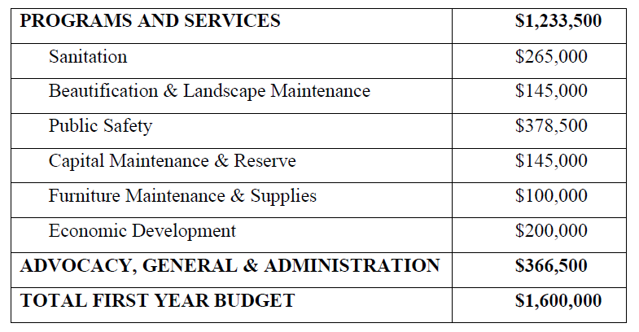
All properties within the District in whole or in part devoted to commercial use, including vacant parcels and parking lots, will be assessed at a rate of no more than $0.24 per commercial square foot. At a rate of $0.24 per commercial square foot, the median annual assessment would be approximately $1,920, the minimum assessment would be approximately $120, and the highest assessment would be $518,878. Government and not-for-profit owned property are exempt from assessment. Residential properties will be assessed $1 per year.
PRECONSIDERED RESOLULTION
This Preconsidered Resolution is required by Section 25-407(b) (2) of the Administrative Code, which requires, in relevant part, that a further hearing shall be called by Resolution if the City Council finds that notice of the initial hearing on the proposed District was incorrectly or insufficiently given to property owners within a proposed district.
The main purpose of this Resolution is to set the public hearing date, time, and place for the review of the local law which would establish the Meatpacking Area BID.
The hearing on the local law and the District Plan will be held on March 11, 2015 at 10:00 a.m. in the Committee Room at City Hall in New York, New York to hear all persons interested in the establishment of the District.
This Resolution also directs Small Business Services (hereinafter “SBS”) and the Meatpacking Area BID Steering Committee, respectively, to, not less than ten nor more than thirty days before the date of the public hearing, mail a copy of this Resolution or a summary thereof to each owner of real property within the proposed District at the address shown on the latest City assessment roll, to such other persons as are registered with the City to receive tax bills concerning real property within the proposed District, and to the tenants of each building within the proposed District. The Resolution also directs SBS to arrange for the publication of a copy of this Resolution or a summary thereof at least once in the City Record or a newspaper in general circulation in the City, the first publication to be not less than ten nor more than thirty days before the date of the public hearing.
Preconsidered Res. No.

Resolution concerning the establishment of the Meatpacking Area Business Improvement District in the Borough of Manhattan and setting the date, time and place for the public hearing to hear all persons interested in the establishment of such district

By Council Members Ferreras
Whereas, pursuant to the authority granted by chapter 4 of title 25 of the Administrative Code of the City of New York (“the Law”), the Mayor, by authorization dated October 14, 2014, provided for the preparation of a district plan (“the Plan”) for the Meatpacking Area Business Improvement District (“the District”) in the Borough of Manhattan; and
Whereas, pursuant to Local Law No. 82 for the year 1990, the City Council assumed responsibility for adopting legislation establishing Business Improvement Districts; and
Whereas, pursuant to section 25-405(c) of the Law, the New York City Department of Small Business Services (“SBS”) submitted the Plan to the City Planning Commission (“the CPC”) on November 3, 2014; and
Whereas, pursuant to section 25-405(c) of the Law, the CPC submitted the Plan to the City Council on November 6, 2014; and
Whereas, pursuant to section 25-405(c) of the Law, the CPC submitted the Plan to the Council Member representing the council district in which the proposed District is located on November 6, 2014; and
Whereas, pursuant to section 25-405(c) of the Law, the CPC submitted the Plan to the community boards for the community districts in which the proposed District is located (Manhattan Community Boards Number 2 and 4, hereinafter “the Community Boards”) on November 6, 2014; and
Whereas, pursuant to section 25-405(c) of the Law, the CPC submitted the Plan to the Manhattan Borough Board and Manhattan Borough President on November 6, 2014; and
Whereas, pursuant to section 25-405(c) of the Law, the Community Boards notified the public of the Plan in accordance with the requirements established by the CPC; and
Whereas, Manhattan Community Board 2 voted to approve the establishment of the District on November 20, 2014; and
Whereas, Manhattan Community Board 4 voted to approve the establishment of the District on December 3, 2014; and
Whereas, pursuant to section 25-405(c) of the Law, the CPC reviewed the Plan, held a public hearing and prepared a report certifying its unqualified approval of the Plan; and
Whereas, pursuant to section 25-405(c) of the Law, the CPC submitted its report to the Mayor, to the Manhattan Borough President, and to the City Council and to the Council Member representing the council district in which the proposed District is located; and
Whereas, pursuant to section 25-405(c) of the Law, a copy of the CPC’s report, together with the original Plan, was transmitted for filing with the City Clerk on January 26, 2015; and
Whereas, pursuant to section 25-406(a) of the Law, a copy of the Plan and the CPC’s report are annexed hereto and are made part of this Resolution; and
Whereas, pursuant to section 25-406(a) of the Law, the Plan is on file for public inspection in the Office of the City Clerk, 141 Worth Street, New York, New York; and
Whereas, pursuant to Section 25-406(b) of the Law, any owner of real property, deemed benefited and therefore within the District, objecting to the plan must file an objection at the Office of the City Clerk within thirty days of the conclusion of the hearing held by the City Council, notice of which is provided by this Resolution, on forms made available by the City Clerk; and
Whereas, pursuant to Section 25-406(b) of the Law, if owners of at least fifty-one percent of the assessed valuation of all the benefited real property situated within the boundaries of the District proposed for establishment, as shown upon the latest completed assessment roll of the City, or at least fifty-one percent of the owners of benefited real property within the area included in the District proposed for establishment, file objections to the Plan with the City Clerk within the thirty-day objection period, the District will not be established; now, therefore, be it
Resolved, That the Council of the City of New York, pursuant to Section 25-406 of the Law, hereby directs that March 11, 2015 is the date and 10:00 a.m. is the time and the City Council Committee Meeting Room, City Hall, is the place for a public hearing (“the Public Hearing”) to hear all persons interested in the establishment of the District; and be it further
Resolved, That the Meatpacking Area BID Steering Committee shall, not less than ten nor more than thirty days before the date of the Public Hearing, mail a copy of this Resolution or a summary thereof to each owner of real property within the proposed District at the address shown on the latest City assessment roll, to such other persons as are registered with the City to receive tax bills concerning real property within the proposed District, and to the tenants of each building within the proposed District; and be it further
Resolved, That SBS shall arrange for the publication of a copy of this Resolution or a summary thereof at least once in the City Record or a newspaper in general circulation in the City, the first publication to be not less than ten nor more than thirty days before the date of the Public Hearing; and be it further
Resolved, That in the event that the Meatpacking Area BID Steering Committee mails, or SBS arranges for the publication of, a summary of this Resolution, such summary shall include the information required by section 25-406(c) of the Law.

