Staff:
Committee on Technology
Irene Byhovsky, Legislative Counsel
Charles Kim, Legislative Policy Analyst
Florentine Kabore, Finance Analyst
Data Operations
Nicholas Montalbano, Data Scientist



THE COUNCIL

Briefing Paper and Committee Report of the

Infrastructure Division
Jeffrey Baker, Legislative Director
Terzah Nasser, First Deputy Director, Infrastructure

COMMITTEE ON TECHNOLOGY
Hon. Robert F. Holden, Chair

October 27, 2021

OVERSIGHT: NYC 311

Int. No. 101: Council Members Koo, Holden, Yeger and Dinowitz

Title: A Local Law to amend the administrative code of the city of New York, in relation to 311 transmitting image and video data for service requests or complaints

Administrative Code: Adds §23-304

Int. No. 1356: Council Members Holden, Ulrich, Yeger, Gjonaj, Powers, Brannan, Salamanca, Reynoso, Perkins and Dinowitz

Title: A Local Law to amend the administrative code of the city of New York, in relation to reports of illegal towing to 311

Administrative Code: Adds § 23-304

Int. No. 2077: Council Members Holden, Yeger, Adams and Dinowitz
Title: A Local Law to amend the administrative code of the city of New York, in relation to the number of steps to submit service requests or complaints on the 311 website and mobile application
Administrative Code: Adds § 23-305

Int. No. 2303 Council Members Dromm, Rosenthal, Kallos, Yeger and Dinowitz

Title: A Local Law to amend the administrative code of the city of New York, in relation to the department of information technology and telecommunications updating 311 complaint types and reporting on such updates

Administrative Code: Adds § 23-307

- Introduction

On October 27, 2021, the Committees on Technology, chaired by Council Member Robert F. Holden, will hold an oversight hearing on NYC 311. Additionally, the Committee on Technology will hear Int. No. 101, sponsored by Council Member Koo, a local law in relation to 311 transmitting image and video data for service requests or complaints; Int. No. 1356, sponsored by Council Member Holden, a local law in relation to reports of illegal towing to 311; Int. No. 2077 sponsored by Council Member Holden, a local law to amend the administrative code of the city of New York, in relation to the number of steps to submit service requests or complaints on the 311 website and mobile application; and Int. No. 2303 sponsored by Council Member Dromm, a local law to amend the administrative code of the city of New York, in relation to the department of information technology and telecommunications updating 311 complaint types and reporting on such updates.
The Committee expects to receive testimony from the Department of Information Technology and Telecommunication (“DOITT”), advocacy groups, academia, and other interested members of the public.
- Background

New York City 3-1-1 (“NYC311” or “3-1-1”) is a City-wide customer service program that provides New York City residents, businesses and visitors with access to non-emergency government services and information. The NYC311 Customer Service Center is housed within DOITT. DOITT also provides additional technological services and general support services for NYC311.
NYC311 is available 24 hours a day, seven days a week via multiple channels, including telephone, website (“311 Online”), text messaging, mobile application, and social media. In Fiscal Year 2020 (“FY20”), NYC311 received more than 21.5 million calls, up from 19.5 million in Fiscal Year 2019 (“FY19”). Fiscal Year 2021 (“FY21”) saw the number of calls to NYC311 increase to 21.7 million. Despite the increase in call numbers, NYC311 saw average wait times for calls decrease from 1 minute, 46 seconds during peak hours in FY20 to 1 minute, 7 seconds during peak hours in FY21. Average off-peak hour wait times saw similar reductions between FY20 and FY21, from 56 seconds to 20 seconds. Online site visits increased from 10.5 million in FY20 to 13.4 million in FY21, but this was still fewer than the 20.1 million visits in FY19. In addition, NYC311 also has information on its website referred to as “knowledge articles” and the number of knowledge articles accessed through the system was highest in FY21 at 25.3 million, compared with 24 million in FY19 and 12.1 million in FY20.

- 311 Overview
  - Contracts and Technology Upgrades
One of the most recent upgrades to the NYC311 system has come through the deployment and completion of a $24 million City contract awarded to IBM that went live in mid-2019, in which IBM’s Watson revamped NYC311’s customer relationship management platform (“CRM”) to support multiple communications channels through its abilities as a computing system with machine-learning capability. On February 11, 2021, DOITT has received an pproval in the amount of $45,500,652 for hardware, software, and professional services necessary to complete the first phase of the 311 Telecommunication System Modernization. Additionally, during a preliminary budget hearing held on March 10, 2021, DOITT Commissioner Jessica Tisch testified that NYC311 had made several improvements over the past year, including: enabling photo and video attachments for more types of service requests; adding additional service request types available via the mobile app; and emailing alerts for all service requests regardless of whether the customer has signed up for an account. The Commissioner also mentioned that planned improvements include improved location selection and accuracy were to begin in April 2021. The Committee seeks to hear testimony on recent updates and technological upgrades to the NYC311 system.
  - NYC311 Performance Indicators, Number of 311 Requests, and Agency Responsiveness to 311 Complaints
Figure No. 1 shows the performance indicators for NYC311 requests, including the number of requests through calls, mobile app contacts, texting contacts, and online site visits; the number of completed service requests, and the number of knowledge articles accessed.
Performance Indicators (000) | FY17 | FY18 | FY19 | FY20 | FY21
311 calls | 20,540 | 20,618 | 19,541 | 21,515 | 21,715
311 Spanish language calls | 698 | 733 | 714 | 897 | 648
311 calls in languages other than English or Spanish | 71 | 65 | 60 | 81 | 112
311 mobile app contacts | 1,365 | 1,829 | 2,234 | 2,201 | 2,227
311-NYC (text) contacts | 144 | 254 | 253 | 424 | 356
311 Online site visits | 17,246 | 19,345 | 20,185 | 10,553 | 13,415
Completed service requests | 2,895 | 3,074 | 3,254 | 2,913 | 3,461
Knowledge articles accessed | 22,538 | 24,667 | 24,026 | 12,194 | 25,371
Figure No. 1: This figure displays a table to note data for performance indicators for NYC311, separated across five fiscal years from Fiscal Year 2017 to Fiscal Year 2021.
Figure No. 2 shows a table that displays the average wait time per fiscal year for 311 calls during peak and off-peak hours. This table compares performance indicator data separated across five fiscal years from Fiscal Year 2017 to Fiscal Year 2021.
Performance Indicators (in seconds) | FY17 | FY18 | FY19 | FY20 | FY21
Average wait time (tier 1 calls) Peak hours (11am-3pm, M-F) | 20 | 26 | 30 | 106 | 67
Average wait time (tier 1 calls) Off-peak hours | 14 | 32 | 24 | 56 | 20
Figure No. 2: This figure displays a table to note data for performance indicators for the average wait times for calls to NYC311 during peak and off-peak hours, separated across five fiscal years from Fiscal Year 2017 to Fiscal Year 2021.

Figures No. 3 and 4 visualizes the data from Figures No. 1 and 2 in the form of line graphs.
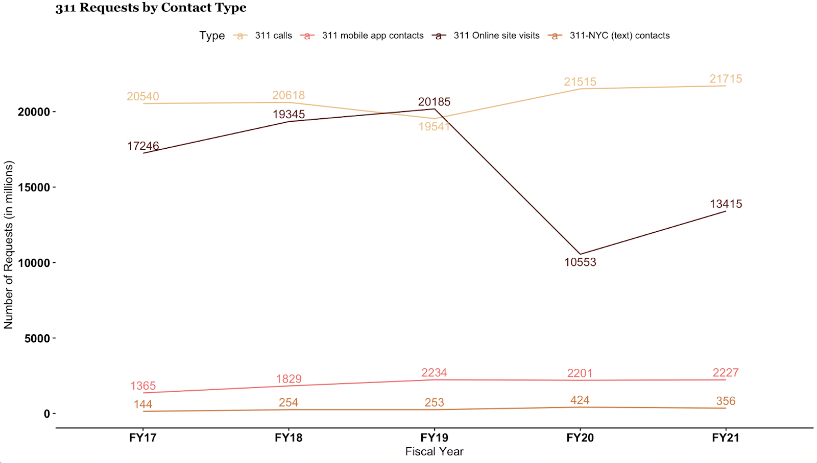
Figure No. 3: This figure displays a line graph that visualizes the number of 311 requests taken by NYC311 during each fiscal year from Fiscal Year 2017 to Fiscal Year 2021. Each line represents a different contact type by which a 311 request was made.
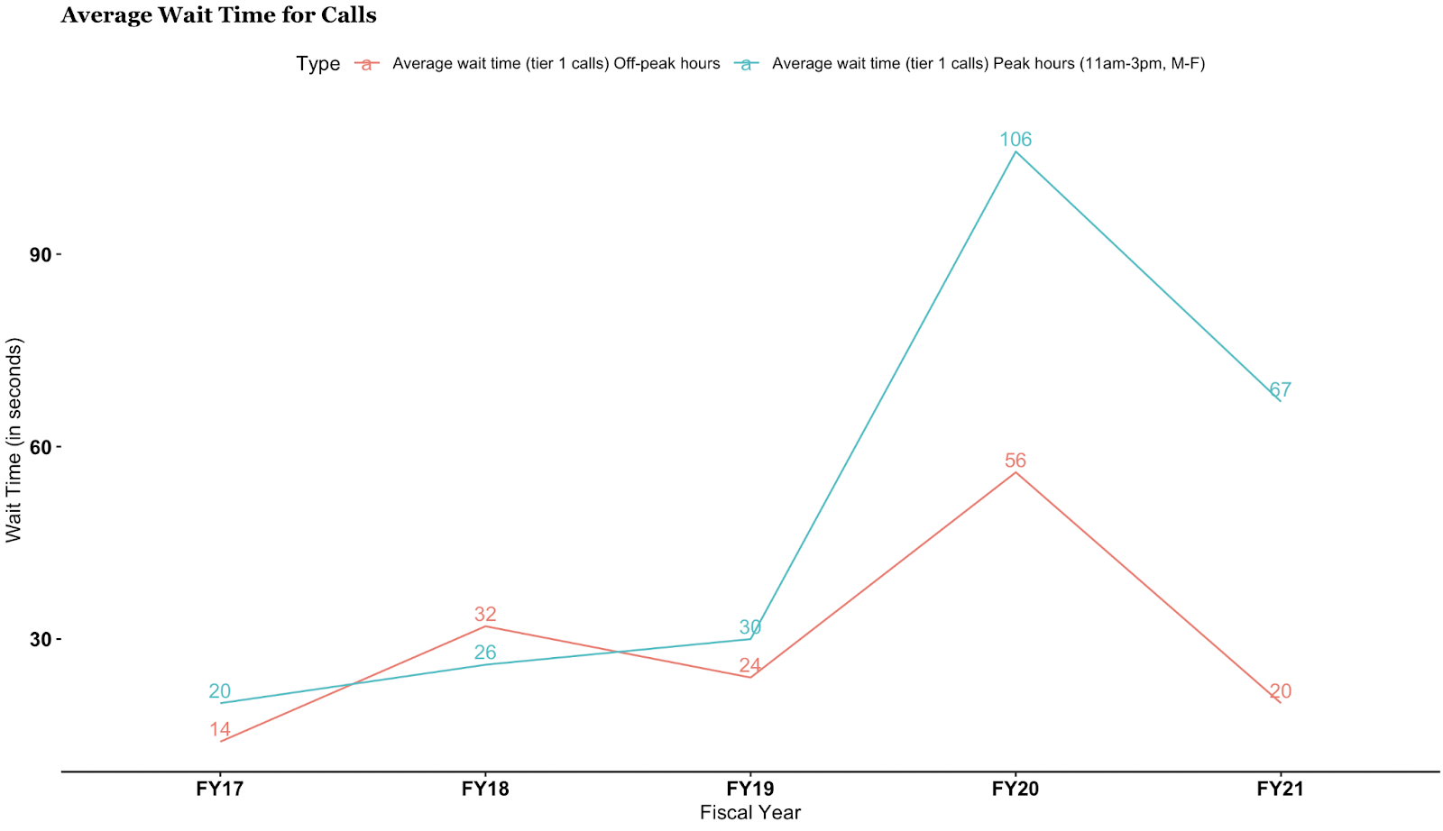
Figure No. 4: This figure displays a line graph that visualizes the average wait time for 311 calls made to NYC311 during each fiscal year from Fiscal Year 2017 to Fiscal Year 2021. Each line represents the average wait time for peak hour calls and off-peak hour calls.
As displayed by the line graphs in Figure No. 4, the average wait time for calls peaked in FY20, which NYC311 noted was due to the onset of the COVID-19 pandemic, the 2020 general election, Tropical Storm Isaias, and student transport.

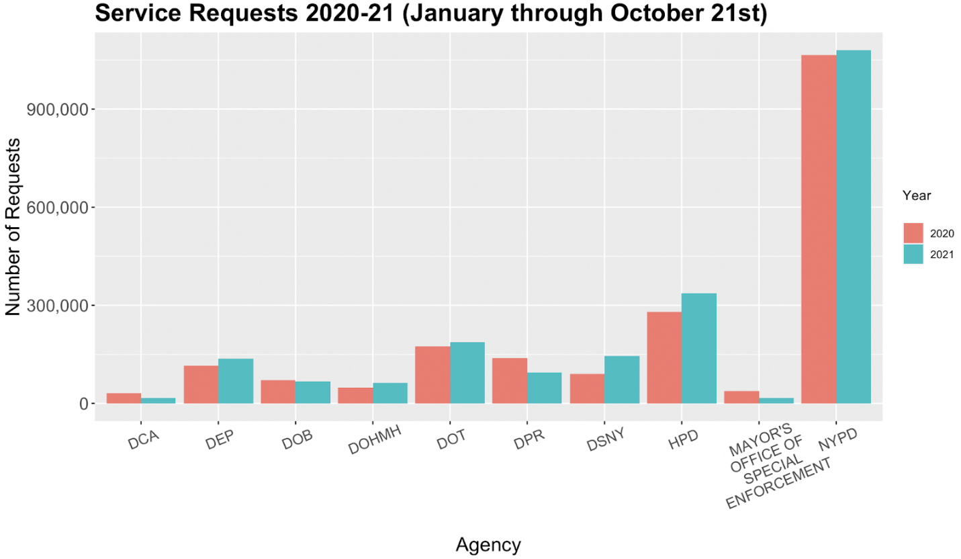
Figure No. 5: This figure displays a bar graph that notes the number of service requests made to ten City agencies that received the most requests. The bars for each agency note the number of requests received from January 1 through October 21 for 2020 and 2021.
Figure No. 5 displays the number of service requests for the ten City agencies that received the most service requests overall from NYC311, from January 1 through October 21 of each year. Six agencies experienced an increase in service requests from 2020 to 2021, while four agencies experienced a decrease. Additionally, while it does appear that NYC311 checks for duplicate cases in their data, the exact means by which they do so is not clear.
Figure No. 6 displays the top ten complaint types in 2021, taken from the same poll of service request data:
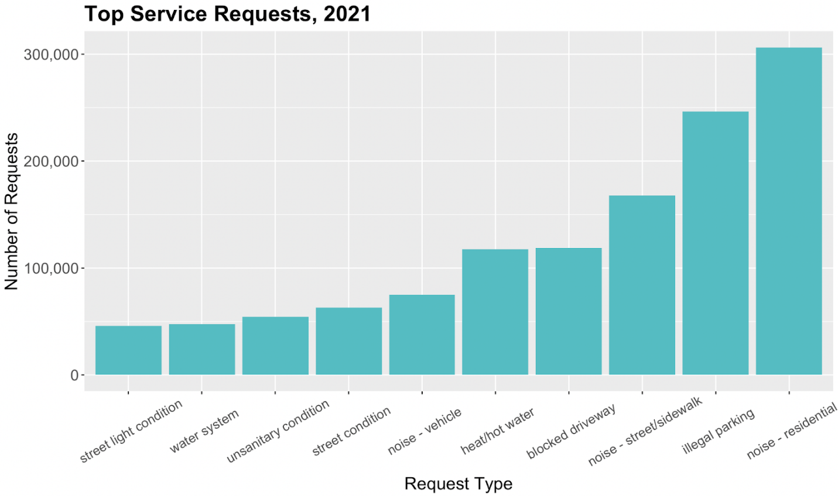
Figure No. 6: This figure shows a bar graph that denotes the number of service requests in 2021, separated by the type of service request in ascending order from left to right.
The requests displayed here show that residential noise complaints were the most common service request to NYC311. Collectively, noise complaints have consistently been the top service request type for NYC311 since 2018. Also largely consistent is that noise, parking, heat and hot water continue to be the most common concerns for New York residents.

Figure No. 7 shows the service request types that took the longest time to resolve:

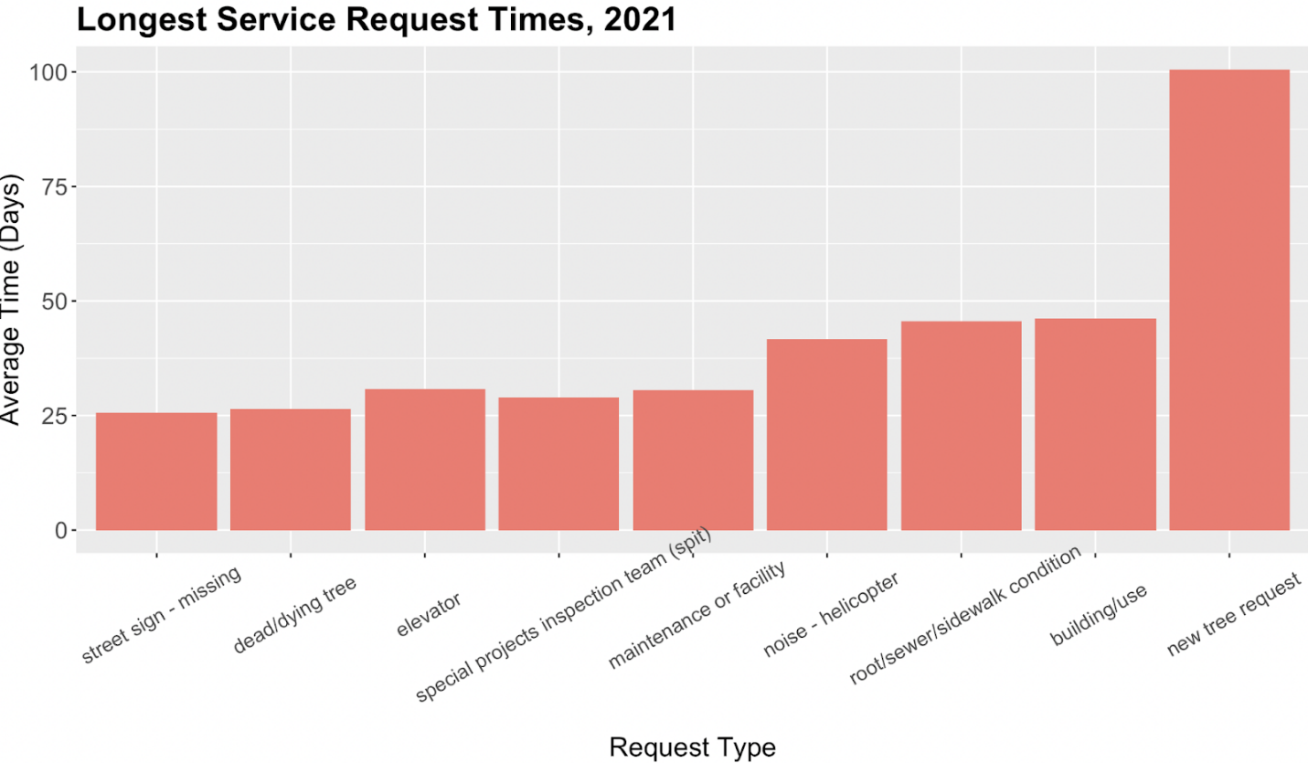
Figure No. 7: This figure shows a bar graph that denotes the average time taken to resolve a service request in 2021, separated by the type of service request.

Unsurprisingly, service requests entailing a large amount of investigation or communication with property owners required time to resolve. However, the data from 2021 shows a positive change from 2019, with the average time to resolve requests decreasing across the board. Interestingly, the time taken to resolve new tree requests increased from around 75 days in 2019 to around 100 days in 2021; new tree requests also went from the third longest to resolve in 2019 to longest in 2021.
Figures No. 8 and 9 visualize the quality of agency responses to NYC311 service requests in 2020 and 2021, respectively:

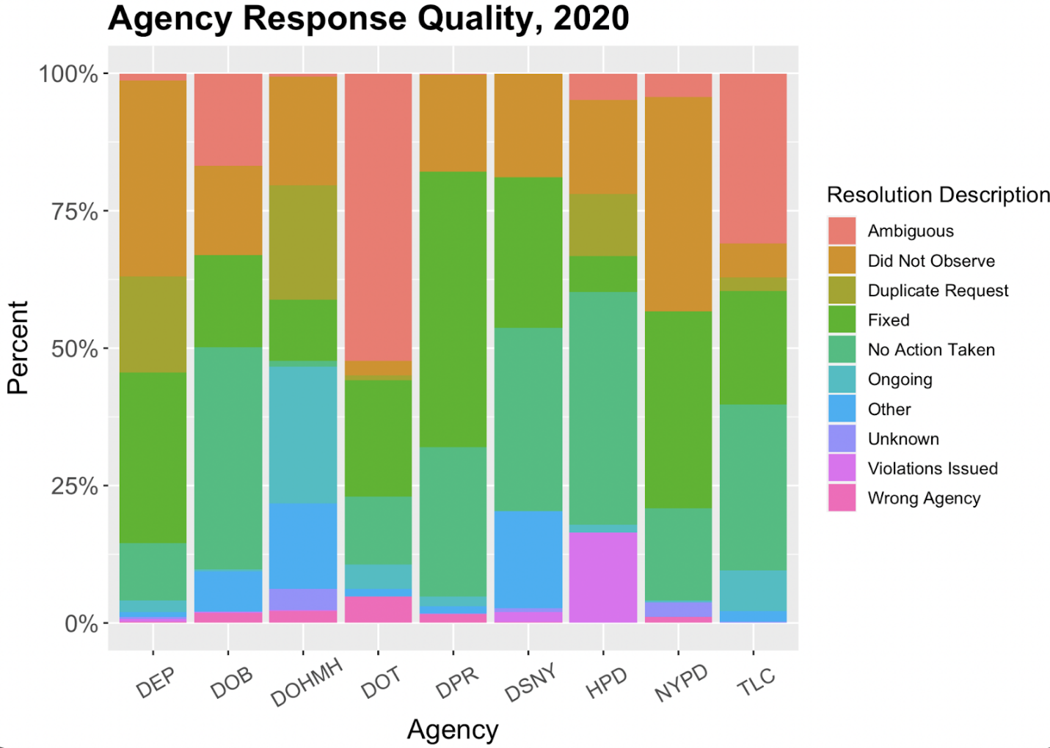
Figure No. 8: This figure shows a stacked bar graph that shows the percentage of an agency’s total 311 service request resolutions in 2020 that can be described according to ten descriptors. The bars are separated out by agency and color-coded according to the ten descriptors’ legend on the right-hand side of the figure.

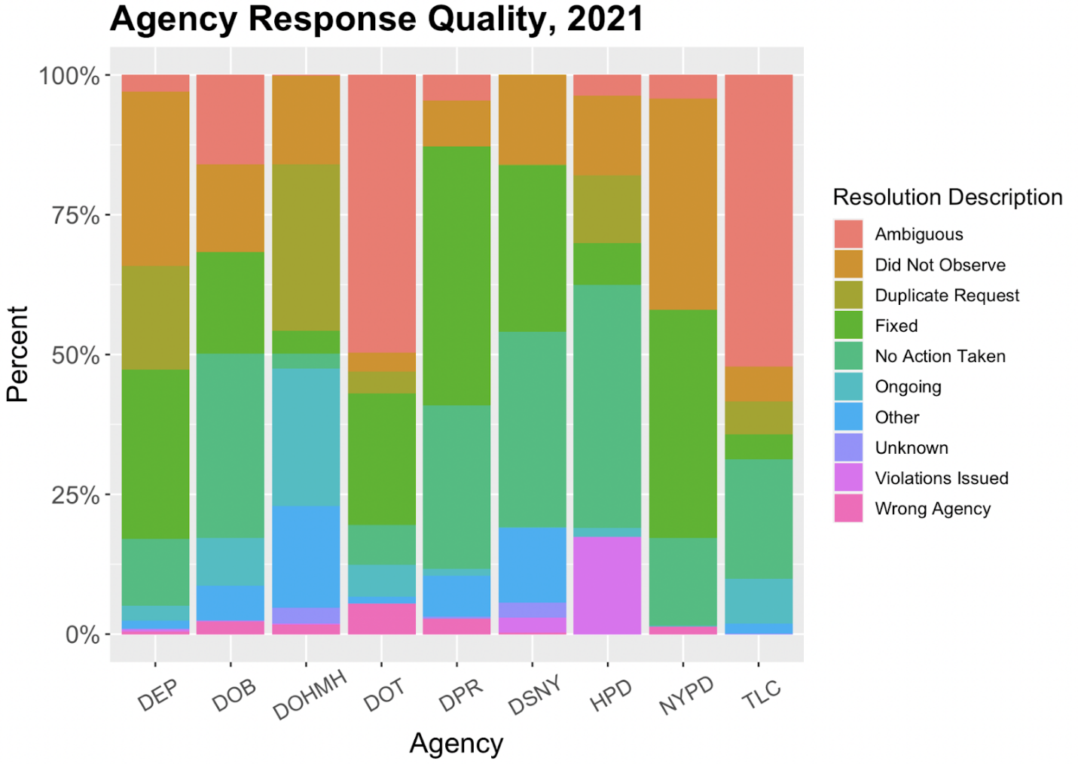
Figure No. 9: This figure shows a stacked bar graph that shows how much percentage of an agency’s total 311 service request resolutions in 2021 can be described according to ten descriptors. The bars are separated out by agency and color-coded according to the ten descriptors’ legend on the right-hand side of the figure
- Issues and Concerns
The usability and accessibility of NYC311’s website and app experiences remain important for public engagement. The Committee is interested in the progress on concerns raised during prior hearings on NYC311, particularly those regarding user experience, language access, disability access, and agency responsiveness.
  - User Experience
App store reviews for the NYC311 mobile app on both the Google Play and Apple App Store have highlighted problems that impact a user’s ability to register service requests to NYC311 and the ability to use the app’s functions. Users complained about lacking the ability to attach photos and videos to 311 requests, while GPS location accuracy and map accuracy was another common issue. Additional issues included having to click through too many pages to submit a service request, as well as being redirected out of the mobile app to a mobile website, or being redirected to a phone number due to lack of app support for a service request. Language access is another important aspect of the NYC311 user experience; in response to changes requested in prior hearings, NYC311 Executive Director Joe Morrisroe testified previously that NYC311 would increase its language access capabilities through initiatives that would be rolled out in the second half of 2020. According to NYC311’s language access plan updated in June 25, 2021, one of these changes appears to be that NYC311 now informs call takers of the language a caller has selected. The Committee looks forward to receiving updates on the deployment of these language access initiatives, as well as hearing how these services were received by NYC311 users. Currently, the NYC311 website and mobile app have translation services supported by Google Translate.

  - Disability Access
As of October 25, 2021, the NYC311 mobile app and website do not appear to have added functionalities for better disability access, such as the option to increase contrast for better visibility, or the option to read out what is on the screen.
  - Customer Satisfaction Surveys
In accordance with Local Law 26 of 2021, NYC311 conducted Customer Satisfaction (“CSAT”) surveys in the 10 designated citywide languages, conducting two survey campaigns between April and June of 2021; customers opted-in for eight of the ten designated languages during the survey period. Responding to the prompt “Overall, I am satisfied with the service provided by the 311 Call Center,” customers’ numerical values for their responses were scored on a scale of 0 to 100, converted from “Strongly Disagree” to “Strongly Agree,” respectively. The overall average CSAT Score for NYC311 call centers was 77 in 2021, compared to 78 in 2020. Disaggregated by language, the average CSAT Scores in 2021 were as follows: English, 77; Cantonese, 75; Korean, 75; Mandarin, 75; Russian, 81; and Spanish, 85. However, according to NYC311, some languages have high margin of error levels and low statistical confidence levels due to the small sample size for some of the languages surveyed. NYC311 has committed to expand outreach and awareness of 311 in-language customer satisfaction surveys to increase survey response rates.

- Legislative Analysis
- Legislative Analysis of Int. No. 101
This bill would require 311 to accept image and video data during the intake of service requests or complaints other than those related to housing, and then to supply that data to the relevant agencies for use by their inspectors or other appropriate persons. The local law would take effect 120 days after it becomes law.
- Legislative Analysis of Int. No. 1356
This bill would require the Department of Information Technology and Telecommunications to create a new complaint function on the 311 website, telephone and mobile device platforms to report tow trucks illegally towing vehicles immobilized due to an accident. The bill would require this new 311 function to provide the ability to upload a photograph or video with the complaint. The local law would take effect 120 days after it becomes law.
- Legislative Analysis of Int. No. 2077
This bill would require the 311 mobile application or website to allow users to submit a request or complaint with no more than four steps. The local law would take effect 180 days after it becomes a law.
- Legislative Analysis of Int. No. Int. 2393
This bill would require the Department of Information Technology and Telecommunications (“DoITT”) to update the complaint types on the 311 customer service center website and mobile device platforms and notify 311 customer service center call takers of such complaint type, by the effective date of a local law that involves a request for service. This bill would also require DoITT to semiannually report to the Mayor and the Speaker of the Council on the updating of 311 complaint types. The local law would take effect 60 days after it becomes law.
- Conclusion
The Committee looks forward to receiving testimony from the Administration, advocacy groups, academia, and other interested members of the public on the operation of 311 system.

This page intentionally left blank.

Int. No. 101

By Council Member Koo, Holden, Yeger and Dinowitz

A Local Law to amend the administrative code of the city of New York, in relation to 311 transmitting image and video data for service requests or complaints

Be it enacted by the Council as follows:

Section 1. Chapter 3 of title 23 of the administrative code of the city of New York is amended by adding a new section 23-304 to read as follows:
§ 23-304 Service requests or complaints by video or photograph. Any website or mobile device application used by the 311 customer service center for the intake of 311 requests from the public shall be capable of receiving image and video data in connection with all requests for service or complaints other than those relating to housing. Such data shall be transmitted to an agency as appropriate and be made available to inspectors or other relevant persons within such agencies.
§ 2. This local law takes effect 120 days after it becomes law
PLS - PLS
LS 11394/Int. 1738-2017
LS 604
12/26/17

This page intentionally left blank.
Int. No. 1356

By Council Members Holden, Ulrich, Yeger, Gjonaj, Powers, Brannan, Salamanca, Menchaca, Reynoso, Perkins and Dinowitz

A Local Law to amend the administrative code of the city of New York, in relation to reports of illegal towing to 311

Be it enacted by the Council as follows:

Section 1. Chapter 3 of title 23 of the administrative code of the city of New York is amended by adding a new section 23-304 to read as follows:
§ 23-304 Complaints related to tow trucks. The department of information technology and telecommunications shall implement on its 311 citizen service center website, telephone and mobile device platforms the capability to file a complaint reporting a tow truck company that tows an immobilized vehicle in violation of paragraph 2 of subdivision b of section 20-518. Such option shall allow the complainant to include a photograph or video when submitting a complaint through such 311 website and mobile device platforms.
§ 2. This local law takes effect 120 days after it becomes law.
JEF
LS #8507
12/18/2018

This page intentionally left blank.

Int. No. 2077

By Council Members Holden, Yeger, Adams and Dinowitz

A Local Law to amend the administrative code of the city of New York, in relation to the number of steps to submit service requests or complaints on the 311 website and mobile application

Be it enacted by the Council as follows:

Section 1. Chapter 3 of title 23 of the administrative code of the city of New York is amended by adding a new section 23-305 to read as follows:
§ 23-305 Service requests or complaints. Any website or mobile device application used by the 311 customer service center for the intake of service requests or complaints from the public shall allow the direct submission of such request or complaint by a member of the public with no more than four steps to input such request or complaint.
§ 2. This local law takes effect 180 days after it becomes law.
IB
LS 15966
8/27/2020

This page intentionally left blank.
Int. No. 2303

By Council Members Dromm, Rosenthal, Kallos, Yeger and Dinowitz

A Local Law to amend the administrative code of the city of New York, in relation to the department of information technology and telecommunications updating 311 complaint types and reporting on such updates

Be it enacted by the Council as follows:

Section 1. Chapter 3 of title 23 of the administrative code of the city of New York is amended by adding a new section 23-307 to read as follows:
§ 23-307 Updating 311 complaint types. a. By no later than the effective date of any local law that involves a request for service, the commissioner of information technology and telecommunications shall add the associated complaint type to the 311 customer service center website and mobile device platforms, and notify the 311 customer service center call takers of such complaint type.
b. For the purposes of subdivision a of this section, a local law involves a request for service if such local law:
1. Requires the department of information technology and telecommunications to implement the capability to file a complaint on the 311 customer service center website and mobile device platforms;
2. Establishes a program or requires an agency to provide information or services to the public;
3. Establishes or expands a right or a protection for a business or person; or
4. Prohibits conduct by an agency, business or person.
c. Report. No more than 180 days after the effective date of the local law that added this section, and semiannually thereafter, the commissioner of information technology and telecommunications shall report to the mayor and the speaker of the council on updating complaint types on the 311 customer service center website and mobile device platforms. Such report shall be posted on the website of the department of information technology and telecommunications and the 311 customer service center and shall include:
1. Data regarding the updating of complaint types on the 311 customer service center website and mobile device platforms after the enactment of a local law that involves a request for service, including, but not limited to, the number of complaint types that the department of information technology and telecommunications added by such local law’s effective date;
2. A list of the local laws enacted during the reporting period that involve a request for service, along with (i) the complaint type that each local law added, (ii) when such complaint type was added to the 311 customer service center website and mobile device platforms and (iii) an explanation of any delays, if applicable, in adding the complaint type to the 311 customer service center website and mobile device platforms; and
3. Any challenges that the department of information technology and telecommunications faced in timely updating the complaint types on the 311 customer service center website and mobile device platforms and any efforts to address such challenges.
§ 2. This local law takes effect 60 days after it becomes law.
NLB
LS#13404
4/28/21

The Official Website of the City of New York, NYC311, https://portal.311.nyc.gov (last accessed May 5, 2020).
NYC Department of Information Technology and Telecommunications, Who We Are, available at https://www1.nyc.gov/site/doitt/about/who-we-are.page.
Testimony of 311 Exec. Dir. Joseph R. Morrisroe before the Committees on Governmental Operations and Technology, The New York City Council, Jan. 17, 2019, available at https://legistar.council.nyc.gov/LegislationDetail.aspx?ID=3723063&GUID=82CF9499-67A5-48FB-BAF1-2E230611B69B&Options=&Search.
Mayor’s Office of Operations, Mayor’s Preliminary Management Report, January 2020, p.125, available at https://www1.nyc.gov/assets/operations/downloads/pdf/pmmr2020/2020_pmmr.pdf.
Mayor’s Management Report, The City of New York, September 2021, NYC 311 Chapter, available at https://www1.nyc.gov/assets/operations/downloads/pdf/mmr2021/311.pdf.
Id.
Id.
Id.
Id.
Id.
Jan. 17, 2019 Committee Report, supra note 5 at 7 (Citing DoITT Request for Systems Integration Services for 311 Customer Service Management System Replacement and Re-Architecture Project, April 28, 2015, available at https://www1.nyc.gov/assets/doitt/downloads/pdf/311-rfs.pdf; Matthew Flamm, City’s 311 Hotline is Getting Some Help of Its Own, Crain’s N.Y. Bus., April 30, 2015, available at https://www.crainsnewyork.com/article/20150430/TECHNOLOGY/150429832/city-s-311-hotline-is-getting-some-help-of-its-own; Task Order Number 1426-001A, NYC 311 CSMS Replacement and Re-Architecture for Department of Information Technology and Telecommunications, available at https://www.scribd.com/document/342938208/NTP-and-NYC-311-IBM-Task-Order-1426-001A-signed-Redacted-v2?secret_password=RtVgjUFEdELXT1pukn65; Matthew Flamm, IBM's Watson will soon answer your 311 calls, Crain’s N.Y. Bus. Jan. 11, 2017, available at https://www.crainsnewyork.com/article/20170112/TECHNOLOGY/170119941/ibm-s-watson-will-soon-answer-your-311-calls-as-part-of-a-24-million-upgrade-to-the-system).
See City of New York Office of Management and Budget, Record 116683 Certificate 70092 Project DP-1, on file with Committee on Technology staff.
Testimony of DOITT Commissioner Jessica Tisch, before the Committees on Land Use and Technology, The New York City Council, March 10, 2021, available at https://legistar.council.nyc.gov/MeetingDetail.aspx?ID=846442&GUID=5EFAFC84-31CD-4429-9DD5-6459FA872F49&Options=info|&Search=.
Id.
The Council’s data team did an analysis of 311 operations using OpenData information on 311 services, available at https://council.nyc.gov/data/311-services/; as well as an analysis of a report published as part of the Mayor’s Management Report published in September 2021, available at https://www1.nyc.gov/assets/operations/downloads/pdf/mmr2021/311.pdf.
Id.
Id.
Id.
Id.
Id.
Id.
Id.
NYC 311 Ratings and Reviews, Apple App Store, last accessed Oct 25, 2021, available at https://apps.apple.com/us/app/nyc-311/id324897619#see-all/reviews; NYC 311, Google Play, last accessed Oct 25, 2021, available at https://play.google.com/store/apps/details?id=gov.nyc.doitt.ThreeOneOne&hl=en_US&gl=US&showAllReviews=tru.
Id.
Id.
Testimony of 311 Exec. Dir. Joseph R. Morrisroe before the Committees on Governmental Operations and Technology, The New York City Council, Jan 21, 2020, available at https://legistar.council.nyc.gov/LegislationDetail.aspx?ID=4288629&GUID=324B4514-8717-4F18-8D8D-B1C4790ECAE1&Options=&Search=.
NYC311, Language Access Implementation Plan, DOITT, updated June 25, 2021, available at https://www1.nyc.gov/assets/doitt/downloads/pdf/311-Language-Access-Plan.pdf.
NYC 311, City of New York, last accessed Oct 25, 2021, available at https://portal.311.nyc.gov/.
Id.
NYC311, Customer Satisfaction Surveys in Designated Citywide Languages, NYC311, Update as of July 1, 2021, available at https://www1.nyc.gov/assets/doitt/downloads/pdf/reports/311-customer-satisfaction-surveys-designated-languages-2021.pdf.
Id.
Id.
Id.
Id.
Id.

