THE COUNCIL OF THE CITY OF NEW YORK
RESOLUTION NO. 758

Resolution approving the decision of the City Planning Commission on Application No. N 240371 ZRM, for an amendment of the text of the Zoning Resolution (L.U. No. 219).

By Council Members Salamanca and Riley
WHEREAS, the New York City Economic Development Corporation filed an application pursuant to Section 201 of the New York City Charter, for an amendment of the text of the Zoning Resolution of the City of New York, modifying APPENDIX F, for the purpose of establishing a Mandatory Inclusionary Housing area, which in conjunction with the related actions would facilitate the development of a new life sciences and education campus at 425 East 25th Street in the Kips Bay neighborhood of Manhattan, Community District 6 (ULURP No. N 240371 ZRM), (the “Application”);
WHEREAS, the City Planning Commission filed with the Council on December 30, 2024, its decision dated December 16, 2024 (the "Decision") on the Application;
WHEREAS, the Application is related to applications C 240369 ZMM (L.U. No. 217), a zoning map amendment to change an R8 district to C6-4 district; C 240370 ZSM (L.U. No. 218), a zoning special permit pursuant to Section 74-171 of the Zoning Resolution to permit a laboratory listed under Use Group VII, not otherwise allowed by the underlying use regulations; C 240372 PPM (L.U. No. 220), a disposition of City-owned property; C 240373 PCM (L.U. No. 221), a site selection and acquisition for use as a forensic pathology center and medical examiner facility; C 240309 MMM (L.U. No. 222), a city map change for the elimination of a pedestrian overpass and the adjustments of grades, block dimensions, and angles necessitated thereby; C 240390 ZSM (L.U. No. 223), a zoning special permit pursuant to Section 74-901 of the Zoning Resolution to modify the height and setback requirements of Section 33-442 (Alternate Front Setbacks In Other Commercial Districts); and C 240391 PQM (L.U. No. 224), an acquisition of real property by the City;
WHEREAS, the Decision is subject to review and action by the Council pursuant to Section 197-d of the City Charter;
WHEREAS, upon due notice, the Council held a public hearing on the Decision and Application on January 9, 2025;
WHEREAS, the Council has considered the land use implications and other policy issues relating to the Decision and Application; and
WHEREAS, the Council has considered the relevant environmental issues, including the Positive Declaration issued January 30th, 2024 (CEQR No. 23DME013M) and a Final Environmental Impact Statement (FEIS) for which a Notice of Completion was issued on December 5, 2024. The proposed project as analyzed in the FEIS identified significant adverse impacts with respect to historic and cultural resources, transportation, and construction (traffic, pedestrians); and in addition, potential significant adverse impacts related to hazardous materials and noise would be avoided through the placement of (E) designation (E-776) as described in the FEIS. The proposed mitigation measures are summarized in the FEIS.
RESOLVED:
Having considered the FEIS with respect to the Decision and Application, the Council finds that:
- The FEIS meets the requirements of 6 N.Y.C.R.R. Part 617;
- The environmental impacts disclosed in the FEIS were evaluated in relation to the social, economic, and other considerations associated with the action[s] set forth in the Decision;
- Consistent with social, economic, and other essential considerations from among the reasonable alternatives provided in the application, the actions are one which minimizes or avoids adverse environmental impacts to the maximum extent practicable; and
- The adverse environmental impacts disclosed in the FEIS will be minimized or avoided to the greatest extent practicable.
The Decision, together with the FEIS issued December 5th, 2024, constitute the written statement of facts, and of social, economic and other factors and standards that form the basis of this determination, pursuant to 6 N.Y.C.R.R. §617.11(d);
Pursuant to Sections 197-d and 200 of the City Charter and on the basis of the Decision and Application, and based on the environmental determination and consideration described in the report, N 240371 ZRM, incorporated by reference herein, and the record before the Council, the Council approves the Decision of the City Planning Commission.

Matter underlined is new, to be added;
Matter struck out is to be deleted;
Matter within # # is defined in Section 12-10;
* * * indicates where unchanged text appears in the Zoning Resolution

APPENDIX F
Inclusionary Housing Designated Areas and Mandatory Inclusionary Housing Areas
* * *
MANHATTAN
* * *
Manhattan Community District 6
* * *
Map 3 — [date of adoption]
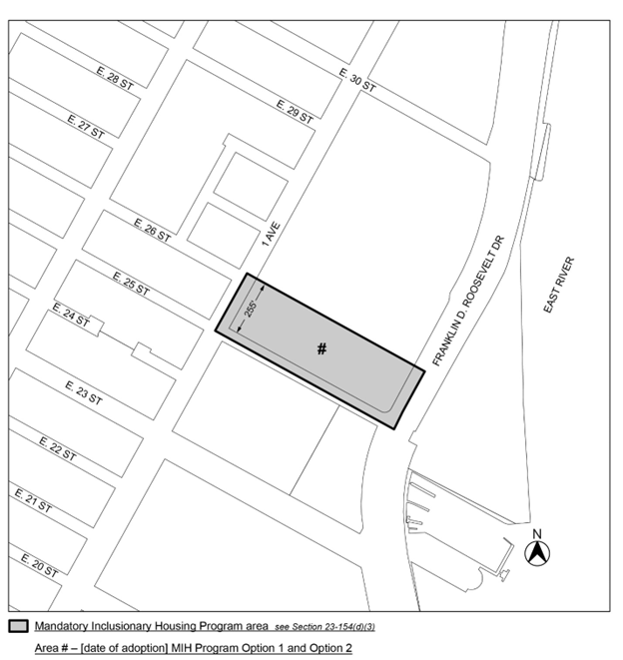
[PROPOSED MAP]
Portion of Community District 6, Manhattan

* * *
Adopted.

Office of the City Clerk,}
The City of New York,} ss.:

I hereby certify that the foregoing is a true copy of a Resolution passed by The Council of The City of New York on _________, 2025, on file in this office.

.....................................................
City Clerk, Clerk of The Council

