THE COUNCIL OF THE CITY OF NEW YORK
RESOLUTION NO. 1690

Resolution approving with modifications the decision of the City Planning Commission on Application No. N 200283 ZRQ, for an amendment of the text of the Zoning Resolution (L.U. No. 786).

By Council Members Salamanca and Moya

WHEREAS, MEDREP Associates, LLC, filed an application pursuant to Section 201 of the New York City Charter, for an amendment of the text of the Zoning Resolution of the City of New York, modifying Appendix F for the purpose of establishing a Mandatory Inclusionary Housing area, which in conjunction with the related action would facilitate the development of an 11-story mixed-use building containing 104 residential units, ground floor commercial space, and community facility space in the cellar at 30-02 Newtown Avenue in the Astoria neighborhood of Queens, Community District 1 (Application No. N 200283 ZRQ) (the “Application”);

WHEREAS, the City Planning Commission filed with the Council on April 26, 2021, its decision dated April 21, 2021 (the “Decision”), on the Application;

WHEREAS, the Application is related to applications C 200282 ZMQ (L.U. No. 785), a zoning map amendment to change a C4-4A zoning district to a C4-4D zoning district;

WHEREAS, the Decision is subject to review and action by the Council pursuant to Section 197-d of the City Charter;

WHEREAS, upon due notice, the Council held a public hearing on the Decision and Application on May 4, 2021;

WHEREAS, the Council has considered the land use implications and other policy issues relating to the Decision and Application; and

WHEREAS, the Council has considered the relevant environmental issues, including the negative declaration issued December 14th, 2020 (CEQR No. 20DCP090Q ), which includes an (E) designation to avoid the potential for significant adverse impacts related to hazardous materials, air quality, and noise (E-593) (the “Negative Declaration”).

RESOLVED:

The Council finds that the action described herein will have no significant impact on the environment as set forth in the (E) Designation (E-593) and Negative Declaration.

Pursuant to Sections 197-d and 200 of the City Charter and on the basis of the Decision and Application, and based on the environmental determination and consideration described in the report, N 200283 ZRQ, incorporated by reference herein, and the record before the Council, the Council approves the Decision of the City Planning Commission with the following modifications:

Matter underlined is new, to be added;
Matter struck out is to be deleted;
Matter double struck out is old, deleted by the City Council;
Matter double-underlined is new, added by the City Council
Matter within # # is defined in Section 12-10;
* * * indicates where unchanged text appears in the Zoning Resolution

* * *
APPENDIX F
Inclusionary Housing Designated Areas and Mandatory Inclusionary Housing Areas

* * *
QUEENS

* * *

Queens Community District 1
* * *

Map 1- (10/17/19) [Date of Adoption]

[PROPOSED MAP]

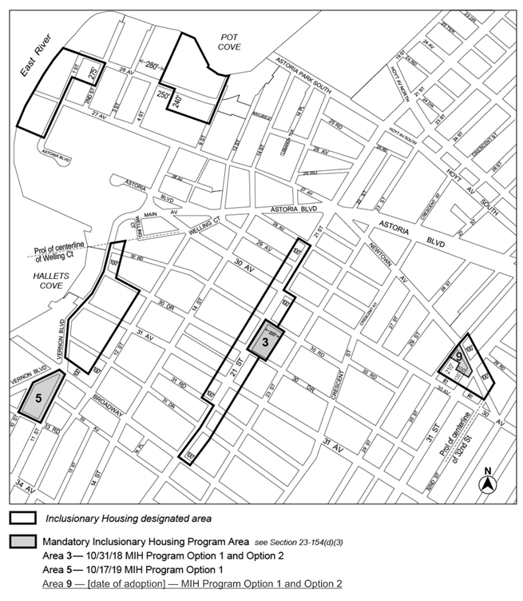
Area 9 – [date of adoption] – MIH Program Option 1 and Option 2
Portion of Community District 1, Queens

Adopted.

Office of the City Clerk, }
The City of New York, } ss.:

I hereby certify that the foregoing is a true copy of a Resolution passed by The Council of The City of New York on June 17, 2021, on file in this office.

.....................................................
City Clerk, Clerk of The Council

