THE COUNCIL OF THE CITY OF NEW YORK
RESOLUTION NO. 1751

Resolution approving with modifications the decision of the City Planning Commission on Application No. N 210250 ZRK, for an amendment of the text of the Zoning Resolution (Preconsidered L.U. No. 827).

By Council Members Salamanca and Moya

WHEREAS, Vanderbilt Atlantic Holdings, LLC, filed an application pursuant to Section 201 of the New York City Charter, for an amendment of the text of the Zoning Resolution of the City of New York, modifying Article III Chapter 5 for the purpose of amending street wall location regulations and APPENDIX F for the purpose of establishing a Mandatory Inclusionary Housing area utilizing Option 2, which in conjunction with the related action would facilitate the construction of an 18-story mixed use development containing 316 dwelling units, 95 of which would be permanently affordable, along with commercial and community facility space, at 840 Atlantic Avenue in the Prospect Heights neighborhood of Brooklyn, Community District 8 (ULURP No. N 210250 ZRK) (the “Application”);

WHEREAS, the City Planning Commission filed with the Council on July 30, 2021, its decision dated July 28, 2021 (the “Decision”) on the Application;

WHEREAS, the Application is related to application C 210249 ZMK (Pre. L.U. No. 826), a zoning map amendment to change M1-1 and R6B zoning districts to a C6-3X zoning district;

WHEREAS, the Decision is subject to review and action by the Council pursuant to Section 197-d of the City Charter;

WHEREAS, upon due notice, the Council held a public hearing on the Decision and Application on August 3, 2021;

WHEREAS, the Council has considered the land use implications and other policy issues relating to the Decision and Application; and

WHEREAS, the Council has considered the relevant environmental issues, including the Negative Declaration issued March 1st, 2021 (CEQR No. 20DCP162K) which includes an (E) designation to avoid the potential for significant adverse impacts related to hazardous materials, air quality, and noise impacts (E-604) (the “Negative Declaration”).

RESOLVED:

The Council finds that the action described herein will have no significant impact on the environment as set forth in the (E) Designation (E-604) and Negative Declaration.

Pursuant to Sections 197-d and 200 of the City Charter and on the basis of the Decision and Application, and based on the environmental determination and consideration described in the report, N 210250 ZRK, incorporated by reference herein, and the record before the Council, the Council approves the Decision of the City Planning Commission with the following modifications:

Matter underlined is new, to be added;
Matter struck out is to be deleted;
Matter double struck out is old, deleted by the City Council;
Matter double-underlined is new, added by the City Council
Matter within # # is defined in Section 12-10;
* * * indicates where unchanged text appears in the Zoning Resolution

* * *
ARTICLE III
COMMERCIAL DISTRICT REGULATIONS

* * *

Chapter 5

Bulk Regulations for Mixed Buildings in Commercial Districts

* * *

35-66
Special Height and Setback Provisions for Certain Areas

* * *
35-662
Special height and setback provisions in C6-2A and C6-3X Districts along Atlantic Avenue within Community District 8, Borough of Brooklyn

In C6-2A and C6-3X Districts in Community District 8, in the Borough of Brooklyn, for a #zoning lot# with frontage along Atlantic Avenue, the #street wall# provisions of paragraph (a) of Section 35-651 shall apply along the Atlantic Avenue #street# frontage, and shall also apply along #street# frontages intersecting Atlantic Avenue, within 50 feet of the intersection.

* * *

APPENDIX F
Inclusionary Housing Designated Areas and Mandatory Inclusionary Housing Areas

* * *
BROOKLYN
* * *
Brooklyn Community District 8
* * *
Map 4. [date of adoption]

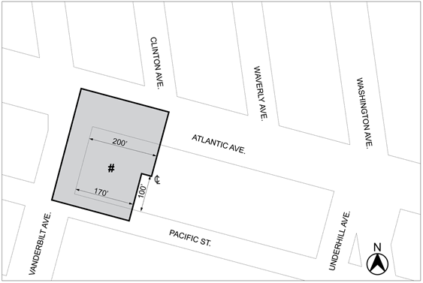

Mandatory Inclusionary Housing area (see Section 23-154(d)(3))
Area # — [date of adoption] MIH Program Option 2 Option 1 and Deep Affordability Option

Portion of Community District 8, Brooklyn

* * *

Adopted.

Office of the City Clerk, }
The City of New York, } ss.:

I hereby certify that the foregoing is a true copy of a Resolution passed by The Council of The City of New York on September 23, 2021, on file in this office.

.....................................................
City Clerk, Clerk of The Council

