THE COUNCIL OF THE CITY OF NEW YORK
RESOLUTION NO. 880

Resolution approving with modifications the decision of the City Planning Commission on Application No. N 220392 ZRR, for an amendment of the text of the Zoning Resolution (Preconsidered L.U. No. 297).

By Council Members Salamanca and Riley

WHEREAS, Epsilon Enterprises Realty, LLC, filed an application pursuant to Section 201 of the New York City Charter, for an amendment of the text of the Zoning Resolution of the City of New York, modifying Article XIII, Chapter 5 (Special Bay Street Corridor District), to create a new Subdistrict, and APPENDIX F, for the purpose of establishing a Mandatory Inclusionary Housing area, which in conjunction with the related action would facilitate the development of an eight-story mixed-use building with ground-floor commercial space and 81 residential units in the Stapleton Neighborhood of Community District 1 in Staten Island (ULURP No. N 220392 ZRR), (the “Application”);

WHEREAS, the City Planning Commission filed with the Council on November 29, 2023, its decision dated November 15, 2023 (the "Decision") on the Application;

WHEREAS, the Application is related to application C 220426 ZMR (Pre. L.U. No. 296), a zoning map amendment Section No. 21c, to change a C4-2 District to a R6 District, establish a C2-3 District within the proposed R6 District, and extend the Special Bay Street Corridor District (BSC) one block south;

WHEREAS, the Decision is subject to review and action by the Council pursuant to Section 197-d of the City Charter;

WHEREAS, upon due notice, the Council held a public hearing on the Decision and Application on November 30, 2023;

WHEREAS, the Council has considered the land use implications and other policy issues relating to the Decision and Application; and

WHEREAS, the Council has considered the relevant environmental issues, including the Negative Declaration issued July 10th, 2023 (CEQR No. 23DCP037R) (the “Negative Declaration”).

RESOLVED:

The Council finds that the action described herein will have no significant impact on the environment as set forth in the Negative Declaration.

Pursuant to Sections 197-d and 200 of the City Charter and on the basis of the Decision and Application, and based on the environmental determination and consideration described in the report, N 220392 ZRR, incorporated by reference herein, and the record before the Council, the Council approves the Decision of the City Planning Commission, with the following modifications.

Matter underlined is new, to be added;
Matter struck out is to be deleted;
Matter within # # is defined in Section 12-10;
* * * indicates where unchanged text appears in the Zoning Resolution.
Matter double struck out is old, deleted by the City Council;
Matter double-underlined is new, added by the City Council

* * *

ARTICLE XIII
SPECIAL PURPOSE DISTRICTS

Chapter 5
Special Bay Street Corridor District

135-00
GENERAL PURPOSES

* * *

135-03
Subdistricts

In order to carry out the purposes and provisions of this Chapter, five six subdistricts are established as follows:

Subdistrict A
Subdistrict B
Subdistrict C
Subdistrict D
Subdistrict E
Subdistrict F

* * *

135-00
SPECIAL USE REGULATIONS

* * *

135-11
Ground Floor Use Regulations

For the purposes of applying to this Chapter the special #ground floor level# streetscape provisions set forth in Section 37-30, any portion of a #ground floor level# #street# frontage along Bay Street, as well as any #ground floor level# #street# frontage within 50 feet of Bay Street or along Prospect Street, shall be considered a #primary street frontage#. A #ground floor level# #street# frontage along any other #street# shall be considered a #secondary street frontage#. For the purposes of this Section, inclusive, defined terms shall include those in Sections 12-10 and 37-311.

* * *

135-20
SPECIAL BULK REGULATIONS

* * *

135-21
Special Floor Area Regulations

* * *

For #zoning lots# with #buildings# containing multiple #uses# or for #zoning lots# with multiple #buildings# containing different #uses#, the maximum #floor area ratio# for each #use# shall be as set forth in the table, and the maximum #floor area ratio# for the #zoning lot# shall not exceed the greatest #floor area ratio# permitted for any such #use# on the #zoning lot#.

MAXIMUM FLOOR AREA RATIO

 | Column 1 | Column 2 | Column 3 | Column 4 | Column 5
Subdistrict, or Subarea, as applicable | For #commercial# #uses# other than offices | For offices | For #residences# other than #MIH sites# and #affordable independent residences for seniors# | For #MIH sites# and #community facility uses# other than #long-term care facilities# | For #affordable independent residences for seniors# or #long-term care facilities#
* * *
E | 2.0 | 2.0 | 2.0 | 2.2 | 2.2
F | 2.0 | 2.0 | 3.0 | 3.6 | 3.9

* * *

135-24
Special Street Wall Location Regulations

The underlying #street wall# location provisions are modified by the provisions of this Section.

(a) Along Bay Street or Prospect Street
Along Bay Street or Prospect Street, and along #streets# within 50 feet of their intersection with Bay Street, the following #street wall# regulations shall apply:

* * *

135-25
Special Height and Setback Regulations

* * *

MAXIMUM BASE HEIGHTS AND MAXIMUM BUILDING HEIGHTS

Subdistrict or Subarea, as applicable | Minimum Base Height (in feet) | Maximum Base Height (in feet) | Maximum Transition Height (in feet) | Maximum Height of #Buildings or Other Structures# in Certain Locations (in feet) | Maximum Number of #Stories#
* * *
E | 30 | 45 | N/A | 55 | 5
F | 40 | 65 | N/A | 85 | 8

* * *

APPENDIX A
SPECIAL BAY STREET CORRIDOR DISTRICT

Map 1 – Special Bay Street Corridor District, Subdistricts and Subareas

[EXISTING MAP]

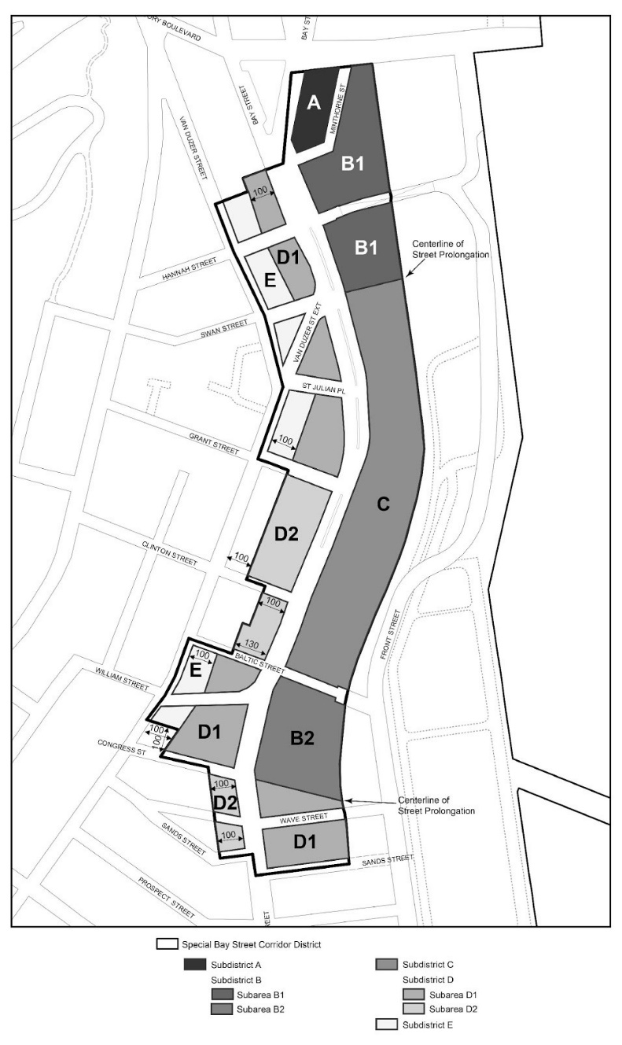

[PROPOSED MAP]

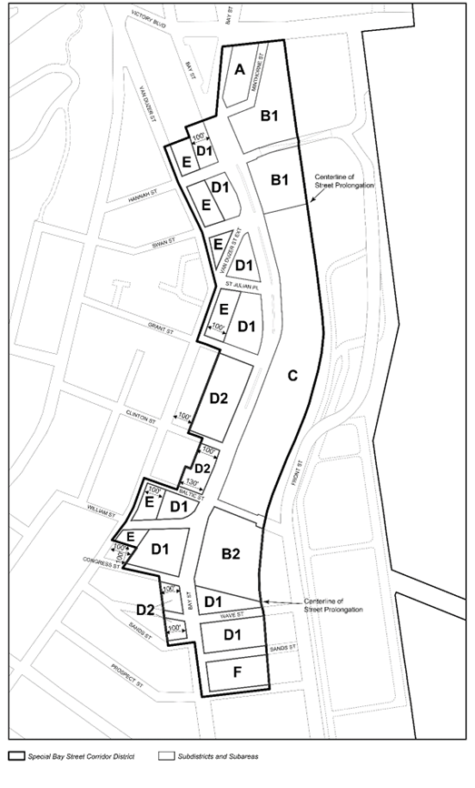

Map 2 – Location of visual corridors

[EXISTING MAP]

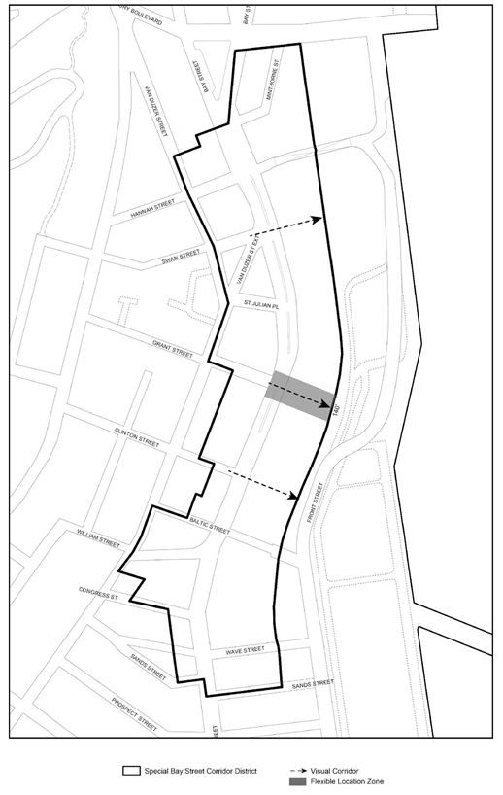
[PROPOSED MAP]
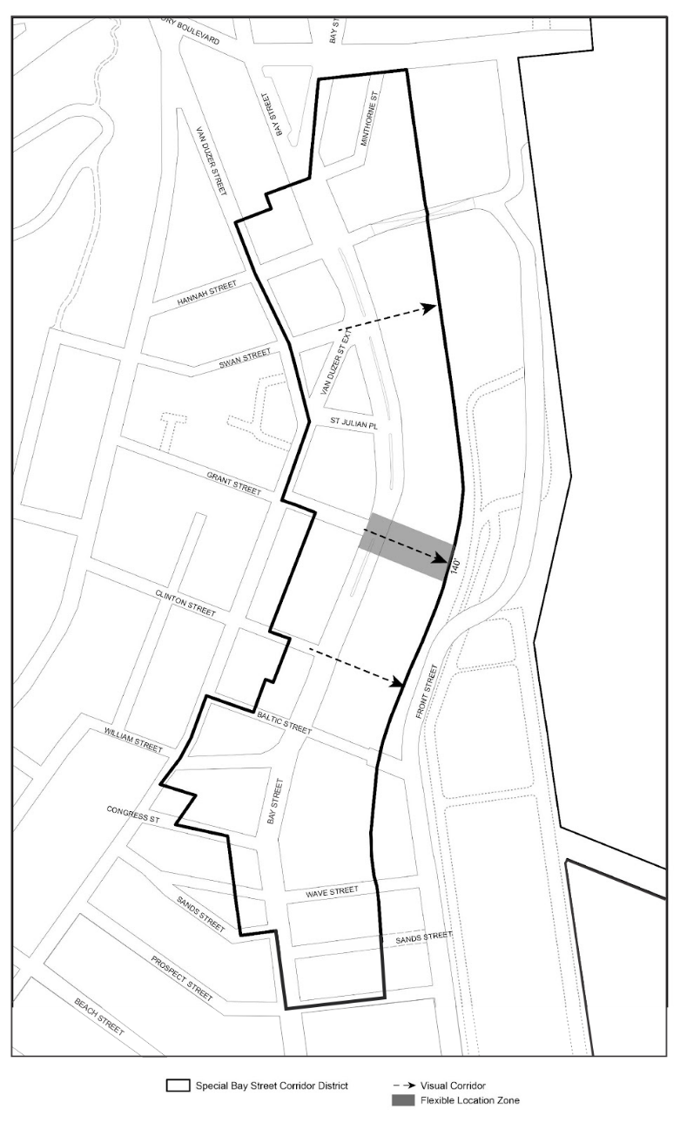
* * *

APPENDIX F
Inclusionary Housing Designated Areas and Mandatory Inclusionary Housing Areas

* * *

STATEN ISLAND

* * *

Staten Island Community District 1

* * *

Map 2 – [date of adoption]

[EXISTING MAP]

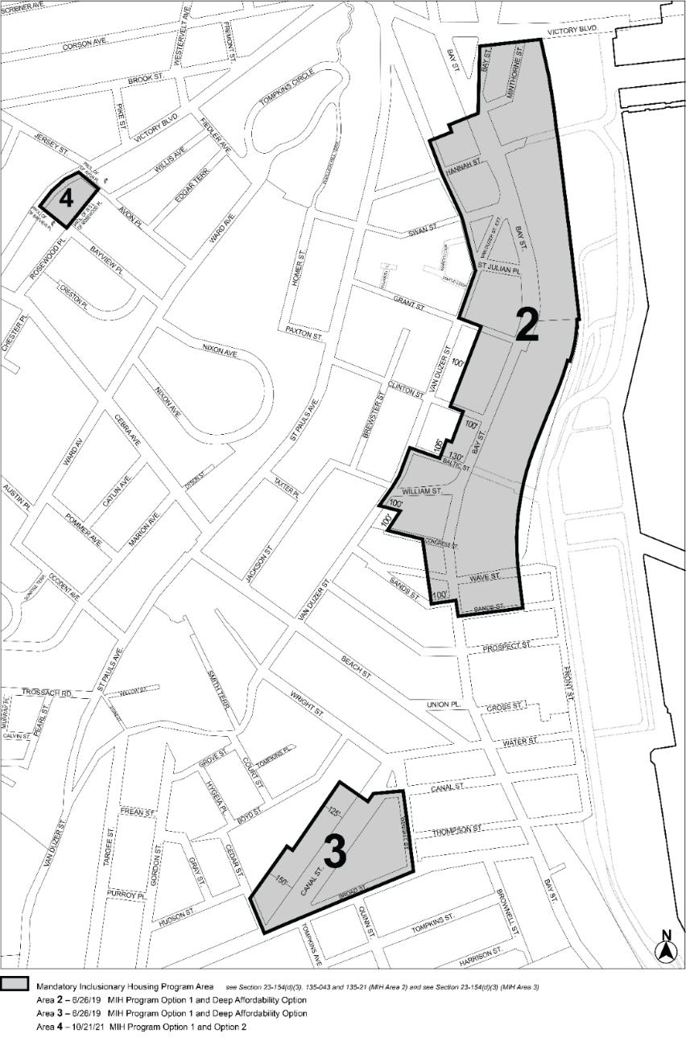

[PROPOSED MAP]

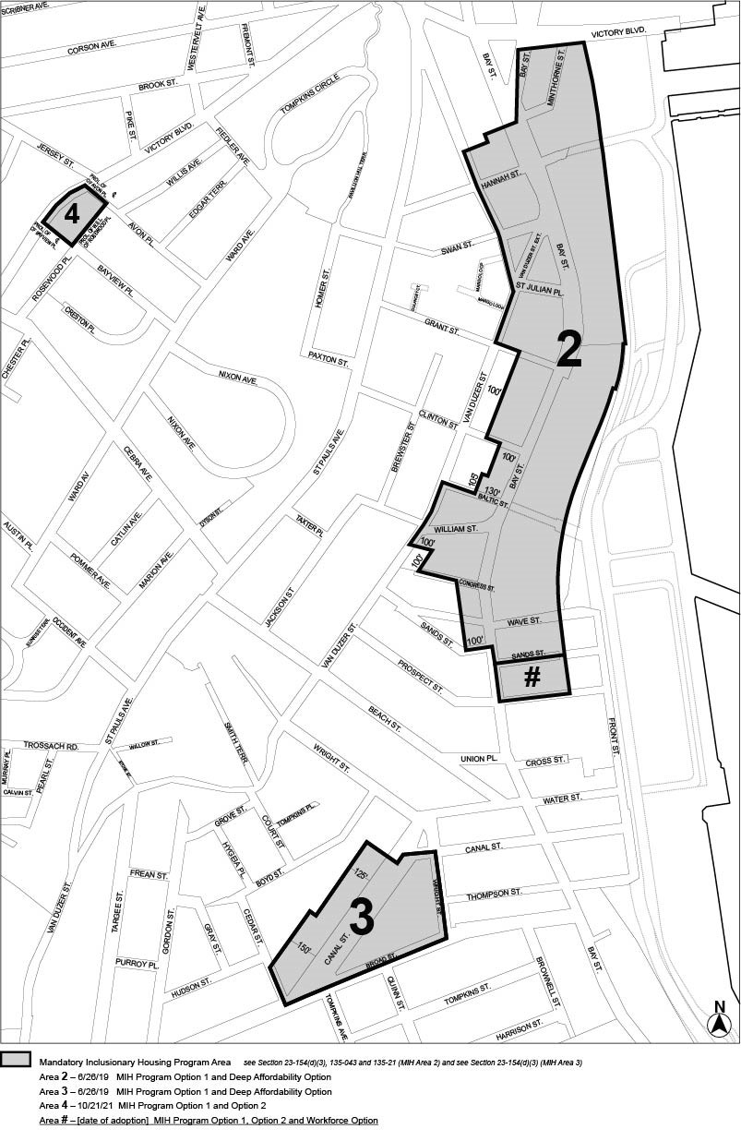

[COUNCIL MODIFIED MAP]

and Option 2

Portion of Community District 1, Staten Island

* * *
Adopted.

Office of the City Clerk,}
The City of New York,} ss.:

I hereby certify that the foregoing is a true copy of a Resolution passed by The Council of The City of New York on [ Date ], 2023, on file in this office.

.....................................................
City Clerk, Clerk of The Council

