THE COUNCIL OF THE CITY OF NEW YORK
RESOLUTION NO. 609

Resolution approving the decision of the City Planning Commission on Application No. N 240329 ZRQ, for an amendment of the text of the Zoning Resolution (L.U. No. 159).

By Council Members Salamanca and Hanks

WHEREAS, Fulcrum Properties, LLC; The Briarwood Organization, LLC; and the New York City Department of Housing Preservation and Development (HPD), filed an application pursuant to Section 201 of the New York City Charter, for an amendment of the text of the Zoning Resolution of the City of New York, modifying APPENDIX F for the purpose of establishing a Mandatory Inclusionary Housing area, which in conjunction with the related actions would facilitate the development of two new nine-story mixed-use buildings with total of approximately 143 residential units that would be 100 percent income-restricted plus two units for superintendents, as well as community facility uses located at 106-01 Guy R. Brewer Boulevard and 162-02 Tuskegee Airmen Way in the Jamaica neighborhood of Queens, Community District 12 (ULURP No. N 240329 ZRQ), (the “Application”);

WHEREAS, the City Planning Commission filed with the Council on September 23, 2024, its decision dated September 11, 2024 (the "Decision") on the Application;

WHEREAS, the Application is related to application C 240328 ZMQ (L.U. No. 158), a zoning map amendment to change an R4, R5B and R5D zoning districts with a C1-4 commercial overlay to an R7A zoning district with a C1-4 commercial overlay; and C 240330 HAQ (L.U. No. 160), an Urban Development Action Area Project (UDAAP) designation, project approval, and disposition of City-owned property;

WHEREAS, the Decision is subject to review and action by the Council pursuant to Section 197-d of the City Charter;

WHEREAS, upon due notice, the Council held a public hearing on the Decision and Application on October 1, 2024;

WHEREAS, the Council has considered the land use implications and other policy issues relating to the Decision and Application; and

WHEREAS, the Council has considered the relevant environmental issues, including the Negative Declaration issued on May 24, 2024 (CEQR No. 22HPD058Q), which includes an (E) designation to avoid the potential for significant adverse impacts related to hazardous materials and noise (E-175 and E-768) (the “Negative Declaration”).

RESOLVED:

The Council finds that the action described herein will have no significant impact on the environment as set forth in the (E) Designations (E-768 and E-175) and Negative Declaration.
Pursuant to Sections 197-d and 200 of the City Charter and on the basis of the Decision and Application, and based on the environmental determination and consideration described in the report, N 240329 ZRQ, incorporated by reference herein, and the record before the Council, the Council approves the Decision of the City Planning Commission.

Matter underlined is new, to be added;
Matter struck out is to be deleted;
Matter within # # is defined in Section 12-10;
* * * indicates where unchanged text appears in the Zoning Resolution

* * *

APPENDIX F
Inclusionary Housing Designated Areas and Mandatory Inclusionary Housing Areas

* * *

QUEENS

* * *

Queens Community District 12

* * *

Map 3 – [date of adoption]
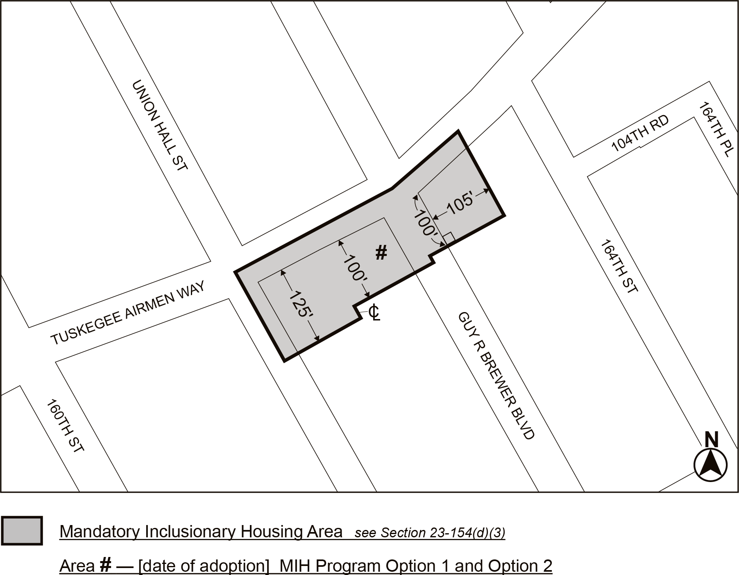

Portion of Community District 12, Queens

* * *

Adopted.

Office of the City Clerk,}
The City of New York,} ss.:

I hereby certify that the foregoing is a true copy of a Resolution passed by The Council of The City of New York on _________, 2024, on file in this office.

.....................................................
City Clerk, Clerk of The Council

