THE COUNCIL OF THE CITY OF NEW YORK
RESOLUTION NO. ___

Resolution approving the decision of the City Planning Commission on ULURP No. N 260062 ZRM, for an amendment of the text of the Zoning Resolution (L.U. No. 76).

By Council Members Riley and Louis
WHEREAS, 760 12th LLC, filed an application pursuant to Section 201 of the New York City Charter, for an amendment of the Zoning Resolution of the City of New York, amending provision of Article VIII, Chapter 9 (Special Hudson River Park District) and Article IX, Chapter 6 (Special Clinton District) and amending Appendix F for the purpose of establishing a Mandatory Inclusionary Housing Area, which in conjunction with the related applications would facilitate a proposed mixed use development containing residential and commercial uses on property located at 629 West 54th Street (Block 1102, Lot 11), within the Special Hudson River Park District and the Special Clinton District, Borough of Manhattan, Community District 4 (ULURP No. N 260062 ZRM) (the "Application");
WHEREAS, the City Planning Commission filed with the Council on May 13, 2026 its decision dated May 13, 2026 (the "Decision") on the Application;
WHEREAS, the Application is related to application C 260060 ZMM (L.U. No. 75), a zoning map amendment to change an M2-4(CL) zoning district to a C4-7(CL) zoning district and establish the Special Hudson River Park and application C 260061 ZSM (L.U. No. 77), a special permit to transfer floor area and modify bulk regulations in connection with the proposed mixed-use development (the “Related Actions”);
WHEREAS, the Decision is subject to review and action by the Council pursuant to Section 197-d of the City Charter;
WHEREAS, upon due notice, the Council held a public hearing on the Decision and Application on May 27, 2026;
WHEREAS, the Council has considered the land use and other policy issues relating to the Decision and Application; and
WHEREAS, the Council has considered the relevant environmental issues, including the Positive Declaration issued on December 30, 2024 (CEQR No. 25DCP049M) and a Final Environmental Impact Statement (the “FEIS”) for which a Notice of Completion was issued on April 30, 2026. To avoid significant adverse impacts related to hazardous materials, air quality, and noise the FEIS includes an (E) designation (E-869) that would apply to Block 1103, Lot 36 (801 11th Avenue), and Block 1102, Lot 11 (629 West 54th Street), which includes the project site (the “E-designation”). The FEIS identified significant adverse impacts and proposed mitigation measures, as summarized in Chapter 18 of the FEIS, related transportation (traffic and transit (buses)) and construction (traffic and noise). To ensure implementation of the mitigation measures identified in the FEIS, in connection with the proposed project, a Restrictive Declaration dated May 13, 2026, attached to the Decision for C 260061 ZSM, would be recorded against the project site which specifies the mitigation measures and the process of their implementation, consistent with the FEIS (the “Restrictive Declaration”). A Technical Memorandum was issued on _______, 2026 (the “Technical Memorandum”) to consider the Council’s modifications to the Related Actions and concluded that the Related Actions, as modified, would not result in any significant adverse environmental impacts that were not already identified in the FEIS (the FEIS, the E-designations, the Restrictive Declaration and the Technical Memorandum are collectively referred to as the “Environmental Documentation”).
RESOLVED:
Having considered the Environmental Documetation with respect to the Decision and Application, the Council finds that:
(1) The environmental impacts disclosed in the FEIS were evaluated in relation to the social, economic, and other considerations associated with the Related Actions that are set forth in the Decision; and
(2) Consistent with social, economic and other essential considerations from among the reasonable alternatives available, thereto, the Related Actions are those which avoid or minimize adverse environmental impacts to the maximum extent practicable by incorporating as conditions to approval, pursuant to the Restrictive Declaration, attached to the Decision for C 260015 ZSM, those project components related to the environment and mitigation measures that were identified as practicable and the placement of (E) designation (E-869) for hazardous materials, air quality and noise.
The Decision, together with the FEIS constitute the written statement of facts, and of social, economic and other factors and standards that form the basis of this determination, pursuant to 6 N.Y.C.R.R. §617.11(d).
Pursuant to Sections 197-d and 200 of the New York City Charter and the Decision and Application, the environmental determination and consideration described in the report, N 260062 ZRM, incorporated by reference herein, and the record before the Council, the Council approves the Decision of the City Planning Commission.
The Zoning Resolution of the City of New York, effective as of December 15, 1961, and as subsequently amended, is further amended as follows:
Matter underlined is new, to be added; Matter struck out is to be deleted;
Matter within # # is defined in Sections 12-10 or 89-02;
* * * indicates where unchanged text appears in the Zoning Resolution.
* * *

ARTICLE VIII
SPECIAL PURPOSE DISTRICTS
Chapter 9
Special Hudson River Park District
89-00
GENERAL PURPOSES
* * *
89-02
Definitions
For the purposes of this Chapter, matter in italics is defined in Section 12-10 (DEFINITIONS) and in this Section.
Granting site
Within the #Special Hudson River Park District#, a “granting site” is a #zoning lot#, or a portion of a #zoning lot#, within the areas Area A, identified as “A1”, or “B1” or within Area B, identified as “B-G1”, “B-G2” or “B-G3”, on the map in the Appendix to this Chapter, upon which development is regulated by contract, lease, covenant, declaration or otherwise to assure compliance with the purposes of this Special District and from which #floor area# may be transferred. A #granting site# may only transfer #floor area# to a #receiving site# within an area
that shares the same letter designation. For example, a #granting site# within area Area A1 may transfer #floor area# to a #receiving site# within area Area A2, but not to a #receiving site# within area B2 Area B.

Receiving site
Within the #Special Hudson River Park District#, a “receiving site” is a #zoning lot#, within the area Area A, identified as “A2”, “B2”, or “B3” or within Area B, identified as “B-R1”, “B-R2” or “B-R4” on the maps in the Appendix to this Chapter, to which #floor area# of a #granting site# may be transferred.
* * *
89-10
USE AND BULK REGULATIONS

89-11
Use and Bulk Regulations on Receiving Sites
The #use# and #bulk# regulations applicable to a #receiving site# shall be modified as follows:
- C6-4 Districts

Within Area A2 on the maps in the Appendix to this Chapter, the #use# and #bulk# regulations of the underlying C6-4 District shall not apply. In lieu thereof, the #use# and #bulk# regulations of an M1-5 District shall apply.
Within Areas B2 and B3 Area B-R1 and Area B-R2, the #use# and #bulk# regulations of the underlying C6-4X District shall not apply. In lieu thereof, the #use# and #bulk# regulations of an M2-3 District shall apply.
- C6-3 and M1-5 Districts

The #use# and #bulk# regulations of the underlying C6-3 and M1-5 Districts shall not apply. In lieu thereof, the #use# and #bulk# regulations of an M2-4 District shall apply.

- C4-7 Districts in Area B-R4

The #use# and #bulk# regulations of the underlying C4-7 District shall not apply. In lieu thereof, the #use# and #bulk# regulations of an M2-4 District shall apply

However, on a #receiving site#, for any #development#, #enlargement# or #conversion# that is the subject of a special permit granted by the City Planning Commission pursuant to Section 89-21 (Transfer of Floor Area From Hudson River Park), the #use# and #bulk# regulations of the underlying C4-7, C6-3, C6-4, or M1-5 District shall only apply to such approved #development#, #enlargement# or #conversion#. However, in C4-7 Districts, automobile dealers and all other motor vehicle dealers, as listed in Use Group VI, may include these additional #uses# only: repair services or preparation of vehicles for delivery.
89-12
Special Floor Area Regulations Within Areas B2 and B3 B-R1 and B-R2

Within Areas B2 and B3 B-R1 and B-R2 on the maps in the Appendix to this Chapter, where a special permit by the City Planning Commission on a #receiving site# is sought pursuant to Section 89-21 (Transfer of Floor Area From Hudson River Park), and the #bulk# regulations of the underlying C6-4X District apply pursuant to the provisions of Section 89-11 (Use and Bulk Regulations on Receiving Sites), the #floor area ratio# for #qualifying affordable housing# shall be 10.0 within a #Mandatory Inclusionary Housing area#, and such maximum #floor area ratio# may be increased to a maximum of 12.0 only, as set forth in Section 89-21.

89-13
Special Floor Area Regulations Within Area B-R4

Within Area B-R4 on the maps in the Appendix to this Chapter, where a special permit by the City Planning Commission on a #receiving site# is sought pursuant to Section 89-21 (Transfer of Floor Area from Hudson River Park), and the bulk regulations of the underlying C4-7 District apply pursuant to the provisions of Section 89-11 (Use and Bulk Regulations on Receiving Sites), the #floor area ratio# for #qualifying affordable housing# shall be 12.0 within a #Mandatory Inclusionary Housing area#, and such maximum residential #floor area ratio# may be increased to a maximum of 14.4 as set forth in Section 89-21.

* * *
89-20
SPECIAL PERMITS

89-21
Transfer of Floor Area from Hudson River Park
The City Planning Commission may permit a transfer of #floor area# from a #granting site# to a #receiving site#, may permit distribution of total allowable #floor area# of a #receiving site# without regard for zoning district boundaries, may permit that such #receiving site# be treated as a single #zoning lot# for all purposes of this Resolution, and may modify #bulk# regulations, except #floor area# regulations, for a #development#, #enlargement#, or #conversion# located on such #receiving site#. In addition, for #receiving sites# within Area B2 B-R1 on the maps in the Appendix to this Chapter, the Commission may exempt floor space from the definition of #floor area# in a #building# that contains an ambulance station and may increase the maximum number of #accessory# off-street parking spaces permitted for such station.

* * *

APPENDIX

Special Hudson River Park District Plan
* * *
Map 2. Transfer of Floor Area — Granting and Receiving Sites within Areas B1, B2 and B3 Area B
[EXISTING MAP]
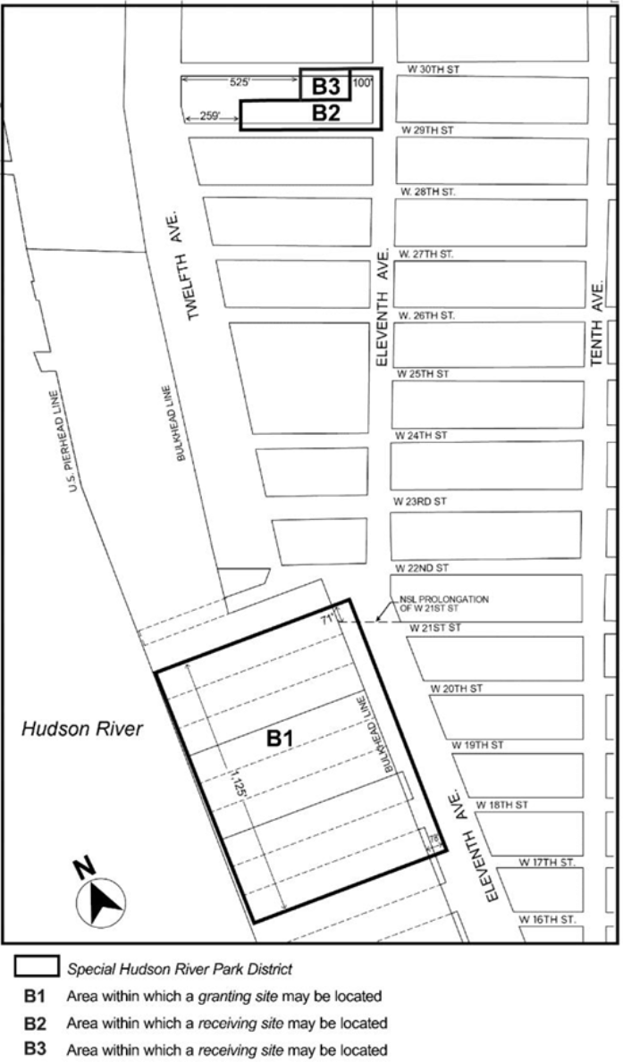
[PROPOSED MAP]
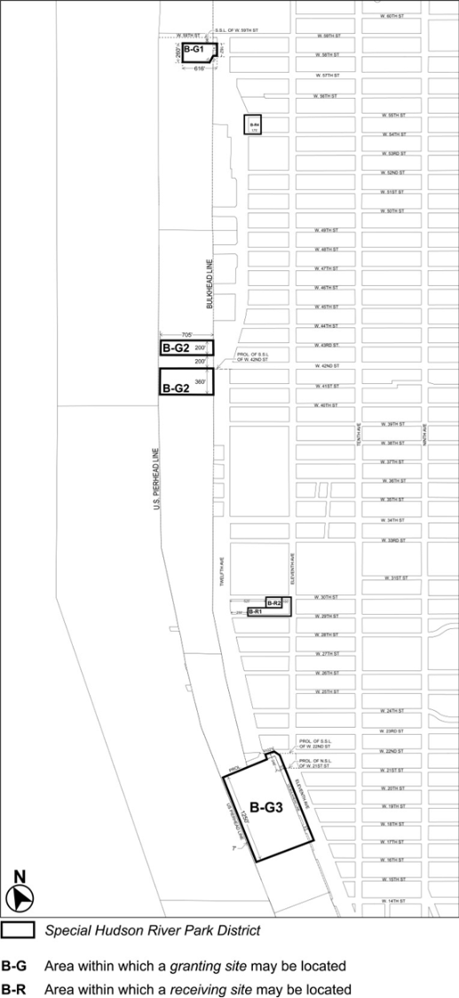

* * *
ARTICLE IX
SPECIAL PURPOSE DISTRICTS

Chapter 6
Special Clinton District

96-00
GENERAL PURPOSES

* * *
96-02
General Provisions
Except as modified by the express provisions of this Chapter, the regulations of the underlying districts, or as modified by the #Special Midtown District#, remain in effect.
The #Special Midtown District# and its regulations, where applicable in the #Special Clinton District#, shall also apply and shall supplement or supersede regulations as set forth in this Chapter pursuant to Section 96-22 (Special Regulations for Eighth Avenue Perimeter Area). In the event of any conflict or discrepancy between the regulations, the more restrictive regulations shall apply in accordance with Section 11-22 (Application of Overlapping Regulations). This portion of the Special Purpose District is designated on the #zoning map# by the letters “CL-MiD.”
Wherever the #Special Clinton District# includes an area which also lies within the #Special Hudson River Park District#, the requirements of the #Special Hudson River Park District#, as set forth in Article VIII, Chapter 9, shall apply.
In #flood zones#, or for #transit-adjacent sites# or #qualifying transit improvement sites#, as defined in Section 66-11 (Definitions), in the event of a conflict between the provisions of this Chapter and the provisions of Article VI, Chapter 4 (Special Regulations Applying in Flood Hazard Areas), or Article VI, Chapter 6 (Special Regulations Applying Around Mass Transit Stations), the provisions of Article VI shall control.
* * *
APPENDIX F
Mandatory Inclusionary Housing Areas and former Inclusionary Housing Designated Areas
* * *
MANHATTAN
* * *
Manhattan Community District 4
* * *
Map 2 – [date of adoption]
[EXISTING MAP]
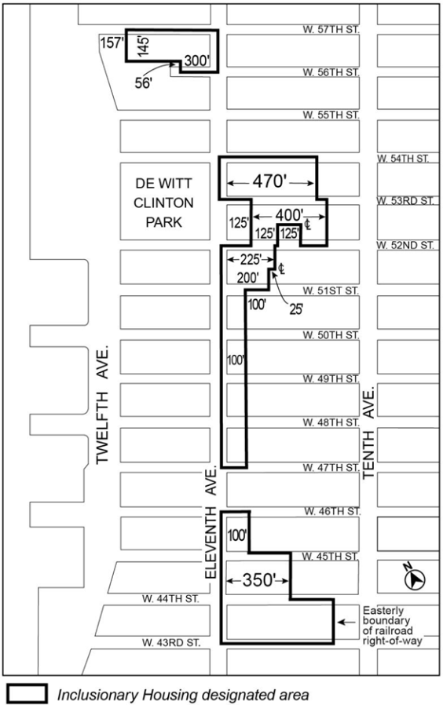
[PROPOSED MAP]
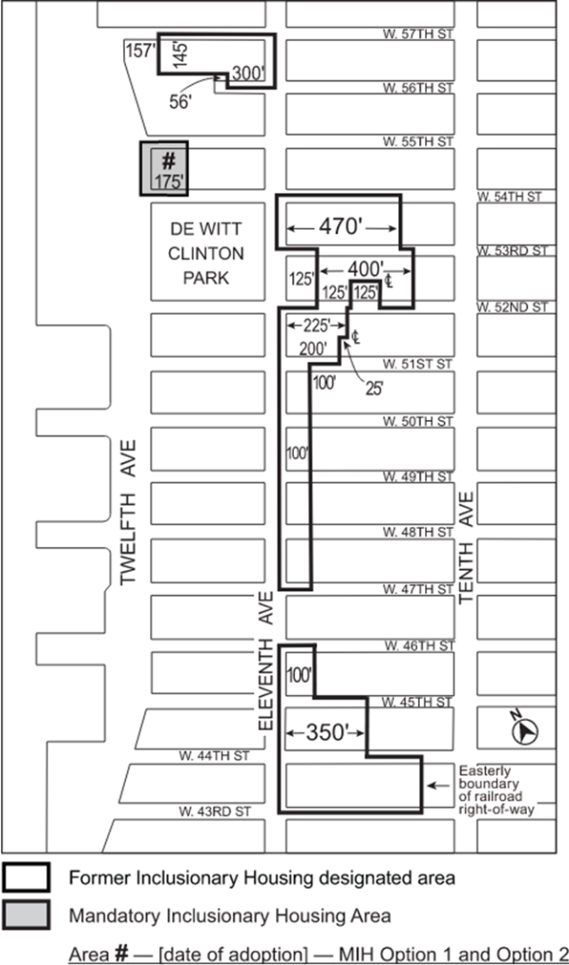

Portion of Community District 4, Manhattan
* * *

Adopted.

Office of the City Clerk, }
The City of New York, } ss.:

I hereby certify that the foregoing is a true copy of a Resolution passed by The Council of The City of New York on _____________ on file in this office.

.....................................................
City Clerk, Clerk of The Council

