THE COUNCIL OF THE CITY OF NEW YORK
RESOLUTION NO. 992

Resolution approving with modifications the decision of the City Planning Commission on Application No. N 190209 ZRX, for an amendment of the text of the Zoning Resolution (L.U. No. 426).

By Council Members Salamanca and Moya

WHEREAS, the New York City Department of Housing Preservation and Development (HPD) and Phipps Houses, filed an application pursuant to Section 201 of the New York City Charter, for an amendment of the text of the Zoning Resolution of the City of New York, modifying APPENDIX F for the purpose of establishing a Mandatory Inclusionary Housing area utilizing Options 1 and 2, which in conjunction with the related actions would facilitate the development of a new nine-story residential building comprising approximately 54 affordable dwelling units plus one unit for a superintendent, comprising approximately 45,231 square feet of residential space and 1,115 square feet of community facility space on Block 2360, Lots 1 and 3 in the Melrose neighborhood of Community District 1 in the Bronx, (Application No. N 190209 ZRX), (the "Application");
WHEREAS, the City Planning Commission filed with the Council on May 10, 2019, its decision dated April 24, 2019 (the "Decision") on the Application;
WHEREAS, the Application is related to applications C 190207 ZMX (L.U. No. 424), a zoning map amendment to rezone the Project Area from R7-2 to C6-2; C 190208 PPX (L.U. No. 425), a disposition of non-residential City-owned property; C 190210 ZSX (L.U. No. 427), a zoning special permit pursuant to ZR 74-681 to allow development over a discontinued railroad right-of-way;
WHEREAS, the Decision is subject to review and action by the Council pursuant to Section 197-d of the City Charter;
WHEREAS, upon due notice, the Council held a public hearing on the Decision and Application on June 6, 2019;
WHEREAS, the Council has considered the land use implications and other policy issues relating to the Decision and Application; and
WHEREAS, the Council has considered the relevant environmental issues, including the negative declaration issued November 28th, 2018 (CEQR No. 19HPD011X) (the “Negative Declaration”).
RESOLVED:
The Council finds that the action described herein will have no significant impact on the environment as set forth in the Negative Declaration.
Pursuant to Sections 197-d and 200 of the City Charter and on the basis of the Decision and Application, and based on the environmental determination and consideration described in the report, N 190209 ZRX, incorporated by reference herein, and the record before the Council, the Council approves the Decision of the City Planning Commission with the following modifications:
Matter underlined is new, to be added;
Matter struck out is to be deleted;
Matter within # # is defined in Section 12-10;
Matter double struck out is old, deleted by the City Council;
Matter double-underlined is new, added by the City Council
* * * indicates where unchanged text appears in the Zoning Resolution.

APPENDIX F

Inclusionary Housing Designated Areas and Mandatory Inclusionary Housing Areas

* * *

THE BRONX

* * *

Community District 1

* * *

Map 6 – [date of adoption]

[PROPOSED MAP]

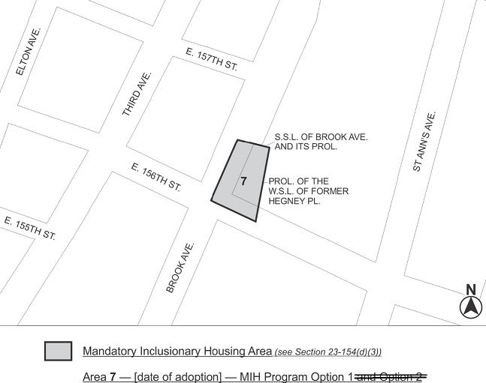

Portion of Community District 1, the Bronx

* * *

Adopted.

Office of the City Clerk, }
The City of New York, } ss.:

I hereby certify that the foregoing is a true copy of a Resolution passed by The Council of The City of New York on June 26, 2019, on file in this office.

.....……......................................... City Clerk, Clerk of The Council

