THE COUNCIL OF THE CITY OF NEW YORK
RESOLUTION NO. 915

Resolution approving the decision of the City Planning Commission on Application No. N 190236 ZRM, for an amendment of the text of the Zoning Resolution (Preconsidered L.U. No. 414).

By Council Members Salamanca and Moya

WHEREAS, the City Planning Commission filed with the Council on April 26, 2019 its decision dated April 24, 2019 (the "Decision"), on the application submitted by the New York City Department of City Planning, pursuant to Section 201 of the New York City Charter, for an amendment of the text of the Zoning Resolution of the City of New York, modifying Article III, Chapter 7 (Special Urban Design Regulations) and modifying the Special East Harlem Corridors District (Article XIII, Chapter 8), in conjunction with the related action, as a follow-up action to the East Harlem Neighborhood Rezoning, to reduce the maximum allowable building heights along Park Avenue in the East Harlem Corridors Special District, Borough of Manhattan, Community District 11, (Application No. N 190236 ZRM), (the "Application");

WHEREAS, the Application is related to application no. C 190235 ZMM (Pre. L.U. No. 413), a zoning map amendment to remove the Special East Harlem Corridor District designation from an existing R7B district;

WHEREAS, the Decision is subject to review and action by the Council pursuant to Section 197-d of the City Charter;
WHEREAS, upon due notice, the Council held a public hearing on the Decision and Application on May 2, 2019;

WHEREAS, the Council has considered the land use implications and other policy issues relating to the Decision and Application; and

WHEREAS, the Council has considered the relevant environmental issues, including the East Harlem Neighborhood Rezoning Final Environmental Impact Statement (FEIS) for which a Notice of Completion was issued on September 19, 2017 (CEQR No. 17DCP048M), and the Technical Memorandum to the East Harlem Neighborhood Rezoning FEIS (TM 004), dated December 14, 2018, which concluded that the proposed actions would not have any new or different significant adverse impacts not already identified in the FEIS (the “Technical Memorandum”).

RESOLVED:

Having considered the FEIS and the Technical Memorandum dated December 14, 2018, with respect to the Application, the Council finds that the action described herein will have no significant impact on the environment.
Pursuant to Sections 197-d and 200 of the City Charter and on the basis of the Decision and Application, and based on the environmental determination and consideration described in the report, N 190236 ZRM, incorporated by reference herein, and the record before the Council, the Council approves the Decision of the City Planning Commission to amend the Zoning Resolution of the City of New York, effective as of December 15, 1961, and as subsequently modified, as follows:

Matter underlined is new, to be added;
Matter struck out is to be deleted;
Matter within # # is defined in Section 12-10;
* * * indicates where unchanged text appears in the Zoning Resolution.

ARTICLE III
COMMERCIAL DISTRICT REGULATIONS

Chapter 7
Special Urban Design Regulations

* * *

37-40
Off-Street Relocation or Renovation of a Subway Stair

Where a #development# or an #enlargement# is constructed on a #zoning lot# of 5,000 square feet or more of #lot area# that fronts on a portion of a sidewalk containing a stairway entrance or entrances into a subway station located within the #Special Midtown District# as listed in Section 81-46, the #Special Lower Manhattan District# as listed in Section 91-43, the #Special Downtown Brooklyn District# as listed in Section 101-43, the #Special Long Island City Mixed Use District# as described in Section 117-44, the #Special Union Square District# as listed in Section 118-50, the #Special East Harlem Corridors District# as described in Section 138-33, and those stations listed in the following table, the existing entrance or entrances shall be relocated from the #street# onto the #zoning lot#. The new entrance or entrances* shall be provided in accordance with the provisions of this Section.

* * *

ARTICLE XIII
SPECIAL PURPOSE DISTRICTS

Chapter 8
Special East Harlem Corridors District

* * *

138-20
SPECIAL BULK REGULATIONS

* * *
138-21
Floor Area Regulations

Within the #Special East Harlem Corridors District#, the underlying #floor area# regulations shall apply as modified in this Section, inclusive.

138-211
Special floor area regulations

(a) In certain #Commercial Districts# and in #Manufacturing Districts# paired with a #Residence District#, as shown on Map 2 of the Appendix to this Chapter, for any #zoning lot# containing #residential floor area#, the maximum #residential floor area ratio# shall be modified as follows:

(1) for #zoning lots# complying with the applicable provisions of paragraph (d)(3) of Section 23-154 (Inclusionary Housing) or, for #affordable independent residences for seniors#, the maximum #residential floor area ratio# set forth on Map 2 shall apply;

(2) for #zoning lots# utilizing the provisions of paragraphs (d)(4)(i) or (d)(4)(iii) of Section 23-154, the maximum #residential floor area ratio# shall apply as modified in the table below:

Maximum #residential floor area ratio# shown on Map 2 | Modified maximum #residential floor area ratio#
8.5 | 7.52
9.0 | 7.52
10.0 | 9.0

(3) except in C2 Districts subject to the provisions of paragraph (b) of this Section, the maximum #floor area ratio# for any combination of #uses# shall be the maximum #floor area ratio# specified in paragraphs (a)(1) or (a)(2) of this Section, whichever is applicable; and

(4) in C4-6 Districts and in C2 Districts mapped within an R9 or R10 District, the #floor area# provisions of Sections 33-13 (Floor Area Bonus for a Public Plaza) or 33-14 (Floor Area Bonus for Arcades) shall not apply.

(b) In C2 Districts mapped within an R7D District that is also located within 100 feet of Park Avenue, the maximum #community facility floor area ratio# shall be 6.5, except that the applicable provisions of paragraph (d) of Section 33-121 (In districts with bulk governed by Residence District bulk regulations) shall apply to #zoning lots# containing philanthropic or non-profit institutions with sleeping accommodations or #long-term care facilities#.

(c) Any floor space occupied by a subway entrance provided pursuant to the provisions of Section 138-33 (Off-street Relocation or Renovation of a Subway Stair) shall not count as #floor area#.

* * *

138-23
Height and Setback Regulations in Commercial Districts

In #Commercial Districts#, the underlying height and setback provisions are modified as follows:

(a) Basic Height and Setback Regulations

In #Commercial Districts#, the maximum height of #buildings or other structures# shall be as set forth in Sections 35-652 (Maximum height of buildings and setback regulations) or 35-654 (Modified height and setback regulations for certain Inclusionary Housing buildings or affordable independent residences for seniors), as applicable, except that:

(1) the minimum base heights shall be modified by the provisions of Section 138-22 (Street Wall Regulations);

(2) in C2 Districts mapped within an R9 District that is also located within 100 feet of Third Avenue, the maximum #building height# for #buildings# utilizing the provisions of Section 35-654 shall be modified to 215 feet and the maximum number of #stories# in permitted pursuant to such Section shall not apply be 21;

(3) in C4-6 Districts whose maximum #residential floor area ratio# is 9.0, as set forth on Map 2 of the Appendix to this Chapter, the applicable provisions of Sections 35-652 or 35-654 for R9 Districts shall apply, except that the minimum base height as set forth in Section 138-22 shall apply, and the maximum #building height# for #buildings# utilizing the provisions of Section 35-654 shall be modified to 215 feet and the maximum number of #stories# in permitted pursuant to Section 35-654 shall not apply be 21; and

(4) in a C2 District mapped within an R7D District that is also located within 100 feet of Park Avenue, the maximum #building height# for #buildings# utilizing the provisions of Section 35-654 shall be modified to 125 feet and the maximum number of stories permitted pursuant to such Section shall be 12; and

(4)(5) where applicable, in lieu of the provisions of this paragraph, the provisions of paragraph (b) of this Section may be applied.

The regulations of paragraph (b)(2) of Section 35-652 relating to requirements for #qualifying ground floors#, where otherwise applicable, shall not apply. In lieu thereof, the provisions of Section 138-30 (STREETSCAPE REQUIREMENTS), inclusive, shall apply.

(b) Alternate Height and Setback Regulations in Certain Districts

In C2 Districts mapped within an R9 or R10 District, or in C4-6 or C6-4 Districts, or in C2 Districts mapped within an R7D or R8A District that are also located within 100 feet of Park Avenue, as an alternative to the provisions of paragraph (a) of this Section, the provisions of this paragraph may be applied to #zoning lots# meeting the applicable criteria set forth in paragraph (a) of Section 23-664 (Modified height and setback regulations for certain Inclusionary Housing buildings or affordable independent residences for seniors), or to #zoning lots# where 50 percent or more of the #floor area# is occupied by non-#residential uses#.

(1) Setbacks

At a height not lower than the minimum base height specified in Section 138-22 (Street Wall Regulations), nor higher than a maximum base height of 85 feet, a setback shall be provided in accordance with paragraph (c) of Section 23-662 (Maximum height of buildings and setback regulations). Above such required setback, any portion of such #building# shall be considered a “tower.”

(2) #Lot coverage# requirements for towers

Each #story# of a tower containing #residential floor area# shall not exceed a maximum #lot coverage# of 40 percent, except that, for #zoning lots# of less than 20,000 square feet, such #lot coverage# may be increased in accordance with the table in Section 23-65 (Tower Regulations). Each #story# of a tower containing exclusively non-#residential floor area# shall not exceed a maximum #lot coverage# of 50 percent. However, where dormers are provided within the required setback, such portions of #buildings# shall not count toward the maximum allowable tower #lot coverage# set forth in this paragraph.

(3) Maximum tower height

(i) The maximum tower height shall be set forth on Map 3 of the Appendix to this Chapter.

(ii) In C2 Districts mapped within R9 Districts that are also located within the #Special Transit Land Use District#, for #zoning lots# which include a transit easement in accordance with the applicable provisions of Article IX, Chapter 5 (Special Transit Land Use District), the maximum tower height shall be:

(a) 325 feet for #zoning lots# which include ancillary facilities with emergency egress and/or ventilation structures as specified in Section 95-032 (Determination of transit easement at other stations); and

(b) 215 feet for #zoning lots# which include only transit facilities specified in Section 95-032 other than ancillary facilities with emergency egress and/or ventilation structures.

(iii) In C6-4 Districts, no height limit shall apply to towers.

* * *

138-30
STREETSCAPE REQUIREMENTS

The provisions of this Section, inclusive, shall apply to #developments# or #ground floor level enlargements# in all districts. In #Commercial Districts# mapped within R7D Districts, the underlying provisions of Section 32-434 (Ground floor use in C4-5D and C6-3D Districts and in certain C2 Districts) shall not apply. Any portion of a #ground floor level# that is within a transit easement required pursuant to the provisions of Article IX, Chapter 5, or any portion of a #ground floor level# that contains a subway entrance required pursuant to the provisions of Section 138-33 (Off-street Relocation or Renovation of a Subway Stair), need not comply with the streetscape requirements of this Section, inclusive.

* * *

138-32
Special Streetscape Provisions for Blank Walls

* * *

138-33
Off-street Relocation or Renovation of a Subway Stair

Where a #development# or #enlargement# is constructed on a #zoning lot# of at least 5,000 square feet that fronts on a portion of sidewalk containing a stairway entrance or entrances into the 116th Street Station of the Lexington Avenue subway line, such #development# or #enlargement# shall be subject to the regulations of Section 37-40 (Off-Street Relocation or Renovation of a Subway Stair).

138-40
OFF-STREET PARKING AND LOADING REGULATIONS

* * *

APPENDIX
Special East Harlem Corridors District Plan

* * *

Map 3: Maximum Height

[EXISTING MAP]
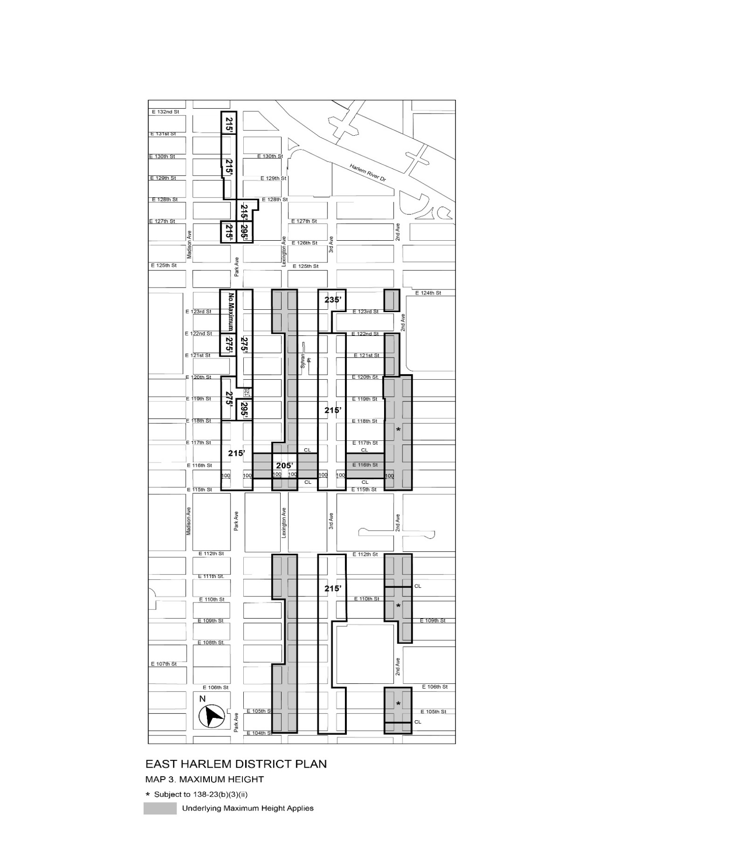
[PROPOSED MAP]
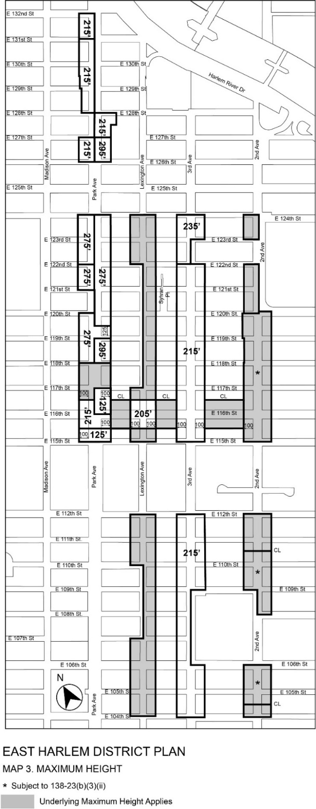

* * *

Adopted.

Office of the City Clerk, }
The City of New York, } ss.:

I hereby certify that the foregoing is a true copy of a Resolution passed by The Council of The City of New York on May 29, 2019, on file in this office.

.....……......................................... City Clerk, Clerk of The Council

