THE COUNCIL OF THE CITY OF NEW YORK
RESOLUTION NO. 883

Resolution approving the decision of the City Planning Commission on Application No. N 180043 ZRK, for an amendment of the text of the Zoning Resolution (L.U. No. 394).

By Council Members Salamanca, Jr. and Moya

WHEREAS, the City Planning Commission filed with the Council on April 8, 2019 its decision dated April 8, 2019 (the "Decision"), on the application submitted by 1010 Pacific Street, LLC, pursuant to Section 201 of the New York City Charter, for an amendment of the text of the Zoning Resolution of the City of New York, modifying Appendix F for the purpose of establishing a Mandatory Inclusionary Housing area utilizing Options 1 and 2 on Block 1133, Lots 32, 42-49, and 51-53, which in conjunction with the related action would facilitate an 11-story mixed-use development with approximately 154 dwelling units and ground floor commercial and community facility space at 1010 Pacific Street in the Crown Heights neighborhood of Brooklyn, Community District 8, (Application No. N 180043 ZRK), (the "Application");

WHEREAS, the Application is related to application C 180042 ZMK (L.U. No. 393), a zoning map amendment to rezone an M1-1 district to an R7D district with a C2-4 commercial overlay;

WHEREAS, the Decision is subject to review and action by the Council pursuant to Section 197-d(b)(1) of the City Charter;

WHEREAS, upon due notice, the Council held a public hearing on the Decision and Application on April 16, 2019;

WHEREAS, the Council has considered the land use implications and other policy issues relating to the Decision and Application; and

WHEREAS, the Council has considered the relevant environmental issues, including the Revised Negative Declaration issued April 10th, 2019, which supersedes the Negative Declaration issued October 29th, 2018, and Revised Environmental Assessment Statement issued April 5th, 2019 (CEQR No. 16DCP134K) which include an (E) designation to avoid the potential for significant adverse impacts related to hazardous materials, air quality, and noise (the “E” Designation (E-503)).

RESOLVED:

The Council finds that the action described herein will have no significant impact on the environment as set forth in the (E) Designation (E-503) and Revised Negative Declaration.

Pursuant to Sections 197-d and 200 of the City Charter and on the basis of the Decision and Application, and based on the environmental determination and consideration described in the report, N 180043 ZRK, incorporated by reference herein, and the record before the Council, the Council approves the Decision of the City Planning Commission.

Matter underlined is new, to be added;
Matter struck out is to be deleted;
Matter within # # is defined in Section 12-10;
* * * indicates where unchanged text appears in the Zoning Resolution

* * *

APPENDIX F
Inclusionary Housing Designated Areas and Mandatory Inclusionary Housing Areas

* * *

Brooklyn

* * *

Brooklyn Community District 8

* * *

Map 3 - [date of adoption]

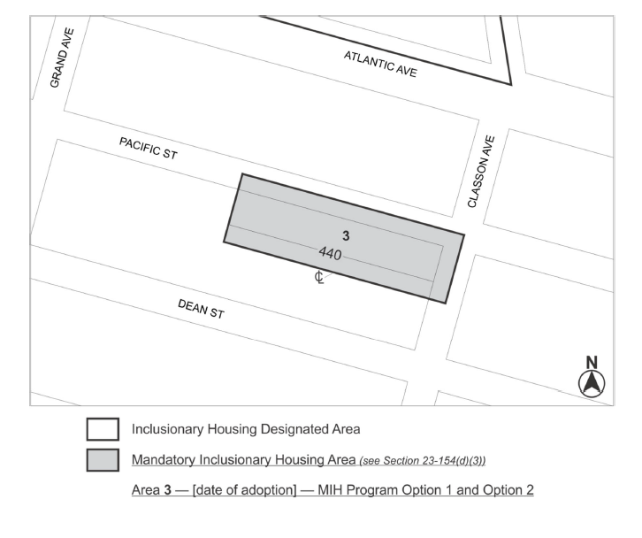

Portion of Community District 8, Brooklyn

* * *

Adopted.

Office of the City Clerk, }
The City of New York, } ss.:

I hereby certify that the foregoing is a true copy of a Resolution passed by The Council of The City of New York on May 8, 2019, on file in this office.

.....................................................
City Clerk, Clerk of The Council

