THE COUNCIL OF THE CITY OF NEW YORK
RESOLUTION NO. 35

Resolution approving the decision of the City Planning Commission on Application No. N 230263 ZRQ, for an amendment of the text of the Zoning Resolution (L.U. No. 10).

By Council Members Salamanca and Riley

WHEREAS, Amar 16611 91st, LLC, filed an application pursuant to Section 201 of the New York City Charter, for an amendment of the text of the Zoning Resolution of the City of New York, modifying Appendix F for the purpose of establishing a Mandatory Inclusionary Housing area, which in conjunction with the related action would facilitate the development of a 13-story mixed-use building with 28 residential uses, eight of which would be permanently income restricted, as well as community facility uses located at 166-11 91st Avenue in the Downtown Jamaica neighborhood of Queens, Community District 12 (ULURP No. N 230263 ZRQ), (the “Application”);

WHEREAS, the City Planning Commission filed with the Council on January 2, 2024, its decision dated December 13, 2023 (the "Decision") on the Application;

WHEREAS, the Application is related to application C 230262 ZSQ (L.U. No. 9), a special permit to permit a development consistent with the height and setback regulations of the Special Downtown Jamaica District as specified in Sections 115-233 and 115-234, without limitations imposed by Section 23-692 (height limitations for narrow buildings or enlargements);

WHEREAS, the Decision is subject to review and action by the Council pursuant to Section 197-d of the City Charter;

WHEREAS, upon due notice, the Council held a public hearing on the Decision and Application on January 23, 2024;

WHEREAS, the Council has considered the land use implications and other policy issues relating to the Decision and Application; and

WHEREAS, the Council has considered the relevant environmental issues, including the Negative Declaration issued June 26th, 2023 (CEQR No. 23DCP052Q) which includes an (E) designation to avoid the potential for significant adverse impacts related to air quality and noise (E-716) (the “Negative Declaration”).

RESOLVED:

The Council finds that the action described herein will have no significant impact on the environment as set forth in the (E) Designation (E-716) and Negative Declaration.

Pursuant to Sections 197-d and 200 of the City Charter and on the basis of the Decision and Application, and based on the environmental determination and consideration described in the report, N 230263 ZRQ, incorporated by reference herein, and the record before the Council, the Council approves the Decision of the City Planning Commission.

Matter underlined is new, to be added;
Matter struck out is to be deleted;
Matter within # # is defined in Section 12-10;
* * * indicates where unchanged text appears in the Zoning Resolution

* * *

APPENDIX F
Inclusionary Housing Designated Areas and Mandatory Inclusionary Housing Areas

* * *

QUEENS

* * *

Queens Community District 12

* * *
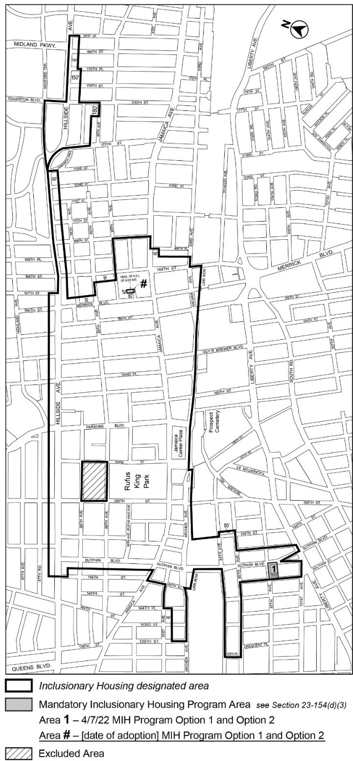

Portion of Community Districts 8 and 12, Queens

* * *
Adopted.

Office of the City Clerk,}
The City of New York,} ss.:

I hereby certify that the foregoing is a true copy of a Resolution passed by The Council of The City of New York on _________, 2024, on file in this office.

.....................................................
City Clerk, Clerk of The Council

