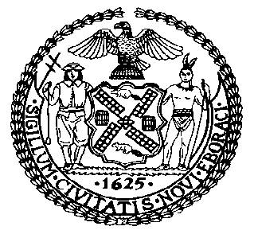 | The Council of the City of New York  Finance Division  Latonia McKinney, Director  Fiscal Impact Statement  Proposed Intro. No: 81-A  Committee: Housing and Buildings
Title: A Local Law to amend the administrative code of the city of New York, in relation to the OSHA notification act | Sponsors: Council Members Lancman, Koo, Rosenthal, Reynoso, Crowley, Levin, Rose, Espinal, Cornegy, Richards, Menchaca, Kallos and Dromm
Summary of Legislation: Proposed Intro. No. 81-A would require the Department of Buildings (“DOB”) to report immediately hazardous or major violations of the New York City Building Code to the federal Occupational Safety and Health Administration as soon as practicable.

Effective Date: This local law would take effect 120 days after it becomes law.
Fiscal Year In Which Full Fiscal Impact Anticipated: Fiscal 2019
Fiscal Impact Statement:

 | Effective FY18 | FY Succeeding Effective FY19 | Full Fiscal Impact FY19
Revenues | $0 | $0 | $0
Expenditures | $0 | $0 | $0
Net | $0 | $0 | $0

Impact on Revenues: It is estimated that there would be no impact on revenues resulting from the enactment of this legislation.
Impact on Expenditures: It is anticipated that there would be no impact on expenditures resulting from the enactment of this legislation because existing resources would be used by DOB to implement the provisions of this local law.
Source of Funds To Cover Estimated Costs: Not applicable.

Source of Information: New York City Council Finance Division

Estimate Prepared by: Sarah Gastelum, Senior Legislative Financial Analyst

Estimated Reviewed by: Chima Obichere, Unit Head
Nathan Toth, Deputy Director
Eric Bernstein, Counsel

Legislative History: This legislation was introduced to the full Council on February 26, 2014 as Intro. No. 81 and was referred to the Committee on Housing and Buildings (Committee). A hearing was held by the Committee on January 31, 2017, and the bill was laid over. The legislation was subsequently amended, and the amended version, Proposed Intro. No. 81-A, will be considered by the Committee on April 24, 2017. Following a successful Committee vote, the bill will be submitted to the full Council for a vote on April 25, 2017.

Date Prepared: April 3, 2017

