THE COUNCIL OF THE CITY OF NEW YORK
RESOLUTION NO. 1513

Resolution approving with modifications the decision of the City Planning Commission on Application No. N 170143 ZRK, for an amendment of the Zoning Resolution of the City of New York, modifying Appendix F for the purpose of establishing a Mandatory Inclusionary Housing area in Community District 16, Borough of Brooklyn (L.U. No. 613).

By Council Members Greenfield and Richards

WHEREAS, the City Planning Commission filed with the Council on April 7, 2017 its decision dated April 5, 2017 (the "Decision"), pursuant to Section 201 of the New York City Charter, regarding an application submitted by Atlantic East Affiliates, LLC, for an amendment of the text of the Zoning Resolution of the City of New York, modifying Appendix F for the purpose of establishing a Mandatory Inclusionary Housing area in the Ocean Hill neighborhood of Brooklyn, which in conjunction with the related action would facilitate the development of a new 10-story mixed-use building containing approximately 67 affordable dwelling units, (Application No. N 170143 ZRK), Community District 16, Borough of Brooklyn (the "Application");

WHEREAS, the Application is related to application C 170142 ZMK (L.U. No. 612), an amendment to the Zoning Map to change R6 and R6/C2-3 zoning districts on portions of two blocks to an R8A/C2-4 district;

WHEREAS, the Decision is subject to review and action by the Council pursuant to Section 197-d(b)(1) of the City Charter;
WHEREAS, upon due notice, the Council held a public hearing on the Decision and Application on May 2, 2017;

WHEREAS, the Council has considered the land use implications and other policy issues relating to the Decision and Application; and

WHEREAS, the Council has considered the relevant environmental issues, including the negative declaration issued on November 28, 2016, (CEQR No. 17DCP068K), which includes (E) designations to avoid the potential for significant adverse impacts related to hazardous materials, air quality, and noise (E-400) (the “Negative Declaration”);

RESOLVED:

The Council finds that the action described herein will have no significant impact on the environment as set forth in the Negative Declaration.

Pursuant to Sections 197-d and 200 of the City Charter and on the basis of the Decision and Application, and based on the environmental determination and consideration described in the report, N 170143 ZRM, incorporated by reference herein, the Council approves the Decision with the following modifications:

Matter underlined is new, to be added;
Matter struck out is to be deleted;
Matter within # # is defined in Section 12-10;
Matter in double strikeout is old, deleted by the City Council;
Matter in double-underline is new, added by the City Council;
* * * indicates where unchanged text appears in the Zoning Resolution

* * *

APPENDIX F
Inclusionary Housing Designated Areas and Mandatory Housing Designated Areas

* * *

Brooklyn

* * *

Brooklyn Community District 16

In the R6A, R6B, R7A, and R7D and R8A Districts within the areas shown on the following Map 1:

Map 1 – [date of adoption]

[EXISTING MAP]

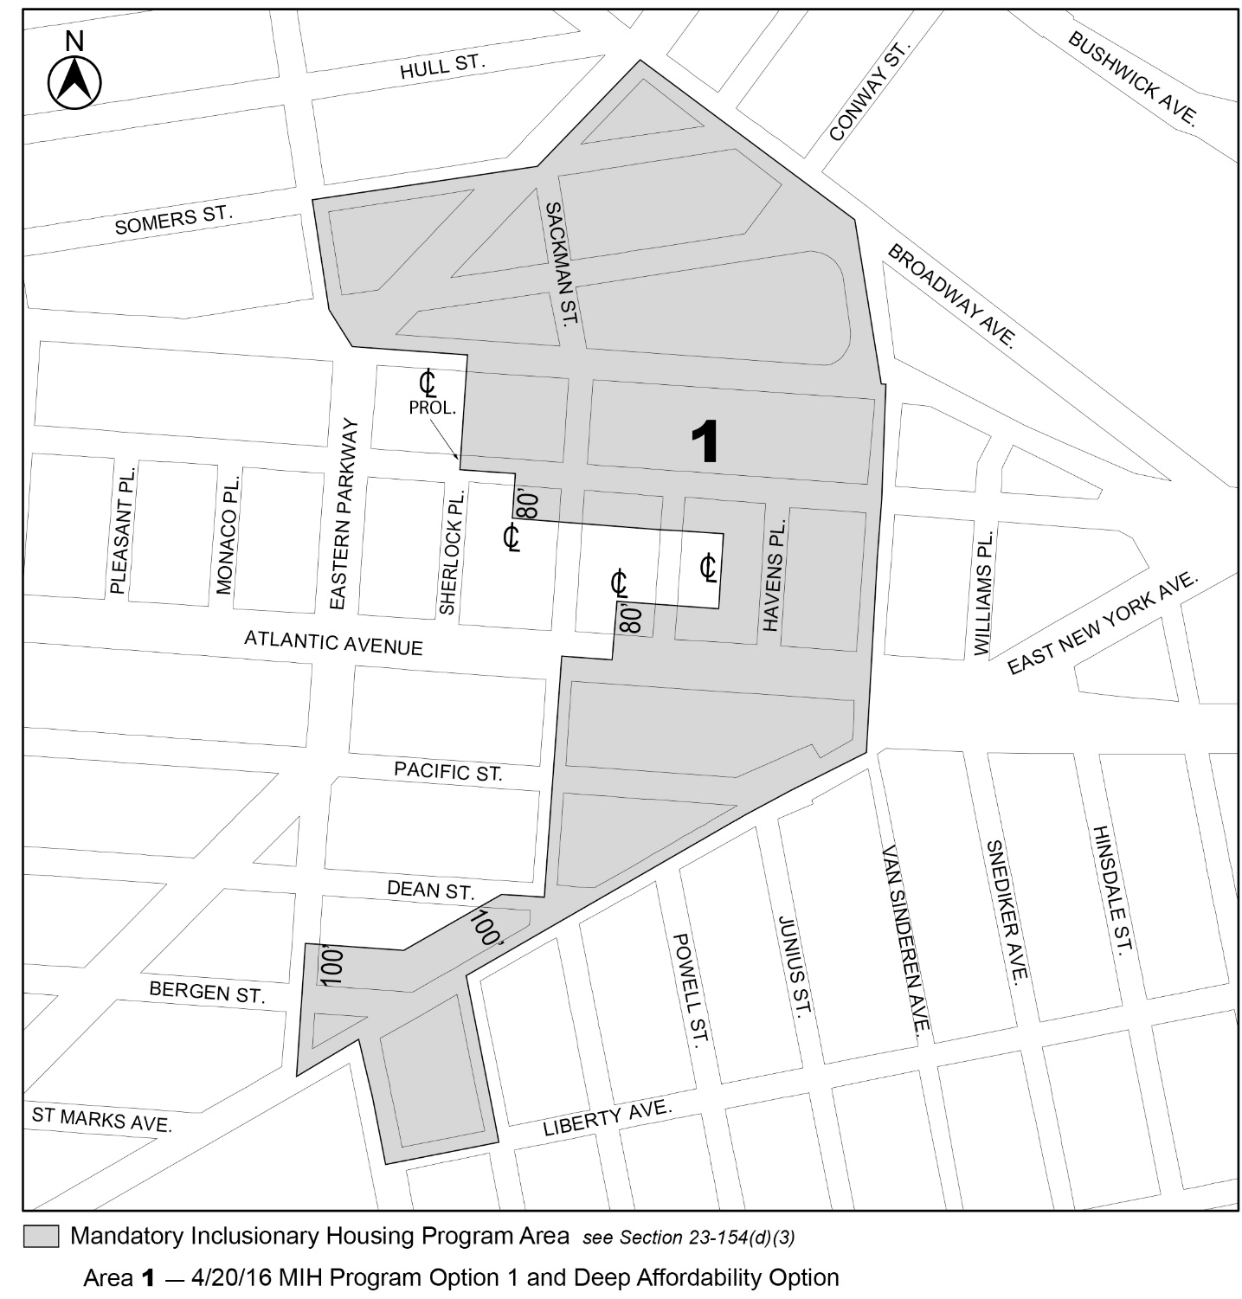

[PROPOSED MAP]

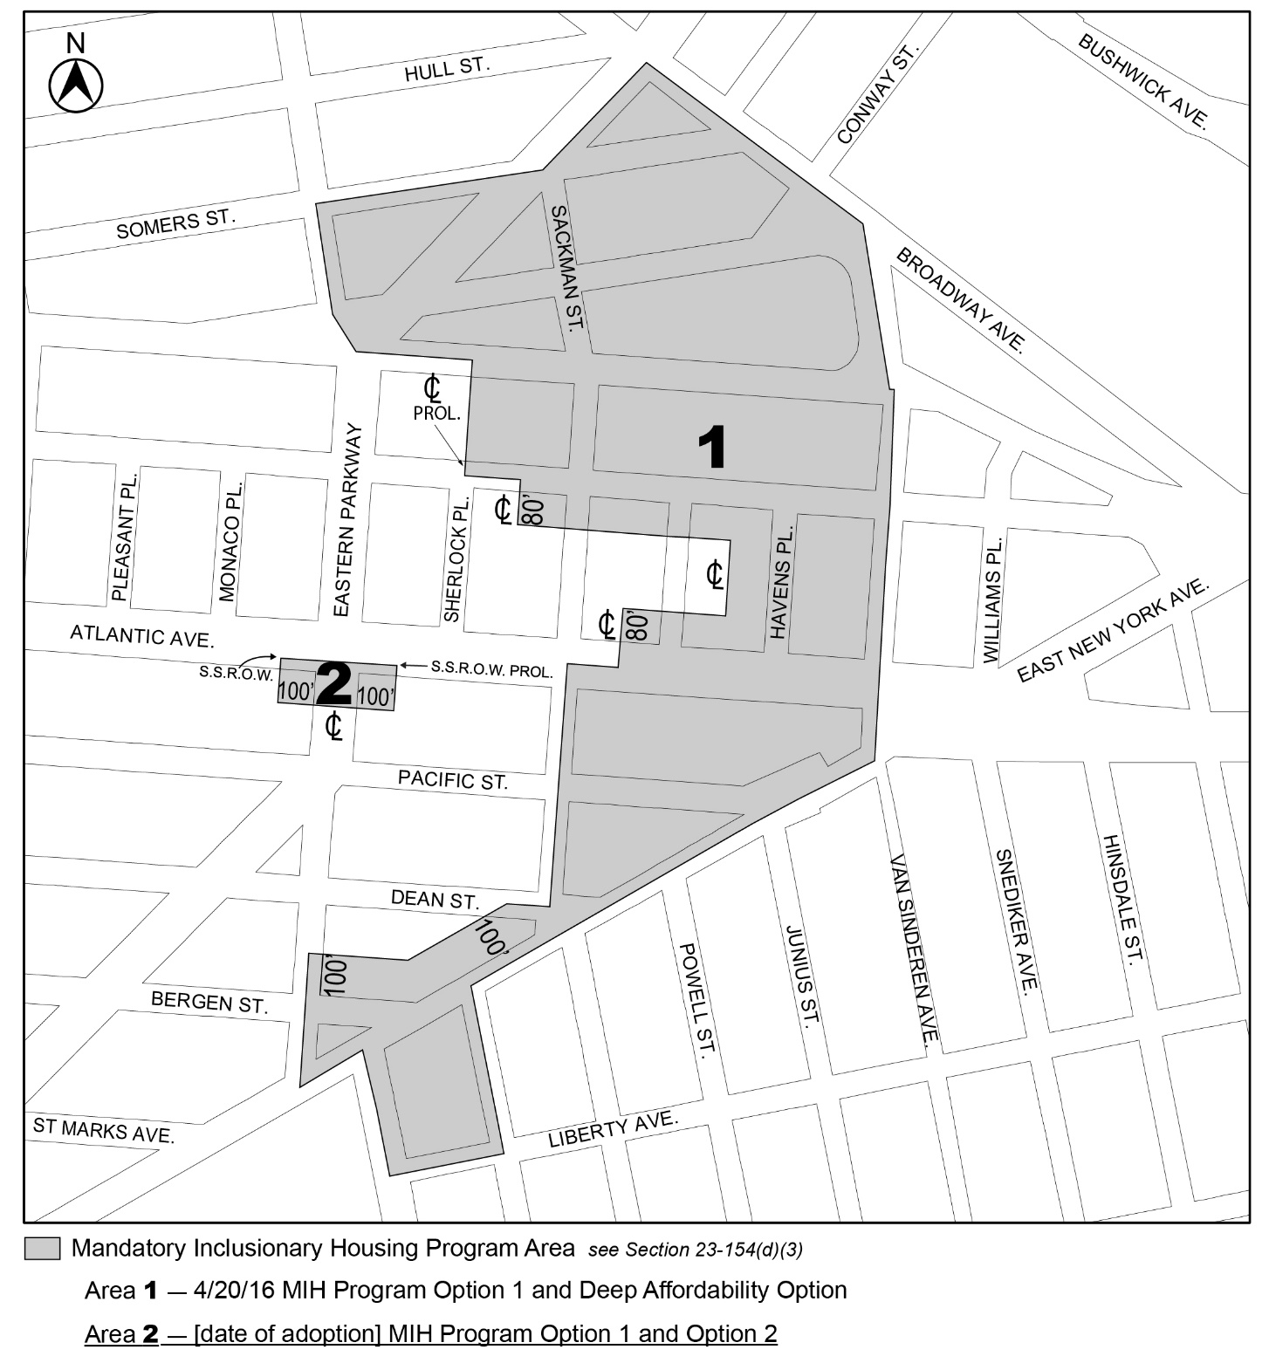

Mandatory Inclusionary Housing Program Area see Section 23-154(d)(3)
Area 1 – 4/20/16 MIH Program Option 1 and Deep Affordability Option
Area 2 – [date of adoption] MIH Program Option 1 and Option 2

Portion of Community District 16, Brooklyn

* * *

Adopted.

Office of the City Clerk, }
The City of New York, } ss.:

I hereby certify that the foregoing is a true copy of a Resolution passed by The Council of The City of New York on May 24, 2017, on file in this office.

.....…….........................................
City Clerk, Clerk of The Council

