Staff: Committee on Sanitation & Solid Waste Management
Morganne Barrett, Legislative Counsel
Ricky Chawla, Senior Legislative Policy Analyst
Andrew Lane-Lawless, Finance Analyst
Brooke Frye, Senior Data Scientist
Reese Hirota, Data Scientist



The New York City Council
Andrea Vazquez, Legislative Director

Committee Report of the Infrastructure Division
Brad Reid, Deputy Director

Committee on Sanitation & Solid Waste Management
Hon. Sandy Nurse, Chair

September 12, 2023
Oversight: DSNY’s Initiatives to Address Street Cleanliness

Int. No. 413: By Council Members Nurse, Farías, Bottcher, Menin, Williams, Velázquez, Richardson Jordan, Ossé, Brewer, Louis, Krishnan, Abreu, Restler, Sanchez and Gennaro (by request of the Queens and Brooklyn Borough Presidents)
Title: A Local Law to amend the administrative code of the city of New York, in relation to establishing a tracking system concerning the disposal of yellow and brown grease
Administrative Code: Amends subdivision c of section 16-515

Int. No. 769: By Council Members Moya, Mealy, Williams, Ung and Gennaro
Title: A Local Law in relation to resources for cleanup and enforcement of dumping

Int. No. 809: By Council Members Ung and Joseph
Title: A Local Law to amend the administrative code of the city of New York, in relation to increasing the civil penalty for repeated littering violations
Administrative Code: Amends section 16-118

Int. No. 861: By Council Members Nurse, Louis, Farías, Hudson, Avilés, Marte, Ossé, Restler, Richardson Jordan and Gennaro (by request of the Queens Borough President)
Title: A Local Law to amend the administrative code of the city of New York, in relation to the emergency and resiliency plans of the department of sanitation
Administrative Code: Adds new section 16-144

Int. No. 981: By Council Members Bottcher, Nurse, Restler, Marte and Menin
Title: A Local Law to amend the administrative code of the city of New York, in relation to expanding the commercial citywide routing system for sidewalk cleanliness violations and technical amendments thereto, including to repeal and reenact subdivision c of section 16-118.1
Administrative Code: Amends section 16-118.1

Int. No. 1032: By Council Members Abreu, Lee, Williams, Nurse, Brooks-Powers, Restler, Richardson Jordan, Brewer, Ung, Bottcher, Riley and Gennaro
Title: A Local Law to amend the administrative code of the city of New York, in relation to removal of abandoned or derelict vehicles
Administrative Code: Amends section 16-128

- Introduction

On September 12, 2023, the Committee on Sanitation and Solid Waste Management (the Committee), chaired by Council Member Sandy Nurse, will hold an oversight hearing on the Department of Sanitation’s (DSNY) Initiatives to Address Street Cleanliness. The Committee will also hear Int. No. 413, which would require the Business Integrity Commission (BIC) to establish a tracking system for the disposal of yellow and brown grease; Int. No. 769, which would require DSNY to report on on the resources required for dumping enforcement; Int. No. 809, which would increase civil penalties for repeated littering violations; Int. No. 861, which would require DSNY to publicize its resiliency and emergency planning; Int. No. 981, expanding the commercial citywide routing system for sidewalk cleanliness; and Int. No. 1032, which would require DSNY to remove abandoned vehicles within 72 hours of becoming aware of their existence. The Committee expects to receive testimony from representatives of BIC, DSNY, sanitation advocates, and interested members of the public.
- Background
Street Cleanliness
On March 12, 2020, then Mayor Bill de Blasio declared a state of emergency in response to the COVID-19 pandemic. In 2020, some City resources were diverted to aid pandemic relief efforts, and Fiscal Year 2021 (FY2021) budget gaps and priorities shifted substantially. Budget cuts in the early days of the pandemic led to a reduction in sanitation services such as trash pick-ups, and changes to alternate side parking (ASP) regulations. Such cuts overlapped with an increase in outdoor dining, and other shifting patterns of human behavior, resulting in spikes in complaints relating to street cleanliness and rat sightings. ASP reductions led to cars remaining parked on streets for longer periods of time, reducing street sweepers’ ability to thoroughly clean the streets. This may have been a contributing factor to the increase in litter being reported throughout the City, which saw significant increases in 311 complaints for dirty street conditions and missed garbage collections between 2020 and 2022 (see Figure 1).
Figure 1:
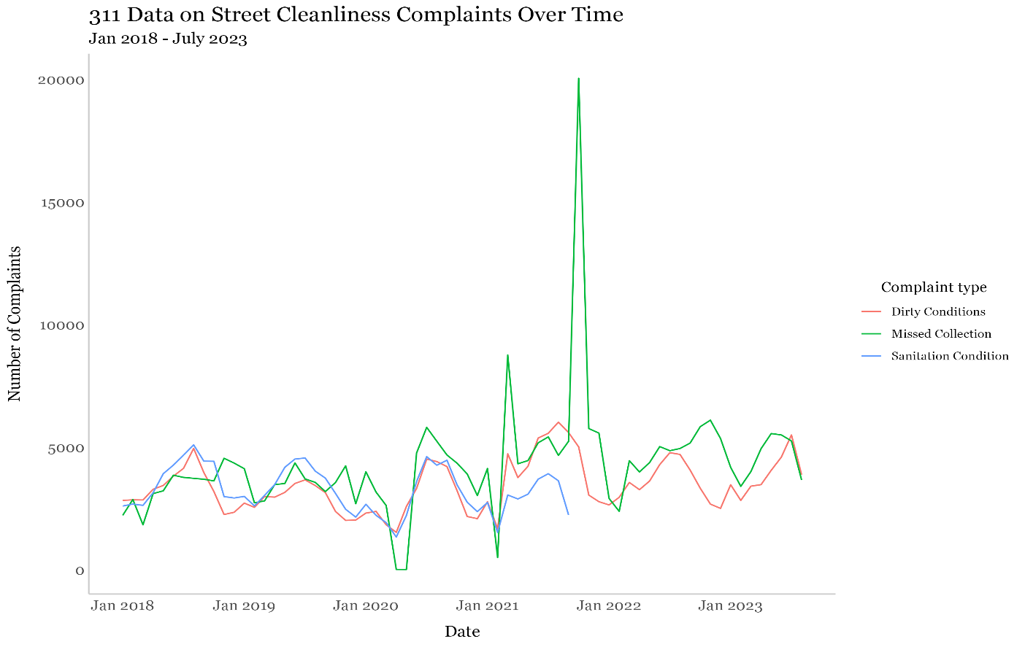
Line graph showing an increase in dirty conditions complaints fluctuating between approximately 2,000 and 5,000 complaints between 2018 and 2020, to nearly 5,000 complaints in the second half of 2023 (red line), and missed collection complaints increasing from approximately 3,000 at the beginning of 2020 to approximately 6,000 at the beginning of 2023 (green line), and a decline in sanitation condition complaints (blue line) over the same period. *Data sourced from NYC open data portal as of 8/31/23.

According to the 2023 Mayor’s Management Report, the percentage of streets rated acceptably clean declined from 96.4% in FY2020 to 89.5% in FY2022. Sidewalks rated acceptably clean remained relatively constant, with 96.8% in FY2020, and 95.1% in FY2022. Across that same timeframe, the percentage of streets rated filthy increased from 0.1% in FY2020 to 1.5% in FY2022, and sidewalks rated filthy increased from 0.1% in FY2020 to 0.78% in FY2022.
The sanitary condition of New York City’s streets has effects beyond general quality of life perception. During flash flood conditions like those experienced on September 1, 2021 when Hurricane Ida hit the City, significant amounts of litter floated with stormwater and swiftly clogged catch basins, exacerbating flooding issues in some neighborhoods, and correlating with a large spike in catch basin complaints called into 311 (see Figure 2).

Figure 2:
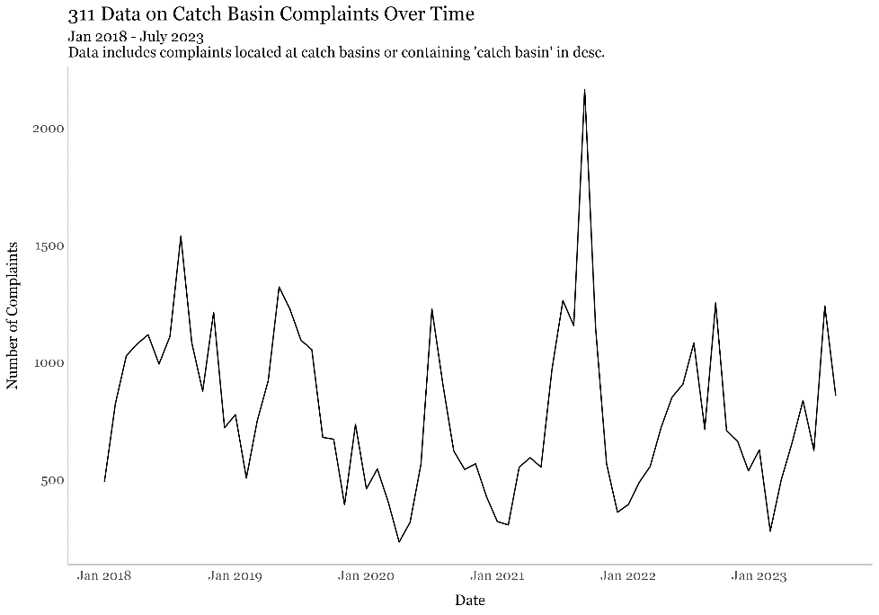
Line graph showing catch basin complaints filed with 311, between January of 2018 and July of 2023, showing that complaints tend to spike during the summer/fall months with the number of complaints between 1,000 and 1,500, other than a spike in fall 2022 where complaints peaked at over 2000, and decline in the winter months, with average complaint volume generally below 500.

In April 2021, then Mayor Bill de Blasio announced as part of his Recovery for All Plan the creation of the City Cleanup Corps (CCC), a jobs program aimed to “make New York City the cleanest, greenest city in the United States.” The goal of the program was to hire up to 10,000 workers across 10 City agencies to clean and beautify public spaces, neighborhoods, parks, and green spaces. This work included graffiti removal, pressure washing sidewalks, designing public murals, and tending to and maintaining community gardens and Open Streets. The CCC was funded with federal stimulus money, and hiring for the initiative began in April 2021. According to a social media post made by the CCC official Instagram account on December 29, 2021, the CCC collected 1,000,000 bags of garbage around the City, and hand swept 70,000 City blocks in 2021. Funding for the CCC program expired in June of 2022, and 80 workers employed through the initiative were transferred to permanent positions with the City.
On June 30th, 2023, Mayor Eric Adams announced the Clean City Alliance, a philanthropic initiative involving DSNY and DSNY”s official nonprofit, the Sanitation Foundation, aimed at cleaning high-traffic commercial corridors across the City, with an emphasis on commercial corridors in neighborhoods not served by a Business Improvement District (BID) to organize street cleaning efforts. The initiative targets streets in the Brooklyn neighborhoods of Crown Heights and Bedford-Stuyvesant, specifically Nostrand Avenue, from Myrtle Avenue to Eastern Parkway, and Utica Avenue, from Fulton Street to East New York Avenue, but is expected to expand to other corridors citywide that are not served by BIDs.

Containerization Pilot Programs
According to DSNY, “dodging between mountains of 44 million daily pounds of trash is a standard part of a New Yorker’s commute.” Containerization in NYC is the storage of waste in sealed, rodent-proof receptacles rather than in plastic bags placed directly on the curb. Containerization could utilize individual bins, which are optimal in low-density neighborhoods, and provide one set of bins for each customer. Alternatively, shared containers are more appropriate in higher-density neighborhoods and are placed near several residential addresses for the community’s use. Shared containers can be wheeled or stationary and are commonly standardized in size, shape, and color.
DSNY’s recent campaigns to move towards containerization are aimed at cleaning up the City streets, reducing the City’s rampant rat population, and addressing other quality of life cleanliness concerns. “Reducing the rat population via containerization would also” help DSNY staff who are members of Teamsters Local 831 avoid “the potential for rats to cause injury and disturbances.”
To address these concerns, DSNY has recently piloted several variations of its Clean Curbs program for DSNY-serviced residential locations, privately-serviced commercial locations, and NYCHA-managed public housing locations. Some of these programs allow participants to elect to participate, in which case participants must purchase, install, and maintain sealed, rodent-proof containers in exchange for storing waste on City property while it awaits collection. DSNY and the NYC Department of Transportation (DOT) review and approve participants’ proposed container locations, and adjacent property owners and Community Board(s) are notified before container installation.
DSNY has also installed stationary steel containers on City streets in the parking lane, to service BIDs and residents, depending on location. Additionally, beginning in the fall of 2023, DSNY plans to run another containerization pilot on 10 residential blocks and at 14 public schools in Manhattan's Community Board 9, which includes the neighborhoods of Morningside Heights, Manhattanville, and Hamilton Heights. Six times a week, refuse and recycling collection in these neighborhoods will be carried out by trucks that are retrofitted to “lift shared wheeled containers” kept in the roadway along the curb. In FY2023, $2.5 million was allocated for the purchase of bins, enclosures, and retrofitting collection trucks for the upper Manhattan waste containerization pilot. DSNY’s budgetary increases for FY2024 include $3.2 million for the containerization pilot program, funding increased collection frequency, and 12 related year-long positions.
DSNY has identified several challenges with expanding containerization citywide. One major challenge is the cost of labor, a leading expense for the agency. Additionally, DSNY workers must unlock the bins and load bags into the truck, which can take several minutes per stop. Some bins are also too small to accommodate waste volume in most mid-to-high density streets, which may require more frequent service as they fill up. Container maintenance costs could also be significant. Moreover, additional community education and buy-in is likely needed because, despite community outreach prior to shared container pilot programs, considerable trash piled up around the shared containers even when they were not full. Another complicating factor is that DSNY’s existing fleet of rear-loader trucks (with retrofits) are compatible only with shared containers that have wheels; however, stationary containers occupy less space and are safer than wheeled ones. NYCHA is also piloting a hoist truck at off-street locations. However, DSNY has “largely ruled out hoist collection as a scalable solution due to concerns about overhead clearance.” Finally, certain areas in the City present space issues, as an estimated “11 percent of the city’s densest residential areas, like neighborhoods in Lower Manhattan and Midtown, would not be able to accommodate any sort of container due to a lack of sufficient street space for the amount of trash that is produced.”
These challenges aside, DSNY has acknowledged that “containerization is viable for 89% of residential street segments.” Additionally, individual bins that would not eliminate any curb space could be used at roughly 50 percent of residences across the city, and 39 percent of streets could use a shared container system.
Commercial waste containerization rules
DSNY administrative rulemaking now prohibits New Yorkers from placing bags directly on the curb before 8:00 p.m., except that businesses that close before 8:00 p.m. may set out their waste in individual bins an hour before closing, incentivizing businesses to use containers.
Food-related businesses were the specific subject of a new set of administrative rules, which took effect on August 1, 2023. Under the new rules, food-related businesses such as restaurants, delis, grocery stores, caterers, and bodegas—of which there are approximately 40,000 in the City—must put their refuse and organic waste in a secure 30 to 96 gallon lidded container, to be emptied by the businesses’ private waste carters. Containers must be stored indoors if space is available, or outdoors within three feet of the building line. The rules do not apply to other recyclables such as metal, glass, plastic, or paper, or to businesses that have waste collected from a loading dock. Another rule, which went into effect on September 5, 2023, extends containerization requirements to all businesses with five or more locations (“chain businesses”), regardless of what they sell. A chain business is defined as “a commercial establishment that operates five or more stores located within the city of New York that are engaged in the same general field of business and conduct business under the same business name or operate under common ownership or management or pursuant to a franchise agreement with the same franchisor.”
According to DSNY, these new commercial containerization rules will move approximately four million pounds of trash per day from City curbs to secure containers, which “will meaningfully limit potential food sources for vermin while also helping to keep our sidewalks free of unattractive piles of black bags.”
Illegal Dumping
Unlawful dumping of household and business waste is an ongoing challenge to maintaining clean and sanitary sidewalks and streets. It is illegal for any person to deposit household or commercial refuse or liquid wastes in or upon any sidewalk, street, lot, park, public place, or in a public litter basket. Local Law 135 of 2018 increased the civil and criminal penalties for unlawful dumping, prohibited improper disposal of household and commercial waste on sidewalks and streets, and allowed DSNY to use identifying information to locate the violator. Despite these changes, illegal dumping and corner litter baskets overflowing with household and commercial waste continue to exacerbate the City’s litter challenges.
According to reporting by CBS News, DSNY received over 4,000 reports of chronic dumping in 2022, and over 1,000 reports of chronic dumping between January and April 2023. According to data obtained from the New York City Open Data Portal, there were 24,418 removal requests filed with 311 in 2022. Between January and July of 2023, 311 received 4,284 chronic dumping complaints, and 18,341 removal requests citywide (see Figure 3). The five community boards with the most chronic dumping complaints to 311 between January 2018 and July of 2023 were Queens Community Board 12 with 567 complaints, Brooklyn Community Board 5 with 406 complaints, Brooklyn Community Board 3 with 329 complaints, Brooklyn Community Board 17 with 299 complaints, and Brooklyn Community Board 1 with 284 complaints. The five community boards with the most removal requests filed over the same period were Queens Community Board 12 with 2,777 requests, Brooklyn Community Board 5 with 1,865 requests, Brooklyn Community Board 3 with 1,730 requests, Bronx Community Board 12 with 1,459 requests, and Staten Island Community Board 3 with 1,377 requests.

Figure 3
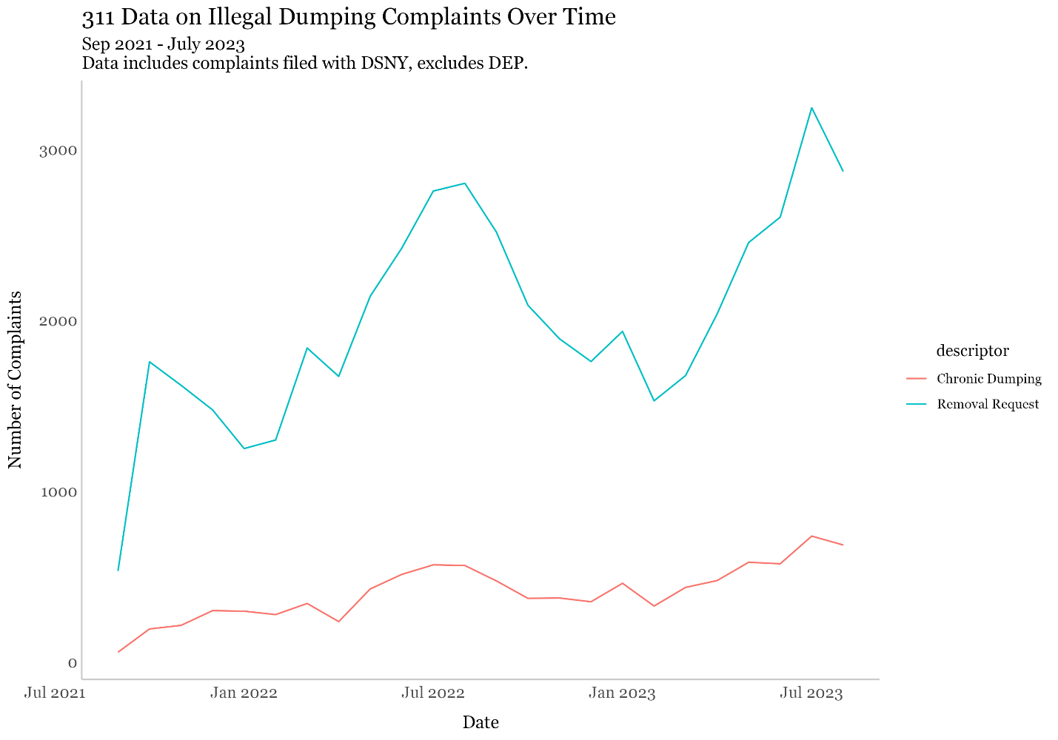
Line graph showing trends in chronic dumping complaints in red and removal requests in blue, between September 2021 and July 2023. Chronic dumping trends show a relatively steady increase over the time period, with minor fluctuations, from 58 complaints in September 2021, to 737 complaints in July of 2023. Removal request trends show distinct seasonal peaks in the summer and early fall, with an overall increase in the number of complaints across the time period in question, from 1,756 requests in October 2021, to 3,242 removal requests in July 2023.

Derelict and Abandoned Vehicles

According to the New York State Vehicle & Traffic Law, motor vehicles are deemed to be abandoned if they are left unattended (i) without license plates for more than six hours on any highway or public place; (ii) for more than 24 hours on any highway or public place, except those on which parking is legally permitted; (iii) for more than 48 hours beyond when the parking of the vehicle would be considered illegal if left on a portion of a highway or public place where parking is legally permitted; or (iv) for more than 96 hours on private property without the permission of the property owner. If a vehicle with license plates accrues more than three tickets, NYPD may tow and impound the car, after which the vehicle’s owner has 90 days to come forward before the property can be put up for auction. Cars that meet the criteria for a derelict vehicle, meaning that the vehicle lacks license plates, has a missing or damaged hood, grill, front bumper or front fender, or is otherwise seriously burned, damaged, or visibly deteriorated or damaged, are removed by DSNY’s Derelict Vehicles Operation Unit.
Between January 2018 and July 2023, 311 complaints for derelict vehicles continued on an upward trend, with dips loosely correlated with the colder months, and peaks largely correlated with the summer and fall seasons. In January 2018, there were 2,479 complaints, compared with 3,087 complaints in January 2019, 3,194 in January 2020, 3,239 in January 2021, 3,140 in January 2022, and 4,135 in January of 2022. In 2018, the month with the most complaints was July, with 3,481 complaints, while the highest monthly total in 2022 was August, with 4,705 complaints. As of August 31, 2023, only February had monthly totals below 4,000 311 complaints, as complaints made later in August may not be fully accounted for in the data(see Figure 4). Between January 2018 and August 2023, the five community boards with the highest volume of 311 complaints relating to derelict vehicles were Queens Community Board 12 with 15,924 complaints, Brooklyn Community Board 18 with 13,876 complaints, Brooklyn Community Board 5 with 13,033 complaints, Brooklyn Community Board 17 with 11,149 complaints, and Bronx Community Board 12 with 10,047 complaints.
Figure 4:
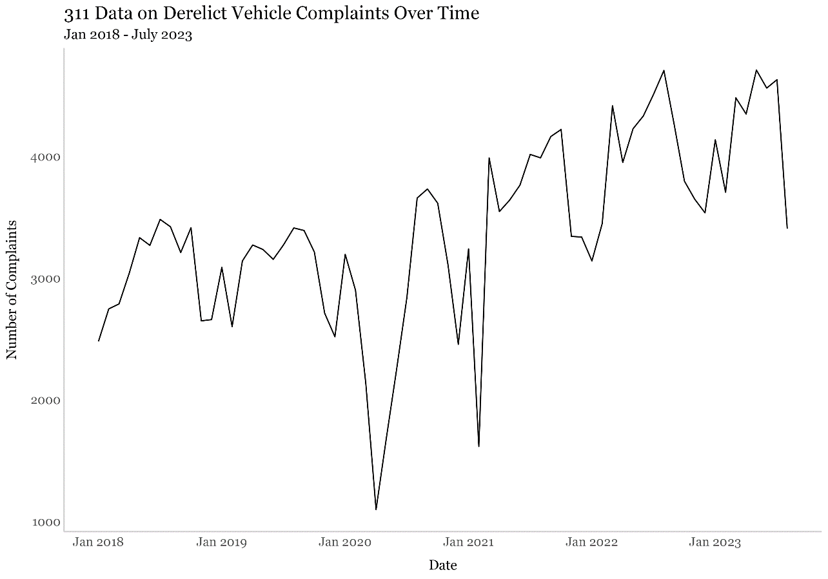
Line graph showing 311 complaints for derelict vehicles from January 2018 to July 2023 continuing on an upward trend, with dips loosely correlated with the colder months, and peaks largely correlated with the summer and fall seasons. In 2018, the month with the most complaints was July, with 3,481 complaints, while the highest monthly total in 2022 was August, with 4,705 complaints. To date in 2023, only February and August have monthly totals below 4,000 311 complaints.

Yellow and Brown Grease

Yellow grease, or waste vegetable oil, generally consists of used cooking oil, while the term brown grease denotes grease that has been recovered from the grease traps of restaurants and food processing facilities. When improperly disposed of down drains, grease can congeal around debris like nonwoven sanitary wipes and discarded plastic, accumulating in sewage grates and wastewater conveyance pipes to form clogging masses known as fatbergs. In 2018, nearly 90% of sewage backups citywide were attributed to grease and wipes. Beneficial reuses for yellow and brown grease can include processing into biodiesel, which can be combusted in engines and used to power machinery. Between 2018 and 2023, Queens County received the most 311 complaints for grease in sewers and catch basins with 313 complaints, followed by Brooklyn, with 284 complaints, Manhattan with 185 complaints, the Bronx with 111 complaints, and Staten Island with 31 complaints.

- Conclusion
At this hearing, the Committee expects to hear updates from DSNY on their efforts to keep New York City sidewalks and streets clean. The Committee is interested in understanding how DSNY is responding to changes in neighborhood use following the COVID-19 pandemic, and their effects on sanitation issues citywide. The Committee would also like to hear from BIC on its insights into the current state of yellow and brown grease, and its work in collaborating with DEP and other agencies to keep such grease out of storm drains and other city infrastructure.

- Legislation
Int. No. 413 would require BIC to establish a system for documenting and tracking the transportation and disposal of yellow and brown grease utilizing a standardized manifesting sheet. Transporters of yellow and brown grease would be required to retain records including the name and address of each location from which grease was obtained, the quantity of grease obtained from each location, dates upon which grease was obtained, and the name and address of the facility at which the grease was disposed, for a period of no less than two years. Commercial establishments with grease interceptors on premises would be required to submit annual reports to BIC with the name of the entity that collects grease from the interceptor, and retain records of this information for no less than two years. The law would establish penalties for violations of these requirements, with a $500 penalty for a first violation, and $1,000 for second and subsequent violations. This local law would take effect 180 days after it becomes law.

Int. No. 769 would require DSNY to report on the resources needed for a dumping enforcement program, including information on current resources for litter pick-up and dumping prevention; number of employees the department has dedicated to the dumping enforcement program; whether additional personnel are required; and the proportion of time each person dedicates to the dumping enforcement program. DSNY would also be required to report on what additional equipment the enforcement program requires; what resources the department would need to install and maintain surveillance equipment at department designated dumping hot spots; locations where cameras are currently installed; and what coordination with other agencies would be necessary to install surveillance cameras on utility poles and infrastructure that is not under DSNY jurisdiction. The report would additionally be required to outline how much funding the department’s budget allocated for a dumping enforcement program, the amount of funding spent in the previous year to address dumping, the total amount of discretionary funding provided by city council members, disaggregated by council district, analysis of total funding each council district would need to address illegal dumping, whether discretionary funding is sufficient to address the issue, or whether additional resources would be needed. This report must be submitted to the mayor and the speaker of the council, and be posted on the department’s website. This local law would take effect immediately, and be repealed upon final submission of the report.

Int. No. 809 would establish new increased penalties for repeated littering violations, setting a civil penalty of 1,000 dollars for the 21st violation and subsequent violations of sidewalk littering and obstruction regulations. This local law would take effect 60 days after it becomes law.

Int. No. 861 would require that DSNY maintain a webpage outlining all of the agency’s emergency and resiliency planning, including provision of services during emergencies including blackouts, hurricanes, storm surges, flash flooding, and other severe weather events and natural disasters; provision and prioritization of services prior to anticipated flooding events in flood-prone areas; and plans relating to the designing of new critical facilities for climate resiliency and retrofitting existing facilities to increase resiliency. DSNY would be required to provide the emergency and resiliency plans on a public website within 120 days of the law’s effective date, and would not be required to disclose any portions of any emergency and resiliency plan information that may compromise public safety. This local law would take effect immediately.

Int. No. 981 would alter DSNY's routing system used for issuing violation notices against owners, lessees, tenants, occupants, or persons in charge of residential premises for acts such as littering, sweeping, or otherwise directing ashes, garbage, paper, dust, or other refuse into a public place, vacant lot, air shaft, backyard, park, or alley; or for spitting on a sidewalk, public place, or on a private or public building or other property commonly used by the public. This bill would also limit the hours during which violation notices can be issued against residential premises located in a local service delivery district, as described in NYC Charter Chapter 69, from 8:00 a.m. to 9:00 a.m. and from 6:00 p.m. to 7:00 p.m. The bill would also expand DSNY's routing system to include enforcement for such violations against commercial premises and specifies that violation notices against such premises must be limited to the business's publicly-displayed hours of operation, or from 8:00 a.m. to 7:00 p.m. for businesses that do not have publicly displayed hours of operation. This local law would take effect immediately.

Int. No. 1032 would require DSNY to remove any abandoned vehicle within 72 hours of being notified of its existence. The bill would also require the commissioner of DSNY to establish regulations relating to notifying owners of property removed, redemption by the owner of such property, reimbursement by the owner for the cost of the removal of the abandoned vehicle, and regulations concerning the keeping of related records, transmission of records to the comptroller and the commissioner of finance, and such regulations as the commissioner deems necessary to carry out the provisions of the section. This local law would take effect 120 days after it becomes law.

This Page Intentionally Left Blank

Int. No. 413

By Council Members Nurse, Farías, Bottcher, Menin, Williams, Velázquez, Richardson Jordan, Ossé, Brewer, Louis, Krishnan, Abreu, Restler, Sanchez, and Gennaro (by request of the Queens and Brooklyn Borough Presidents)

A Local Law to amend the administrative code of the city of New York, in relation to establishing a tracking system concerning the disposal of yellow and brown grease

Be it enacted by the Council as follows:
Section 1. Subdivision c of section 16-515 of the administrative code of the city of New York, as amended by local law 80 for the year 2020, is amended to read as follows:
c. (i) Any person who violates subdivision b of section 16-505 of this chapter or any rule pertaining thereto shall, upon conviction thereof, be punished by a civil penalty not to exceed [one thousand] 1,000 dollars for each such violation to be recovered in a civil action or returnable to the office of administrative trials and hearings or otherwise consistent with orders of the mayor issued in accordance with section 1048 of the charter[.];
(ii) Any person that violates section 16-529 shall be liable for a civil penalty in the amount of 500 dollars for the first violation and 1,000 dollars for a second or subsequent violation to be recovered in a civil action or returnable the office of administrative trials and hearings or otherwise consistent with orders of the mayor issued in accordance with section 1048 of the charter.
§ 2. Chapter 1 of title 16-a of the administrative code of the city of New York is amended by adding a new section 16-529 to read as follows:
§16-529 Grease tracking system. a. The commission shall establish a program for documenting and tracking the collection, transportation and disposal of yellow and brown grease utilizing an industry standard manifesting sheet.
b. In addition to any other records required by this title, every transporter of yellow or brown grease shall report to the commission quarterly and maintain for not less than two years the following:
1. The name and address of each location from which the transporter obtained the yellow or brown grease;
2. The quantity of yellow or brown grease received from each location;
3. The dates on which the yellow or brown grease was obtained from each location; and
4. The name and address of the facility where the yellow or brown grease was ultimately disposed.
c. In addition to any records required by this title, a commercial establishment that has on its premises a grease interceptor shall report to the commission annually and maintain for not less than two years the name and address of the company or other entity that collects material from the grease interceptor and the dates during the immediately preceding 12 months on which the yellow or brown grease was retrieved from the commercial establishment.
§ 3. This local law takes effect 180 days after it becomes law, except that the commissioner shall take such steps as are necessary for its implementation, including the promulgation of rules, prior to such effective date.

Session 12
JSA
LS # 37, 8409
5/10/2022

Session 11
JCH/NKA
LS #198
Int. #282-20
Int. No. 769

By Council Members Moya, Mealy, Williams, Ung, and Gennaro

A Local Law in relation to resources for cleanup and enforcement of dumping

Be it enacted by the Council as follows:

Section 1. Dumping enforcement program study. a. Definitions. For purposes of this local law the following terms have the following meanings:
Department. The term “department” means the department of sanitation.
Dumping. The term “dumping” has the same meaning as in section 16-119 of the administrative code of the city of New York.
Litter. The term “litter” has the same meaning as in section 16-118 of the administrative code of the city of New York.
b. No later than April 1, 2023, the department shall post on its website and submit to the mayor and speaker of the council a report that details the resources the department needs for a dumping enforcement program and the resources the department uses to pick-up litter and prevent dumping. The report shall include, at minimum:
1. The number of employees the department has dedicated for a dumping enforcement program and the number of employees the department needs dedicated for a dumping enforcement program, if such numbers are different, and the proportion of such persons’ time dedicated to such program;
2. The type of equipment the department has and additional equipment the department would need for a dumping enforcement program;
3. What resources the department needs to install and maintain surveillance cameras in locations where dumping is most prevalent, as determined by the department;
4. Locations where surveillance cameras are currently installed; and
5. A description of the coordination with the department of transportation or other agencies or offices that would be necessary to install surveillance cameras on utility poles or locations not within the department’s jurisdiction.
c. The report required pursuant to subdivision b of this section shall also include a description of how much funding the department’s budget allocated for a dumping enforcement program and the amount of funding actually spent to address dumping during the previous fiscal year. Such report shall include the total amount of discretionary funding provided by members of the city council, disaggregated by council district, and analyze the total amount of funding each council district would need to address dumping. Such report shall detail whether the total amount of funding by the department and the total amount of discretionary funding by members of the city council is sufficient to address dumping, and if such funding is not sufficient, what additional resources would be necessary to address such dumping.
§ 2. This local law takes effect immediately, and expires and is deemed repealed upon final submission of the report as required by section one of this local law.

JSA
LS #8145, 8150
7/11/2022

Int. No. 809

By Council Members Ung and Joseph

A Local Law to amend the administrative code of the city of New York, in relation to increasing the civil penalty for repeated littering violations

Be it enacted by the Council as follows:

Section 1. Paragraph a of subdivision 9 of section 16-118 of the administrative code of the city of New York, as amended by local law number 80 for the year 2021, is amended to read as follows:
a. (1) not less than 50 and not more than 250 dollars for a first violation, except that the civil penalty shall be not less than 250 and not more than 350 dollars for a second violation of subdivision 4 or 6 of this section within any 12 month period, and not less than 350 and not more than 450 dollars for a third or subsequent violation of subdivision 4 or 6 of this section within any 12 month period;
(2) notwithstanding subparagraph (1) of paragraph a of this subdivision, 50 dollars for a first violation [of paragraph (a) of subdivision 2 or] of subdivision 3 of this section, or of any rules promulgated pursuant thereto, 100 dollars for a second violation of such [paragraph or] subdivision or of any rules promulgated pursuant thereto within any 12 month period, and 100 dollars for a third or subsequent violation of such [paragraph or] subdivision or of any rules promulgated pursuant thereto within any 12 month period;
(3) notwithstanding subparagraph (1) of paragraph a of this subdivision, 50 dollars for a first violation of paragraph (a) of subdivision 2 of this section, or of any rules promulgated pursuant thereto, 100 dollars for a subsequent violation, up to twenty violations, of such subdivision or of any rules promulgated pursuant thereto within any 12 month period, and 1,000 dollars for a twenty-first or subsequent violation within any 12 month period;
§ 2. This local law takes effect 60 days after it becomes law.

JGP
LS #10400
9/26/2022 9:30a

Int. No. 861

By Council Members Nurse, Louis, Farías, Hudson, Avilés, Marte, Ossé, Restler, Richardson Jordan and Gennaro (by request of the Queens Borough President)

A Local Law to amend the administrative code of the city of New York, in relation to the emergency and resiliency plans of the department of sanitation

Be it enacted by the Council as follows:

Section 1. Chapter 1 of title 16 of the administrative code of the city of New York is amended by adding a new section 16-144 to read as follows:
§ 16-144 Emergency and resiliency plans. a. The department shall maintain a separate page on the city’s website where all emergency and resiliency plans of the department are made available to the public. Such plans shall include, without limitation:
1. Provision of services during various types of emergencies including blackouts, hurricanes, storm surges, flash flooding and other severe weather events and natural disasters;
2. Provision and prioritization of services prior to anticipated flooding events, including waste collection and cleaning services such as street sweeping, in areas that are identified as prone to flooding in the rainfall-based flooding maps prepared by the department of environmental protection; and
3. Design of critical facilities in accordance with climate resiliency design guidelines and retrofitting existing facilities to increase resiliency.
b. The department shall make all of its emergency and resiliency plans available on a separate page of the city’s website within 120 days following the effective date of the local law that added this section and shall make new or updated plans available on such page when they are finalized by the department.
c. Notwithstanding the requirements of this section, the department shall not be required to disclose any portions of any emergency and resiliency plan if disclosure of such information could compromise public safety.
§ 2. This local law takes effect immediately.

NAB
LS #8745
11/15/22 12:35PM

Int. No. 981

By Council Members Bottcher, Nurse, Restler, Marte and Menin

A Local Law to amend the administrative code of the city of New York, in relation to expanding the commercial citywide routing system for sidewalk cleanliness violations and technical amendments thereto, including to repeal and reenact subdivision c of section 16-118.1

Be it enacted by the Council as follows:

Section 1. Section 16-118.1 of the administrative code of the city of New York, subdivision a of such section as amended by local law number 47 for the year 2007 and subdivision b of such section as amended by local law number 9 for the year 2004, is amended to read as follows:
§ 16-118.1 Citywide routing system. a. 1. The department shall implement a citywide routing system for residential premises for the enforcement of subdivision two of section 16-118 of this code, as such subdivision relates to the cleaning of sidewalks, flagging, curbstones, airshafts, backyards, courts, alleys and roadway areas by owners, lessees, tenants, occupants or persons in charge of any such premises[, and for commercial premises for the enforcement of such subdivision as such subdivision relates to cleaning of sidewalks, flagging, curbstones and roadway areas by owners, lessees, tenants, occupants or persons in charge of such premises]. The citywide enforcement routing system shall limit the issuance of notices of violation, appearance tickets or summonses for residential premises within any sub-district of a local service delivery district to predetermined periods of a total of no more than two hours each day, provided that each such predetermined period shall be one hour. [The department shall establish a citywide schedule of periods for issuing notices of violation, appearance tickets or summonses for commercial premises in each district and shall give written notice to the owners, lessees, tenants, occupants or persons in charge of such premises in each district of the periods for the district in which their premises are located by the use of flyers, community meetings or such other techniques as the commissioner reasonably determines to be useful.] The two one-hour predetermined periods for issuing notices of violation, appearance tickets or summonses for residential premises shall be from 8:00 a.m. until 9:00 a.m. and from 6:00 p.m. until 7:00 p.m.
2. The department shall implement a citywide routing system for commercial premises for the enforcement of subdivision two of section 16-118 of this code, as such subdivision relates to the cleaning of sidewalks, flagging, curbstones, and roadway areas by owners, lessees, tenants, occupants, or persons in charge of such premises. The department may issue notices of violation, appearance tickets, or summonses for commercial premises at any time during the hours of operation of such premises, where such premises have hours of operation posted in plain view and are generally open to the public during such hours. The department may issue notices of violation, appearance tickets, or summonses to any other commercial premises from 8:00 a.m. until 7:00 p.m.
b. Notwithstanding the provisions of paragraph one of subdivision a of this section, the commissioner may provide an additional predetermined period of one hour per day during which notices of violation, appearance tickets or summonses may be issued in any sub-district within a local service delivery district upon the commissioner's determination that the total of two hours otherwise permitted by this section is not sufficient to maintain the sidewalks, flagging, curbstones and roadways in such sub-districts in an adequately clean condition. Such determination shall be based upon a finding that there has been a decline in the average street cleanliness ratings compiled by the mayor's office of operations for such district for the most recent three-month period as compared to the average street cleanliness ratings compiled by the mayor's office of operations for the same three-month period in fiscal year nineteen hundred ninety. Notice of any increase in the number of hours during which notices of violation, appearance tickets or summonses can be issued or of any change in such hours shall be given by letter to the community board, the owners, lessees, tenants, occupants or persons in charge of any premises in the affected sub-districts within a local service delivery district and every council member representing the local service delivery district no less than forty-five days prior to the implementation of such increase or change. Any additional notice may be given by use of letters, flyers, community meetings or such other techniques as the commissioner reasonably determines to be useful. Written notice to a council member shall be sent to the council member's district office.
§ 2. Subdivision c of section 16-118.1 of the administrative code of the city of New York is REPEALED and a new subdivision c is added to read as follows:
c. As used in this section, the following terms have the following meanings:
Commercial premises. The term “commercial premises” means any premises abutting the sidewalk at which goods or services are sold directly to consumers or other businesses, and may, in appropriate instances to be determined by the commissioner, also include any other class of real property that is used for the conduct of any business, trade or profession.
Local service delivery district. The term “local service delivery district” means a local service delivery district as described in chapter sixty-nine of the charter.
Residential premises. The term “residential premises” means those portions of premises used predominantly for residential purposes, other than hotels, that abut the sidewalk and do not constitute commercial premises.
Sub-district. The term “sub-district” means a section within a local service delivery district as described in chapter sixty-nine of the charter.
§ 3. This local law takes effect 120 days after it becomes law.

NAW
LS #10907
1/6/2023 1:00 PM

Int. No. 1032

By Council Members Abreu, Lee, Williams, Nurse, Brooks-Powers, Restler, Richardson Jordan, Brewer, Ung, Bottcher, Riley, and Gennaro

A Local Law to amend the administrative code of the city of New York, in relation to removal of abandoned or derelict vehicles

Be it enacted by the Council as follows:

Section 1. Section 16-128 of the administrative code of the city of New York is amended to read as follows:
§ 16-128 Removal of [incumbrances] encumbrances from streets. a. 1. The commissioner shall remove, or cause to be removed any [vehicle,] box, barrel, bale of merchandise or other movable property or article or thing whatsoever found upon any street, in accordance with regulations adopted by the [board of estimate] commissioner.
2. The commissioner shall remove, cause to be removed, or refer for removal any abandoned vehicle described in subdivision 1 of section 1224 of the vehicle and traffic law within 72 hours after the department becomes aware of such vehicle. The commissioner shall remove any abandoned vehicle described in subdivision 2 of section 1224 of the vehicle and traffic law within 72 hours after the department becomes aware of such vehicle.
b. The [board of estimate shall set forth, in such regulations, the procedures to be followed by the commissioner] commissioner shall set forth regulations relating to:
1. [the] The leasing of yards for storage of property removed under the authority of this section;
2. [notification] Notification to the owner of the property removed, if such owner is ascertainable, that the property is being held by the commissioner;
3. [redemption] Redemption, by the owner, of the property removed;
4. [reimbursement] Reimbursement, by the owner, of the expenses of removal incurred by the commissioner;
5. [the] The sale, by the commissioner, of the property held by [him or her] the commissioner;
6. [the] The keeping of records and accounts, the transmission of such records to the comptroller, and the transmission of funds collected to the commissioner of finance; and
7. [such] Such other regulations as the [board of estimate] commissioner may deem necessary to carry out the provisions of this section.
[c. Such regulations shall not become effective until adopted by the board of estimate and filed, by the secretary of such board, with the city clerk, pursuant to section eleven hundred five of the charter.]
§ 2. This local law takes effect 120 days after it becomes law.

NAW
LS #8377
3/30/23 4:24 PM

City of New York Office of the Mayor, Executive Order 98 of 2020, (March 12, 2020), https://www1.nyc.gov/assets/home/downloads/pdf/executive-orders/2020/eeo-98.pdf. (last accessed 8/31/23)
Id.
Sanders, Anna “NYC alternate-side parking suspended through April 28 for coronavirus” New York Daily News (April 13, 2020) https://www.nydailynews.com/coronavirus/ny-coronavirus-alternate-side-parking-nyc-suspended-20200413-57bqabfhl5fhtkepzx3j37jx74-story.html (last accessed 8/31/23)
Based on information obtained from New York City Open Data portal on 8/31/23 by Council Data Team
Based on information obtained from New York City Open Data portal on 8/31/23 by Council Data Team
Mayor’s Office of Operations. DMMR DSNY https://dmmr.nyc.gov/city-services/basic-services-for-all-new-yorkers/department-of-sanitation (last accessed 8/31/23)
Id.
Clayton Guse, "NYC street sweeping remains halved, despite Ida flooding drains clogged with trash" New York Daily News (September 5, 2021), https://www.nydailynews.com/new-york/ny-alternate-side-parking-drain-basin-flood-hurricane-ida-20210905-vn5wveblxzbydm2lv2wj37nnim-story.html
Julian Roberts Grmela, “How do we prevent damage and flooding in Bushwick like what happened during Ida?” Bushwick Daily (September 28, 2021) https://bushwickdaily.com/community/how-do-we-prevent-flooding-and-damage-in-bushwick-like-what-happened-during-ida/
Based on information obtained from New York City Open Data portal on 8/31/23 by Council Data Team
NYC Office of the Mayor. "Recovery for All of Us: New York City Launches New Deal-Inspired City Cleanup Corps" (April 6, 2021), https://www1.nyc.gov/office-of-the-mayor/news/246-21/recovery-all-us-new-york-city-launches-new-deal-inspired-city-cleanup-corps
Id.
Id.
Id.
Data obtained from City Clean Up Corps social media account. https://www.instagram.com/p/CYFN5jSNQIl/?utm_medium=copy_link
Max Parrott. NYC restored over a hundred Parks ‘Cleanup Corps’ positions after fumbling budget promise. AmNY (7/24/22) https://www.amny.com/business/nyc-restored-parks-cleanup-corps-positions/ (last accessed 8/31/23)
New York City Office of the Mayor. Mayor Adams, Department of Sanitation, Sanitation Foundation announce new Philanthropic Initiative to Provide Sidewalk Cleaning to High Traffic Commercial Corridors. (June 30, 2023) https://www.nyc.gov/office-of-the-mayor/news/478-23/mayor-adams-department-sanitation-sanitation-foundation-new-philanthropic-initiative (last accessed 8/31/23)
Id.
The Future of Trash Waste Containerization Models and Viability in New York City, DSNY (Apr. 2023), available at: https://dsny.cityofnewyork.us/wp-content/uploads/reports/future-of-trash-april-2023.pdf.
Id.
Mayor Adams, Sanitation Commissioner Tisch Announce Next Steps in War on Rats: Rules Requiring More Businesses to Containerize Their Waste, Office of the Mayor (June 28, 2023), available at: https://www.nyc.gov/office-of-the-mayor/news/466-23/mayor-adams-sanitation-commissioner-tisch-next-steps-war-rats-rules-requiring-more#/0.
Cole Rosengren, New York’s containerization push raises big questions about labor needs, equipment costs, Waste Dive (Aug. 24, 2023), available at: https://www.wastedive.com/news/new-york-containerization-teamsters-equipment-truck/691569/.
Cole Rosengren, New York pursuing multiple options to containerize waste on 89% of streets, Waste Dive (Aug. 23, 2023), available at: https://www.wastedive.com/news/new-york-waste-containerization-dsny-adams-tisch-parking/689237/.
Clean Curbs, DSNY (last visited Aug. 29, 2023), available at: https://www.nyc.gov/assets/dsny/site/our-work/containerized-waste-rfei.
The Future of Trash Waste Containerization Models and Viability in New York City, DSNY (Apr. 2023), available at: https://dsny.cityofnewyork.us/wp-content/uploads/reports/future-of-trash-april-2023.pdf.
Kevin Duggan, Sanitation: Trash Containerization Can Be Done With a Historic Reuse of Parking; Pilot to Start This Fall, Streets Blog (May 3, 2023), available at: https://nyc.streetsblog.org/2023/05/03/sanitation-trash-containerization-can-be-done-with-a-historic-reuse-of-parking-pilot-to-start-uptown-this-fall.
Report to the Committee on Finance and the Committee on Sanitation and Solid Waste Management on the Fiscal 2024 Executive Plan and the Fiscal 2024 Executive Capital Commitment Plan for the Department of Sanitation, New York City Council Finance Division (May 12, 2023), available at: https://legistar.council.nyc.gov/View.ashx?M=F&ID=11738245&GUID=65F65F8D-AB80-4691-9F4F-6615B8120FC9
Cole Rosengren, New York’s containerization push raises big questions about labor needs, equipment costs, Waste Dive (Aug. 24, 2023), available at: https://www.wastedive.com/news/new-york-containerization-teamsters-equipment-truck/691569/.
The Future of Trash Waste Containerization Models and Viability in New York City, DSNY (Apr. 2023), available at: https://dsny.cityofnewyork.us/wp-content/uploads/reports/future-of-trash-april-2023.pdf.
Cole Rosengren, New York pursuing multiple options to containerize waste on 89% of streets, Waste Dive (Aug. 23, 2023), available at: https://www.wastedive.com/news/new-york-waste-containerization-dsny-adams-tisch-parking/689237/.
Aaron Ginsburg, NYC’s containerized trash program would eliminate 150,000 parking spaces, 6SqFt (May 4, 2023), available at: https://www.6sqft.com/nycs-containerized-trash-program-would-eliminate-150000-parking-spaces/.
The Future of Trash Waste Containerization Models and Viability in New York City, DSNY (Apr. 2023), available at: https://dsny.cityofnewyork.us/wp-content/uploads/reports/future-of-trash-april-2023.pdf.
Id.
The Future of Trash Waste Containerization Models and Viability in New York City, DSNY (Apr. 2023), available at: https://dsny.cityofnewyork.us/wp-content/uploads/reports/future-of-trash-april-2023.pdf.
Mayor Adams, Sanitation Commissioner Tisch Announce Next Steps in War on Rats: Rules Requiring More Businesses to Containerize Their Waste, Office of the Mayor (June 28, 2023), available at: https://www.nyc.gov/office-of-the-mayor/news/466-23/mayor-adams-sanitation-commissioner-tisch-next-steps-war-rats-rules-requiring-more#/0.
Major Changes Coming to City Landscape; Food-Related Businesses Now Required to Use Lidded Containers to Keep the Rats OUT, DSNY (Aug. 1, 2023), available at: https://www.nyc.gov/assets/dsny/site/resources/press-releases/major-changes-coming-to-city-landscape-food-related-businesses-now-required-to-use-lidded-containers-to-keep-the-rats-out#:~:text=The%20second%20rule%2C%20starting%20September,the%20plan%20to%20containerize%20waste..
Major Changes Coming to City Landscape; Food-Related Businesses Now Required to Use Lidded Containers to Keep the Rats OUT, DSNY (Aug. 1, 2023), available at: https://www.nyc.gov/assets/dsny/site/resources/press-releases/major-changes-coming-to-city-landscape-food-related-businesses-now-required-to-use-lidded-containers-to-keep-the-rats-out#:~:text=The%20second%20rule%2C%20starting%20September,the%20plan%20to%20containerize%20waste..
Opening Statement Of Madelynn Liguori Senior Counsel, Bureau Of Legal Affairs regarding Public Hearing On DSNY’s Proposed Rule Relating To The Use Of Certain Receptacles By A Chain Of Stores, DSNY (July 31, 2023), available at: https://dsny.cityofnewyork.us/wp-content/uploads/2023/08/Chain-of-Stores-Comments-Combined.pdf.
Major Changes Coming to City Landscape; Food-Related Businesses Now Required to Use Lidded Containers to Keep the Rats OUT, DSNY (Aug. 1, 2023), available at: https://www.nyc.gov/assets/dsny/site/resources/press-releases/major-changes-coming-to-city-landscape-food-related-businesses-now-required-to-use-lidded-containers-to-keep-the-rats-out#:~:text=The%20second%20rule%2C%20starting%20September,the%20plan%20to%20containerize%20waste..
Opening Statement Of Madelynn Liguori Senior Counsel, Bureau Of Legal Affairs regarding Public Hearing On DSNY’s Proposed Rule Relating To The Use Of Certain Receptacles By A Chain Of Stores, DSNY (July 31, 2023), available at: https://dsny.cityofnewyork.us/wp-content/uploads/2023/08/Chain-of-Stores-Comments-Combined.pdf.
NYC Administrative Code section 16-119 (a)
NYC Administrative Code section 16-120 (e) (f)
Local Law 135 of 2018, https://legistar.council.nyc.gov/LegislationDetail.aspx?ID=3363746&GUID=D9B2BB3B-4AA0-450C-B1DC-40B3B2581131&Options=ID|Text|
Jennifer Bisram, “New York City sanitation department cracking down on illegal dumping thanks to surveillance cameras” CBS News ( April 6, 2023) https://www.cbsnews.com/newyork/news/new-york-city-illegal-dumping-sanitation-department-ride-along/ (last accessed 8/30/23)
Based on information obtained from New York City Open Data portal on 8/31/23 by Council Data Team
Id.
Id.
Id.
Based on information obtained from New York City Open Data portal on 8/31/23 by Council Data Team
Consolidated Laws of New York. Vehicle & Traffic Section 1224. https://www.nysenate.gov/legislation/laws/VAT/1224 (last accessed 8/31/23)
Id.
Id.
Based on information obtained from New York City Open Data portal on 8/31/23 by Council Data Team
Id.
Id.
Id.
Based on information obtained from New York City Open Data portal on 8/31/23 by Council Data Team
Id.
Babadeh et al. Non-edible feedstock: necessity and societal implications. Production of Biodiesel from Non-Edible Sources. 2022. https://www.sciencedirect.com/topics/engineering/brown-grease (last accessed 8/31/23)
CBS News. Exclusive: NYC Waging Costly War Against 'Fatbergs' (February 20, 2019) https://www.cbsnews.com/newyork/news/fatberg-nyc-dep-baby-wipes-grease-flushed-down-toilet-sewers/ (last accessed 9/1/23)
Id.
Id at 57
Based on information obtained from New York City Open Data portal on 8/31/23 by Council Data Team

