THE COUNCIL OF THE CITY OF NEW YORK
RESOLUTION NO. 666

Resolution approving with modifications the decision of the City Planning Commission on Application No. N 230357(A) ZRK, for an amendment of the text of the Zoning Resolution (L.U. No. 162).

By Council Members Salamanca and Riley

WHEREAS, Franklin Ave. Acquisition, LLC, filed an application pursuant to Section 201 of the New York City Charter, for an amendment of the text of the Zoning Resolution of the City of New York, modifying bulk regulations in Article II, Chapter 3 (Residential Bulk Regulations in Residence Districts) and Chapter 4 (Bulk Regulations for Community Facilities in Residence Districts), as well as Appendix F for the purpose of establishing a Mandatory Inclusionary Housing area, which in conjunction with the related actions would facilitate the construction of a 14-story mixed use building containing 475 dwelling units, along with commercial space, at 962 Franklin Avenue in the Crown Heights neighborhood of Brooklyn, Community District 9 (ULURP No. N 230357 (A) ZRK), (the “Application”);
WHEREAS, the City Planning Commission filed with the Council on September 24, 2024, its decision dated September 23, 2024 (the “Decision”) on the Application;
WHEREAS, the Application is related to applications C 230356 ZMK (L.U. No. 161), a zoning map amendment to change an R6A district to R8A and R8A/C2-4 districts; and C 230358 ZSK (L.U. No. 163), a special permit pursuant to Zoning Resolution Section 74-52 to reduce residential off-street parking to facilitate affordable housing;
WHEREAS, the Decision is subject to review and action by the Council pursuant to Section 197-d of the City Charter;
WHEREAS, upon due notice, the Council held a public hearing on the Decision and Application on October 16, 2024;
WHEREAS, the Council has considered the land use implications and other policy issues relating to the Decision and Application; and
WHEREAS, the Council has considered the relevant environmental issues, as reflected in the Positive Declaration issued June 27th, 2023 (CEQR No. 23DCP165K) and the Final Environmental Impact Statement (“FEIS”) for which a Notice of Completion was issued on September 12, 2024, which identified significant adverse impacts with respect to open space, shadows, and natural resources, and construction (noise). In addition, significant adverse impacts related to hazardous materials and air quality would be avoided through the placement of (E) designations (E-728) on the project site as specified in the Environmental Assessment Statement and Chapters 1, 7, and 12 of the FEIS. The application, as analyzed in the FEIS, contained Project Components Related to the Environment (“PCREs”) related to construction air quality, which are set forth in Chapter 10, “Construction”. The identified significant adverse impacts and proposed mitigation measures under the proposed actions are summarized in Chapter 11 “Mitigation” of the FEIS which include commitments related to improvements at Jackie Robinson Playground and the Brooklyn Botanic Garden; and construction noise. The Council has also considered the Technical Memorandum dated [__________] (the “Technical Memorandum”.
RESOLVED:

Having considered the FEIS and Technical Memorandum with respect to the Decision and Application, the Council finds that:
- The FEIS meets the requirements of 6 N.Y.C.R.R. Part 617;
- The environmental impacts disclosed in the FEIS were evaluated in relation to the social, economic, and other considerations associated with the action(s) that are set forth in the Decision;
- Consistent with social, economic and other essential considerations, from among the reasonable alternatives provided in the application, the actions adopted are those which minimize or avoid adverse environmental impacts to the maximum extent practicable; and
- The adverse environmental impacts revealed in the FEIS will be minimized or avoided to the maximum extent practicable by incorporating as conditions to the approval, pursuant to the restrictive declaration dated September 23, 2024, those project components related to the environment and mitigation measures that were identified as practicable.
The Decision, together with the FEIS and the Technical Memorandum, constitute the written statement of facts, and of social, economic and other factors and standards that form the basis of this determination, pursuant to 6 N.Y.C.R.R. §617.11(d).
Pursuant to Sections 197-d and 200 of the City Charter and on the basis of the Decision and Application, and based on the environmental determination and consideration described in the report, N 230357(A) ZRK, incorporated by reference herein, and the record before the Council, the Council approves the Decision of the City Planning Commission, with the following modifications.
Matter underlined is new, to be added;
Matter struck out is to be deleted;
Matter double-underlined is new, added by the City Council
Matter double struck out is old, deleted by the City Council;
Matter within # # is defined in Section 12-10;
* * * indicates where unchanged text appears in the Zoning Resolution.

* * *

[EXISTING TEXT REFLECTS CITY OF YES FOR HOUSING OPPORTUNITY ZONING TEXT WHICH IS BEING VOTED ON BY CPC SEPTEMBER 25th, 2024]

ARTICLE II
RESIDENCE DISTRICT REGULATIONS

Chapter 3
Residential Bulk Regulations in Residence Districts

* * *

23-40
HEIGHT AND SETBACK REGULATIONS

* * *

23-44
Special Provisions for Certain Areas

* * *

23-442
Special provisions for certain community districts

* * *

(b) Borough of Brooklyn

(1) Street wall modifications in Community Districts 8 and 9

For the purposes of applying the #street wall# location as well as the height and setback provisions of Sections 23-431 and 23-432, respectively, where the Administrative Code establishes restrictions on the location of #buildings# on lots fronting upon and within 30 feet of Eastern Parkway in Community Districts 8 and 9 in the Borough of Brooklyn, lines drawn 30 feet north of and 30 feet south of, and parallel to, Eastern Parkway shall be considered the northern and southern #street lines# of Eastern Parkway.

(2) Height and setback modifications in Community District 9

For #zoning lots# in #Mandatory Inclusionary Housing areas# within the portion of Community District 9 in the Borough of Brooklyn, on the #block# bounded by Montgomery Street, Washington Avenue, Sullivan Place, and Franklin Avenue, the following height and setback modifications shall apply. The maximum height of a #building or other structure# shall not exceed an imaginary plane that:

(i) begins at an elevation of 85 90 feet above the level of the #base plane#, beginning at the point along the center line of Sullivan Place, distant 120 feet, 4 inches east of the center line of Washington Avenue and parallel to Sullivan Place, and extending to Montgomery Street at an angle of
83˚17' 38''; and

(ii) extends upwards at a slope equivalent of 15 10 percent to the horizontal, in an easterly direction, as measured perpendicular to the line established by paragraph (b)(2)(i) of this Section.

Obstructions permitted pursuant to Section 23-411 may penetrate such imaginary plane provided that they are at least 90 percent transparent. In addition, obstructions specified in Section 23-412(c) located within 85 feet of Franklin Avenue may penetrate such imaginary plane up to 12 feet if there is a minimum of 30 feet between such obstructions and the obstruction is no longer than 60 feet in length along the frontage of Franklin Avenue.

* * *

Chapter 4
Bulk Regulations for Community Facilities in Residence Districts

* * *

24-50
HEIGHT AND SETBACK REGULATIONS

* * *

24-56
Special Height and Setback Provisions for Certain Areas

* * *

(d) Notwithstanding any other provisions of this Resolution, in #Mandatory Inclusionary Housing areas# within the portion of Community District 9 in the Borough of Brooklyn, on the #block# bounded by Montgomery Street, Washington Avenue, Sullivan Place, and Franklin Avenue, any #building or other structure# hereafter constructed or any existing #building or other structure# hereafter relocated, #enlarged# or reconstructed shall comply with the provisions of Section 23-442(b)(2), inclusive.

* * *

APPENDIX F
Inclusionary Housing Designated Areas and Mandatory Inclusionary Housing Areas

* * *

BROOKLYN

* * *

Brooklyn Community District 9

* * *

Map 1 – [date of adoption]

[EXISTING MAP]
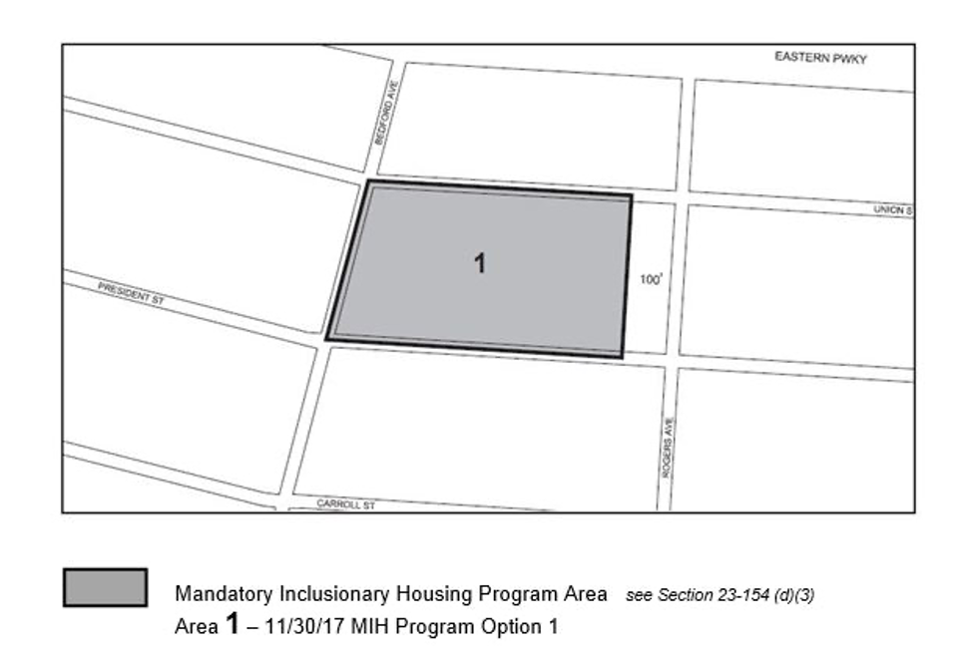

Map 2 – (12/20/18)

[EXISTING MAP]
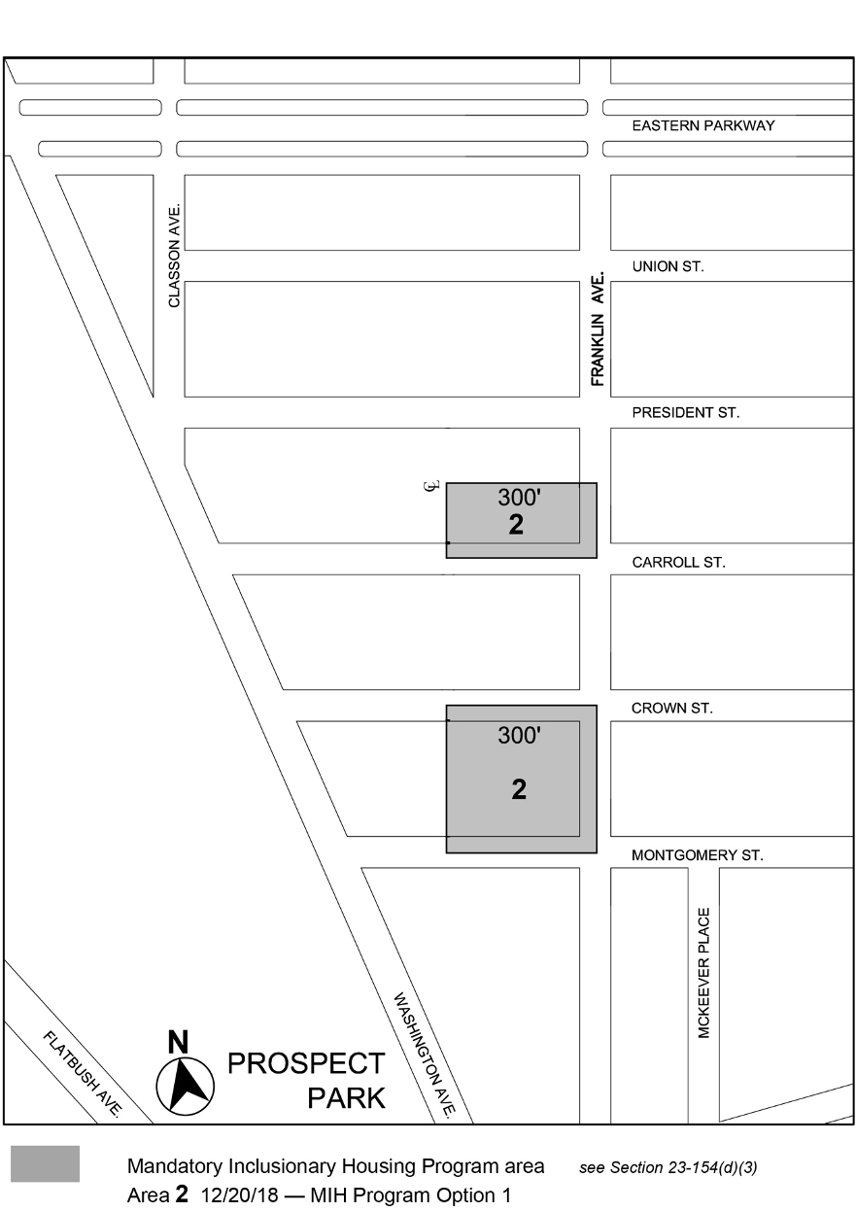
[PROPOSED MAP]
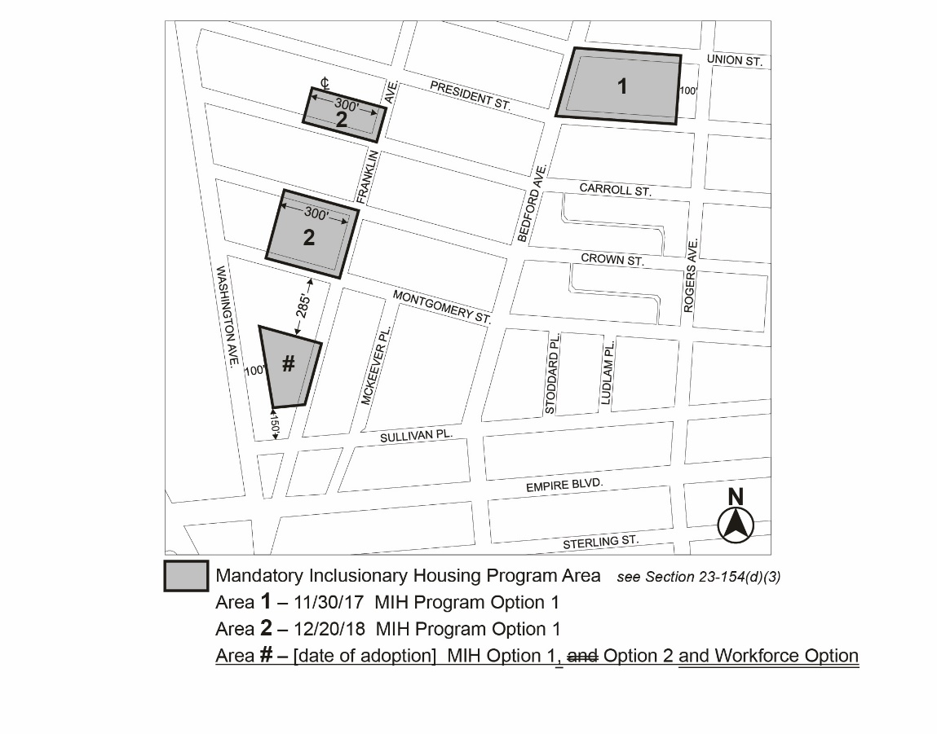

Portion of Community District 9, Brooklyn

* * *

Adopted.

Office of the City Clerk,}
The City of New York, } ss.:

I hereby certify that the foregoing is a true copy of a Resolution passed by The Council of The City of New York on _________, 2024, on file in this office.

.....................................................
City Clerk, Clerk of The Council

