Committee on Consumer and Worker Protection
Wiam Diouri, Senior Legislative Policy Analyst
Florentine Kabore, Finance Analyst

Committee on Public Safety:
Joshua Kingsley, Senior Legislative Counsel
Chad Benjamin, Legislative Policy Analyst
Jack Storey, Senior Finance Analyst
Owen Kotowski, Finance Analyst
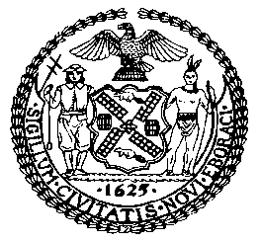

THE COUNCIL OF THE CITY OF NEW YORK
COMMITTEE REPORT OF THE GOVERNMENTAL AFFAIRS DIVISION
Andrea Vazquez, Legislative Director
Rachel Cordero, Deputy Director, Governmental Affairs Division

COMMITTEE ON CONSUMER AND WORKER PROTECTION
Hon. Marjorie Velázquez, Chair

COMMITTEE ON PUBLIC SAFETY
Hon. Kamillah Hanks, Chair

October 20, 2022

OVERSIGHT: Secondhand Auto Dealers and Theft Prevention

PROP. INT. NO. 525-A: By Council Members Brewer, Brannan, Yeger, Restler, Holden, Dinowitz, De La Rosa, Sanchez, Williams, Nurse, Velázquez, Kagan, Menin, Farías, Schulman, Riley, Louis and Joseph

TITLE: A Local Law to amend the administrative code of the city of New York, in relation to in relation to the purchase of catalytic converters

INT. NO. 759: By Council Members Lee, Holden, Hanks, Brooks-Powers, Velázquez, Mealy and Restler

TITLE: A Local Law to amend the administrative code of the city of New York, in relation to the creation of a program to distribute catalytic converter etching kits

- INTRODUCTION

On October 20, 2022, the Committee on Consumer and Worker Protection, chaired by Council Member Marjorie Velázquez, will hold an oversight hearing on second hand auto dealers and theft prevention, with a focus on the recent swath of thefts of catalytic converters. The Committee will also hear Proposed Introduction Number 525-A (“Prop. Int. No. 525-A”), in relation to the purchase of catalytic converters and Introduction Number 759 (“Int. No. 759”), in relation to the creation of a program to distribute catalytic converter etching kits. Those invited to testify at the hearing include the Department of Consumer and Worker Protection (DCWP), the New York City Police Department (NYPD), and other interested parties.
- BACKGROUND
Used car dealerships have a history of contentious relationships with consumers in the City. DCWP has fielded numerous complaints regarding what the City locally refers to as “second hand auto dealers” that pressure customers to sign blank financing contracts, sell vehicles with serious mechanical problems, misrepresent the cash value of vehicles, inflate loan interest rates, fail to honor warranties, and push the sale of or disguise costly add-ons. Consumers have reported being charged interest rates of up to 25 percent when purchasing a used car in the City. A 2017 DCWP report found that the highest concentration of complaints came from the neighborhoods of Cypress Hills, Canarsie, East New York, Ridgewood and Brownsville. The characteristics of these neighborhoods suggest that used car dealer issues are concentrated in communities of color, with limited English proficiency populations, and “unbanked” or “underbanked” residents. A 2010 DCWP investigation conducted over a three-month period found that 55% of used auto dealer advertisements violated the City’s consumer protection laws. DCWP has attempted to curb unscrupulous second hand auto dealers by issuing violations, but several issues persist.
Predatory lending practices have been a problem in the used car industry. In 2016, the consumer credit reporting company, Experian, reported that more than 25% of auto loans were subprime. In November of 2016, the Federal Reserve Bank of New York (FRBNY) released data noting that auto loan debt is one of the fastest growing household debt levels, with Americans having nearly $1.2 trillion in outstanding debt at the end of 2016. A recent FRBNY report found that auto debt increased by $87 billion between Q2 of 2021 and Q2 of 2022, and has now reached $1.5 trillion nationally.
For consumers, predatory lending and subprime loans that were not fully explained or disclosed at the time of a used car purchase can have detrimental long-term impacts on financial security. According to a 2014 National Independent Automobile Dealers Association report on the used car industry, nearly 16 percent of new loans in New York State were subprime.
On May 19, 2020, New York State Attorney General Letitia James announced with a coalition of 33 attorney generals from around the country a settlement with Santander Consumer USA Inc., the largest subprime auto financing company in the country. The settlement will provide approximately $550 million in relief to consumers nationwide, with more than $27 million allocated to New Yorkers. Santander’s subprime lending practices violated consumer protection laws by exposing consumers to unnecessarily high levels of risk and knowingly matching these consumers with auto loans that had a high probability of default.
DCWP currently licenses over 500 used car dealerships across NYC. Over the past five years, DCWP has received over 5,000 complaints about the industry and has conducted more than 3,346 inspections. These inspections led DCWP to issue 2,070 violations, most of which were for failure to post required signs, parking or storing cars on sidewalks and public roadways, or missing price disclosures. The resulting mediated complaints led DCWP to secure over $1.8 million in consumer restitution, and over $4.7 million in fines against used car dealerships over the past five years.
On July 15, 2022, Mayor Adams and DCWP Commissioner Vilda Vera Mayuga announced that the City reached a settlement with two used car dealerships, Brooklyn Mitsubishi and Brooklyn Volkswagen, that will deliver over $300,000 to New Yorkers wronged by the companies’ deceptive practices. DCWP also secured $500,000 in civil penalties from the companies, and issued a seven-day suspension of Brooklyn Mitsubishi’s two licenses. DCWP found the dealerships were using deceptive advertising to lure customers to their dealerships and then illegally selling cars at prices above the advertised prices. The dealerships consistently advertised “expired” prices with false claims stating “the price you see is the price you pay” and “no dealer fees” that weren’t honored when consumers got to the dealership. The dealerships falsely advertised accessories, warranties, and add-on products that did not come with the vehicle. The dealerships also had a practice of luring consumers with lower credit scores by promising “guaranteed approval” for financing and pre-approval for financing from a fake finance company. The dealerships misled consumers about warranties, executed illegal contracts, failed to maintain required records, failed to respond to DCWP’s subpoenas, and submitted false license applications to DCWP.
Over the years, the City Council has attempted to address the recurring issues in the used car industry by enacting legislation to protect consumers. In 2015, Local Law 44 was enacted requiring second hand auto dealers to display prices that included all administrative and service fees, as well as commonly sold add-ons, with signage to indicate such add-ons are optional. In 2017, the Council enacted Local Law 197 and 198, which further strengthened consumer protections against predatory practices in the used car industry. Local Law 197 mandated that used car dealers disclose certain information to consumers including: i) the itemized prices of add-on products; ii) the total cost of the vehicle; ii) the total cost of the vehicle, broken down by monthly payments with or without any add-ons; iii) the lowest interest rate (APR) offered to the consumer by a finance company; and iv) any other financing-related disclosures the Commissioner prescribes by rule. Local Law 198 required used car dealerships to post and provide consumers with a consumer bill of rights, which dealerships are required to give each consumer before they sign a sales contract. The bill of rights must be provided to the consumer in the language in which the contract was negotiated.
- CATALYTIC CONVERTER THEFT
Catalytic converters are a part of a vehicle’s exhaust system located between the engine and muffler, and a key component of the emissions control system, reducing the amount of pollution exuding from the tailpipe. All modern vehicles with internal combustion engines have a catalytic converter, as they have been required on new cars since 1975. New York State also requires yearly emission testing; if a car does not have a catalytic converter, it will fail the test, making it illegal to drive a vehicle in New York without a catalytic converter. To decrease the amount of smog that would otherwise be release from the tailpipe while a vehicle is in operation, catalytic converters contain precious metals such as rhodium, palladium and platinum, which can be salvaged and sold at a high price. As such, individuals can sell a stolen catalytic converter for up to $300, or up to $1,400 if the part comes from a hybrid vehicle.
Catalytic Converter Theft in New York City
According to NYPD data, catalytic converter theft in New York City has risen exponentially this past year. Citywide, as of mid-August 2022, catalytic converter theft had increased by 269% as compared to figures from the same period last year.
Reported Catalytic Converter Theft in NYC
 | 2021 | 2021 | Percent Increase
Citywide | 1505 | 5548 | 269%
Brooklyn | 403 | 1534 | 281%
Manhattan | 195 | 584 | 199%
Queens | 574 | 2092 | 264%
Bronx | 286 | 976 | 241%
Staten Island | 47 | 362 | 670%
*Year-to-Date: 8/14/2021; 8/14/2022
A challenging aspect of preventing catalytic converter theft is that it takes little over a minute to remove such device from a vehicle, and doing so requires readily available equipment such as a common jack lift and a saw. Thefts are rather simple endeavors, but reports show elaborate tactics employed to make theft more prevalent and widespread, such as arriving and exiting the scene in a getaway vehicle, and deploying lookouts along neighborhood blocks to observe parked vehicles.
Catalytic Converter Theft Remedies
The NYPD introduced an etching program that allows individuals to inscribe a code/number to their vehicle’s catalytic converter, and link that code to a website where it can be tracked. If NYPD or a potential buyer later comes across such catalytic converter, the number will be visible and can be tracked to the original vehicle, which permits an easy determination regarding the chain of custody of the catalytic converter and whether the part might have been stolen. Without such labeling, individuals can sell stolen catalytic converters by claiming they removed the part from a willing vehicle owner. The NYPD is also attempting to deter catalytic converter theft by expanding undercover investigations and inspections of auto body shops.

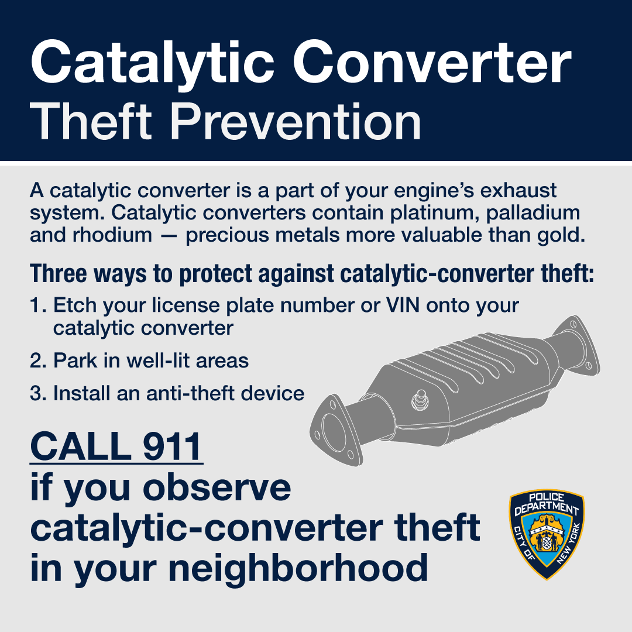

On October 18, 2022, Governor Kathy Hochul signed NYS legislation that aims to impede the theft of catalytic converters by imposing restrictions on the purchase, sale and possession of catalytic converters by vehicle dismantlers, scrap processors and others. In addition to the maintenance of catalytic convertor ownership records, the law will require that all new motor vehicle dealers and qualified dealers to stock etching kits to offer to any person purchasing a new motor vehicle.
The Council is considering legislation to address the issue at the local level, codifying labeling efforts started by NYPD, and requiring documentation for the purchase of catalytic converters to prove chain of custody while tying such requirements to relevant business licenses issued by the City.
- LEGISLATIVE ANALYSIS
- Prop. Int. No. 525-A

This bill would amend subchapter 11 of title 20 of the Administrative Code (Ad Code) to add new section 20-268.7, which would create new requirements for the purchase of catalytic converters in the portion of the Ad Code containing licensing requirements for dealers in secondhand goods. It would require that when anyone licensed as a secondhand dealer (or any person who for commercial purposes, rather than personal use) purchases a catalytic converter, they must first obtain certain documents from the seller to show the catalytic converter is consistent with manufacturer specifications. Documentation would include: year, make and model of the vehicle from which the part was removed; and a copy of certificate of title or other documentation for such vehicle to show the seller has rights to either the vehicle from which the part was removed or to the part itself. Such documentation would be subject to inspection by the Department of Consumer and Worker Protection, the Fire Department and NYPD, and be maintained for at least five years after purchase. Violators would be subject to monetary penalties and those who hold a business license issued by the City, such as a secondhand automobile dealer or scrap metal processor license, would be additionally subject to license suspension or revocation.
This bill would take effect 60 days after enactment.

- Int. No 759

This bill would amend chapter 1 of title 10 of the Ad Code to add new section 10-185, establishing a catalytic converter etching program administered by NYPD. NYPD would collaborate with the Department of Transportation and other relevant agencies to: distribute catalytic converter etching kits to new and used vehicle dealers; and provide the kits and assistance using them to the public, as well as outreach and education. The bill would take effect 90 days after enactment.

Proposed Int. No. 525-A

By Council Members Brewer, Brannan, Yeger, Restler, Holden, Dinowitz, De La Rosa, Sanchez, Williams, Nurse, Velázquez, Kagan, Menin, Farías, Schulman, Riley, Louis, Joseph, Ayala, Hanif, Moya, Krishnan, Gennaro, Narcisse and Hanks

A Local Law to amend the administrative code of the city of New York, in relation to the purchase of catalytic converters

Be it enacted by the Council as follows:
Section 1. Subchapter 11 of title 20 of the administrative code of the city of New York is amended by adding a new section 20-268.7 to read as follows:
§ 20-268.7 Purchase of catalytic converters. a. Before any dealer in second-hand articles as defined by this subchapter, or any person who for commercial purposes rather than personal use, purchases any catalytic converter, such dealer or person must receive the following information from the seller and determine that the catalytic converter is consistent with the manufacturer’s specifications for a catalytic converter from the vehicle identified in such information:
1. The year, make, model and vehicle identification number for the vehicle from which the catalytic converter was removed; and
2. A copy of the certificate of title or other documentation indicating that the seller has an ownership interest in the vehicle described in paragraph 1, or where the seller is the owner of a garage or repair shop and the catalytic converter was removed in connection with a repair of the vehicle, the name and address of the vehicle’s owner and copies of all related invoices.
b. Purchasers shall maintain a written or electronic record of the information provided pursuant to subdivision a for a minimum of five years from the date the information was provided. Such records shall be open to the inspection by the department, the fire department or the police department.
c. In addition to the penalties provided pursuant to section 20-275, any violation of this section shall be grounds for the suspension or revocation of any license issued pursuant to this subchapter or any other license issued by any agency.
§ 2. This local law takes effect 60 days after it becomes law.

NAB
LS #8782
10/3/22

Int. No. 759

By Council Members Lee, Holden, Hanks, Brooks-Powers, Velázquez, Mealy and Restler

A Local Law to amend the administrative code of the city of New York, in relation to the creation of a program to distribute catalytic converter etching kits

Be it enacted by the Council as follows:
Section 1. Chapter 1 of title 10 of the administrative code of the city of New York is amended by adding a new section 10-185 to read as follows:
§ 10-185 Catalytic converter etching kit program. a. Definitions. For purposes of this section, the term “etching kit” means a kit used to etch a unique, identifying number into a catalytic converter of a motor vehicle.
b. The police department, in collaboration with the department of transportation and any other appropriate agency, shall establish a program to:
1. Distribute etching kits to dealers of new and used motor vehicles for the purpose of etching the catalytic converters of motor vehicles offered for sale;
2. Provide etching kits to the public and assistance in using such kits to etch catalytic converters; and
3. Engage in an outreach campaign to inform the public of the efforts required pursuant to paragraphs 1 and 2 of this subdivision.
§ 2. This local law takes effect 90 days after it becomes law.

NAB
LS #9954/10082
10/4/22 5:35PM

Department of Consumer Affairs, Used and Abused by the Used Car Industry: Predatory Lending in the Secondhand Auto Industry”, April 5, 2017, available at: https://www1.nyc.gov/assets/dca/downloads/pdf/partners/SHAD_Report.pdf
Id.
Id.
Id.
“Department of Consumer Affairs (DCA) Conducts Used Car Dealer ‘Bait and Switch’ Enforcement Sweep,” Press Release, October 14, 2010
Department of Consumer Affairs charges nine used car dealers with using illegal sales tactics to deceive ad pressure consumers to pay more than advertised prices,” Press release, May 1, 2013, Available at https://katyusca.files.wordpress.com/2015/01/used-car-dealers-charged.pdf
Zabristski, Melinda, Experian Automotive, State of Automotive Finance Market: A Look at Loans and Leases in Q1 2016, Available at http://www.experian.com/assets/automotive/quarterly-webinars/2016-q1-safm.pdf
“Total Household Debt Surpasses $16 trillion in Q2 2022; Mortgage, Auto Loan, and Credit Card Balances Increase” Federal Reserve Bank of New York, August 2, 2022, available at: https://www.newyorkfed.org/newsevents/news/research/2022/20220802 s
Alexandre Tanzi, “US Household Debt Surpasses $16 Trillion on Higher Mortgages”, Bloomberg, August 2, 2022, available at: https://www.bloomberg.com/news/articles/2022-08-02/us-household-debt-surpasses-16-trillion-amid-higher-mortgages
Department of Consumer Affairs, Used and Abused by the Used Car Industry: Predatory Lending in the Secondhand Auto Industry” available at: https://www1.nyc.gov/assets/dca/downloads/pdf/partners/SHAD_Report.pdf
“Attorney General James Announces Over $550 Million Settlement with Nation’s Largest Subprime Auto Financing Company, Delivering Relief to Hundreds of Thousands of Struggling Consumers”, NYS Attorney General, May 19, 2020, available at: https://ag.ny.gov/press-release/2020/attorney-general-james-announces-over-550-million-settlement-nations-largest
Id.
Id.
“Mayor Adams Announces NYC has Secured More Than $300,000 for Consumers Harmed by Predatory Used Car Dealerships Brooklyn Mitsubishi and Brooklyn Volkswagen”, July 15, 2022, available at: https://www1.nyc.gov/office-of-the-mayor/news/510-22/mayor-adams-nyc-has-secured-more-300-000-consumers-harmed-predatory-used-car#/0
Id.
Id.
Id.
Id.
Id.
Id.
Id.
Id.
Id.
Local Law 44 of 2015, New York City Council, available at: https://legistar.council.nyc.gov/LegislationDetail.aspx?ID=1681124&GUID=47378FC7-3CC9-41ED-8873-BA84261D556F&Options=Advanced&Search=
Local Law 197 of 2017, New York City Council, available at: https://legistar.council.nyc.gov/LegislationDetail.aspx?ID=3008983&GUID=C3212579-670A-4B52-975B-B572DDD65D20&Options=Advanced&Search=
Local Law 198 of 2017, New York City Council, available at: https://legistar.council.nyc.gov/LegislationDetail.aspx?ID=3008990&GUID=2C47856B-FAF1-468E-A45A-CA79FC432631&Options=ID|Text|&Search=1540
Popely, Rick. “What Is a Catalytic Converter? - CARFAX.” CARFAX, 22 Sept. 2022, www.carfax.com/blog/catalytic-converters.
Id.
Sam, S. (2022, September 1). Know Everything about New York Catalytic Converter Laws. Way Blog. Retrieved October 14, 2022; available at: https://www.way.com/blog/new-york-catalytic-converter-laws/.
“What’s a Catalytic Converter and Why Do People Steal Them? | News | Cars.com.” Cars.com, 13 Feb. 2022; available at: www.cars.com/articles/whats-a-catalytic-converter-and-why-do-people-steal-them-446861.
“More Than 5000 Catalytic Converter Thefts Reported in NYC.” New York Post, 20 Aug. 2022; available at: www.nypost.com/2022/08/20/more-than-5000-catalytic-converter-thefts-reported-in-nyc.
Ibid.
Ibid.
“Catalytic-converter Thieves Work in Queens Robbery Video.” New York Post, 3 Sept. 2022; available at: www.nypost.com/2022/09/03/catalytic-converter-thieves-work-in-queens-robbery-video.
Ibid.
“NYPD Distributes New Tracking Device at Combat Catalytic Converter Theft Event - silive.com.” Silive, 15 July 2022, www.silive.com/news/2022/07/nypd-distributes-new-tracking-device-at-combat-catalytic-converter-theft-event.html.
Ibid.
Moses, Dean. “NYPD Is Cutting off Catalytic Converter Thieves With Anti-theft Label Enrollment | amNewYork.” amNewYork, 19 July 2022; available at: www.amny.com/news/nypd-is-cutting-off-catalytic-converter-thieves-with-anti-theft-label-enrollment .
Tremayne-Pengelly, Alexandra. “Thefts of Catalytic Converters Have Quadrupled in New York City This Year | Observer.” Observer, 20 July 2022; available at: www.observer.com/2022/07/thefts-of-catalytic-converters-have-quadrupled-in-new-york-city-this-year.
“NY State Senate Bill S9428.” NY State Senate, 26 May 2022; available at: www.nysenate.gov/legislation/bills/2021/S9428.

