THE COUNCIL OF THE CITY OF NEW YORK
RESOLUTION NO. 1032

Resolution approving with modifications the decision of the City Planning Commission on Application No. N 250186 ZRM, for an amendment of the text of the Zoning Resolution (L.U. No. 325).

By Council Members Salamanca and Riley

WHEREAS, the New York City Department of City Planning, filed an application pursuant to Section 201 of the New York City Charter, to amend various sections of the Zoning Resolution of the City of New York relating to the establishment of the Special Midtown South Mixed Use District (Article XII, Chapter 1), the elimination of the Special Garment Center District (Article XII, Chapter 1) and amending other related provisions, including APPENDIX F, for the purpose of establishing a Mandatory Inclusionary Housing area, which in conjunction with the related action would facilitate land use changes for a 42-block area to implement the Midtown South Mixed-Use Plan (MSMX) in Manhattan Community District 4 and Manhattan Community District 5 (ULURP No. N 250186 ZRM, (the “Application”);

WHEREAS, the City Planning Commission filed with the Council on June 30, 2025, its decision dated June 18, 2025 (the "Decision") on the Application;

WHEREAS, the Application is related to application C 250185 ZMM (L.U. No. 324), an amendment to the New York City Zoning Map to eliminate a Special Midtown District (MiD), eliminate a Special Garment Center District (GC), change M1-6 and M1-6D districts to M1-8A/R11, M1-8A/R12, and M1-9A/R12 districts, establish a Special Hudson Yards District (HY), and establish a Special Midtown South Mixed-Use District (MSX);

WHEREAS, the Decision is subject to review and action by the Council pursuant to Section 197-d of the City Charter;

WHEREAS, upon due notice, the Council held a public hearing on the Decision and Application on July 1, 2025;

WHEREAS, the Council has considered the land use implications and other policy issues relating to the Decision and Application; and

WHEREAS, the Council has considered the relevant environmental issues, including the Positive Declaration issued March 19th, 2024 (CEQR No. 24DCP094M) and a Final Environmental Impact Statement (FEIS) for which a Notice of Completion was issued on June 6, 2025, in which significant adverse impacts related to hazardous materials, air quality and noise would be avoided through the placement of (E) designations (E-830) on selected projected and potential development sites as specified in Chapters 9, 14 and 16, respectively, of the FEIS. The FEIS determined that approval of the proposed actions would result in significant adverse impacts to Open Space, Shadows, Historic and Cultural Resources, Transportation, Air Quality and Construction. Additionally, due to the non–site-specific nature of DCP’s model for residential conversions because of the Proposed Actions, significant adverse Hazardous Materials, Air Quality, and Noise impacts cannot be precluded for the residential conversion area, and the identified significant adverse impacts and proposed mitigation measures under the proposed actions are summarized in Chapter(s) 21, “Mitigation” of the FEIS. A Technical Memorandum (“Technical Memorandum 002”) was issued on June 13, 2025, in connection with this application and the related applications, which assesses potential modifications to the proposed actions, in which Technical Memorandum 002 concludes that the application as modified would not result in any significant adverse impacts that were not already identified in the FEIS issued on June 6, 2025. The Council has also considered the Technical Memorandum dated August ____, 2025 (the “Technical Memorandum 003”; and, together with Technical Memorandum 002, the “Technical Memoranda”).

RESOLVED:

Having considered the FEIS, and the Technical Memoranda, with respect to the Decision and Application, the Council finds that:

- The requirements of 6 N.Y.C.R.R. Part 617 have been met;

- The environmental impacts disclosed in the FEIS and the Technical Memoranda were evaluated in relation to the social, economic, and other considerations associated with the actions that are set forth in the Decision; and

- Consistent with social, economic, and other essential considerations from among the reasonable alternatives available, the actions, with modification set forth and analyzed in the Technical Memoranda, are those which avoid or minimize adverse environmental impacts to the maximum extent practicable;

The Decision, together with the FEIS issued June 6th, 2025, and the Technical Memoranda, constitute the written statement of facts, and of social, economic and other factors and standards that form the basis of this determination, pursuant to 6 N.Y.C.R.R. §617.11(d);

Pursuant to Sections 197-d and 200 of the City Charter and on the basis of the Decision and Application, and based on the environmental determination and consideration described in the report, N 250186 ZRM, the FEIS, and the Technical Memoranda, incorporated by reference herein, and the record before the Council, the Council approves the Decision of the City Planning Commission, with the following modifications.

Matter underlined is new, to be added;
Matter struck out is to be deleted;
Matter double-underlined is new, added by the City Council;
Matter double struck out is old, deleted by the City Council;
Matter within # # is defined in Section 12-10;
* * * indicates where unchanged text appears in the Zoning Resolution.

ARTICLE I
GENERAL PROVISIONS
Chapter 1
Title, Establishment of Controls and Interpretation of Regulations
* * *
11-10

ESTABLISHMENT AND SCOPE OF CONTROLS, ESTABLISHMENT OF DISTRICTS, AND INCORPORATION OF MAPS
* * *

11-12
Establishment of Districts

In order to carry out the purposes and provisions of this Resolution, the following districts are hereby established:

* * *

11-122
Districts established

[SPECIAL GARMENT CENTER (GC) DISTRICT REMOVED AND SPECIAL MIDTOWN SOUTH MIXED USE DISTRICT (MSX) ESTABLISHED]
* * *
Special Purpose Districts
* * *
Establishment of the Special Forest Hills District
In order to carry out the special purposes of this Resolution as set forth in Article VIII, Chapter 6, the Special Forest Hills District is hereby established.

Establishment of the Special Garment Center District
In order to carry out the special purposes of this Resolution as set forth in Article XII, Chapter 1, the Special Garment Center District is hereby established.

Establishment of the Special Governors Island District
In order to carry out the special purposes of this Resolution, as set forth in Article XIII, Chapter 4, the Special Governors Island District is hereby established.
* * * Establishment of the Special Midtown District
In order to carry out the special purposes of this Resolution as set forth in Article VIII, Chapter 1, the Special Midtown District is hereby established.

Establishment of the Special Midtown South Mixed Use District
In order to carry out the special purposes of this Resolution as set forth in Article XII, Chapter 1, the #Special Midtown South Mixed Use District# is hereby established.

Establishment of the Special Mixed Use District
In order to carry out the special purposes of this Resolution as set forth in Article XII, Chapter 3, the Special Mixed Use District is hereby established.
* * *
Chapter 2
Construction of Language and Definitions
* * *
12-10

DEFINITIONS

[SPECIAL GARMENT CENTER (GC) DISTRICT REMOVED AND SPECIAL MIDTOWN SOUTH MIXED USE DISTRICT (MSX) ADDED TO DEFINITIONS]
* * *
Special Garment Center District
The "Special Garment Center District" is a Special Purpose District designated by the letters "GC" in which special regulations set forth in Article XII, Chapter 1, apply.
* * *
The “Special Midtown District” is a Special Purpose District designated by the letters “MiD” in which special regulations set forth in Article VIII, Chapter 1, apply.

Special Midtown South Mixed Use District
The “Special Midtown South Mixed Use District” is a Special Purpose District designated by the letters “MSX” in which special regulations set forth in Article XII, Chapter 1, apply.

The “Special Mixed Use District” is a Special Purpose District designated by the letters “MX” in which special regulations set forth in Article XII, Chapter 3, apply. The Special Mixed Use District appears on the zoning maps superimposed on paired M1 and Residence Districts, and its regulations supplement or modify those of the M1 and Residence Districts. The Special Mixed Use District includes any district that begins with the letters “MX.”
* * *

ARTICLE I
GENERAL PROVISIONS

Chapter 5
Residential Conversion within Existing Buildings
* * *

15-00
GENERAL PURPOSES

* * *

15-02
General Provisions

15-021
Special use regulations

[REMOVED AREAS SUBSUMED BY DISTRICT BOUNDARIES TO ALIGN WITH MSX PROPOSAL]
- In M1-5 and M1-6 Districts located within the rectangle formed by West 23rd Street, Fifth Avenue, West 31st Street and Eighth Avenue West 31st Street, Eighth Avenue, West 30th Street, and Sixth Avenue, no new #dwelling units# shall be permitted. However, #dwelling units# which the Chairperson of the City Planning Commission determines were occupied on September 1, 1980, shall be a permitted #use# provided that a complete application for a determination of occupancy is filed by the owner of the #building# or the occupant of a #dwelling unit# in such #building# not later than June 21, 1983. For the purposes of Article 7C of the New York State Multiple Dwelling Law, such a determination of #residential# occupancy on September 1, 1980, shall be deemed to permit #residential use# as-of-right for such #dwelling units#.
All #dwelling units# permitted pursuant to this paragraph (a) shall be required to comply with the requirements of Section 15-024 (Special bulk regulations for certain pre-existing dwelling units and joint living-work quarters for artists) where applicable.
Where the Chairperson of the City Planning Commission has determined that #floor area# was occupied as #dwelling units# on September 1, 1980, and where such #dwelling units# are located in a #building# which, on the date of application to the Department of City Planning under the provisions of this Section, also has #floor area# which is occupied by #referenced commercial and manufacturing uses#, the Chairperson may permit that any #floor area# in the #building# be used for #dwelling units# provided that:
(1) the total amount of #floor area# to be used for #dwelling units# does not exceed the amount of #floor area# occupied as #dwelling units# on September 1, 1980;
(2) #referenced commercial and manufacturing uses# located on #floor area# to be used for #dwelling units# that has been offered a new or amended lease within the #building#, with a minimum term of two years from the date of application, at a fair market rental for the same amount of #floor area# previously occupied, and such lease is not subject to cancellation by the landlord;
(3) any #residential# tenant who occupied a #dwelling unit# shall be relocated to a #dwelling unit# within the #building# with a #floor area# equal to not less than 95 percent of the amount of #floor area# in the #dwelling unit# previously occupied; and
(4) as a result of such action by the Chairperson, #residential uses# will be located on #stories# above #manufacturing# #uses#.
(b) In M1-6 Districts located within the rectangle formed by West 35th Street, Fifth Avenue, West 40th Street and Sixth Avenue, no #dwelling units# shall be permitted, except that:
  - #dwelling units# which the Chairperson determines were occupied on May 18, 1981, shall be a permitted #use# provided that a complete application to permit such #use# is filed by the owner of the #building# or the occupant of the #dwelling unit# not later than June 21, 1983. For the purposes of Article 7C of the New York State Multiple Dwelling Law, such a determination of #residential# occupancy shall be deemed to permit #residential use# as-of-right for such #dwelling unit#.
  - in any #building# for which an alteration application for conversion of #floor area# used for non-#residential use# to #dwelling units# or for an #extension# or minor #enlargement# of existing #residential use#, was filed prior to May 18, 1981, #dwelling units# shall be permitted, provided that such alterations shall comply with the regulations in effect on the date of such filing. The right to convert to #dwelling units# or #extend# or #enlarge# existing #residential use# pursuant to the provisions of this paragraph (b) shall expire one year from July 23, 1981, unless a temporary or permanent certificate of occupancy has been issued.
* * *

ARTICLE IV
MANUFACTURING DISTRICT REGULATIONS

Chapter 2
Use Regulations
* * *
42-30

SPECIAL PROVISIONS APPLICABLE TO CERTAIN AREAS AND DISTRICTS
* * *
42-31
Special Regulations Applicable to Certain Districts
* * *
42-314
Use regulations in certain M1-1, M1-5 and M1-6 Districts

[REMOVED AREAS SUBSUMED BY DISTRICT BOUNDARIES TO ALIGN WITH MSX PROPOSAL]
- In the M1-1 District bounded by 95th Avenue, 148th Street, 97th Avenue and 147th Place in Community District 12 in the Borough of Queens, the #use# regulations of an M1 District shall apply, except that #residential use# is allowed subject to the #bulk# regulations of Section 43-01 (Applicability of This Chapter) and the #accessory# off- street parking regulations of Section 44-024 (Applicability of regulations in an M1-1 District in Community District 12 in the Borough of Queens).
- In M1-5 and M1-6 Districts, except for M1-6D Districts, located within the rectangle formed by West 23rd Street, Fifth Avenue, West 31st Street, and Eighth Avenue West 31st Street, Eighth Avenue, West 30th Street, and Sixth Avenue, no new #dwelling units# shall be permitted. However, #dwelling units# which the Chairperson of the City Planning Commission determines were occupied on September 1, 1980, shall be a permitted #use# provided that a complete application to permit such #use# is filed by the owner of the #building# or the occupant of a #dwelling unit# in such #building# not later than June 21, 1983.

Such #dwelling units# shall comply with the requirements of Section 15-024 (Special bulk regulations for certain pre-existing dwelling units and joint living-work quarters for artists). For the purposes of Article 7C of the New York State Multiple Dwelling Law, such a determination of #residential# occupancy on September 1, 1980, shall be deemed to permit #residential use# as-of-right for such #dwelling units#.
- In M1-6 Districts located within the rectangle formed by West 35th Street, Fifth Avenue, West 40th Street and Sixth Avenue, no #dwelling units# shall be permitted, except that:
  - #dwelling units# which the Chairperson of the City Planning Commission determines were occupied on May 18, 1981, shall be a permitted #use# provided that a complete application to permit such #use# is filed by the owner of the #building# or the occupant of the #dwelling unit# not later than June 21, 1983. For the purposes of Article 7C of the New York State Multiple Dwelling Law, such a determination of #residential# occupancy shall be deemed to permit #residential use# as-of-right for such #dwelling unit#;
  - in any #building# for which an alteration application for #conversion# of #floor area# used for non-#residential use# to #dwelling units# or for an #extension# or minor #enlargement# of existing #residential use#, was filed prior to May 18, 1981, #dwelling units# shall be permitted, provided that such alterations shall comply with the regulations in effect on the date of such filing. The right to #convert# to #dwelling units# or #extend# or #enlarge# existing #residential use# pursuant to the provisions of this Section shall expire one year from July 23, 1981, unless a temporary or permanent certificate of occupancy has been issued; and

  - in M1-6D Districts, #residential use# shall be permitted as-of-right subject to the #use# regulations set forth in Section 42-312 (Use regulations in M1-6D Districts).
* * *
Chapter 3
Bulk Regulations
* * *

43-40

HEIGHT AND SETBACK REGULATIONS
* * *
43-43
Maximum Height of Front Wall and Required Front Setbacks

[REMOVED M1-6 SETBACK REQUIREMENTS TO ALIGN WITH MSX PROPOSAL] M1 M2 M3
In all districts, other than districts with an A suffix, the front wall or any other portion of a #building or other structure# is located at the #street line# or within the #initial setback distance# as set forth in the table in this Section, the height of such front wall or other portion of a #building or other structure#, except as otherwise set forth in this Section, shall not exceed the maximum height above #curb level# set forth in the table. Above such maximum height and beyond the #initial setback distance#, the #building or other structure# shall not penetrate the #sky exposure plane# set forth in the table.
The regulations of this Section shall apply, except as otherwise provided in Sections 43-42 (Permitted Obstructions), 43-44 (Alternate Front Setbacks) or 43-45 (Tower Regulations). In M1-1 Districts, for #community facility buildings#, the maximum height of a front wall shall be 35 feet or three #stories#, whichever is less, and the height above the #street line# shall be 35 feet, and in M1-4 Districts, for #community facility buildings#, the maximum height of a front wall shall be 60 feet or six #stories#, whichever is less.
For #zoning lots# in M1-6 Districts that are both within 100 feet of the western #street line# of Seventh Avenue and between West 28th and West 30th Streets in the Borough of Manhattan, the following #street wall# regulations shall apply to #street# frontages not occupied by a #public plaza#. The #street wall# of a #building# shall be located on the #street line# and extend along the entire #street# frontage of the #zoning lot# up to a minimum height of 125 feet or the height of the #building#, whichever is less, and a maximum height of 150 feet. Above a height of 150 feet, no portion of a #building# may penetrate a #sky exposure plane# except for towers, pursuant to Section 43-45. The #sky exposure plane# shall begin at a height of 150 feet above the #street line# and rise over the #zoning lot# at a slope of 5.6 feet of vertical distance for each foot of horizontal distance on a #wide street#, and at a slope of 2.7 feet of vertical distance for each foot of horizontal distance on a #narrow street#. The provisions of Section 43-44 shall not apply. On the ground floor, recesses shall be permitted where required to provide access to the #building#, provided such recesses do not exceed three feet in depth as measured from the #street line#. Above the level of the second #story#, up to 30 percent of the #aggregate width of street walls# may be recessed beyond the #street line#. However, no recesses shall be permitted within 20 feet of an adjacent #building# and within 30 feet of the intersection of two #street lines#.
* * *

ARTICLE VI
SPECIAL REGULATIONS APPLICABLE TO CERTAIN AREAS
Chapter 6
Special Regulations Applying Around Mass Transit Stations
* * *
66-10

GENERAL PROVISIONS

66-11
Definitions

[SPECIAL GARMENT CENTER (GC) DISTRICT REMOVED AND SPECIAL MIDTOWN SOUTH MIXED USE DISTRICT (MSX) ADDED TO CENTRAL BUSINESS DISTRICTS APPLICABILITY]
For purposes of this Chapter, matter in italics is defined in Section 12-10 (DEFINITIONS) and in this Section, except where explicitly stated otherwise in individual provisions in this Chapter.
* * *
Central Business Districts
For the purposes of this Chapter, “Central Business Districts” shall refer to #Special Midtown District#, #Special Hudson Yards District#, #Special Lower Manhattan District#, #Special Downtown Brooklyn District#, #Special Long Island City Mixed Use District# or #Special Garment Center District#. #Special Midtown South Mixed Use District#.
* * *

ARTICLE VII ADMINISTRATION
Chapter 3
Special Permits by the Board of Standards and Appeals
* * *

73-60

MODIFICATIONS OF BULK REGULATIONS
* * *
73-62
Modification of Bulk Regulations for Buildings Containing Residences

* * *
73-624
Modification of Affordable Housing Fund payment options in the SoHo NoHo Mixed Use District and the Special Midtown South Mixed Use District

[ADDING APPLICABILITY FOR SPECIAL MIDTOWN SOUTH MIXED USE DISTRICT]
Within the #Special SoHo-NoHo Mixed Use District# and the #Special Midtown South Mixed Use District#, for #conversions# from non-#residential# to #residential use# in #buildings# existing prior to December 15, 2021, that are not otherwise subject to paragraph (a)(3)(v) of Section 27-131 (Mandatory Inclusionary Housing), the Board of Standards and Appeals may permit a contribution to the #affordable housing fund# pursuant to such paragraph to satisfy the requirements of paragraph (a)(3), inclusive, of such Section, provided that the Board finds that:

- the configuration of the #building# imposes constraints, including, but not limited to, deep, narrow or otherwise irregular #building# floorplates, limited opportunities to locate #legally required windows#, or pre-existing locations of vertical circulation or structural column systems, that would create practical difficulties in reasonably configuring the required #affordable floor area# into a range of apartment sizes and bedroom mixes serving a number of lower-income residents comparable to what such quantity of #affordable floor area# would serve in a more typical configuration, pursuant to the #guidelines# of the Inclusionary Housing Program. Before the Board issues a final determination on any application made pursuant to this Section, the Department of Housing Preservation and Development shall submit comment or appear before the Board regarding this finding;
- the practical difficulties existed on December 15, 2021.
For the purposes of this Section, defined terms include those set forth in Sections 12-10 and 27- 11.
A copy of each application to the Board for a special permit under the provisions of this Section shall be provided by the applicant to the Department of Housing Preservation and Development concurrently with its submission to the Board.
The Board may prescribe such conditions and safeguards as it deems necessary to minimize adverse effects upon the surrounding area and the community at large.
* * *
Chapter 4
Special Permits by the City Planning Commission
* * *
74-80

ADDITIONAL PERMITS
* * *
74-85
Covered Pedestrian Space

[ADDING APPLICABILITY FOR SPECIAL MIDTOWN SOUTH MIXED USE DISTRICT (MSX) AND CERTAIN M1-A DISTRICTS]
C4-7 C5-2 C5-3 C5-4 C5-5 C6-4 C6-5 C6-6 C6-7 C6-8 C6-9 C6-11 C6-12 M1-6A M1-7A
M1-8A M1-9A
In the districts indicated and in the #Special Midtown South Mixed Use District#, the City Planning Commission may permit #floor area# bonuses for #covered pedestrian space# in accordance with the provisions of Sections 74-851 through 74-853, inclusive.

74-851
Floor area bonus for covered pedestrian space

[REMOVING 12.0 FAR RESTRICTION; ADDING M1-A DISTRICT APPLICABILITY]
For the #development# or #enlargement# of a #commercial#, #community facility# or #mixed building#, for each square foot of #covered pedestrian space# provided on a #zoning lot#, the total #floor area# permitted on that #zoning lot# under the provisions of Section 33-12 (Maximum Floor Area Ratio) or Section 43-132 (Floor area regulations in M1 Districts with an A suffix), as applicable, may be increased as set forth in the following table:

PERMITTED ADDITIONAL FLOOR AREA PER SQUARE FOOT OF COVERED PEDESTRIAN SPACE

District | Basic (in square feet) | Maximum (in square  feet)
C5-3 C5-5 C6-6 C6-7 C6- 9 C6-11 C6-12  M1-8A M1-9A | 11 | 14
C4-7 C5-2 C5-4 C6-4 C6- 5 C6-8  M1-6A M1-7A | 8 | 11

In no event shall the resulting #floor area ratio# exceed the amount set forth in Section 33-12 the underlying provisions by more than 20 percent. Any #floor area# bonus earned by providing a #covered pedestrian space# may be applied to increase the #residential# #floor area# of a #mixed building#, provided the maximum #floor area ratio# for the #residential# portion does not exceed 12.0.

Any portion of the #covered pedestrian space# that is within 10 feet of a #street line# or #lot line# and that is extended along such #street line# or #lot line# on either side of an entrance to it from an adjoining #street#, #arcade#, #publicly accessible open area#, #court#, #yard# or other #covered pedestrian space#, may receive only that #floor area# bonus accorded to an #arcade#.
* * *

ARTICLE VIII
SPECIAL PURPOSE DISTRICTS
Chapter 1
Special Midtown District
* * *
81-20

BULK REGULATIONS

81-21
Floor Area Ratio Regulations
* * *
81-211
Maximum floor area ratio for non-residential or mixed buildings

[REMOVE MENTION OF M1-6 FROM CHART]
- For #non-residential buildings# or #mixed buildings#, the basic maximum #floor area ratios# of the underlying districts shall apply as set forth in this Section.
- In the #Special Midtown District#, the basic maximum #floor area ratio# on any #zoning lot# may be increased by bonuses or other #floor area# allowances only in accordance with the provisions of this Chapter, and the maximum #floor area ratio# with such additional #floor area# allowances shall in no event exceed the amount set forth for each underlying district in the following table:

MAXIMUM FLOOR AREA ALLOWANCES FOR SPECIFIED FEATURES AND MAXIMUM FLOOR AREA RATIOS BY DISTRICTS

 | Maximum #Floor Area Ratio# (FAR)
Means for Achieving Permitted FAR Levels on a #Zoning Lot# | C5P | C6-4 C6-5 M1-6 | C5-2.5  C6-4.5  C6-5.5  C6-6.5 | C6-7T | C5-3 C6-6 C6-7

A. Basic Maximum FAR | 8.0 | 10.0 | 12.0 | 14.0 | 15.0
B. Maximum As-of-Right #Floor Area# Allowances: #Public plazas# - Section 81-  23 | — | 1.01,2 | 1.01,3 | — | 1.0²
C. Maximum Total FAR with As-of-Right Incentives | 8.0 | 11.01,2,6 | 13.0¹,3 | 14.0 | 16.0
D. Maximum District-wide #Floor Area# Allowances: #Mass Transit Station# -  Section 66-51 | 1.6⁵ | 2.0⁵ | 2.4 | 2.8 | 3.0
E. Maximum Total FAR with District-wide and As-of-Right Incentives | 9.6 | 12.0 | 14.4 | 16.8 | 18.0
F. Maximum #Floor Area# Allowances in Penn Center Subdistrict: #Mass Transit Station# Improvement - Section 81-541 | — | 2.0 | — | — | 3.0
G. Maximum Total FAR with As-of-Right, District-wide and Penn Center Subdistrict Incentives | — | 12.0 | — | — | 18.0
H. Maximum As-of-Right #Floor Area# Allowances in Theater Subdistrict:
Development rights (FAR) of a “granting site” - Section 81- 744 | — | 10.0 | 12.0 | 14.0 | 15.0
Maximum amount of transferable development rights (FAR) from "granting sites" that may be utilized on a "receiving site" - Section 81-744(a) | — | 2.0 | 2.4 | 2.8 | 3.0
I. Maximum Total FAR with As-of-Right #Floor Area# Allowances in Theater Subdistrict | — | 12.0 | 14.4 | 16.8 | 18.0
J. Maximum #Floor Area# Allowances by Authorization in Eighth Avenue Corridor - Section 81-744(b) | — | 2.4 | — | — | —
K. Maximum Total FAR with As-of-Right and Theater Subdistrict Authorizations | — | 14.4 | 14.4 | 16.8 | 18.0
L. Maximum Special Permit #Floor Area# Allowances in Theater Subdistrict: Rehabilitation of "listed theaters" Section 81-745 | — | 4.4 | 2.4 | 2.8 | 3.0
M. Maximum Total FAR with Theater Subdistrict, District- wide and As-of-Right Incentives | 9.6 | 14.4 ⁷ | 14.4 | 16.8 | 18.0
N. Maximum FAR of Lots Involving Landmarks:
Maximum FAR of a lot containing non-bonusable landmark - Section 74-711 or as-of-right | 8.0 | 10.0 | 12.0 | 14.0 | 15.0
Development rights (FAR) of a landmark lot for transfer purposes - Section 75-42 | 8.0 | 10.0 | 13.0 ⁴ | 14.0 | 16.0
Maximum amount of transferable development rights (FAR) from a landmark #zoning lot# that may be utilized on a #receiving lot# - Section 75-42 | 1.6 | 2.0 | 2.4 | No Limit | No Limit
O. Maximum Total FAR of a Lot with Transferred Development Rights from Landmark #Zoning Lot#, Theater Subdistrict Incentives, District-wide Incentives and As-of Right Incentives | 9.6 | 14.4 ⁷ | 14.4 | No Limit | No Limit
1 Not available for #zoning lots# located wholly within Theater Subdistrict Core
2 Not available within the Eighth Avenue Corridor
3 Not available within 100 feet of a #wide street# in C5-2.5 Districts
4 12.0 in portion of C6-5.5 District within the Theater Subdistrict Core
5 For #zoning lots# with #qualifying affordable housing# or #qualifying senior housing#, the permitted #floor area# bonus shall be calculated in accordance with Section 66-51 (Additional Floor Area for Mass Transit Station Improvements)
6 12.0 for #zoning lots# with full #block# frontage on Seventh Avenue and frontage on West 34th Street, pursuant to Section 81-542 (Retention of floor area bonus for plazas or other public spaces)
7 For #zoning lots# utilizing a #floor area# bonus pursuant to Section 66-51, such maximum #floor area ratio# shall only be permitted with the provision of #qualifying affordable housing# or #qualifying senior housing#.
* * *
81-70

SPECIAL REGULATIONS FOR THEATER SUBDISTRICT

81-71
General Provisions

[REVISE BOUNDARIES OF SPECIAL MIDTOWN DISTRICT TO EXCLUDE MSX]
The regulations of Sections 81-72 to 81-75, inclusive, relating to Special Regulations for the Theater Subdistrict, are applicable only in the Theater Subdistrict, of which the Theater Subdistrict Core and the Eighth Avenue Corridor are parts, except that any listed theater designated in Section 81-742, or portion thereof, located outside of the Theater Subdistrict shall be deemed to be a “granting site” pursuant to Section 81-744 (Transfer of development rights from listed theaters).
The Theater Subdistrict is bounded by West 57th Street, Avenue of the Americas, West 40th Street, Eighth Avenue, West 42nd Street, a line 150 feet west of Eighth Avenue, West 45th Street and Eighth Avenue.
The Theater Subdistrict Core is bounded by West 50th Street, a line 200 feet west of Avenue of the Americas, West 43rd Street and a line 100 feet east of Eighth Avenue.
The Eighth Avenue Corridor is bounded by West 56th Street, a line 100 feet east of Eighth Avenue, West 43rd Street, Eighth Avenue, West 42nd Street, a line 150 feet west of Eighth Avenue, West 45th Street and Eighth Avenue.
The west side of Eighth Avenue between 42nd and 45th Streets is also subject to the provisions of the Special Clinton District to the extent set forth in Article IX, Chapter 6, subject to Section 81-023 (Applicability of Special Clinton District regulations).
These boundaries are shown on Map 1 (Special Midtown District and Subdistricts) in Appendix A of this Chapter. The regulations of Sections 81-72 to 81-75, inclusive, supplement or modify the regulations of this Chapter applying generally to the #Special Midtown District# of which the Subdistrict is a part.
* * *
81-72
Use Regulations Modified

[REVISING BOUNDARIES OF SPECIAL MIDTOWN DISTRICT TO EXCLUDE MSX]
The #use# regulations of this Section, inclusive, shall apply within that portion of the Theater Subdistrict bounded by West 40th Street, a line through the midblock between 40th Street and 41st Street, a line 100 feet east of Eighth Avenue, West 51st Street and a line 200 feet west of Avenue of the Americas, to #buildings# #developed# after May 13, 1982, to portions of #buildings# #enlarged# on the ground floor level after May 13, 1982, and to #extensions#.
* * *

81-74
Special Incentives and Controls in the Theater Subdistrict

81-741
General provisions

[REMOVING MENTION OF M1-6 DISTRICT AS IT IS NO LONGER APPLICABLE]
* * *

(f) Limitations on non-theater-related bonuses in C6-4, or C6-5 or M1-6 Districts
For #zoning lots# or portions thereof in C6-4, or C6-5 or M1-6 Districts, the total amount of #floor area# derived from non-theater-related bonuses or other special #floor area# allowances, pursuant to provisions of this Chapter other than those in Sections 81-744, 81-745, 81-746 or 81-747, shall not exceed a #floor area ratio# of 2.0.
* * *
81-745
Floor area bonus for rehabilitation of existing listed theaters

[REMOVING MENTION OF M1-6 DISTRICT AS IT IS NO LONGER APPLICABLE]
* * *
- Amount of rehabilitation bonus
The amount of bonus #floor area# granted for a qualifying theater rehabilitation shall be at the discretion of the Commission after consideration of the following findings:
  - how and to what extent the proposed rehabilitation will improve the theater's suitability for #use# as a legitimate theater;
  - how the proposed rehabilitation will contribute toward satisfying the needs of the Theater Subdistrict;
  - whether the bonus #floor area# will unduly increase the #bulk# of any #development# or #enlargement#, density of population or intensity of #use# on any #block# to the detriment of occupants of #buildings# on the #block# or the surrounding area; and
  - whether the distribution and location of such #floor area# bonus will adversely affect the surrounding area by restricting light and air or otherwise impair the essential character or future development of the surrounding area.
Such bonus #floor area# shall not exceed 20 percent of the basic maximum #floor area# permitted on the #zoning lot# containing the #development# or #enlargement# by the regulations of the underlying district, except that in the case of an underlying C6-4, or C6-5 or M1-6 District, the bonus #floor area# shall not exceed 44 percent of the basic maximum #floor area# permitted in such underlying district, and except that in the case of a #zoning lot# located partially in a C6-5.5 District and partially in a C6-7T District, the Commission may allow bonus #floor area# to be utilized anywhere on the #zoning lot#.
* * *
Appendix A
Midtown District Plan Maps

[REVISING MAPS 1, 3, AND 4]
Map 1: Special Midtown District and Subdistricts

[EXISTING MAP]

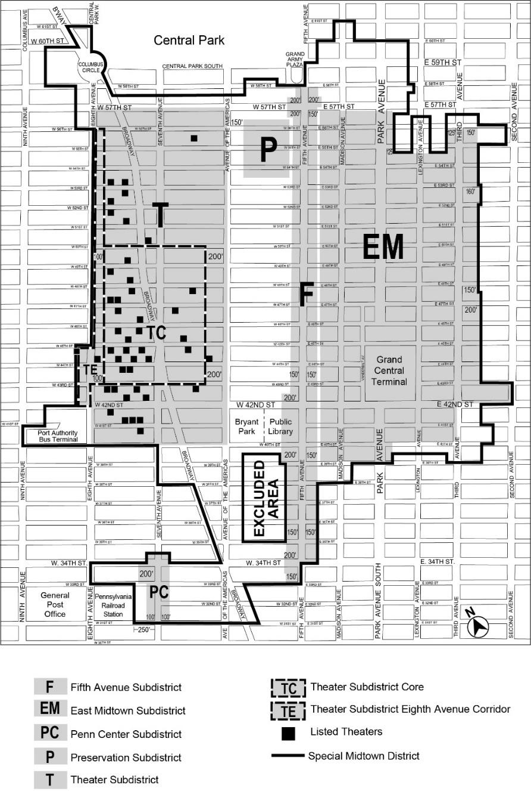

[PROPOSED MAP]
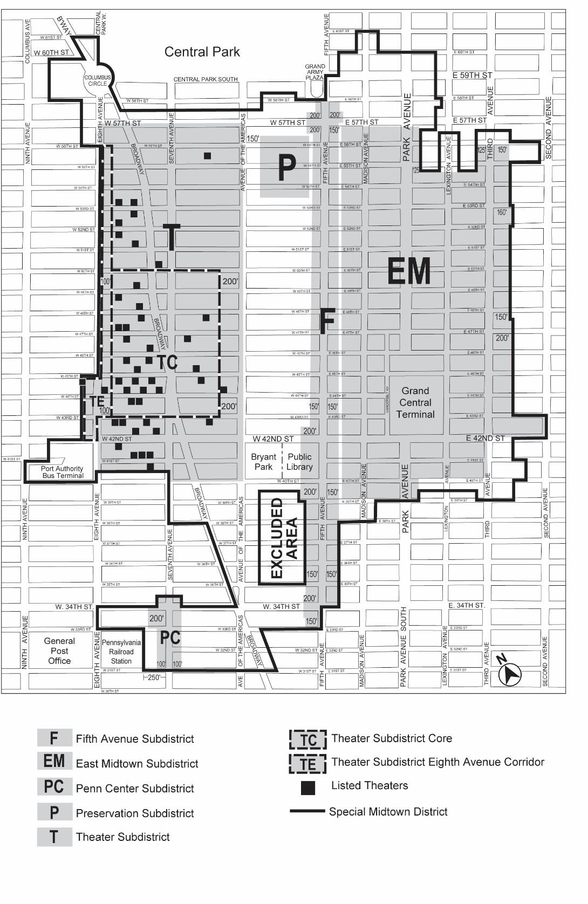
* * *
Map 3: Retail and Street Wall Continuity

[EXISTING MAP]
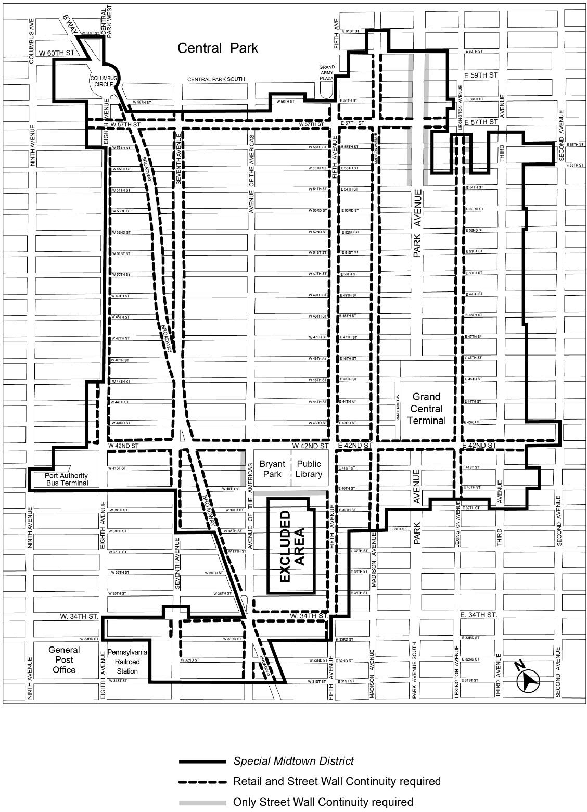

[PROPOSED MAP]
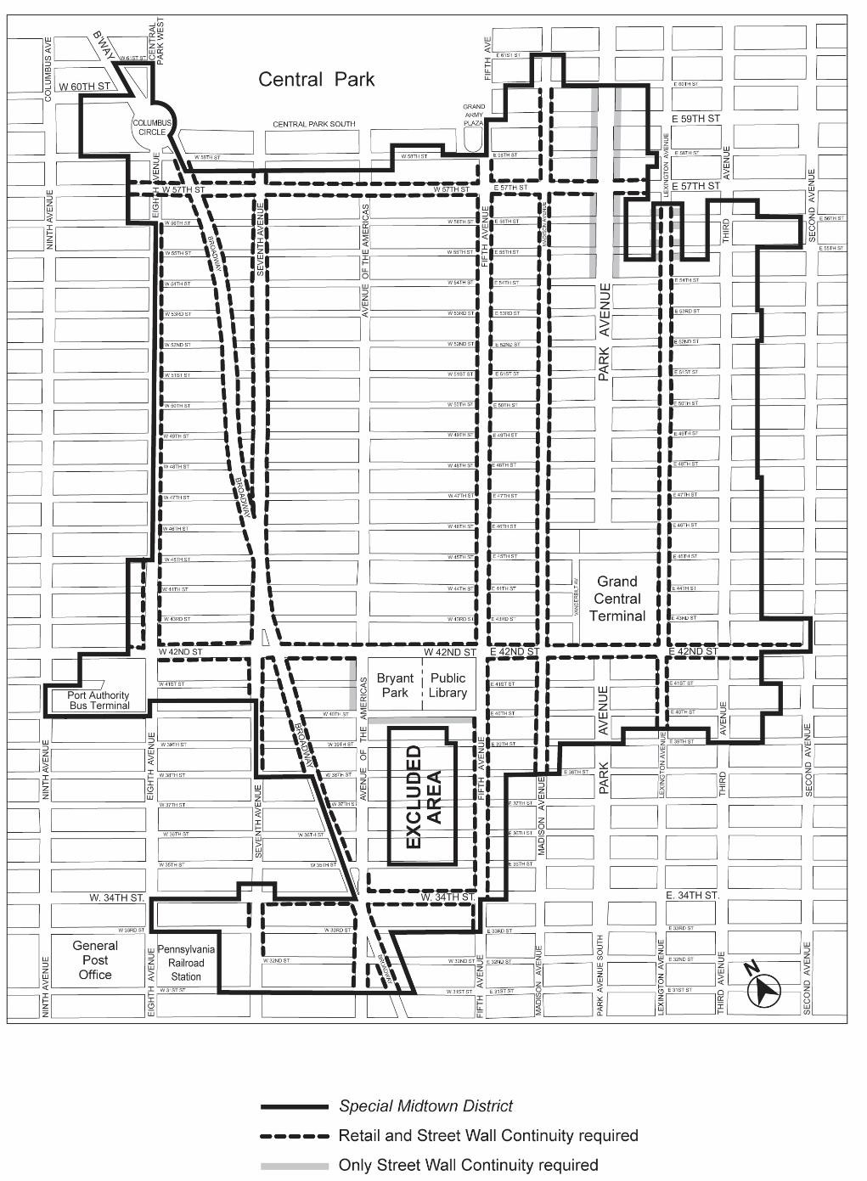

Map 4: Subway Station and Rail Mass Transit Facility Improvement Areas

[EXISTING MAP]
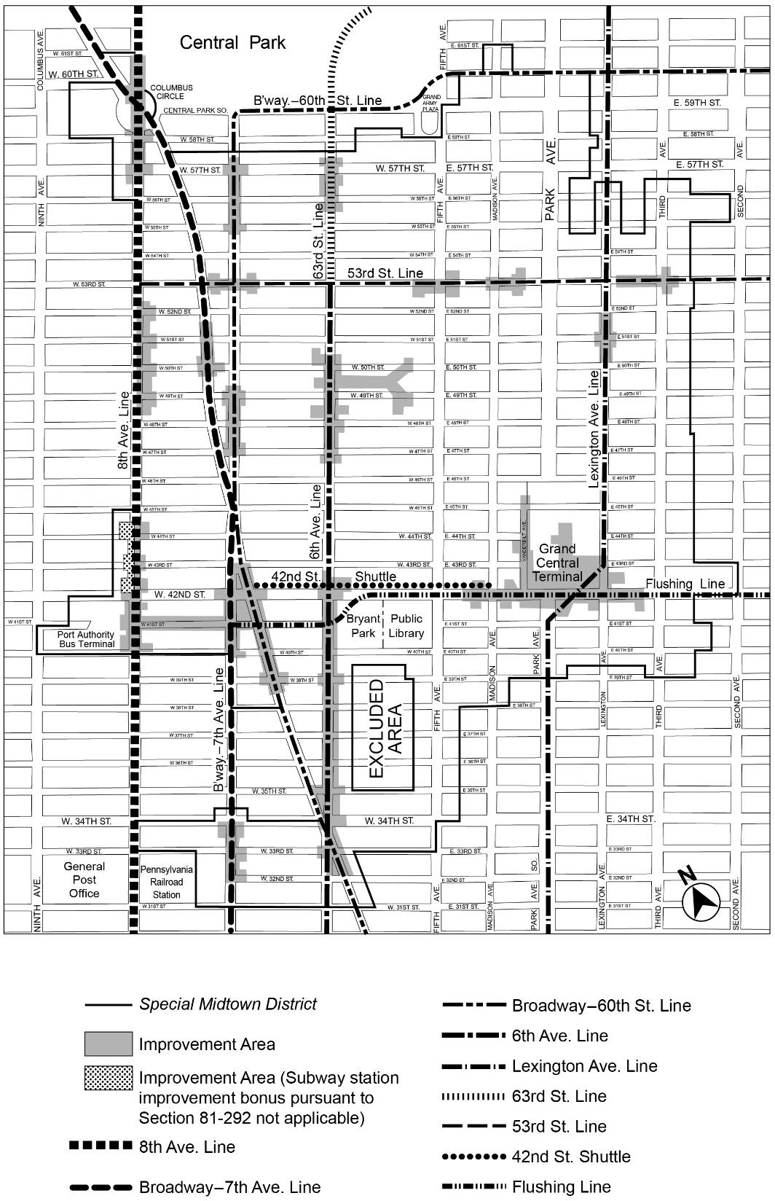

[PROPOSED MAP]
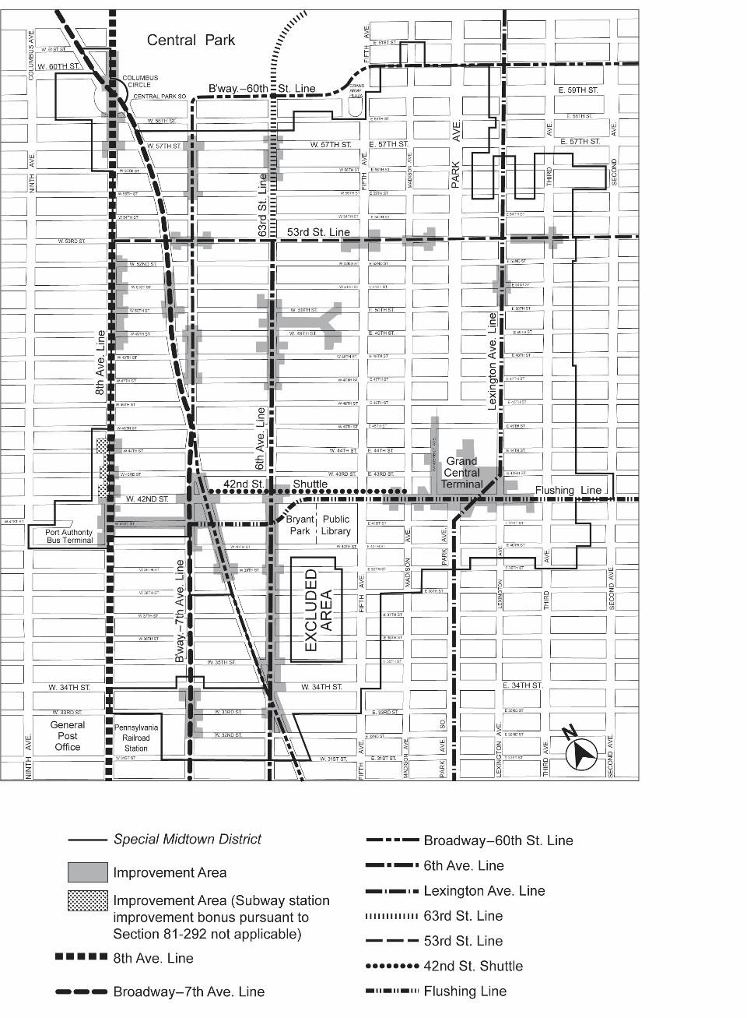
* * *

ARTICLE IX
SPECIAL PURPOSE DISTRICTS

Chapter 3
Special Hudson Yards District (HY)
* * *
93-00

GENERAL PURPOSES

[REPLACING REFERENCE TO SPECIAL GARMENT CENTER DISTRICT WITH MSX]
* * *
- to provide a transition between the Hudson Yards District and the Clinton community to the north;
- to provide a transition between the Hudson Yards District and the Garment Center Midtown South Mixed Use District to the east;
- to provide a transition between the Hudson Yards District and the West Chelsea area to the south;
* * *
93-01
Definitions

[REMOVING REFERENCE TO SPECIAL GARMENT CENTER DISTRICT]
* * *
Hudson Yards Redevelopment Area
The “Hudson Yards Redevelopment Area” shall be the areas within the #Special Hudson Yards District#, Subdistrict A-2 of the #Special Garment Center District#, the 42nd Street Perimeter Area of the #Special Clinton District#, and the area bounded by the center line of Eleventh Avenue, the northern #street line# of West 43rd Street, the westerly prolongation of the northern #street line# of West 43rd Street to the U.S. Pierhead Line, the U.S. Pierhead Line, the westerly prolongation of the southern #street line# of West 29th Street to the U.S. Pierhead Line, and the southern #street line# of West 29th Street. However, the area bounded by the westerly side of Eleventh Avenue, the southerly side of West 43rd Street, the westerly side of Twelfth Avenue and the northerly side of West 33rd Street shall not be included in the #Hudson Yards Redevelopment Area#, except for any portion of such #blocks# containing a transit easement for subway-related use. Furthermore, the #Hudson Yards Redevelopment Area# shall not include any underground connections from a subway station to any #use# located on such excluded #blocks# or between any such #uses#.
* * *

93-04
Subdistricts and Subareas

[ADDING GARMENT CENTER SUBDISTRICT H]
In order to carry out the provisions of this Chapter, six subdistricts are established, as follows: Large-Scale Plan Subdistrict A
Farley Corridor Subdistrict B 34th Street Corridor Subdistrict C Hell’s Kitchen Subdistrict D
South of Port Authority Subdistrict E Western Rail Yard Subdistrict F Eleventh Avenue Subdistrict G Garment Center Subdistrict H
* * *

93-10
USE REGULATIONS

* * *

93-13
Special Commercial Use Regulations

* * *

93-131
Certification for office use

[REMOVING MENTION OF SPECIAL GARMENT CENTER DISTRICT]

The provisions of this Section shall apply to all #developments# or #enlargements# in the #Hudson Yards Redevelopment Area#, with the exception of Subdistricts F and G.

(a) No temporary certificate of occupancy from the Department of Buildings may be issued for any portion of a #development# or #enlargement# in the #Hudson Yards Redevelopment Area# that includes #uses# listed under Office in Use Group VII #developed# or #enlarged# after January 19, 2005, until the Chairperson of the Department of City Planning certifies to the Commissioner of Buildings that:

(1) such #development# or #enlargement# does not utilize any #floor area# increases pursuant to Section 96-25 (Floor Area Bonus for New Theater Use); or

(2) such #development# or #enlargement# utilizes #floor area# increases pursuant to the special provisions for #qualifying affordable housing# or #qualifying senior housing# in Sections 93-222 (Maximum floor area ratio in the 34th Street Corridor Subdistrict C) or 93-223 (Maximum floor area ratio in Hell’s Kitchen Subdistrict D), or the provisions of Sections 93-30 (SPECIAL FLOOR AREA REGULATIONS), inclusive, or 96-25, and will not result in a total amount of office #floor area# #developed# or #enlarged# after January 19, 2005, within the #Hudson Yards Redevelopment Area# of over 20 million square feet.

All #developments# or #enlargements# so certified shall be permitted in accordance with the provisions of this Chapter, or the provisions of the #Special Clinton District# or the #Special Garment Center District#, as applicable.

(b) Where the Chairperson of the Department of City Planning determines that the amount of #floor area# for #uses# listed under Offices in Use Group VII in any #development# or #enlargement# will result in a total amount of #floor area# #developed# or #enlarged# WITH SUCH #USE#after January 19, 2005, within the #Hudson Yards Redevelopment Area# of over 20 million square feet, no building permit from the Department of Buildings shall be issued for any #development# or #enlargement# that includes offices constructed after January 19, 2005, until the Chairperson certifies to the Commissioner of Buildings that:

(1) such #development# or #enlargement# does not utilize any #floor area# increases pursuant to the special provisions for #qualifying affordable housing# or #qualifying senior housing# in Sections 93-222 or 93-223, or the provisions of Sections 93-30, inclusive, or 96-25; or

(2) such #development# or #enlargement# utilizes #floor area# increases pursuant to the special provisions for #qualifying affordable housing# or #qualifying senior housing# in Sections 93-222 or 93-223, or the provisions of Sections 93-30, inclusive, or 96-25, and will not result in a total amount of office #floor area# #developed# or #enlarged# after January 19, 2005, within the #Hudson Yards Redevelopment Area# of over 25 million square feet.

All #developments# or #enlargements# so certified shall be permitted in accordance with the provisions of this Chapter, or the provisions of the #Special Clinton District# or the #Special Garment Center District#, as applicable.

However, if such #developments# or #enlargements# fail to comply with the provisions of Section 11-331 with respect to completion of foundations within one year of the date of certification pursuant to this Section, such building permit shall lapse, and any new building permit will require a new Chairperson’s certification pursuant to this Section.

* * *

93-133
Transient hotels and offices in Subdistrict H

[ADDING TEXT FROM EXISTING SECTION 121-11 TO NEW SUBDISTRICT H]

For a #building# subject to the provisions of Sections 93-90 (HARASSMENT) and 93-91 (Demolition) and for which #HPD# issued a #certification of no harassment# that was in effect on June 11, 2018, a special permit pursuant to Section 74-152 (In Commercial Districts) shall not be required where such #building# is #enlarged# and a portion of which is subsequently converted to #residences# pursuant to Article I, Chapter 5 (Residential Conversions Within Existing Buildings), provided that all new #transient hotel# rooms shall be located in the #enlarged# portion of such #building#, and except for #transient hotel# lobbies and #accessory# #uses# located below the floor level of the second #story#, the non-#enlarged# portion of such #building# shall contain only permanently affordable #residences# pursuant to a #regulatory agreement# enforceable by #HPD#.

In Subdistrict H, any #development# or #enlargement# that includes #uses# listed under Offices in Use Group VII, #developed# or #enlarged# after January 19, 2005, shall be permitted only pursuant to Section 93-13 (Special Office Use Regulations).

93-134
C6-4M Districts in Subdistrict H

[ADDING TEXT FROM EXISTING SECTION 121-12 TO NEW SUBDISTRICT H]
In the C6-4M District located within Subdistrict H, for #buildings# existing on January 19, 2005, the #use# regulations of the underlying district shall be modified as follows:
- The following #uses# shall be allowed: From Use Group IX
All #uses# listed under Use Group IX(A) that are permitted in a C8 District From Use Group X
All #uses# listed under Use Group X that are permitted in a C8 District.

93-133
93-135
Vehicle storage establishments

[UPDATING SECTION NUMBER; TITLE AND TEXT UNCHANGED]

Within Subdistrict G, commercial or public vehicle storage, including #accessory# motor fuel pumps listed under Use Group IX(C) shall be permitted as-of-right, applicable to a C8 District. The #floor area# of a #building# shall not include floor space used for public utility vehicle storage provided in any #story# located not more than 56 feet above #curb level#.
* * *
93-16
Modification of Sign Regulations

[ADDING TEXT FROM EXISTING SECTION 121-20 TO NEW SUBDISTRICT H]
* * *
(b) Subdistrict F
* * *
(2) Other locations
Within Subdistrict F, the underlying #sign# regulations shall apply for #signs# located beyond 50 feet of the #High Line#, and for portions of #signs# located entirely below the level of the #High Line bed# along West 30th Street. However, #flashing signs# shall not be permitted in Subdistrict F, except along frontages within 200 feet of the intersection of the West 33rd Street and Eleventh Avenue #street lines#.
(c) Subdistrict H
In Subdistrict H, #flashing signs# shall not be permitted.
* * *

93-20

FLOOR AREA REGULATIONS
* * *
93-22
Floor Area Regulations in Subdistricts B, C, D, E, F, and G, and H

[ADDING TEXT FROM EXISTING SECTION 121-41 TO NEW SUBDISTRICT H]
* * *
- Subdistrict G
In Subdistrict G, the #floor area ratio# provisions of Section 93-226 (Floor area regulations in Subdistrict G) shall apply.

(d) Subdistrict H
The basic maximum #floor area ratio# of a #zoning lot# containing non-#residential buildings# shall be 10.0 and may be increased to a maximum #floor area ratio# of 12.0 pursuant to Section 93-31 (District Improvement Fund Bonus). Such #zoning lot# may also contain #residences# within #buildings# existing on January 19, 2005, provided that such #buildings# are not #enlarged# after such date. For #zoning lots# containing #residences# within a #building# that is #developed# or #enlarged# on or after January 19, 2005, the basic maximum #floor area ratio# shall be 6.5. The #floor area ratio# of any such #zoning lot# may be increased from 6.5 as follows:
  - The #residential# #floor area# may be increased to a maximum of 12.0 where the following are met:
    - an amount of #floor area# equal to at least 20 percent of the total #residential# #floor area# is allocated to #qualifying affordable housing# or #qualifying senior housing#; and
    - a #floor area# increase or transfer equal to a #floor area ratio# of 2.5 has been earned pursuant to Section 93-31 or 93-32 (Floor Area Regulations in the Phase 2 Hudson Boulevard and Park).
  - For the #conversion# to #dwelling units# of non-#residential buildings#, or portions thereof, where the total #floor area# on the #zoning lot# to be #converted# to #residential use# exceeds a #floor area ratio# of 12.0, such excess #floor area# shall be permitted only pursuant to Section 93-31.
For #developments# or #enlargements# on #qualifying transit improvement sites#, a #floor area# bonus for #mass transit station# improvements may be granted by the City Planning Commission pursuant to the provisions of Section 66-51 (Additional Floor Area for Mass Transit Station Improvements). As a pre-condition to applying for such #floor area# bonus, the applicant shall demonstrate that a #floor area ratio# of no less than 0.1 of the maximum #floor area ratio# pursuant to Section 93-31 or the provisions of paragraph
(a) of this Section, has been achieved prior to, or in conjunction with, the application. For the purposes of this paragraph, defined terms additionally include those in Section 66-11 (Definitions).
* * *
93-30

SPECIAL FLOOR AREA REGULATIONS

93-31
District Improvement Fund Bonus

[REMOVING REFERENCE TO SPECIAL GARMENT CENTER DISTRICT]

In Subdistrict A-2 of the #Special Garment Center District# and in the #Special Hudson Yards District#, except in Subdistrict F, the Chairperson of the City Planning Commission shall allow, by certification, the applicable basic maximum #floor area ratio# to be increased up to the maximum amount specified in Sections 93-21, or 93-22 or 121-31, as applicable, provided that instruments in a form acceptable to the City are executed and recorded and that, thereafter, a contribution has been deposited in the #Hudson Yards District Improvement Fund#. The execution and recording of such instruments and the payment of such non-refundable contribution shall be a precondition to the filing for or issuing of any building permit allowing more than the basic maximum #floor area# for such #development# or #enlargement#.
* * *
- a letter from the applicant for such permit dated no earlier than 30 days prior to issuance thereof, stating whether as of such date the applicant anticipates filing an application to increase the applicable basic maximum #floor area ratio# pursuant to the provisions of this Section and/or other provisions in Sections 93-222 (Maximum floor area ratio in the 34th Street Corridor Subdistrict C), or 93-223 (Maximum floor area ratio in Hell’s Kitchen Subdistrict D) or 121-41 (Maximum Permitted Floor Area Within Subdistrict A- 2); or
- an application for a bonus from such applicant to increase the applicable basic maximum #floor area ratio# pursuant to the provisions of this Section and/or other provisions in Sections 93-222, or 93-223 or 121-41.
Copies of letters received from applicants pursuant to paragraph (a) of this Section shall be forwarded by the Department of City Planning to the Community Board and local City Council member, and maintained on file and be available for public inspection at such Department.
The contribution amount shall be $100 per square foot of #floor area# as of January 19, 2005, and shall be adjusted by the Chairperson annually. Such adjustment shall occur on August 1 of each calendar year, based on the percentage change in the Consumer Price Index for all urban consumers as defined by the U.S. Bureau of Labor Statistics for the twelve months ended on June 30 of that year. The contribution amount shall be determined based upon the rate which is in effect at the time the contribution is received, and contributions may be made only on days when the Hudson Yards Infrastructure Corporation (the “Corporation”) is open for business and during business hours as specified by the Corporation.
The Commission may promulgate rules regarding the administration of this Section, and the Commission may also, by rule, adjust the contribution amount specified in the preceding paragraph to reflect changes in market conditions within the #Hudson Yards Redevelopment Area# if, in its judgment, the adjusted amount will facilitate the district-wide improvements that are consistent with the purposes of this Chapter and the purposes of the #Special Garment Center District#. The Commission may make such an adjustment by rule, not more than once a year.
* * *
93-40

HEIGHT AND SETBACK REGULATIONS
* * *
93-42
Height and Setback in Subdistricts A, B, C, D, E, F and G
* * *
(d) Length of #building# wall
The maximum length of any #story# located above a height of 500 feet shall not exceed 250 feet. Such length shall be measured by inscribing within a rectangle the outermost walls at the level of each #story# entirely above a height of 500 feet. No side of such rectangle shall exceed a width of 250 feet.

93-43
Height of Street Walls and Maximum Building Height Within Subdistrict H

[ADDING TEXT FROM EXISTING SECTION 121-42 TO NEW SUBDISTRICT H]
- Height of #street walls#
The #street wall# location provisions of paragraph (a) of Section 35-631 shall apply to all #street frontages#, except that the #street wall# shall extend to a minimum base height of 80 feet and a maximum base height of 90 feet before setback. However, if the height of an adjacent #street wall# fronting on the same #street line# is higher than 90 feet before setback, the #street wall# of the new or #enlarged# #building# may rise without setback to the height of such adjacent #street wall#, up to a maximum height of 120 feet.
For #zoning lots#, or portions thereof, with #street# frontage of 25 feet or less and existing on June 29, 2010, a minimum base height lower than 80 feet shall be permitted along such #street# frontage in accordance with the following provisions:
  - where the height of an adjacent #street wall# fronting on the same #street line# is at least 60 feet and less than 80 feet, the #street wall# of the new or #enlarged# #building# may rise without setback to the height of such adjacent #street wall#; or
  - where the height of an adjacent #street wall# fronting on the same #street line# is less than 60 feet, the #street wall# of the new or #enlarged# #building# may rise without setback to a minimum #street wall# height of 60 feet.
The #street wall# of any #building# may rise to a height less than the minimum base height required pursuant to this paragraph (a), provided that no #building# on the #zoning lot# exceeds such height, except where such #building# is located on a #zoning lot# with multiple #buildings#, one or more of which is #developed#, #enlarged# or altered after February 2, 2011, to a height exceeding the minimum base height required pursuant to this paragraph (a).
- Maximum #building# height
Above a height of 90 feet or the height of the adjacent #street wall# if higher than 90 feet, no portion of a #building or other structure# shall penetrate a #sky exposure plane# that begins at a height of 90 feet above the #street line#, or the height of the adjacent #street wall# if higher than 90 feet, and rises over the #zoning lot# at a slope of four feet of vertical distance for each foot of horizontal distance to a maximum height limit of 250 feet, except as provided below:
  - any portion of the #building or other structure# #developed# or #enlarged# pursuant to the tower regulations of Section 33-45 (Tower Regulations) or paragraph (d) of Section 35-632 (Maximum height of buildings and setback regulations), as applicable, may penetrate the #sky exposure plane#, provided no portion of such #building or other structure# exceeds the height limit of 250 feet; and
  - permitted obstructions, as listed in Section 33-42, may penetrate the #sky exposure plane# and the height limit of 250 feet. In addition, a dormer shall be allowed as a permitted obstruction pursuant to paragraph (b) of Section 23-413 (Permitted obstructions in certain districts).

On a #zoning lot# with frontage of at least 200 feet along at least one #street#, up to 20 percent of the #aggregate width of the street wall# facing such #street#, for a maximum width of 50 feet, may be recessed to a maximum depth of 15 feet from the #street line#, provided the recessed area is located a minimum of 20 feet from an adjacent #building# and that a minimum of 60 percent of such area is planted with any combination of grass, ground cover, shrubs, trees or other living plant material in the ground or in planters permanently affixed to the ground.

93-50
SPECIAL HEIGHT, SETBACK AND YARD REGULATIONS
* * *
93-80

OFF-STREET PARKING REGULATIONS
* * *
93-81
Definitions

[REMOVING REFERENCE TO SPECIAL GARMENT CENTER DISTRICT]
Hudson Yards parking regulations applicability area
The “Hudson Yards parking regulations applicability area” is comprised of Subdistricts A, B, C, D and E of the #Special Hudson Yards District#, the 42nd Street Perimeter Area of the #Special Clinton District#. and Subdistrict A-2 of the #Special Garment Center District#

* * *
93-90

HARASSMENT

[REMOVING REFERENCE TO SPECIAL GARMENT CENTER DISTRICT]
- Definitions
  - Anti-harassment area
“Anti-harassment area” shall mean the #Special Hudson Yards District# and Subdistrict A-2 of the #Special Garment Center District#.
* * *
(d) Certification of Cure for Harassment
* * *
(3) No portion of the #low income housing# required under this Section shall qualify to:
    - increase the #floor area ratio# pursuant to the provisions of Section 27-10 (ADMINISTRATION OF AFFORDABLE HOUSING), as modified by
the provisions of the #Special Hudson Yards District# and the #Special Garment Center District#; or

(ii) satisfy an eligibility requirement of any real property tax abatement or exemption program with respect to any #multiple dwelling# that does not contain such #low income housing#.

* * *

93-91
Demolition

[REMOVING REFERENCE TO SPECIAL GARMENT CENTER DISTRICT AND ADDING MENTION OF SUBDISTRICT H OF SPECIAL HUDSON YARDS DISTRICT]
The Department of Buildings shall not issue a permit for the demolition of a #multiple dwelling#, as defined in Section 93-90 (HARASSMENT), paragraph (a)(14), located within Subareas D4 or D5 in the Hell’s Kitchen Subdistrict D or within Subdistrict A-2 H of the #Special Garment Center District# #Special Hudson Yards District#, or an alteration permit for the partial demolition of a #multiple dwelling# located within Subareas D4 and D5 or within Subdistrict A-2 H of the #Special Garment Center District# #Special Hudson Yards District#, where such partial demolition would decrease the amount of #residential# #floor area# in such #multiple dwelling# by 20 percent or more, unless:

* * *

Appendix A
Special Hudson Yards District

Map 1 — Special Hudson Yards District, Subdistricts and Subareas (93-A1)

[EXISTING MAP]

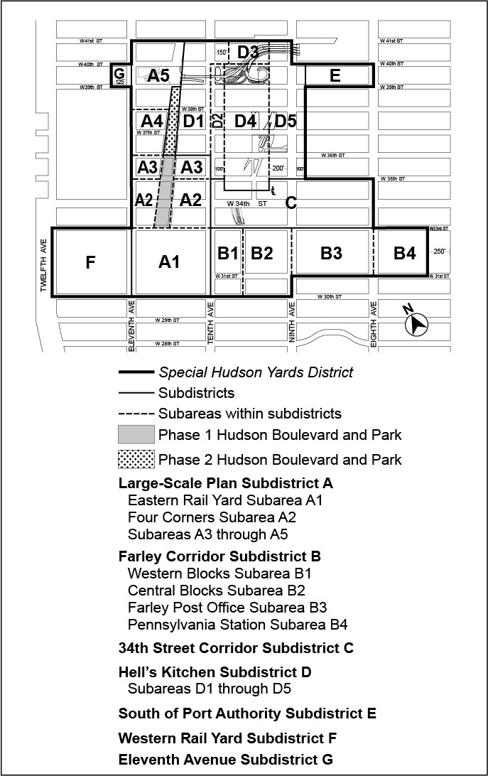

[PROPOSED MAP]

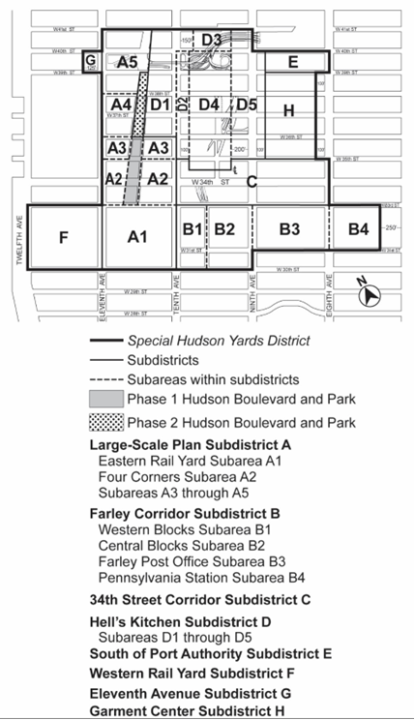

Map 2 — Mandatory Ground Floor Retail

[EXISTING MAP]

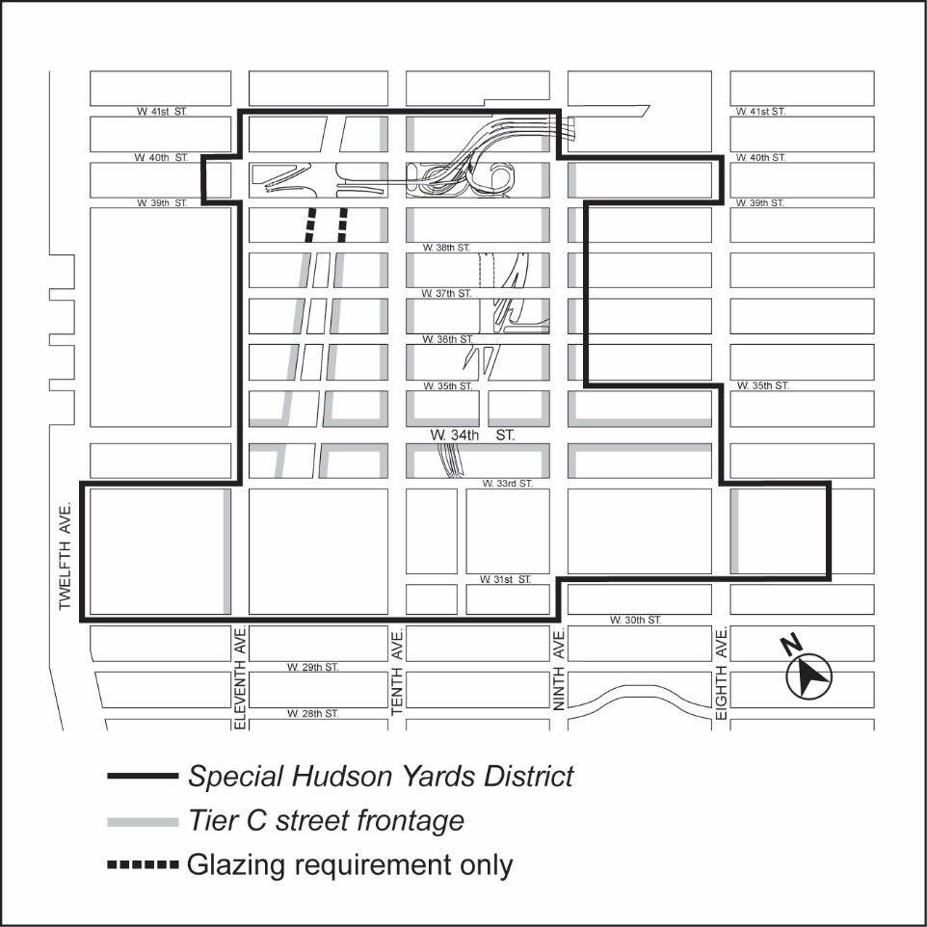

[PROPOSED MAP]

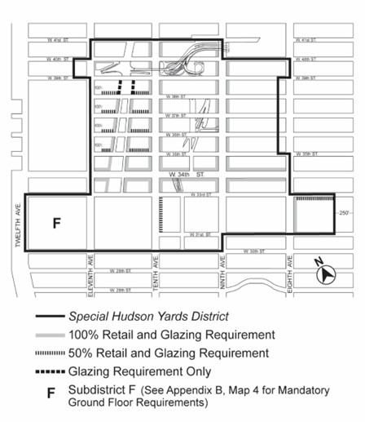

Map 3 — Mandatory Street Wall Requirements

[EXISTING MAP]

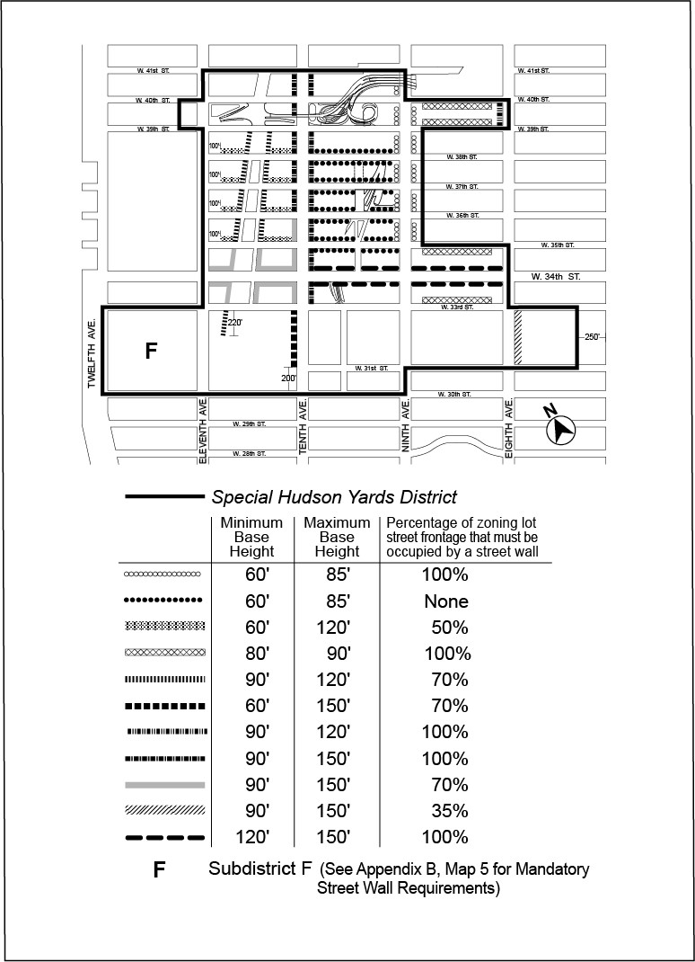

[PROPOSED MAP]
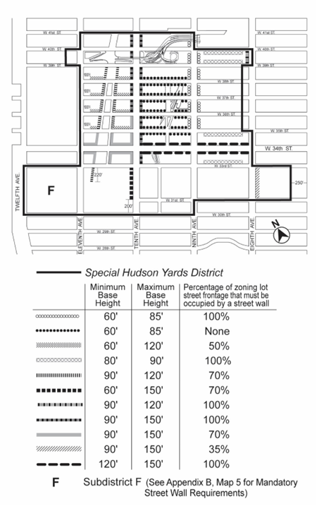

Map 4 — Mandatory Sidewalk Widenings

[EXISTING MAP]

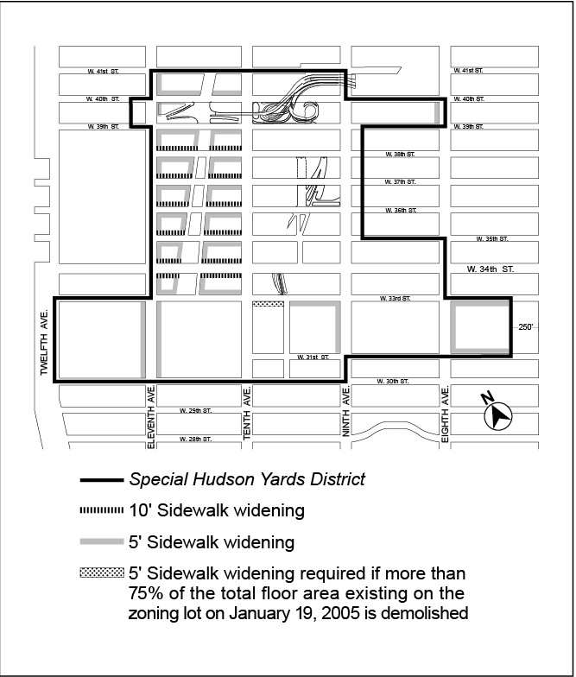

[PROPOSED MAP]
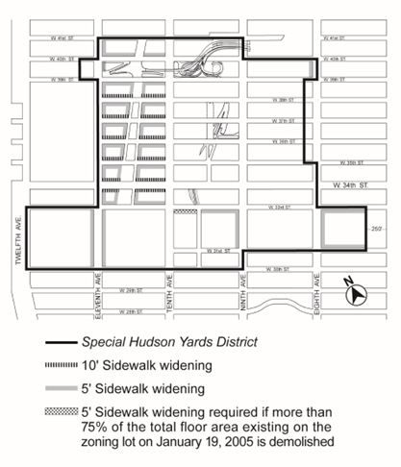

Map 5 — Transit Facilities (93-A5)

[EXISTING MAP]

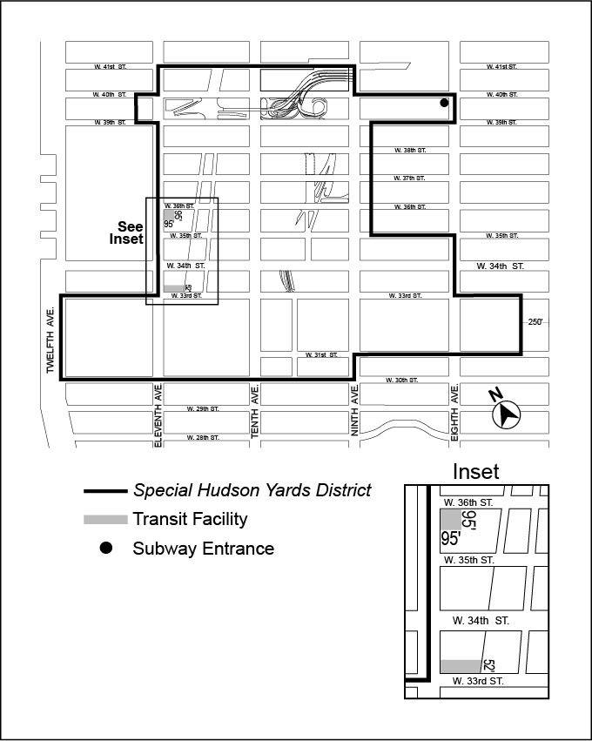

[PROPOSED MAP]
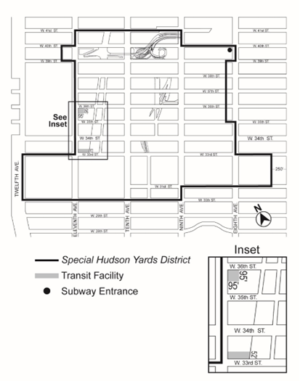

Map 6 — Sites Where Special Parking Regulations Apply (93-A6)

[EXISTING MAP]

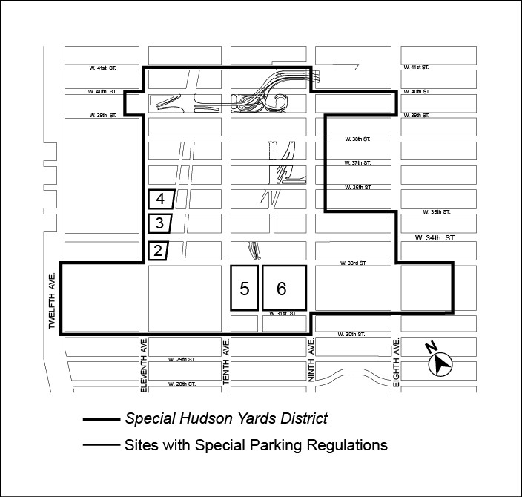

[PROPOSED MAP]
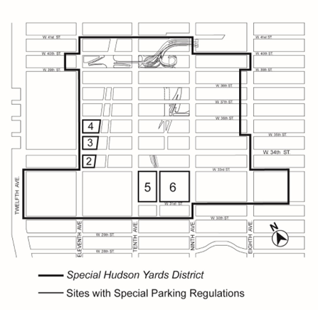

Chapter 6
Special Clinton District
* * *

96-10

PRESERVATION AREA
* * *
96-107
Harassment and cure

[REMOVING REFERENCE TO SPECIAL GARMENT CENTER DISTRICT]
* * *
- Certification of Cure for Harassment
* * *
  - No portion of the #low income housing# required under this Section shall qualify to:
    - increase the #floor area ratio# pursuant to Section 96-21 (Special Regulations for 42nd Street Perimeter Area); Section 96-22 (Special Regulations for Eighth Avenue Perimeter Area); any #floor area ratio# increase provision of the #Special Garment Center District#, #Special Hudson Yards District#, #Special West Chelsea District#; or requirements pursuant to Section 27-10 (ADMINISTRATION OF AFFORDABLE HOUSING); or
    - satisfy an eligibility requirement of any real property tax abatement or exemption program with respect to any #multiple dwelling# that does not contain such #low income housing#.
* * *

Chapter 8
Special West Chelsea District
* * *
98-70

SUPPLEMENTAL REGULATIONS

[REMOVING REFERENCE TO SPECIAL GARMENT CENTER DISTRICT]
* * *
Referral date
“Referral date” shall mean December 20, 2004.
In addition, Section 93-90, paragraph (d)(3), is modified as follows:
No portion of the #low income housing# required under this Section shall qualify to:
- increase the #floor area ratio# pursuant to the provisions of Section 27-10 (ADMINISTRATION OF AFFORDABLE HOUSING), inclusive, as modified by the provisions of the #Special West Chelsea District#, #Special Hudson Yards District#, #Special Garment Center District# or #Special Clinton District#; or
- satisfy an eligibility requirement of any real property tax abatement or exemption program with respect to any #multiple dwelling# that does not contain such #low income housing#.
* * *

ARTICLE XII
SPECIAL PURPOSE DISTRICTS
Chapter 1
Special Garment Center District (GC)
[SPECIAL GARMENT CENTER (GC) DISTRICT PROVISIONS BEING DELETED AND BEING REPLACED BY NEW SPECIAL MIDTOWN SOUTH MIXED USE DISTRICT TEXT. GC’S SUBDISTRICT A-2 INCORPORATED INTO SPECIAL HUDSON YARDS DISTRICT’S NEW SUBDISTRICT H]
121-00

GENERAL PURPOSES

The “Special Garment Center District” established in this Resolution is designed to promote and protect public health, safety, and general welfare. These general goals include, among others, the following specific purposes:
- to retain adequate wage and job-producing industries within the Garment Center;
- to provide an opportunity for apparel production and showroom space in designated areas of the Garment Center;
- to preserve a variety of types of space for a diversity of businesses that service the Garment Center and the city;
- to recognize the unique character of the western edge of the Special District as integral to the adjacent Special Hudson Yards District;
- to establish an appropriate urban scale and visual character within the Garment Center; and
- to promote the most desirable use of land within the district, to conserve the value of land and buildings, and thereby protect the City’s tax revenues.

121-01
General Provisions

The provisions of this Chapter shall apply within the #Special Garment Center District#. The regulations of all other Chapters of this Resolution are applicable, except as superseded, supplemented or modified by the provisions of this Chapter. In the event of a conflict between the provisions of this Chapter and other regulations of this Resolution, the provisions of this Chapter shall control. However, for #transit-adjacent sites# or #qualifying transit improvement sites#, as defined in Section 66-11 (Definitions), in the event of a conflict between the provisions of this Chapter and the provisions of Article VI, Chapter 6 (Special Regulations Applying Around Mass Transit Stations), the provisions of Article VI, Chapter 6 shall control.

121-02
District Plan
The regulations of this Chapter are designed to implement the #Special Garment Center District# Plan. The District Plan includes the following map:
Special Garment Center District and Subdistricts
The map is located in Appendix A of this Chapter and is hereby incorporated and made an integral part of this Resolution. It is incorporated for the purpose of specifying locations where special regulations and requirements set forth in the text of this Chapter apply.

121-03
Subdistricts
In order to carry out the purposes and provisions of this Chapter, two Subdistricts, A1 and A2 are established within the #Special Garment Center District#. The location of the Subdistricts is shown on the map (Special Garment Center District and Subdistricts) in Appendix A of this Chapter.

121-10

SPECIAL USE REGULATIONS
The #use# regulations of the applicable underlying district shall apply except as set forth in this Section.

121-11
Transient Hotels and Offices
For a #building# subject to the provisions of Section 121-60 (ANTI-HARASSMENT AND DEMOLITION REGULATIONS IN SUBDISTRICT A-2) and for which #HPD# issued a
#certification of no harassment# that was in effect on June 11, 2018, a special permit pursuant to Section 74-152 (In Commercial Districts) shall not be required where such #building# is #enlarged# and a portion of which is subsequently converted to #residences# pursuant to Article I, Chapter 5 (Residential Conversions Within Existing Buildings), provided all new #transient hotel# rooms shall be located in the #enlarged# portion of such #building#, and except for #transient hotel# lobbies and #accessory# #uses# located below the floor level of the second #story#, the non-#enlarged# portion of such #building# shall contain only permanently affordable #residences# pursuant to a #regulatory agreement# enforceable by #HPD#.
In Subdistrict A-2, any #development# or #enlargement# that includes #uses# listed under Offices in Use Group VII, #developed# or #enlarged# after January 19, 2005, shall be permitted only pursuant to Section 93-13 (Special Office Use Regulations).

121-12
C6-4M Districts in Subdistrict A-2
In the C6-4M District located within Subdistrict A-2, for #buildings# existing on January 19, 2005, the #use# regulations of the underlying district shall be modified as follows:
- For #buildings# with 70,000 square feet or more of #floor area#, the #conversion# of
non-#residential# #floor area# to #residences#, or to college or school student dormitories and fraternity or sorority student houses shall not be permitted.
- The following #uses# shall be allowed: From Use Group IX
All #uses# listed under Use Group IX(A) that are permitted in a C8 District From Use Group X
All #uses# listed under Use Group X that are permitted in a C8 District.

121-13
M1-6 District in Subdistrict A-1
In the M1-6 District located within Subdistrict A-1, #uses# listed under Use Groups IV(B), IX and X shall be limited to those permitted within M1 Districts in #Special Mixed Use Districts#, as set forth in Section 123-21 (Modifications to M1 Use Regulations), inclusive.

121-20

SIGN REGULATIONS
In the #Special Garment Center District#, all #signs# shall be subject to the regulations applicable in C6-4 Districts, as set forth in Section 32-60 (SIGN REGULATIONS). However, in Subdistrict A-2, #flashing signs# shall not be permitted.

121-30

SPECIAL BULK REGULATIONS WITHIN SUBDISTRICT A-1
The following special #bulk# regulations shall apply within Subdistrict A-1, as shown in Appendix A of this Chapter.

121-31
Maximum Permitted Floor Area Within Subdistrict A-1
The basic maximum #floor area ratio# of a #zoning lot# shall be as specified for the underlying district in Section 43-12 (Maximum Floor Area Ratio) and may be increased only pursuant to Section 43-13 (Floor Area Bonus for Public Plazas). No #public plaza#, or any part thereof, shall be permitted on or within 100 feet of a #wide street#. The provisions of Section 43-14 (Floor Area Bonus for Arcades) shall not apply.

121-32
Height of Street Walls and Maximum Building Height Area Within Subdistrict A-1
In Subdistrict A-1, the underlying height and setback regulations set forth in Sections 43-43 (Maximum Height of Front Wall and Required Front Setbacks) and 43-44 (Alternate Front Setbacks) shall not apply. In lieu thereof, the following provisions shall apply:
- #Street wall# location
The #street wall# of any #building# shall be located on the #street line# and extend along the entire #street# frontage of the #zoning lot# up to at least the maximum base height specified in paragraph (b) of this Section. On the ground floor, recesses shall be permitted where required to provide access to the #building#, provided such recesses do not exceed three feet in depth as measured from the #street line#. In addition, the #street wall# location provision of this paragraph shall not apply along such #street line# occupied by a #public plaza# as set forth in Section 37-70 (PUBLIC PLAZAS).
- Base height
  - Along #wide streets#
On #wide streets#, and on #narrow streets# within 50 feet of their intersection with a #wide street#, the #street wall# of a #building# shall rise without setback to a minimum base height of 125 feet and may rise to a maximum base height of 155 feet.
However, where the height of an existing adjacent #street wall# fronting on the same #street line# rises to a height exceeding 155 feet before setback, the maximum base height may be increased to the height of such existing adjacent #street wall# but shall not exceed a base height of 205 feet. In addition, where existing adjacent #street walls# on both sides of the #building# rise to a height exceeding 155 feet before setback, the maximum base height of such #building# may be increased to the higher of the two existing adjacent #street walls#, except in no instance shall the base height of such #building# exceed 205 feet.
  - Along #narrow streets#
On #narrow streets#, beyond 50 feet of their intersection with a #wide street#, the #street wall# of a #building# shall rise without setback to a minimum base height of 85 feet and may rise to a maximum base height of 135 feet.
As an alternative, the minimum and maximum base heights applicable to a #wide street# may be applied along a #narrow street# beyond 50 feet of a #wide street#, up to a maximum of 100 feet from such #wide street#.
- Required setbacks
  - Along #wide streets#
For #buildings#, or portions thereof, located on #wide streets# and on #narrow streets# within 100 feet of a #wide street#, the portion of such #building# above the applicable maximum base height set forth in paragraph (b)(1) of this Section, shall be set back from the #street wall# of the #building# at least 10 feet along a #wide street# and at least 15 feet along a #narrow street#, except such dimensions may include the depth of any permitted recesses in the #street wall#. Above such required setback, any portion of a #building# on the #zoning lot# shall be
considered a “tower.”
  - Along #narrow streets#
For #buildings#, or portions thereof, located on #narrow streets# beyond 100 feet of a #wide street#, the portion of such #building# above the applicable maximum base height set forth in paragraph (b)(2) of this Section shall be set back from the #street wall# of the #building# at least 15 feet along a #narrow street#, except such dimensions may include the depth of any permitted recesses in the #street wall#. Above such required setback, any portion of a #building# on the #zoning lot# shall be considered a “tower.”
- Tower Regulations
Each #story# of a tower above the required setback shall not exceed a maximum #lot coverage# of 40 percent of the #lot area# of a #zoning lot# or, for #zoning lots# of less than 20,000 square feet, the percent set forth in Section 43-451 (Towers on small lots).
- Maximum #building# height
No height limit shall apply to towers.

121-40

SPECIAL BULK REGULATIONS WITHIN SUBDISTRICT A-2
The following special #bulk# regulations shall apply within Subdistrict A-2, as shown on the map in Appendix A of this Chapter.

121-41
Maximum Permitted Floor Area Within Subdistrict A-2
The basic maximum #floor area ratio# of a #zoning lot# containing non-#residential buildings# shall be 10.0 and may be increased to a maximum #floor area ratio# of 12.0 pursuant to Section 93-31 (District Improvement Fund Bonus). Such #zoning lot# may also contain #residences# within #buildings# existing on January 19, 2005, provided that such #buildings# are not #enlarged# after such date. For #zoning lots# containing #residences# within a #building# that is #developed# or #enlarged# on or after January 19, 2005, the basic maximum #floor area ratio# shall be 6.5. The #floor area ratio# of any such #zoning lot# may be increased from 6.5 as follows:

- The #residential# #floor area# may be increased to a maximum of 12.0 where the following are met:
  - an amount of #floor area# equal to at least 20 percent of the total #residential# #floor area# is allocated to #qualifying affordable housing# or #qualifying senior housing#; and
  - a #floor area# increase or transfer equal to a #floor area ratio# of 2.5 has been earned pursuant to Section 93-31 or 93-32 (Floor Area Regulations in the Phase 2 Hudson Boulevard and Park).
- For the #conversion# to #dwelling units# of non-#residential buildings#, or portions thereof, where the total #floor area# on the #zoning lot# to be #converted# to #residential use# exceeds a #floor area ratio# of 12.0, such excess #floor area# shall be permitted only pursuant to Section 93-31.
For #developments# or #enlargements# on #qualifying transit improvement sites#, a #floor area# bonus for #mass transit station# improvements may be granted by the City Planning Commission pursuant to the provisions of Section 66-51 (Additional Floor Area for Mass Transit Station Improvements). As a pre-condition to applying for such #floor area# bonus, the applicant shall demonstrate that a #floor area ratio# of no less than 0.1 of the maximum #floor area ratio# pursuant to Section 93-31 or the provisions of paragraph (a) of this Section, has been achieved prior to, or in conjunction with, the application. For the purposes of this paragraph, defined terms additionally include those in Section 66-11 (Definitions).

121-42
Height of Street Walls and Maximum Building Height Within Subdistrict A-2
- Height of #street walls#

The #street wall# location provisions of paragraph (a) of Section 35-631 shall apply, except that the #street wall# shall extend to a minimum base height of 80 feet and a maximum base height of 90 feet before setback. However, if the height of an adjacent #street wall# fronting on the same #street line# is higher than 90 feet before setback, the #street wall# of the new or #enlarged# #building# may rise without setback to the height of such adjacent #street wall#, up to a maximum height of 120 feet.
For #zoning lots#, or portions thereof, with #street# frontage of 25 feet or less and existing on June 29, 2010, a minimum base height lower than 80 feet shall be permitted along such #street# frontage in accordance with the following provisions:
  - where the height of an adjacent #street wall# fronting on the same #street line# is at least 60 feet and less than 80 feet, the #street wall# of the new or #enlarged# #building# may rise without setback to the height of such adjacent #street wall#; or
  - where the height of an adjacent #street wall# fronting on the same #street line# is less than 60 feet, the #street wall# of the new or #enlarged# #building# may rise without setback to a minimum #street wall# height of 60 feet.
The #street wall# of any #building# may rise to a height less than the minimum base height required pursuant to this paragraph (a), provided that no #building# on the #zoning lot# exceeds such height, except where such #building# is located on a #zoning lot# with multiple #buildings#, one or more of which is #developed#, #enlarged# or altered after February 2, 2011, to a height exceeding the minimum base height required pursuant to this paragraph (a).
- Maximum #building# height

Above a height of 90 feet or the height of the adjacent #street wall# if higher than 90 feet, no portion of a #building or other structure# shall penetrate a #sky exposure plane# that begins at a height of 90 feet above the #street line#, or the height of the adjacent #street wall# if higher than 90 feet, and rises over the #zoning lot# at a slope of four feet of vertical distance for each foot of horizontal distance to a maximum height limit of 250 feet, except as provided below:
  - any portion of the #building or other structure# #developed# or #enlarged# pursuant to the tower regulations of Section 33-45 (Tower Regulations) or paragraph (d) of Section 35-632 (Maximum height of buildings and setback regulations), as applicable, may penetrate the #sky exposure plane#, provided no portion of such #building or other structure# exceeds the height limit of 250 feet; and
  - permitted obstructions, as listed in Section 33-42, may penetrate the #sky exposure plane# and the height limit of 250 feet. In addition, a dormer shall be allowed as a permitted obstruction pursuant to paragraph (b) of Section 23-413 (Permitted obstructions in certain districts).

On a #zoning lot# with frontage of at least 200 feet along at least one #street#, up to 20 percent of the #aggregate width of the street wall# facing such #street#, for a maximum width of 50 feet, may be recessed to a maximum depth of 15 feet from the #street line#, provided the recessed area is located a minimum of 20 feet from an adjacent #building# and that a minimum of 60 percent of such area is planted with any combination of grass, ground cover, shrubs, trees or other living plant material in the ground or in planters permanently affixed to the ground.

121-50

PARKING PROVISIONS FOR SUBDISTRICT A-2
Within Subdistrict A-2, as shown on the map in Appendix A of this Chapter, the underlying parking provisions shall not apply. In lieu thereof, the parking regulations of the #Special Hudson Yards District#, as set forth in Section 93-80 (OFF-STREET PARKING REGULATIONS) shall apply.

121-60

ANTI-HARASSMENT AND DEMOLITION REGULATIONS IN SUBDISTRICT A-2
In Subdistrict A-2, the provisions of Section 93-90 (HARASSMENT) and Section 93-91 (Demolition), inclusive, shall apply.

Appendix A
Special Garment Center District and Subdistricts
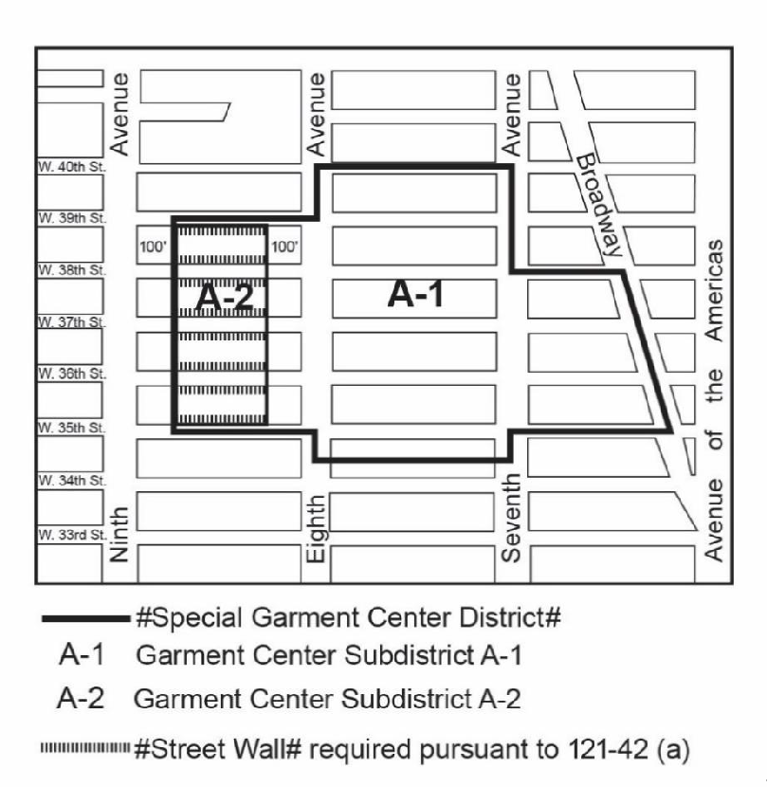

Chapter 1
Special Midtown South Mixed Use District (MSX)
[SPECIAL GARMENT CENTER (GC) DISTRICT PROVISIONS BEING DELETED AND BEING REPLACED BY NEW SPECIAL MIDTOWN SOUTH MIXED USE DISTRICT TEXT. GC’S SUBDISTRICT A-2 INCORPORATED INTO SPECIAL HUDSON YARDS DISTRICT’S NEW SUBDISTRICT H]

121-00
GENERAL PURPOSES
The “Special Midtown South Mixed Use District” established in this Resolution is designed to promote and protect public health, safety, and general welfare. These general goals include, among others, the following specific purposes:
- to retain adequate wage and job-producing industries within the Midtown South District;
- to preserve a variety of types of space for a diversity of businesses that service the Midtown South District and the city;
- to establish an appropriate urban scale and visual character within the Midtown South District;
- to provide opportunities for housing growth through office to residential conversions and new development; and
- to promote the most desirable use of land within the district, to conserve the value of land and buildings, and thereby protect the City’s tax revenues.

121-01
General Provisions
The provisions of this Chapter shall apply within the #Special Midtown South Mixed Use District. The regulations of all other Chapters of this Resolution are applicable, except as superseded, supplemented or modified by the provisions of this Chapter. In the event of a conflict between the provisions of this Chapter and other regulations of this Resolution, the provisions of this Chapter shall control. However, for #transit-adjacent sites# or #qualifying transit improvement sites#, as defined in Section 66-11 (Definitions), in the event of a conflict between the provisions of this Chapter and the provisions of Article VI, Chapter 6 (Special Regulations Applying Around Mass Transit Stations), the provisions of Article VI, Chapter 6 shall control.

121-02
Definitions
For the purposes of this Chapter, matter in italics is defined in Sections 12-10 (Definitions) or 32-301 (Definitions).

121-03
District Plan
The regulations of this Chapter are designed to implement the #Special Midtown South Mixed Use District# Plan. The District Plan includes the following map:
Special Midtown South Mixed Use District
The map is located in Appendix A of this Chapter and is hereby incorporated and made an integral part of this Resolution. It is incorporated for the purpose of specifying locations where special regulations and requirements set forth in the text of this Chapter apply.

121-04
Applicability of the Mandatory Inclusionary Housing Program

For the purposes of applying the Mandatory Inclusionary Housing Program provisions set forth in Section 27-10 (ADMINISTRATION OF AFFORDABLE HOUSING), #Mandatory
Inclusionary Housing areas# within the #Special Midtown South Mixed Use District# are shown on the maps in APPENDIX F of this Resolution.
For #conversions# in #buildings# existing prior to [date of adoption], that are not otherwise subject to paragraph (a)(3)(v) of Section 27-131 (Mandatory Inclusionary Housing), the Board of Standards and Appeals may permit a contribution to the #affordable housing fund#, pursuant to the provisions of Section 73-624 (Modification of Affordable Housing Fund payment options in the SoHo NoHo Mixed Use District and the Special Midtown South Mixed Use District).

121-05
Applicability of Article XII, Chapter 3
In the #Special Midtown South Mixed Use District#, M1 Districts are paired with a #Residence District#. In paired districts, the special #use#, #bulk#, and parking and loading provisions of Article XII, Chapter 3 (Special Mixed Use District) shall apply, except where modified by the provisions of this Chapter.
Notwithstanding the provisions of Section 123-10 (GENERAL PROVISIONS), in the event of a conflict between the provisions of this Chapter and the provisions of Article XII, Chapter 3, the provisions of this Chapter shall control.

121-10
SPECIAL USE REGULATIONS
Within the #Special Midtown South Mixed Use District# the #use# provisions of Article XII, Chapter 3 or the underlying district, as applicable, are modified by the provisions of this Section, inclusive.

121-11
Regulations for M1-9A Districts
In M1A Districts without a paired #Residence District#, #uses# listed under Use Groups IV(B), IX and X shall be limited to those permitted within M1 Districts paired with #Residence Districts# pursuant to the provisions of Section 123-21 (Modifications to M1 Use Regulations), inclusive.

121-11 121-12
Regulations for Use Group VI
In addition to all #uses# permitted in the designated M1A District, all #uses# listed under Use Group VI shall be permitted, and where such #uses# have a size limitation, as denoted with an “S” in the use group tables set forth in Section 42-16 (Use Group VI – Retail and Services), such size limitation shall not apply.

121-12 121-13
Streetscape Regulations
The underlying #ground floor level# streetscape provisions set forth in Section 32-30 (STREETSCAPE REGULATIONS), inclusive, shall apply, except that #ground floor level# #street# frontages along #streets#, or portions thereof, designated on Map 1 in the Appendix to this Chapter shall be considered #Tier C street frontages#.

121-20
SIGN REGULATIONS
All #signs# shall be subject to the regulations applicable in C6-4 Districts, as set forth in Section 32-60 (SIGN REGULATIONS). However, #flashing signs# shall not be permitted.

121-30
SPECIAL BULK REGULATIONS
Within the #Special Midtown South Mixed Use District# the #bulk# provisions of Article XII, Chapter 3 or the underlying district, as applicable, are modified by the provisions of this Section, inclusive.

121-31
Floor Area Exemption for Public Schools
On #zoning lots# above 20,000 square feet in #lot area#, up to 150,000 square feet of #floor area# within a public #school#, constructed in whole or in part pursuant to agreement with the New York City School Construction Authority and subject to the jurisdiction of the New York City Department of Education, shall be exempt from the definition of #floor area# for the purposes of calculating the permitted #floor area ratio# for #community facility# #uses# and the maximum #floor area ratio# of the #zoning lot#.

121-32
Yard and Open Area Regulations

121-321
Rear yard equivalent
Where the designated #Residence District# is an R6 through R12 District without a letter suffix, for #buildings#, or portions thereof, containing #residential uses#, the alternative location allowances set forth in paragraph (c)(2) of Section 23-343 (Rear yard equivalent requirements) shall not apply.

121-322
Minimum distance between buildings
On In M1 Districts paired with a #Residence District#, on any single #zoning lot#, if two or more #buildings# or portions of #buildings# are detached from one another at any level, such #buildings# or portions of #buildings# shall at no point be less than eight feet apart.

121-33
Height and Setback Regulations
All #zoning lots# shall follow the underlying height and setback regulations.

121-331
Street wall regulations
For all #buildings#, 100 percent of the width of #street walls# along a #street# frontage at the #ground floor level# shall be located within eight feet of the #street line#. For any #story# above the #ground floor level#, at least 70 percent of the width of #street walls# shall be located within eight feet of the #street line# and extend to at least a minimum base height of 60 feet, or the height of the #building#, whichever is less; or as modified by Section 121-332 (Base Height Regulations). Up to 30 percent of the #aggregate width of street walls# above the ground floor may be recessed beyond eight feet of the #street line#, provided that any such recesses deeper than 10 feet along a #wide street# or 15 feet along a #narrow street# are located within an #outer court#. In addition, the #street wall# location provision of this paragraph shall not apply along such #street line# occupied by a #public plaza# as set forth in Section 37-70 (PUBLIC PLAZAS), nor within 15 feet of a landmark #building or other structure#.

121-332
Base height regulations
The Except for #zoning lots# located south of West 31st Street and east of Avenue of the Americas, the maximum base height of a #street wall# may vary between the applicable maximum set forth in the underlying regulations, inclusive, and the height of the #street wall# of adjacent #building# before setback, if such height is higher than the maximum base height.

121-34
Additional Bulk Modifications

121-341
Transfer of development rights from landmarks
For #zoning lots# existing on [date of enactment] containing landmark #buildings or other structures#, where more than 50 percent of the #lot area# is located within the #Special Midtown South Mixed Use District#, the provisions of Section 77-22 (Floor Area Ratio) shall be modified to permit the distribution of #floor area# anywhere on the #zoning lot#, regardless of the district boundary.
121-342
Transfer of development rights from Theater Subdistrict
For #zoning lots# #abutting# the Theater Subdistrict of the #Special Midtown District#, the boundaries for which are shown in Map 1 of Appendix A of Article VIII Chapter 1, the provisions of Section 81-744 (Transfer of development rights from listed theaters) may be applied and such #zoning lots# may be “receiving sites” as defined in such section.

Appendix A
Special Midtown South Mixed Use District

Map 1. Special Midtown South Mixed Use District

[PROPOSED MAP]
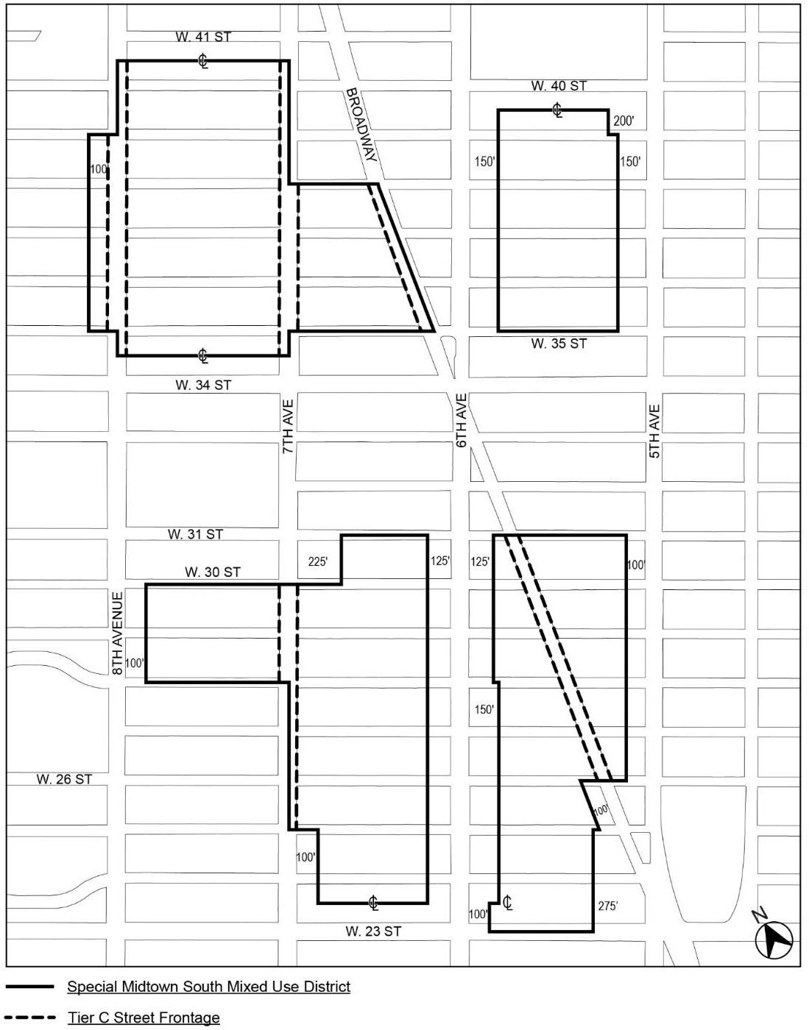

* * *

APPENDIX F
Mandatory Inclusionary Housing Areas and former Inclusionary Housing Designated Areas

MANHATTAN
* * *
Manhattan Community District 5
Map 1 – (9/21/11)

[EXISTING MAP]
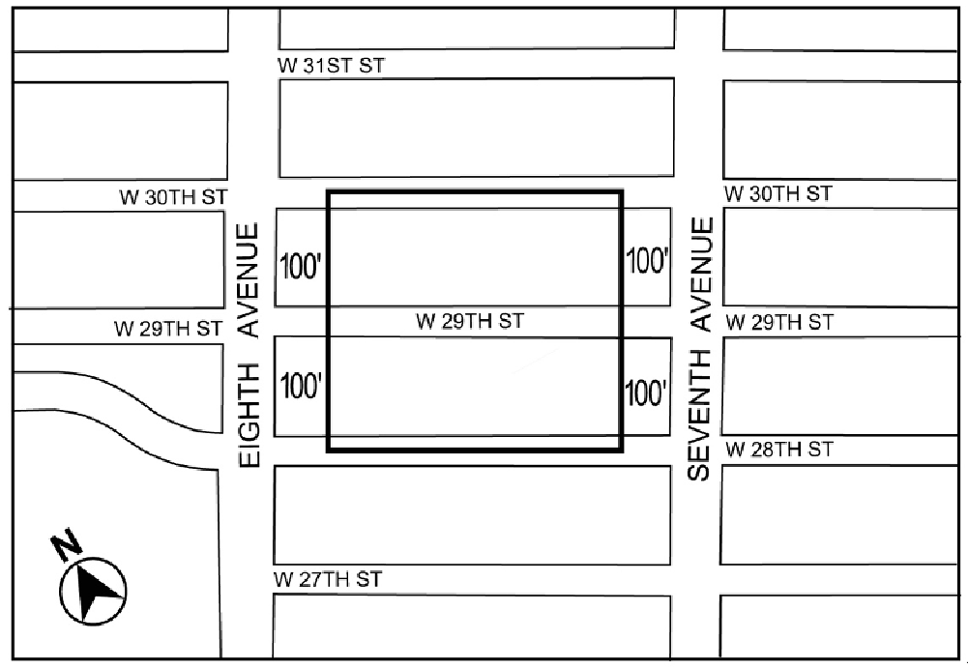
Portion of Community District 5, Manhattan

Manhattan Community Districts 4 and 5
Map 1 – [date of adoption]

[MAP APPROVED BY CPC]

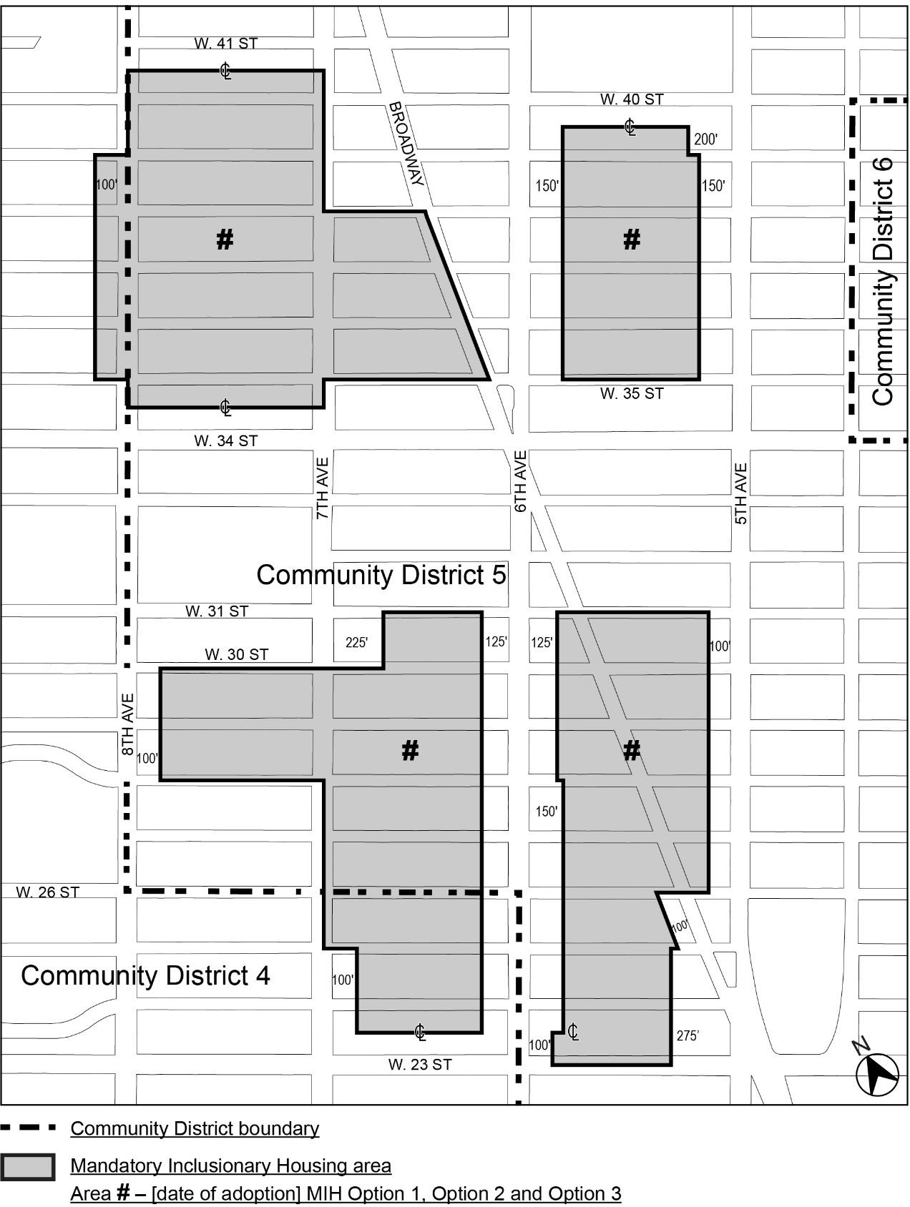
Portions of Community Districts 4 and 5, Manhattan

[PROPOSED MAP – MODIFIED BY CITY COUNCIL]
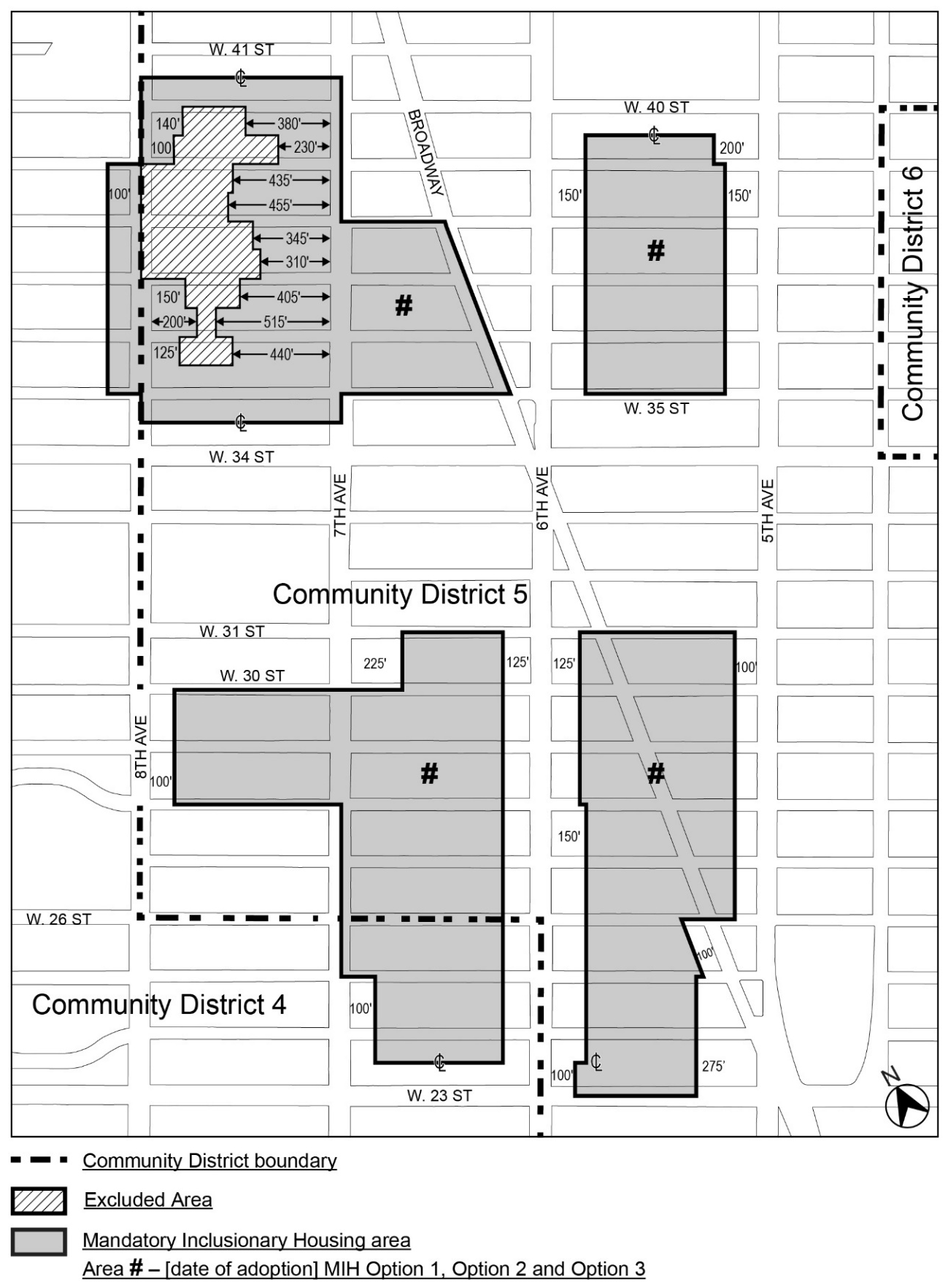
* * *

Adopted.

Office of the City Clerk,}
The City of New York,} ss.:

I hereby certify that the foregoing is a true copy of a Resolution passed by The Council of The City of New York on _________, 2025, on file in this office.

.....................................................
City Clerk, Clerk of The Council

