THE COUNCIL OF THE CITY OF NEW YORK
RESOLUTION NO. 433

Resolution approving the decision of the City Planning Commission on ULURP No. N 250320 ZRR, for a Zoning text amendment (L.U. No. 46).

By Council Members Riley and Louis

WHEREAS, Hamilton Property Holdings LLC, filed an application pursuant to Section 201 of the New York City Charter, for an amendment of the Zoning Resolution of the City of New York, amending the Appendix to Article XII, Chapter 8 (Special St. George District) and APPENDIX F for the purpose of establishing a Mandatory Inclusionary Housing area, Borough of Staten Island, Community District 1. (ULURP No. N 250320 ZRR) (the "Application");

WHEREAS, the City Planning Commission filed with the Council on March 6, 2026 its decision dated March 4, 2025 (the "Decision") on the Application;

WHEREAS, the Application is related to application C 250318 ZMR (L.U. No. 45), a zoning map amendment to eliminate a Special Hillsides Preservation District, change from an R6 District to an R7-3 District, establish within the proposed R7-3 District a C2-4 District, and establish a Special St. George District;

WHEREAS, the Decision is subject to review and action by the Council pursuant to Section 197-d of the City Charter;

WHEREAS, upon due notice, the Council held a public hearing on the Decision and Application on March 18, 2026;

WHEREAS, the Council has considered the land use and other policy issues relating to the Decision and Application; and

WHEREAS, the Council has considered the relevant environmental issues, including the Type II Memorandum issued on October 31, 2025, pursuant to the City’s Green Fast Track for Housing process (CEQR No. 25DCP090R), which includes an (E) designation to avoid the potential for significant adverse impacts related to hazardous materials, air quality, and noise (E-856) (the “Type II Memorandum”);

RESOLVED:

The Council finds that the action described herein will have no significant impact on the environment as set forth in the Type II Memorandum.

Pursuant to Sections 197-d and 200 of the New York City Charter and the Decision and Application, the environmental determination and consideration described in the report, N 250320 ZRR, incorporated by reference herein, and the record before the Council, the Council approves the Decision of the City Planning Commission.
The Zoning Resolution of the City of New York, effective as of December 15, 1961, and as subsequently amended, is further amended as follows:
Matter underlined is new, to be added; Matter struck out is to be deleted;
Matter within # # is defined in Section 12-10;
* * * indicates where unchanged text appears in the Zoning Resolution
* * *
ARTICLE XII
SPECIAL PURPOSE DISTRICTS
Chapter 8 – Special St. George District (SG)
Appendix – Special St. George District Plan
Map 1 – Special St. George District and Subdistricts [date of adoption]
[EXISTING MAP]
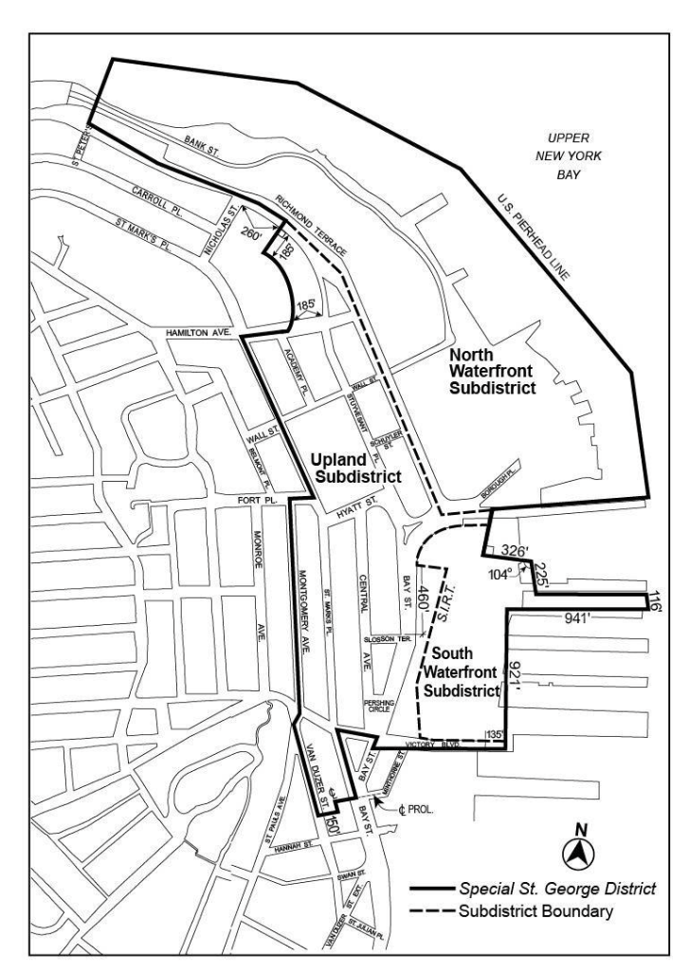

[PROPOSED MAP]

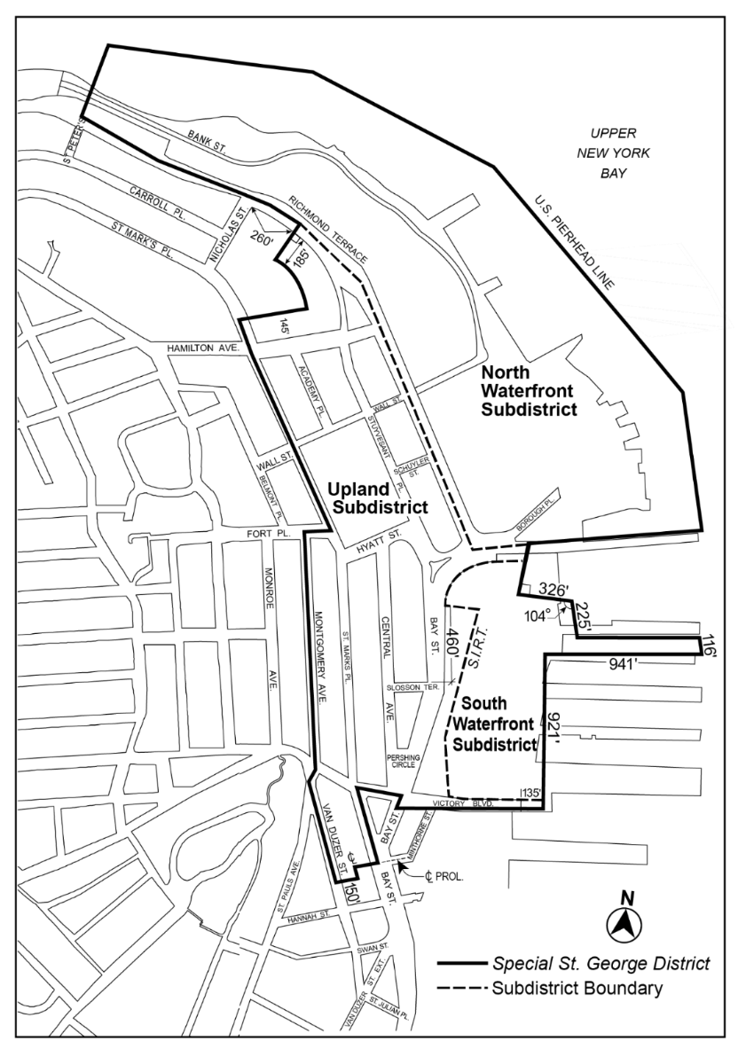

Map 2 – Commercial Streets [date of adoption]

[EXISTING MAP]
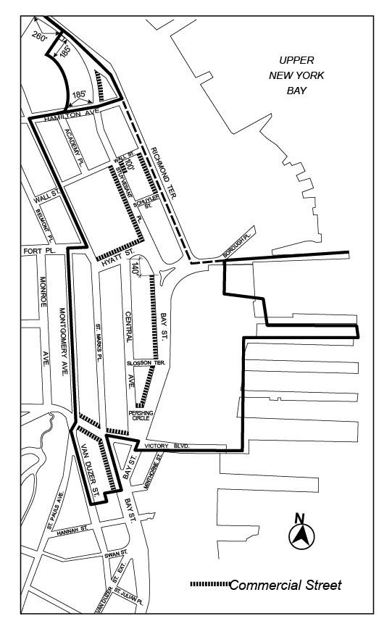

[PROPOSED MAP]
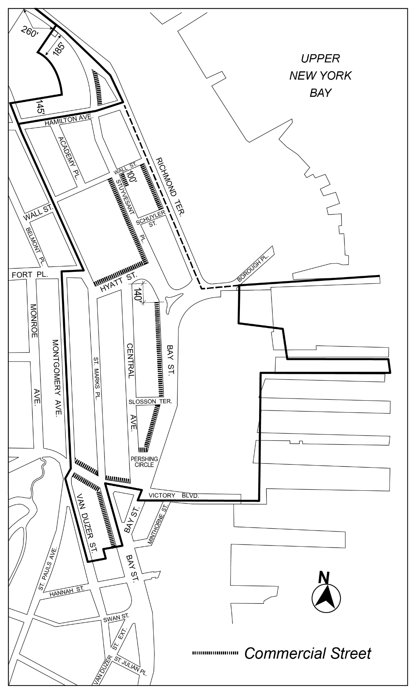

Map 3 – Minimum and Maximum Base Heights [date of adoption]
[EXISTING MAP]
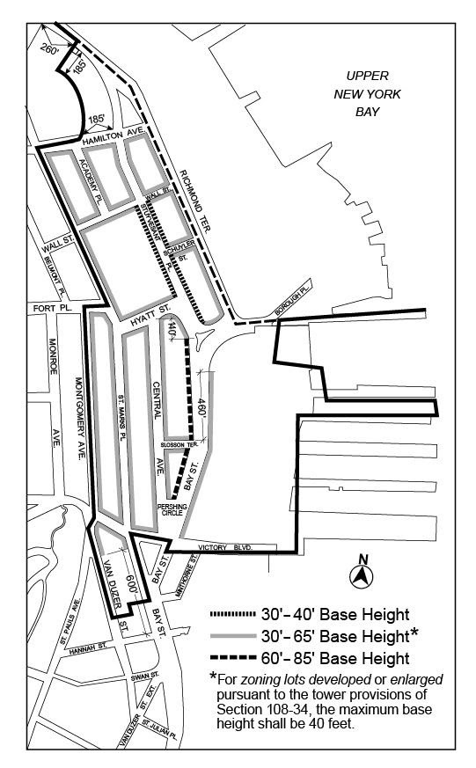

[PROPOSED MAP]
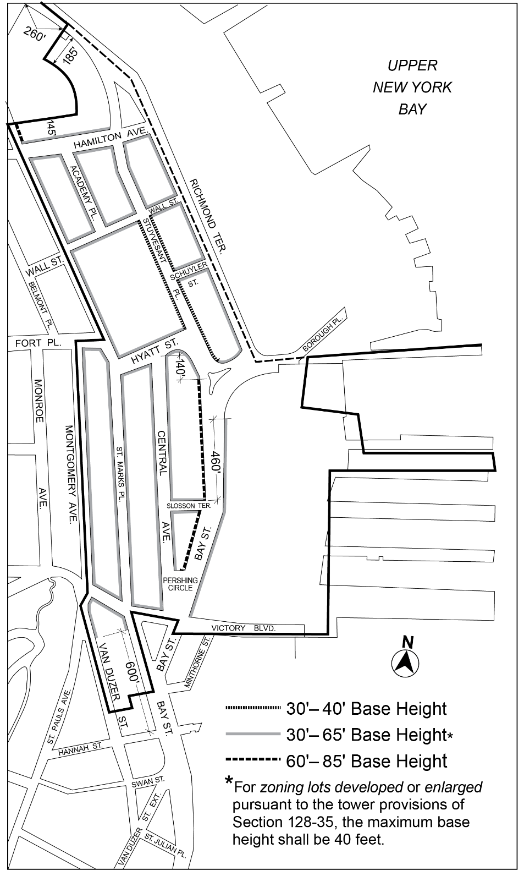

Map 4 – Tower Restriction Areas [date of adoption]
[EXISTING MAP]
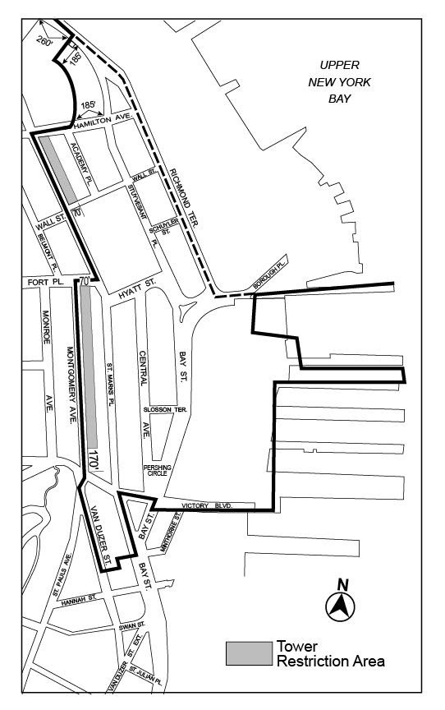

[PROPOSED MAP]
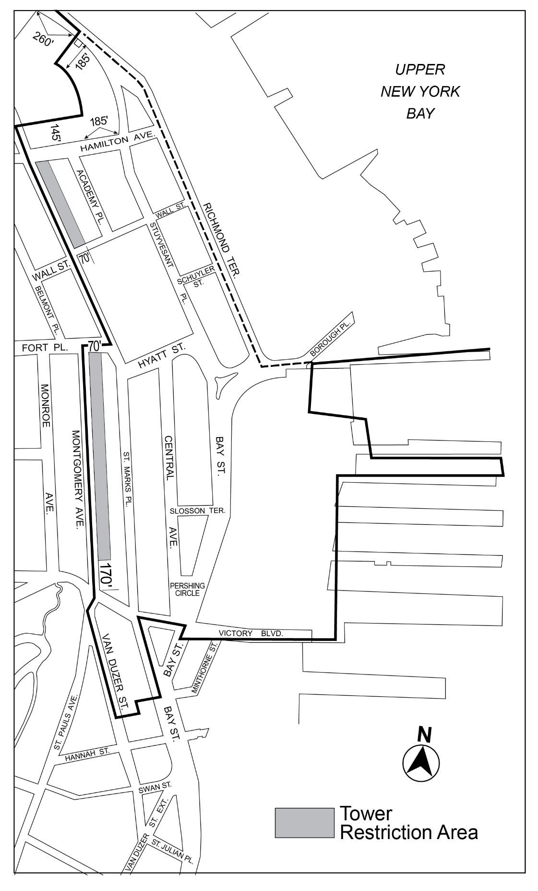

Map 5 – Visual Corridors and Parcels [date of adoption]
[EXISTING MAP]
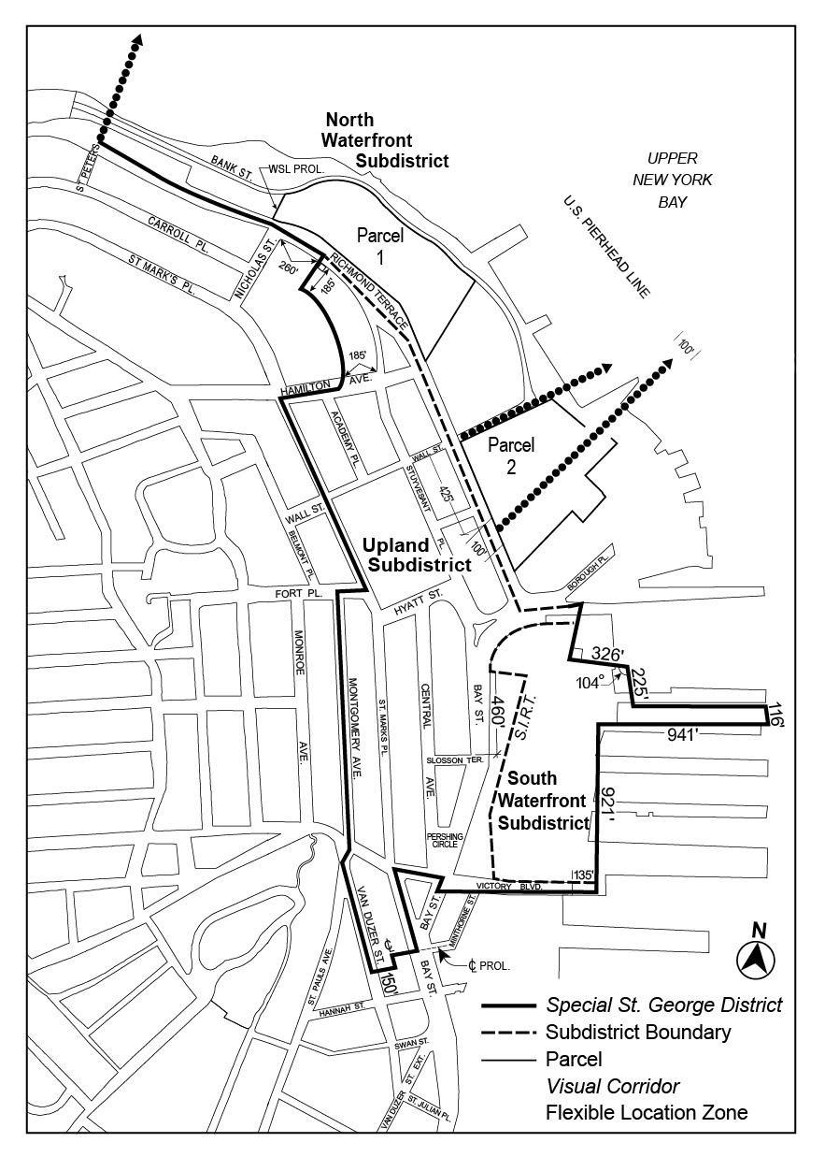

[PROPOSED MAP]
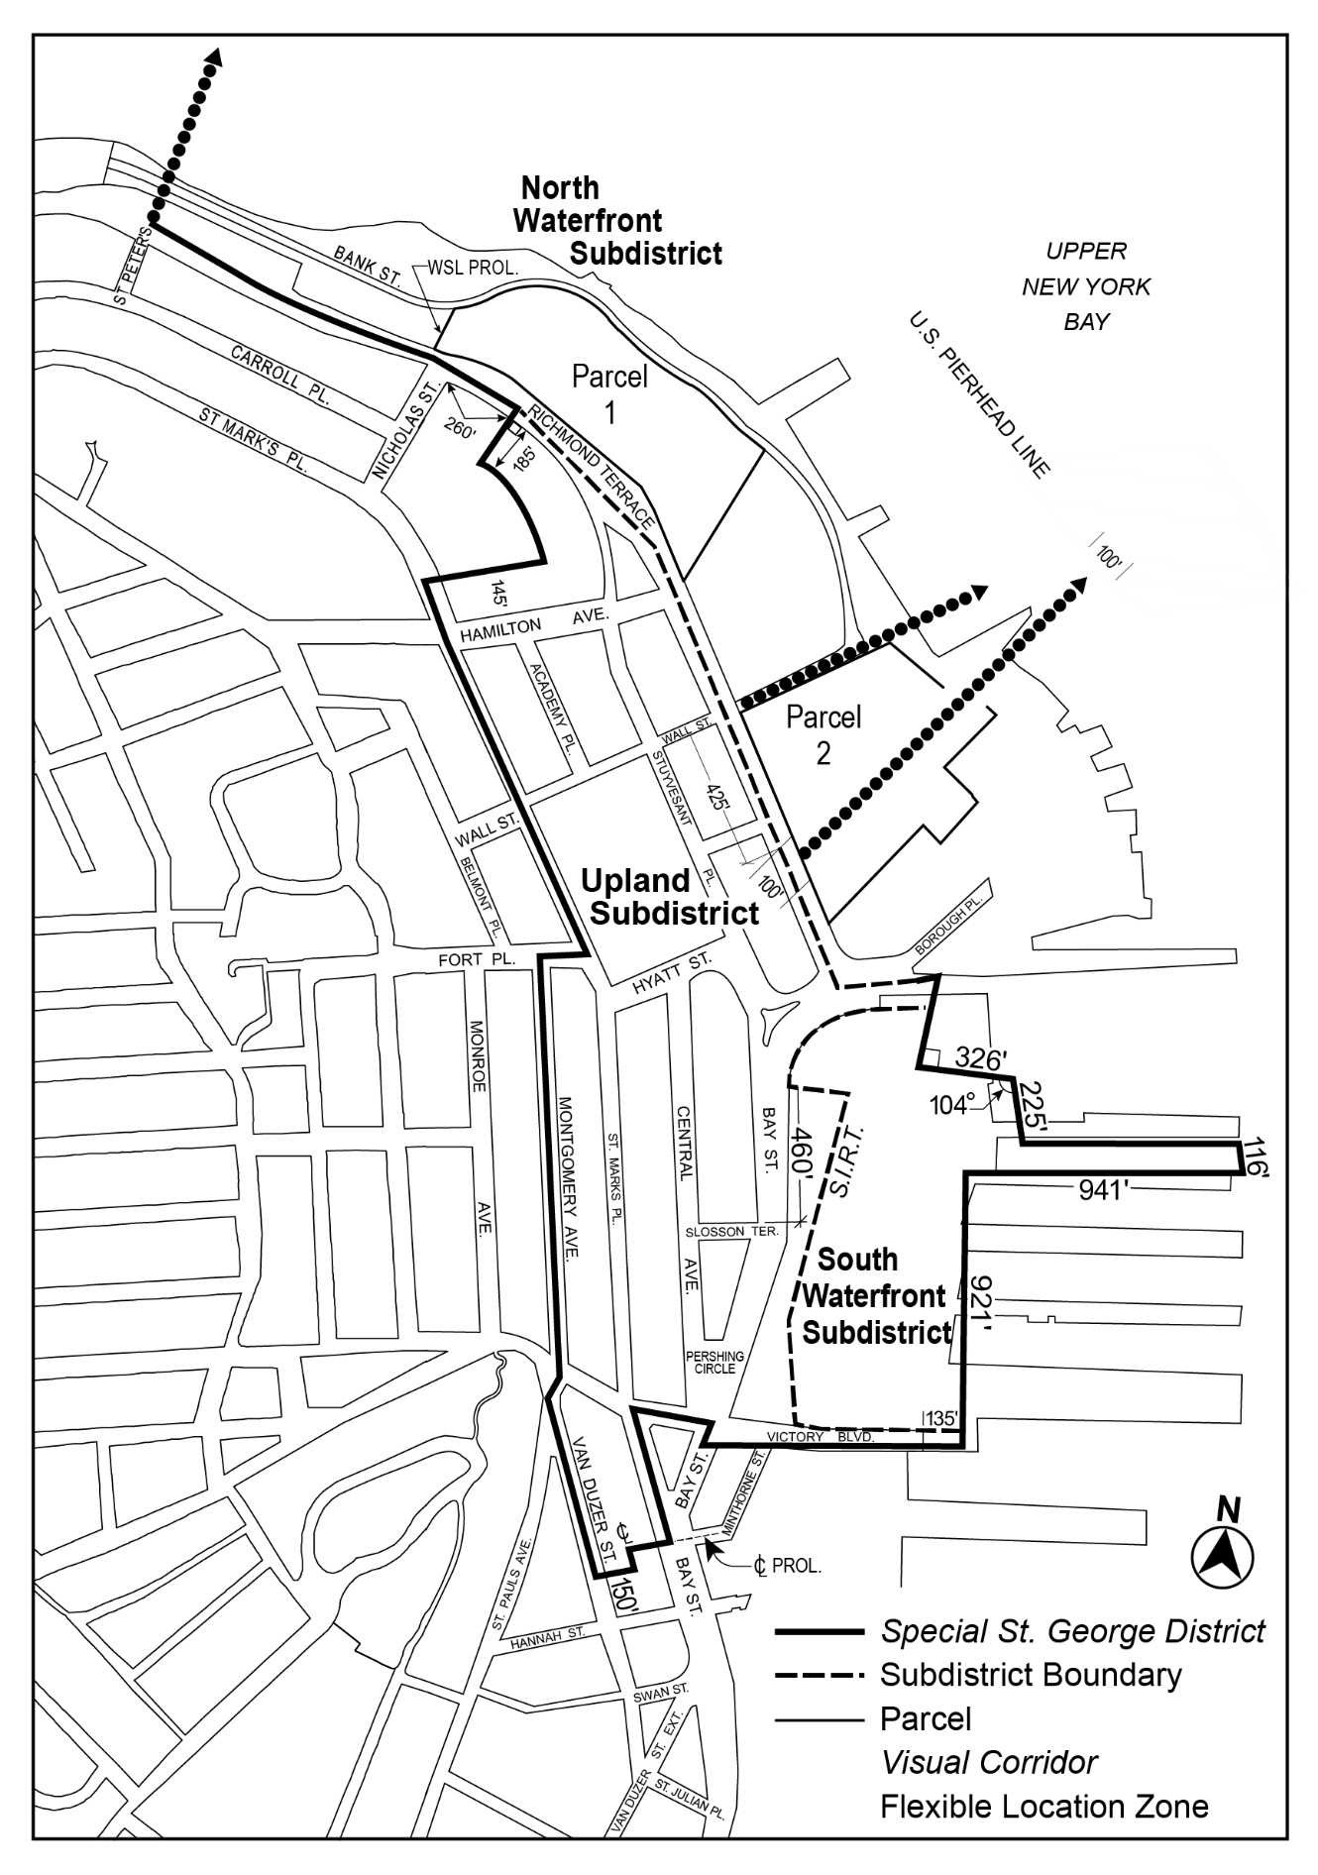

* * *

APPENDIX F
Mandatory Inclusionary Housing Areas and former Inclusionary Housing Designated Areas

* * *
STATEN ISLAND

Staten Island Community District 1
* * *
Map 3 – [date of adoption]
[EXISTING MAP]
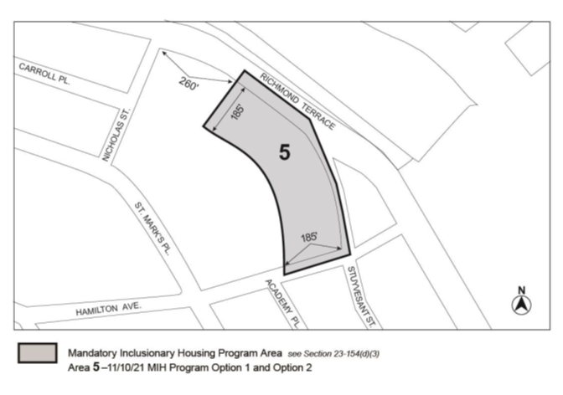
[PROPOSED MAP]
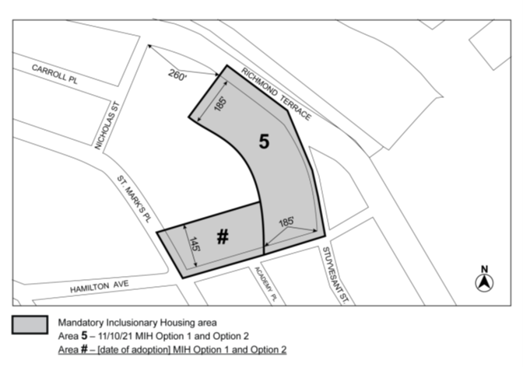
Portion of Community District 1, Staten Island

* * *

Adopted.

Office of the City Clerk, }
The City of New York, } ss.:

I hereby certify that the foregoing is a true copy of a Resolution passed by The Council of The City of New York on _______________, on file in this office..

.....................................................
City Clerk, Clerk of The Council

