Oversight & Investigations Committee Staff
Nicole Catá, Legislative Counsel
Alex Yablon, Legislative Policy Analyst
Erica Cohen, Legislative Policy Analyst
Owen Kotowski, Financial Policy Analyst



THE COUNCIL OF THE CITY OF NEW YORK

BRIEFING PAPER OF THE GOVERNMENTAL AFFAIRS DIVISION

Andrea Vazquez, Director, Legislative Division

Rachel Cordero, Deputy Director, Governmental Affairs, Legislative Division

COMMITTEE ON OVERSIGHT & INVESTIGATIONS
Hon. Gale A. Brewer, Chair

May 2, 2024

Oversight – The Department of Investigation’s Oversight of NYC’s Marshals

INTRODUCTION

On May 2, 2024, the Committee on Oversight and Investigations, chaired by Council Member Gale A. Brewer, will conduct an oversight hearing on the Department of Investigation’s oversight of NYC’s marshals. Those invited to testify include representatives from the New York City Department of Investigation (DOI) and other interested stakeholders and members of the public.
BACKGROUND
- NYC’s Marshals
The Dutch founders of New York City created the marshal system in 1655. The New York City marshals are private citizens appointed by the city primarily to enforce orders from Civil Court cases, “including collecting on judgments, towing, seizing utility meters and carrying out evictions.” Marshals “collectively perform approximately 25,000 evictions per year.” Marshals “are regulated by DOI but, unlike the City Sheriff, they are not City employees.” Marshals are regulated by state law, not by New York City law.
The Mayor appoints city marshals for five-year terms, with no term limits. State law limits the number of marshals to 83. Between 29 and 31 marshals currently work in NYC. Neither current nor past mayoral administrations have always appointed new marshals despite remaining open slots. As recently as 2008, the city had as many as 46 active marshals.
As private citizens not paid by the city, the marshals receive compensation from fees set by state schedule as well as a 5% cut of collections known as “poundage.” In return, marshals pay the city an annual assessment of $1,500 as well as 4.5% of their gross income.
As determined by state law, Section 1601 of the New York City Civil Court Act, the Mayor appoints marshals after receiving up to three recommendations per opening from the Mayor’s Committee on City Marshals. The committee was established by a 1980 executive order. The mayor appoints all fifteen members of the committee. The Mayor appoints six of the members directly, three after selection by Presiding Justice of the Appellate Division, First Judicial Department, three after selection by the Presiding Justice of the Second Judicial Department, and three after selection by the deans of three New York City law schools, who each select one member for appointment. Currently, the Committee lists only twelve members.
- DOI’s Oversight of NYC’s Marshals
DOI has only limited oversight over the marshals, which are not technically part of city government and are a creation of state law. The revenue generated by the program is ultimately a function of the number of evictions and the number of marshals available to carry them out. The number of evictions is largely a consequence of economic trends, and the number of marshals is determined by political appointments. DOI does not publish any regular report on the marshals beyond annual revenue.
DOI’s supervisory powers “include the power to conduct investigations into marshals’ activities, examine their books and records, promulgate directives concerning the official records to be kept by them and the procedures for performing their official duties, as well as the power to discipline them.” These powers are set forth in Joint Administrative Orders 453 and 456 of the Appellate Divisions for the First and Second Judicial Departments. DOI’s Marshals Handbook sets forth the agency’s directives for official conduct and record keeping. Among other topics, the handbook includes information about marshal integrity and discipline, levies, sales, summary proceedings, income execution, recovery of chattels, attachment, the restriction of marshals’ authority, fiscal and administrative requirements, required bank accounts, maintenance of marshals’ records, and requirements regarding an annual financial statement.
The Fiscal 2025 Preliminary Budget for the Department of Investigation includes approximately $353,000 in Fiscal 2024 – 2027 for the Marshals Program. The majority of the funding goes to support six full-time salaries. The remaining funding is for overtime, longevity differential and supper money. The $353,000 in FY24 represented a $3,919 increase from FY 2023 when DOI had approximately $348,600 budgeted for the same six positions.
ISSUES AND CONCERNS
- Relationship between Revenue and Evictions
Marshals enforce court judgments, which include serving evictions. State law sets the fees marshals collect for conducting evictions. Although DOI does not collect data on how much of the marshals’ revenue comes directly from evictions, the revenue numbers from the recent eviction moratorium may help illuminate the relationship between the marshals’ revenue and evictions.
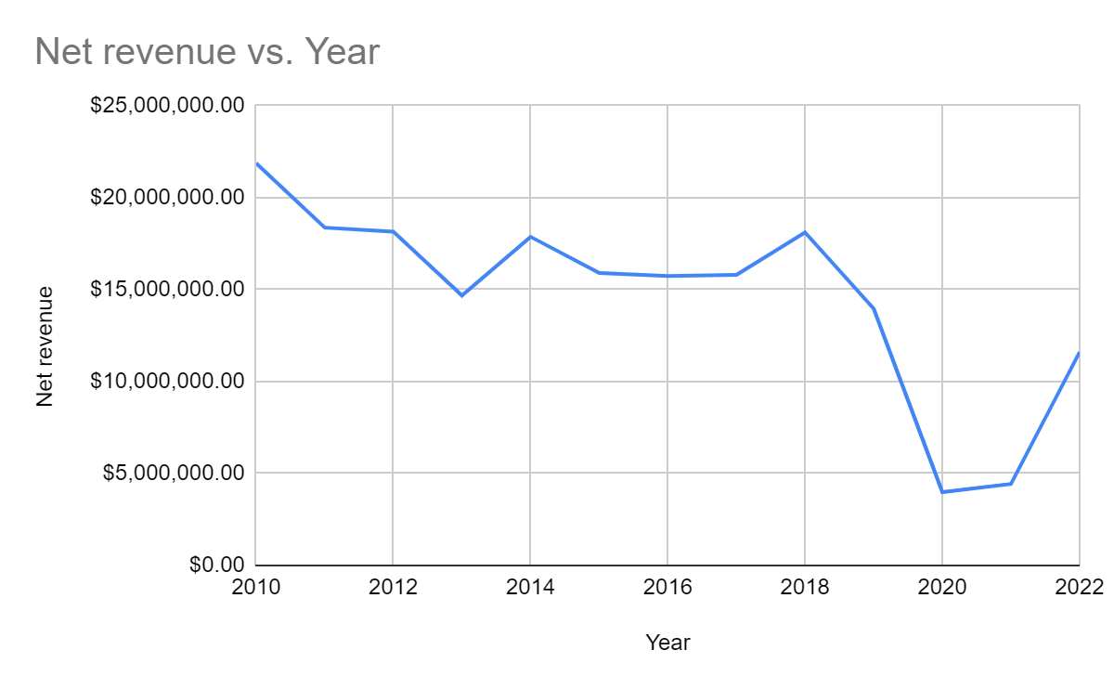Source: New York City Department of Investigation
Although marshal revenues recovered sharply from 2021 to 2022 due to the expiration of COVID-related eviction moratoriums, the program has seen an overall decline in income in recent years. Net income has steadily declined from a 2010 peak of more than $21 million, and the most recent data for 2022 showed that revenues returned to around $11 million only once evictions restarted.
The declining revenue is not surprising in light of general declines in evictions. The number of evictions remained far lower than pre-pandemic levels for all of 2022, and approached pre-pandemic levels only in 2023.
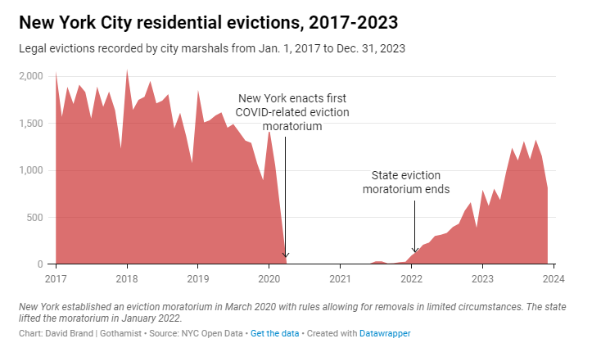
Revenue generated by the marshals had been steadily decreasing in the years before the pandemic-era eviction moratorium went into effect in March of 2020. According to the Department of Investigation, in 2010, the marshals had combined revenue of over $21 million. By 2019, the last year before the pandemic, that number had dropped to just under $14 million.
The COVID-era eviction moratorium that began in March 2020 officially ended in January of 2022. The marshals’ revenue fell precipitously during the two years courts issued almost no evictions. In 2020, the marshals’ revenue was only $3.9 million and ticked up only slightly to $4.3 million in 2021. In 2022, when evictions resumed, the courts had to work through the backlog of eviction cases that had been paused by the COVID emergency, leading to a reduction in the number of evictions approved by the courts. Eviction numbers did not return to pre-pandemic levels until the second half of 2023.
Even with the lower eviction numbers in 2022, the marshals still brought in over $11 million in revenue. Although the marshals’ revenue that year was lower than in pre-pandemic eras, the reduction is in line with the year-over-year decreases occurring prior to the pandemic.
- Profit Incentives
The number of marshals has also been steadily decreasing. In 2012, 46 marshals collectively made a total of $18,146,367 in revenue. Three of those marshals made over $1 million, with one netting almost $3 million. By 2022, New York City had only 31 active marshals, who collectively earned a total of $11,604,740 in revenue. Three of those marshals earned over $1 million even after paying their staff and sending the city the legally mandated portion of their gross proceeds. The highest grossing marshal made over $1.8 million in 2022. Although overall revenue declined by $6.5 million over the last decade, the revenue per marshal has remained fairly steady. In 2012, each marshal made an average of $394,486, while by 2022, that amount had decreased only slightly to $374,346 in revenue.
Marshals run their own offices and can have their own paid staff. As detailed above, they enforce court judgments, including evictions, foreclosures, utility shut-offs and debt collections. Critics claim that this system, in which politically connected citizens appointed by the Mayor are allowed to keep a portion of the debts that they collect, incentivizes aggressive debt collection strategies. Marshals tend to have their most profitable years during times of economic hardship for many others. The marshals recorded their highest grossing year in 2009, during the worst part of the Great Recession.
- The Role of the NYC Marshal
As detailed above, NYC marshals are not city employees, and they perform similar duties as New City sheriffs. The primary difference between marshals and sheriffs is that sheriffs are salaried employees of the city and marshals are not, with reports characterizing them as private entrepreneurs. According to the Independent Budget Office, if each marshal was replaced by 1.25 city employees earning the median salary of a deputy sheriff, the City could collect an additional $11 million dollars per year. Instead, the city received less than $1.2 million of the $25.2 million that marshals made in 2022. The New York City Independent Budget Office has calculated that making city marshals city employees would yield $11 million in annual revenue.
Since City marshals are appointed by the Mayor, natural political forces are at play in their selection. Although good government groups have long argued against the potential for corruption within this system, any change to the structure of the marshals would need to be made by the state legislature.
CONCLUSION
The Committee on Oversight and Investigations looks forward to hearing from DOI and interested stakeholders regarding the agency’s oversight of the city’s marshals. The Council seeks a better understanding of how the agency conducts its oversight, the financial and other resources DOI has at its disposal to conduct its oversight of marshals, and any recommendations DOI has regarding the overall performance and future functions of NYC’s marshals.

Duncan Bryer, “Now More Than Ever: Abolish The City Marshal,” Gotham Gazette, Apr. 21, 2020, available at https://www.gothamgazette.com/130-opinion/9323-abolish-the-new-york-city-marshal-coronavirus-evictions-debt (last visited Apr. 29, 2024).
NYC Department of Investigation, “Marshals,” available at https://www.nyc.gov/site/doi/offices/nyc-marshals.page (last visited Apr. 19, 2024).
Id.
Id.
New York Civil Court Act, Article 16, available at https://www.nysenate.gov/legislation/laws/CCA/A16.
Id.
Id.
NYC Department of Investigation, “NYC Marshals List,” available at https://www.nyc.gov/site/doi/offices/marshals-list.page (last visited Apr. 19, 2024).
David Brand, “With NYC evictions on the rise, these contractors made millions,” Gothamist, Oct. 25, 2023, available at https://gothamist.com/news/with-nyc-evictions-on-the-rise-these-contractors-made-millions (last visited Apr. 19, 2024).
Rich Calder, “There aren’t enough marshals to collect debts owed to the city,” New York Post, June 26, 2015, available at https://nypost.com/2015/06/26/there-arent-enough-marshals-to-collect-debts-owed-to-city/ (last visited Apr. 24, 2024).
Angela Montefinise, “ARM TWISTERS GRAB $$ FROM CITY COFFERS,” New York Post, May 3, 2009, available at https://nypost.com/2009/05/03/arm-twisters-grab-from-citys-coffers/ (last visited on Apr. 24, 2024).
NYC Independent Budget Office, “Revenue Options: Fares, Tolls, and Other Revenue Generators,” Feb. 2019, available at https://ibo.nyc.ny.us/iboreports/revenue-options-fares-tolls-and-other-revenue-generators-2019.pdf (last visited Apr. 29, 2024).
NYC Independent Budget Office, “Revenue Options: Fares, Tolls, and Other Revenue Generators,” Feb. 2019, available at https://ibo.nyc.ny.us/iboreports/revenue-options-fares-tolls-and-other-revenue-generators-2019.pdf (last visited Apr. 29, 2024).
Mayor’s Committee on Marshals, “About the Committee,” available at https://www.nyc.gov/site/marshals/about/about-committee.page (last visited on Apr. 25, 2024).
The City of New York Office of the Mayor, “Executive Order No. 44,” February 13, 1980, available at https://www.nyc.gov/assets/marshals/downloads/pdf/executive_order_44.pdf (last visited on Apr. 25, 2024).
Mayor’s Committee on Marshals, “About the Committee,” available at https://www.nyc.gov/site/marshals/about/about-committee.page (last visited on Apr. 25, 2024).
Mayor’s Committee on Marshals, “About the Committee,” available at https://www.nyc.gov/site/marshals/about/about-committee.page (last visited on Apr. 25, 2024).
Mayor’s Committee on Marshals, “Committee Members,” available at https://www.nyc.gov/site/marshals/about/committee-members.page (last visited on Apr. 25, 2024).
NYC Department of Investigation, “Marshals,” available at https://www.nyc.gov/site/doi/offices/nyc-marshals.page (last visited Apr. 19, 2024).
Id.
Id.
Id.
NYC Department of Investigation, “NYC Marshals Handbook of Regulations,” available at https://www.nyc.gov/site/doi/offices/marshals-handook.page (last visited Apr. 29, 2024).
Id.
Id.
Id.
The City of New York Executive Budget Fiscal Year 2025, “Supporting Schedules,” available at https://www.nyc.gov/assets/omb/downloads/pdf/ss4-24.pdf (last visited Apr. 29, 2024)
The City of New York Executive Budget Fiscal Year 2024, “Supporting Schedules,” available at https://www.nyc.gov/assets/omb/downloads/pdf/ss4-23.pdf
NYC Department of Investigation, “Marshals,” available at https://www.nyc.gov/site/doi/offices/nyc-marshals.page
NY CPLR § 8011 (2022).
David Brand, “With NYC evictions on the rise, these contractors made millions,” Gothamist, Oct. 25, 2023, available at https://gothamist.com/news/with-nyc-evictions-on-the-rise-these-contractors-made-millions (last visited Apr. 19, 2024).
NYC Department of Investigation, “City Marshals’ Annual Revenue: 2022 Annual Revenue,” available at https://www.nyc.gov/assets/doi/reports/pdf/CMAR/MarshalRevenue2022.pdf (last visited Apr. 29, 2024).
Id.
David Brand, “NYC evictions surged in 2023, with legal lockouts nearing pre-COVID levels,” Gothamist, Jan. 11, 2024, available at https://gothamist.com/news/nyc-evictions-surged-in-2023-with-legal-lockouts-nearing-pre-covid-levels (last visited Apr. 25, 2024).
New York City Department of Investigations “City Marshals’ Annual Revenue” available at https://www.nyc.gov/site/doi/offices/cmar.page.
Id.
David Brand, “With NYC evictions on the rise, these contractors made millions,” Gothamist, Oct. 25, 2023, available at https://gothamist.com/news/with-nyc-evictions-on-the-rise-these-contractors-made-millions (last visited Apr. 19, 2024).
New York City Department of Investigations “City Marshals’ Annual Revenue” available at https://www.nyc.gov/site/doi/offices/cmar.page.
David Brand, “NYC evictions surged in 2023, with legal lockouts nearing pre-COVID levels,” Gothamist, Jan. 11, 2024, available at https://gothamist.com/news/nyc-evictions-surged-in-2023-with-legal-lockouts-nearing-pre-covid-levels (last visited Apr. 25, 2024).
David Brand, “NYC evictions surged in 2023, with legal lockouts nearing pre-COVID levels,” Gothamist, Jan. 11, 2024, available at https://gothamist.com/news/nyc-evictions-surged-in-2023-with-legal-lockouts-nearing-pre-covid-levels (last visited Apr. 25, 2024).
NYC Department of Investigation, “Marshals,” available at https://www.nyc.gov/site/doi/offices/nyc-marshals.page
David Brand, “With NYC evictions on the rise, these contractors made millions,” Gothamist, Oct. 25, 2023, available at https://gothamist.com/news/with-nyc-evictions-on-the-rise-these-contractors-made-millions (last visited Apr. 19, 2024).
New York City Department of Investigations, “City Marshals’ Annual Revenue” available at https://www.nyc.gov/site/doi/offices/cmar.page.
New York City Department of Investigations, “City Marshals’ Annual Revenue” available at https://www.nyc.gov/site/doi/offices/cmar.page.
David Brand, “With NYC evictions on the rise, these contractors made millions,” Gothamist, Oct. 25, 2023, available at https://gothamist.com/news/with-nyc-evictions-on-the-rise-these-contractors-made-millions (last visited Apr. 19, 2024).
Id.
New York City Department of Investigations “City Marshals’ Annual Revenue” available at https://www.nyc.gov/site/doi/offices/cmar.page.
New York City Department of Investigations “City Marshals’ Annual Revenue” available at https://www.nyc.gov/site/doi/offices/cmar.page.
Duncan Bryer, “Now More Than Ever: Abolish The City Marshal,” Gotham Gazette, Apr. 21, 2020, available at https://www.gothamgazette.com/130-opinion/9323-abolish-the-new-york-city-marshal-coronavirus-evictions-debt (last visited Apr. 29, 2024).
David Brand, “With NYC evictions on the rise, these contractors made millions,” Gothamist, Oct. 25, 2023, available at https://gothamist.com/news/with-nyc-evictions-on-the-rise-these-contractors-made-millions (last visited Apr. 19, 2024).
Duncan Bryer, “Now More Than Ever: Abolish The City Marshal,” Gotham Gazette, Apr. 21, 2020, available at https://www.gothamgazette.com/130-opinion/9323-abolish-the-new-york-city-marshal-coronavirus-evictions-debt (last visited Apr. 29, 2024).
NYC Department of Investigation, “Marshals,” available at https://www.nyc.gov/site/doi/offices/nyc-marshals.page (last visited Apr. 19, 2024).
Duncan Bryer, “Now More Than Ever: Abolish The City Marshal,” Gotham Gazette, Apr. 21, 2020, available at https://www.gothamgazette.com/130-opinion/9323-abolish-the-new-york-city-marshal-coronavirus-evictions-debt (last visited Apr. 29, 2024).
Id.
Duncan Bryer, “Now More Than Ever: Abolish The City Marshal,” Gotham Gazette, Apr. 21, 2020, available at https://www.gothamgazette.com/130-opinion/9323-abolish-the-new-york-city-marshal-coronavirus-evictions-debt (last visited Apr. 29, 2024).
David Brand, “With NYC evictions on the rise, these contractors made millions,” Gothamist, Oct. 25, 2023, available at https://gothamist.com/news/with-nyc-evictions-on-the-rise-these-contractors-made-millions (last visited Apr. 19, 2024).
NYC Independent Budget Office, “Revenue Options: Fares, Tolls, and Other Revenue Generators,” Feb. 2019, available at https://ibo.nyc.ny.us/iboreports/revenue-options-fares-tolls-and-other-revenue-generators-2019.pdf (last visited Apr. 29, 2024).
Duncan Bryer, “Now More Than Ever: Abolish The City Marshal,” Gotham Gazette, Apr. 21, 2020, available at https://www.gothamgazette.com/130-opinion/9323-abolish-the-new-york-city-marshal-coronavirus-evictions-debt (last visited Apr. 29, 2024).
Id.
New York State Legislature. Consolidated Laws of New York. Chapter 693, Article 16. The New York State Senate https://www.nysenate.gov/legislation/laws/CCA/A16.

