Committee on Contracts
Alex Paulenoff, Legislative Counsel
Casie Addison, Senior Legislative Policy Analyst
Andrew Wilber, Financial Analyst
John Russell, Finance Unit Head



THE COUNCIL OF THE CITY OF NEW YORK
BRIEFING PAPER OF THE GOVERNMENTAL AFFAIRS DIVISION
Jeffrey Baker, Legislative Director
Rachel Cordero, Deputy Director, Governmental Affairs Division

COMMITTEE ON CONTRACTS
Hon. Benjamin Kallos, Chair

June 20, 2019

INT. NO. 0346: By Council Members Rosenthal, Brannan, Salamanca, Jr, Ayala, Reynoso, Lander

TITLE: A Local Law to amend the New York city charter, in relation to establishing auditing requirements for minority and women-owned business enterprise procurement

NEW YORK CITY CHARTER: Amends § 93(c)

PROPOSED INT. NO. 1293-A: By Council Members Rose, Cornegy, Brannan, Ayala, Levin, Rosenthal, Adams

TITLE: A Local Law to amend the administrative code of the city of New York, in relation to minority and women-owned business enterprises

ADMINISTRATIVE CODE: Amends § 6-129(c)(26) & § 6-129(d)
INT. NO. 1379 By Council Members Rosenthal, The Public Advocate (Mr. Williams), Levine
TITLE: A Local Law to amend the administrative code of the city of New York, in relation to requiring a minority and women-owned business enterprise consultant for city projects in excess of ten million dollars.
ADMINISTRATIVE CODE: Adds § 6-129(h)(2)(g)
INT. NO. 1452: By Council Member Cornegy, (by the request of the Mayor)
TITLE: A Local Law to amend the administrative code of the city of New York, in relation to minority and women-owned business enterprises
ADMINISTRATIVE CODE: Amends § 6-129

PRECONSIDERED INT.: By Council Member Brannan
TITLE: A Local Law to amend the administrative code of the city of New York, in relation to including the most recent data available in the citywide M/WBE disparity study
ADMINISTRATIVE CODE: Amends § 6-129(d)(4)(a)

PRECONSIDERED INT.: By Council Member Kallos
TITLE: A Local Law to amend the administrative code of the city of New York, in relation to tracking statistically significant changes to key disparity indicators in M/WBE procurement
ADMINISTRATIVE CODE: Amends § 6-129(e)(1)
- INTRODUCTION

On June 20, 2019, the Committee on Contracts, chaired by Council Member Benjamin Kallos will hold a hearing on the following legislation: Introductory Number 0346 (Int. No. 0346”) a local law to amend the New York city charter, in relation to establishing auditing requirements for minority and women-owned business enterprise procurement; Proposed Introductory Number 1293-A (“Int. No. 1293”) A local law to amend the administrative code of the city of New York, in relation to minority and women-owned business enterprises; Introductory Number 1379 (“Int. No. 1379”) A local law to amend the administrative code of the city of New York, in relation to requiring a minority and women-owned business enterprise consultant for city projects with budgets in excess of ten million dollars; Introductory Number 1453 (“Int. No. 1452”) a local law to amend the administrative code of the city of New York, in relation to minority and women-owned business enterprises; Preconsidered Introduction (“Preconsidered Int. on Recent Data”), A Local Law to amend the administrative code of the city of New York, in relation to including the most recent data available in the citywide M/WBE disparity study; and Preconsidered Introduction (“Preconsidered Int. on Disparity Indicators”), A Local Law to amend the administrative code of the city of New York, in relation to tracking statistically significant changes to key disparity indicators in M/WBE procurement. Those invited to testify include the Mayor’s Office of Contract Services (“MOCS”), the Department of Small Business Services (“SBS”), the Mayor’s Office of M/WBEs and members of the public.

- BACKGROUND
According to the United States Small Business Administration, New York is home to millions of small businesses, which collectively employ over 3.9 million people and represent the diversity of the City. Despite the large presence of M/WBEs in the City, these businesses have historically struggled with participation in City contracting. The City’s M/WBE program was originally established following a 1989 voter referendum approving the establishment of a program to assist M/WBEs. The M/WBE disparity study conducted pursuant to the program examined the number of M/WBEs that operate in the city compared to rates of procurement of government contracts and found substantial underutilization of M/WBEs. The study revealed that M/WBEs were underutilized in the awarding of both prime contracts and subcontracts.
In 2005, the Council passed Local Law 129, which re-established the City’s M/WBE program to “address the impact of discrimination on the city's procurement process, and to promote the public interest in avoiding fraud and favoritism in the procurement process, increasing competition for city business, and lowering contract costs.” Local Law 129 set aspirational goals for City agencies to increase their contracting with MWBEs, set target percentages for certain types of contracts, and established an M/WBE certification program, which provides greater access to information about contracting opportunities through classes, networking events, targeted solicitations, and includes an online directory for certified businesses within the City that promotes M/WBE businesses to purchasers.
In 2013, the City passed Local Law 1, which made a number of significant changes to the city’s M/WBE program, including: (i) removing the requirement that M/WBE goals only apply to contracts valued at one million dollars or less; (ii) the creation of “M/WBE stat,” an accountability program that requires agency M/WBE officers to convene quarterly to discuss progress with reaching M/WBE goals; (iii) requiring M/WBE reports from MOCS on a quarterly basis instead of semi-annually (as was required under Local Law 129 of 2005); and (iv) overall, improving and increasing education and outreach regarding the MWBE program and city contracting.

- FINDINGS OF THE 2018 NYC M/WBE DISPARITY STUDY

In May 2018, the independent consulting firm MGT Consulting Group (“MGT”) released the City of New York Disparity Study (“Disparity Study”), which analyzed the utilization rate of M/WBEs in city contracting in order to inform the city in its establishment of future aspirational goals for the M/WBE program. The critical question posed by the Disparity Study was whether there was “statistical evidence of disparity between the availability and utilization of M/WBE firms” by city agencies in their contracting processes. In the course of its analysis for the Disparity Study, MGT considered agency procurement data from 2006 – 2015, and reviewed contracting opportunities and awards in several procurement categories to determine whether there was a statistical disparity of data for particular groups identified by the M/WBE program.
The three primary recommendations from MGT in the Disparity Study were:
- Revising the State’s 100,000 cap on goods or commodities purchased from M/WBE firms;

- Crediting Asian-American firms in the Professional Services category towards M/WBE participation goals;

- Expanding the minority categories to include Native American firms

Much of the data analyzed in the Disparity Study was done in light of the administration’s stated aspirational goal of achieving 30% M/WBE utilization in procurement, as part of the OneNYC Plan. Unfortunately, none of the data considered by the Disparity Study takes into account programs that have been initiated since 2015, which means its findings are inherently out of date. Nonetheless, the utilization rates revealed in the Disparity Study are consistent with the continuation of the citywide M/WBE program in accordance with federal requirements.
A more up-to-date analysis of M/WBE procurement citywide is provided in the next section and includes data up to and including Q4 of fiscal year 2018.

- FISCAL YEAR 2018 M/WBE UTILIZATION
In Fiscal Year 2018 (“FY18”) the City’s total contracting budget was $19.8 billion dollars. Of the City’s total contracting budget, $5.3 billion dollars was subject to the M/WBE program. In FY18, the City achieved a combined prime and subcontract M/WBE utilization rate of 19% amongst contracts subject to Local Law 1, an increase from 11.4% in FY17. FY18 was the highest combined utilization rate under the City’s M/WBE Program. M/WBEs were awarded 16% ($835.3 million) of prime contracts in FY18 and 51% ($258 million) of subcontracts subjected to the program.
Although 35 agencies are subject to M/WBE participation goals, a significant percentage of the total dollar value of citywide awards to M/WBEs were made by three agencies, consistent with prior years. The Department of Design and Construction (“DDC”), the Department of Parks and Recreation (“DPR”), and the Department of Environmental Protection (‘DEP”) collectively awarded 72% of all prime and 67.75% of subcontracts awarded to M/WBEs. In recent years, awards made by DDC have accounted for a significant proportion of both prime and subcontract awards. In FY18, DDC awarded 467.6 million in prime contracts to M/WBEs, an increase from $91.7 million in FY17, more than any other agency.
While certain agencies have contributed significantly to the City’s M/WBE efforts, analyzing each agency solely by the total dollar value of their awards does not present an indicative assessment of that agencies success in awarding M/WBE contracts compared to other agencies. Since many agencies have budgets that are substantially larger than others, it is an incomplete comparison. It is important to note that while DDC awarded the greatest dollar value in awards to M/WBEs, the agencies prime and subcontract awards represents a very small fraction of the agency’s total contracting budget subject to the M/WBE program.
In FY18, DDC had the largest prime contracting budget, compared to all other agencies at $2.3 billion. While DDC awarded 19.69% ($467.6 million) to M/WBEs, the agency also awarded $1.9 billion to non-certified firms. Understandably, agencies with larger budgets face different challenges than agencies with smaller budgets. Generally, agencies with smaller budgets have awarded a greater share of contracts to M/WBEs and have higher utilization rates, compared to agencies, like DDC, with considerably larger budgets. For example, the agency that awarded the highest percentage of its budget in prime contracts to M/WBE firms in FY18 was the NYC Commission on Human Rights (“CCHR”). CCHR awarded M/WBE firms 77.94% of its $1.2 million in prime contracts. Notably, the Department of Health and Mental Hygiene (DOHMH) awarded 99.84% of its $6.3 million in subcontracts to M/WBE firms. However, some agencies with substantial budgets do have high utilization rates. In FY18, the New York City Police Department awarded M/WBEs nearly 50% of its $131 million dollar budget. Comparatively, the Department of Transit, which had the second largest contracting budget subject to the program, awarded 98% ($632 million) to non-certified firms and just 2% ($13 million) to M/WBE firms. The charts below illustrate the agencies with the highest and lowest M/WBE utilization rates, with budgets greater than one million dollars in FY18.
Agencies with the Highest M/WBE Utilization Rates of Fiscal Year 2018*
Agency | Total FY18 Budget Subject to M/WBE Goals | % Awarded to M/WBEs
NYC Commission on Human Rights (CCHR) | $1.2 Million | 77.94%
Department of Small Business Services (SBS) | $3.2 Million | 74.43%
Department of Buildings (DOB) | $2.4 Million | 64.88%
New York City Police Department (NYPD) | $131.8 Million | 49.95%
Department of Housing, Preservation, and Development | $27 Million | 47.73%
Department of Probation (DOP) | $1.2 Million | 45.99%
NYC Human Resources Administration (HRA) | $16.9 Million | 34.87%
Department of Parks & Recreation (DPR) | $315.2 Million | 29.82%
Department of Investigations (DOI) | $2 Million | 28.07%
* includes agencies with budgets greater than $1 million dollars, subject to the program.

Agencies with the Lowest M/WBE Utilization Rates of Fiscal Year 2018*
Agency | Total FY18 Budget Subject to M/WBE Goals | % Awarded to M/WBEs
Department of Transportation | $645.5 Million | 2.04%
Department of Information & Telecommunications | $513.1 Million | 4.27%
Department of City Planning (DCP) | $5.6 Million | 4.43%
FDNY | $148.5 Million | 4.84%
Department of Sanitation (DSNY) | $220.4 Million | 7.68%
Department of Environmental Protection (DEP) | $533.5 Million | 8.16%
Law Department | $38 Million | 8.67%
Department of Youth & Child Development (DYCD) | $8.7 Million | 11.07%
Department of Corrections (DOC) | $38.6 Million | 12.35%
DOHMH | $58.5 Million | 15.09%
New York City Emergency Management ( | $8.8 Million | 17.44%
Administration for Children Services (ACS) | $42.5 Million | 18.53%
Department of Finance (DOF) | $4.8 Million | 19.38%
Department of Design and Construction (DDC) | $2.3 Billion | 19.69%
Department of Homeless Services (DHS) | $57.3 Million | 22.16%
* includes agencies with budgets greater than $1 million dollars, subject to the program.
- DISPARITIES WITHIN CITY-CONTRACTING OF M/WBEs
Awards by Certification & Industry
Firms included in the M/WBE Program can be certified as either a minority owned-business (“MBE”) or a women-owned business (“WBE”). Businesses owned by women of color can be certified as both and are listed as MBE/WBE. As part of the M/WBE program, participation goals are attached to four industries: construction, goods, professional services, and standard services. Of the $835 million in prime contracts awarded to M/WBE firms, 50% derived from goods contracts, 20.51% from professional services contracts, 10.93% from construction contracts, and 7.80% from standard services contracts. Of the $258 million in subcontract awards, 77% standard services contracts, 54.88% derived from professional services contracts and 46% from construction contracts. In FY18, no subcontracts for goods contracts were awarded to M/WBEs, consistent with prior years.
Awards by Race and Gender
While the City has generally improved it’s contracting with M/WBE firms, disparities exist among the type of MWBEs awarded contracts across industries. Of the $835 million in prime contracts awarded to M/WBEs in FY18, nearly half was awarded to businesses owned by Asian Male-owned firms. Of the total dollar value of prime contracts awarded to M/WBEs in FY18, 47.50% were awarded to Asian Male-owned firms, 23.46% were awarded to White Women-owned firms, 9.73% to Black Male-owned firms, 8.59% to Hispanic Male-owned firms, 5.83% to Asian Women-owned firms, 2.77% to Black Women-owned firms, and 2.13% were awarded to Hispanic Women-owned firms. The pie chart below depicts the distribution of prime contract awards to M/WBEs by race and gender.
FY18- Total Dollar Value of Prime Awards to M/WBEs by Race and Gender
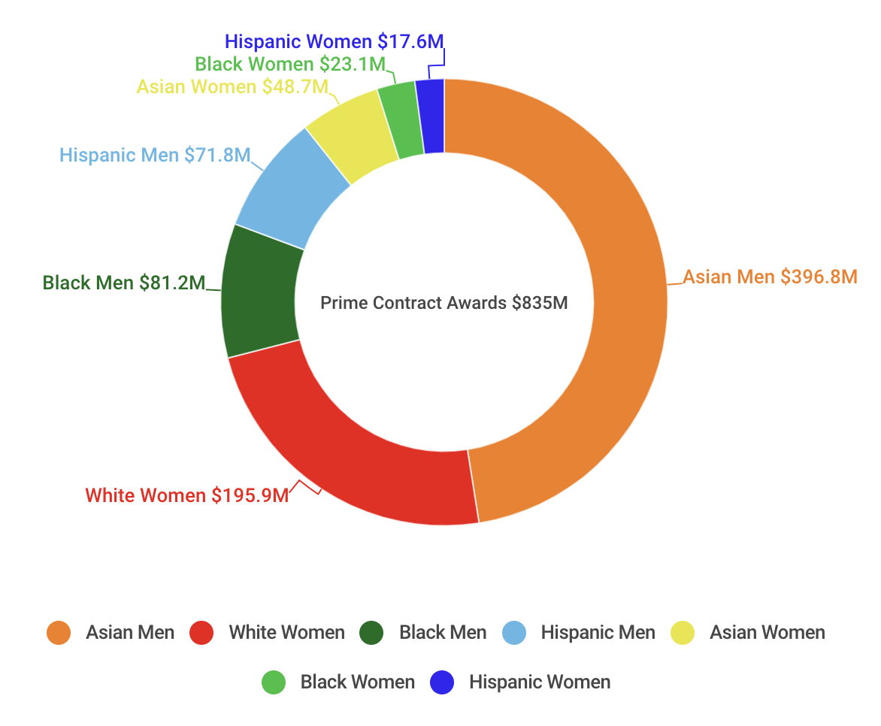
Of the $258 million in subcontracts awarded to M/WBE firms, 42.45% were awarded to White Women-owned firms, 21.23% to Hispanic Male-owned firms, 15.84% to Asian Male owned firms, 13.60% to Black Male-owned firms, 5.18% to Hispanic Women-owned firms, 1.08% to Asian Women-owned firms, and 0.61% to Black Women-owned firms. The pie chart below depicts the distribution of subcontract awards to M/WBEs by race and gender.
FY18- Total Dollar Value of Subcontract Awards to M/WBEs by Race and Gender
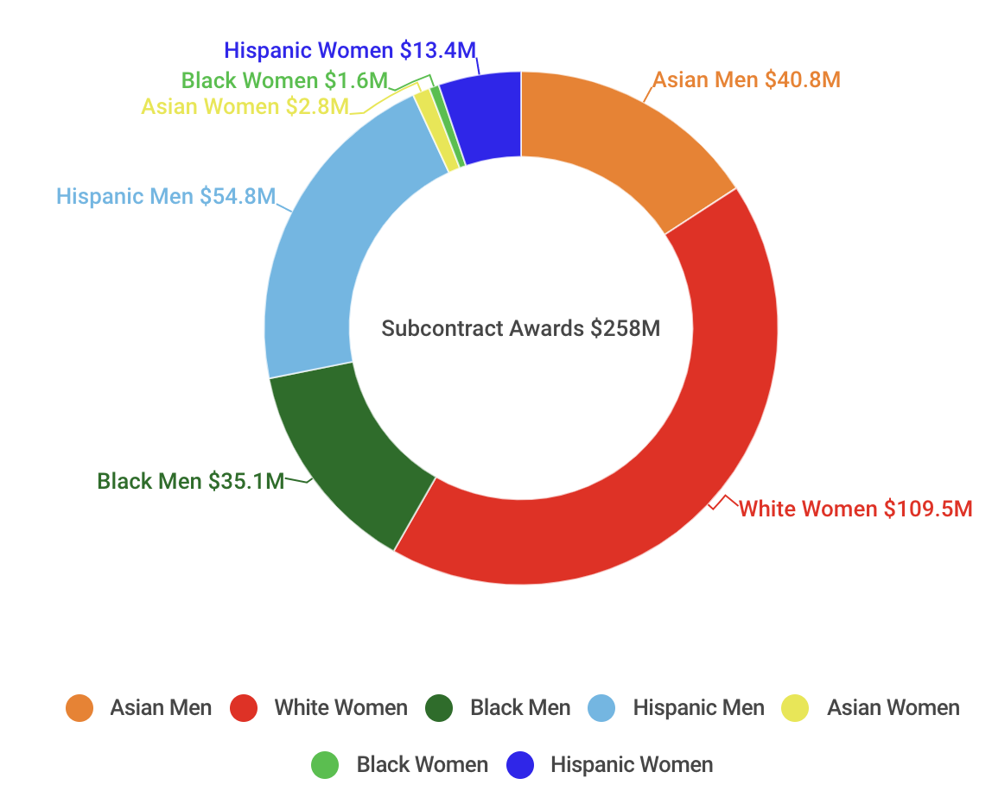
In the last three fiscal years, a dominant share of the total value of contracts awarded to certified M/WBE firms has been awarded to businesses owned by Asian Men and White Women. In Fiscal Years 2016, 2017, and 2018 combined, the City awarded M/WBE firms a total of $2.3 billion dollars in prime contracts and $532 million in subcontracts. Asian Male and White Women-owned businesses were collectively awarded 68% of the total value in prime and subcontracts awards to M/WBEs between FY16 and FY18. Businesses owned by Asian Men and White Women have benefited most often from the City’s M/WBE program while businesses owned by women of color have seen minimal impact. Of the total value of all contracts awarded to M/WBE firms between FY16 and FY17, 1.78% were awarded to businesses owned by Black Women, 2.25% to Hispanic Women, and 5.52% to Asian Women owned firms. The chart below illustrates the distribution of all contract awards to M/WBEs between FY16 and FY18.

Total Dollar Value of Prime/Subcontracts Awarded to M/WBEs in FY16, FY17, and FY18

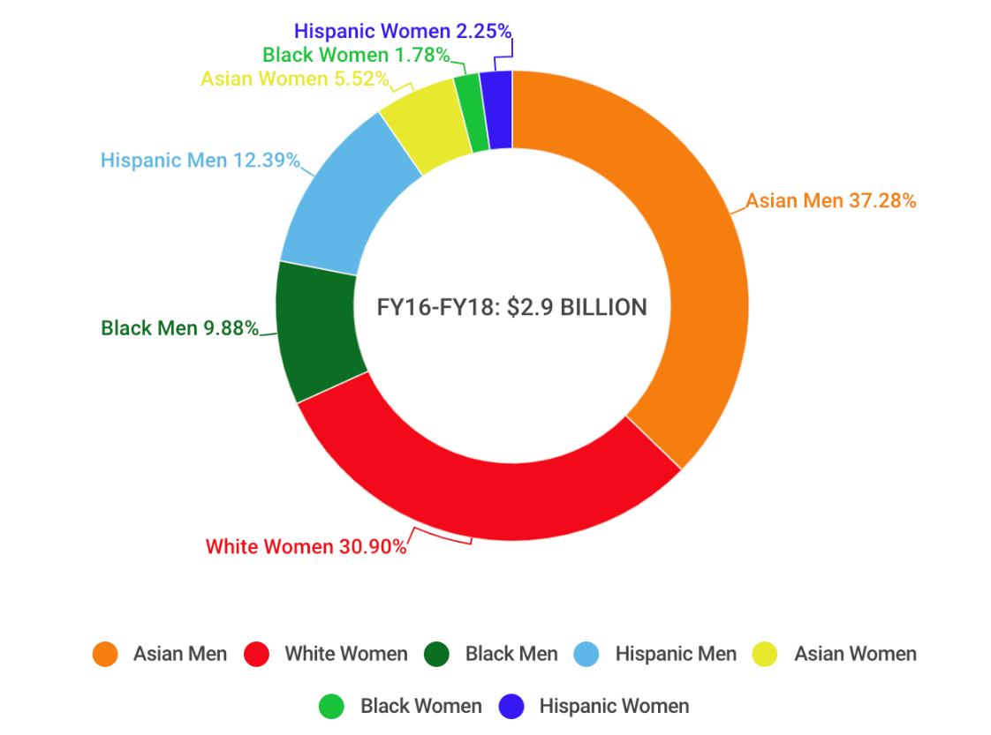
From the data provided by the administration, it is unclear how the proportion of certified firms and the services they provide reflect the distribution of awards. For example, more White-Women and Asian Male owned firms could be certified in particular industries than other groups, which could possibly explain why they are awarded a greater share of contracts. Additionally, there are a myriad of challenges M/WBEs experience when trying to contract with the City. These findings and trends may provide a deeper understanding of which M/WBEs need targeted support and capacity building.

- CITY PROGRAMS TO ASSIST M/WBES
The Department of Small Business Services (“SBS”) offers several programs to assist small businesses and M/WBES toward approval and completion of city projects. In recent years, the administration has sought to create programs that assist M/WBEs with the financing.
- Contract Financing Loan Fund
The Contract Financing Loan Fund is administered by SBS and is offered to small businesses and M/WBEs that have been awarded city projects. The fund loans up to $500,000 at an annual interest rate of 3% to existing prime or subcontracting firms that are applying for financing toward a contract with a city agency or city-funded entity.

- Bond Readiness Program
The Bond Readiness Program is a 3-month intensive program offered by SBS for M/WBE-certified and small construction firms. The program provides a variety of financial management training and one-on-one guidance towards obtaining surety bonds and expanding bond capacity on city construction projects. SBS connects program participants to a network of surety companies, and provides training on the surety bonding process and guidance on how to qualify for bonding.

- Construction Mentorship Program
The Construction Mentorship Program is a four-month intensive program offered by SBS to M/WBE-certified construction firms to assist in navigating city contracting opportunities and expanding professional networking. The program offers one-on-one business mentoring, specialized education and training, bidding assistance, and customized business needs assessment and growth plans to qualified M/WBE-certified construction firms.

- NYC Goods and Services Mentorship Program

The NYC Goods and Services Mentorship Program is a four-month intensive program offered by SBS to M/WBE-certified firms in non-construction industries. The program is designed to assist non-construction M/WBEs toward expanding their businesses and successfully bidding on city contracts. The program offers tailored business development courses, bidding assistance for city contracts, one-on-one mentoring with management consultants, and customized business assessments and growth plans. The target businesses of this program are certified M/WBEs looking to provide goods or professional or standard services to city agencies.

- LEGISLATIVE ANALYSIS OF INT. NO. 0346
Int. No. 0346 would require the City Comptroller to conduct annual audits focused solely on M/WBE procurement. The bill would also authorize the Comptroller to appoint a qualified person to oversee and execute such audits.

- LEGISLATIVE ANALYSIS OF PROPOSED INT. NO. 1293-A
Proposed Int. No. 1293-A would amend the definition of “Minority group” for purposes of the City’s Minority and Women-owned business enterprises (“M/WBE”) program to add a category for Native American-owned businesses. The bill would also update citywide procurement goals for all minority groups across all procurement categories in accordance with the findings from the 2018 citywide disparity study.

- LEGISLATIVE ANALYSIS OF INT. NO. 1379
Int. No. 1379 would require City contractors to hire an independent M/WBE consultant with expertise in M/WBE procurement for every contract over ten million dollars in order to enhance City procurement opportunities for minority and women-owned businesses. Such a consultant would be responsible for: (i) assisting contractors in recruiting M/WBE vendors; (ii) monitoring contractor compliance with M/WBE participation goals; and (iii) reporting to the contracting agency on prime contractor performance in meeting M/WBE participation goals.

- LEGISLATIVE ANALYSIS OF INT. NO. 1452
Int. No. 1452 would, among other things, require the chief procurement officer, in conjunction with the mayor’s office of minority and women-owned businesses, to more frequently update operational protocols for the city’s M/WBE program, as well as facilitate additional agency and contractor training of M/WBE program implementation. The bill would also empower agency chief contracting officers to require contracting agencies to identify MBE, WBE or EBEs that such agencies intend to employ for certain contracts. Lastly, the bill would enable the chief procurement officer to exempt portions of certain contracts from the M/WBE program in instances where, after an exhaustive search by a contracting agency, it is determined that no eligible MBE, WBE or EBE firms are eligible to perform the work required.

- LEGISLATIVE ANALYSIS OF PRECONSIDERED INT. ON RECENT DATA
Preconsidered Introduction on Recent Data would require the Division of Economic and Financial Opportunity within the Department of Small Business Services and the Mayor’s Office of Contract Services to use the most recent data available when considering revisions to citywide M/WBE participation goals.

- LEGISLATIVE ANALYSIS OF PRECONSIDERED INT. ON DISPARITY INDICATORS
Preconsidered Introduction on Disparity Indicators would require the Division of Economic and Financial Opportunity within the Department of Small Business Services to regularly update the percentage difference of any change between the immediately preceding M/WBE disparity study findings and the real number of vendors available for each industry classification of potential M/WBE vendors. The bill would also require the division’s updated vendor directory to be submitted to the Council at the same time it is sent to contracting agencies.

Int. No. 346

By Council Members Rosenthal, Brannan, Salamanca, Ayala, Reynoso and Lander

A Local Law to amend the New York city charter, in relation to establishing auditing requirements for minority and women-owned business enterprise procurement

Be it enacted by the Council as follows:

Section 1. Subdivision c of section 93 of chapter 5 of the New York city charter is amended to read as follows:
c. The comptroller shall have power to audit all agencies, as defined in subdivision two of section eleven hundred fifty, and all agencies, the majority of whose members are appointed by city officials. The comptroller shall be entitled to obtain access to agency records required by law to be kept confidential, other than records which are protected by the privileges for attorney-client communications, attorney work products, or material prepared for litigation, upon a representation by the comptroller that necessary and appropriate steps will be taken to protect the confidentiality of such records. The comptroller shall establish a regular auditing cycle to ensure that one or more of the programs or activities of each city agency, or one or more aspects of each agency’s operations, is audited at least once every four years, except that the comptroller shall audit each relevant agency’s minority and women-owned business enterprise utilization plan and related activities at least once every year. The audits conducted by the comptroller shall comply with generally accepted government auditing standards. In accordance with such standards, and before any draft or final audit or audit report, or portion thereof, may be made public, the comptroller shall send a copy of the draft audit or audit report to the head of the audited agency and provide the agency, in writing, with a reasonable deadline for its review and response. The comptroller shall include copies of any such agency response in any draft or final audit or audit report, or portion thereof, which is made public. The comptroller shall send copies of all final audits and audit reports to the council, the mayor, and the audit committee.
The comptroller may appoint a qualified person to oversee minority and women-owned business enterprise audits conducted pursuant to this subdivision.
§ 2. This local law shall take effect immediately.

Proposed Int. No. 1293-A

By Council Members Rose, Cornegy, Brannan, Ayala, Levin, Rosenthal and Adams

A Local Law to amend the administrative code of the city of New York, in relation to minority and women-owned business enterprises

Be it enacted by the Council as follows:

Section 1. Paragraph 26 of subdivision c of Section 6-129 of the administrative code of the city of New York, as amended by local law number 1 for the year 2013, is amended to read as follows:
(26) “Minority group” means Black Americans[;], Asian Americans, [and] Hispanic Americans and Native Americans, provided that the commissioner shall be authorized to add additional groups to this definition upon a finding that there is statistically significant disparity between the availability of firms owned by individuals in such a group and the utilization of such firms in city procurement.
§ 2. Subdivision d of Section 6-129 of the administrative code of the city of New York, as amended by local law number 1 for the year 2013, is amended to read as follows:
d. Citywide goals. (1) The citywide contracting participation goals for MBEs, WBEs and EBEs, which may be met through awards of prime contracts or subcontracts as described in subdivision j of this section, shall be as follows:
For construction contracts:
Category: | Participation goal:
Black Americans | [8]12% of total annual agency expenditures on such contracts
Asian Americans | [8]11.1% of total annual agency expenditures on such contracts
Hispanic Americans | [4]17.95% of total annual agency expenditures on such contracts
Native Americans | 0.56% of total annual agency expenditures on such contracts
Women | [18]25.66% of total annual agency expenditures on such contracts
Emerging | 6% of total annual agency expenditures on such contracts

For professional services contracts:
Category: | Participation goal:
Black Americans | [12]11.81% of total annual agency expenditures on such contracts
Asian Americans | 9.4% of total annual agency expenditures on such contracts
Hispanic Americans | [8]8.99% of total annual agency expenditures on such contracts
Native Americans | 0.65% of total annual agency expenditures on such contracts
Women | [37]36.67% of total annual agency expenditures on such contracts
Emerging | 6% of total annual agency expenditures on such contracts

For standard services contracts:
Category: | Participation goal:
Black Americans | [12]14.32% of total annual agency expenditures on such contracts
Asian Americans | [3]9.88% of total annual agency expenditures on such contracts
Hispanic Americans | [6]10.2% of total annual agency expenditures on such contracts
Native Americans | 0.03% of total annual agency expenditures on such contracts
Women | [10]29.26% of total annual agency expenditures on such contracts
Emerging | 6% of total annual agency expenditures on such contracts

For goods contracts under one [hundred thousand] million dollars:
Category: | Participation goal:
Black Americans | [7]5.94% of total annual agency expenditures on such contracts
Asian Americans | [8]10.59% of total annual agency expenditures on such contracts
Hispanic Americans | [5]7.07% of total annual agency expenditures on such contracts
Native Americans | 2.44% of total annual agency expenditures on such contracts
Women | [25]30.51% of total annual agency expenditures on such contracts
Emerging | 6% of total annual agency expenditures on such contracts
§ 3. This local law takes effect 180 days after it becomes law, except that the department of small business services shall take such measures as are necessary for the implementation of this local law, including the promulgation of rules, before such date.

Int. No. 1379

By Council Members Rosenthal, the Public Advocate (Mr. Williams) and Levine

A Local Law to amend the administrative code of the city of New York, in relation to requiring a minority and women-owned business enterprise consultant for city projects with budgets in excess of ten million dollars

Be it enacted by the Council as follows:
Section 1. Paragraph 2 of subdivision h of section 6-129 of the administrative code of the city of New York is amended to add new subparagraph g to read as follows:
(g) For each agency project with a contract budget in excess of ten million dollars and for which minority and women-owned business participation goals have been established pursuant to this section, the contracting agency shall hire an independent consultant with expertise in minority and women-owned business procurement to perform the following functions: (i) assisting the prime contractor in recruiting minority and women-owned businesses for procurement opportunities on such project; (ii) monitoring the prime contractor’s compliance with minority and women-owned business participation goals; and (iii) reporting to the contracting agency on the prime contractor’s performance in meeting minority and women-owned business participation goals.
The prime contractor shall pay all costs associated with such independent consultant.
§ 2. This local law takes effect 120 days after it becomes law.

[THIS PAGE LEFT INTENTIONALLY BLANK]

Int. No. 1452

By Council Member Cornegy (by request of the Mayor)

A Local Law to amend the administrative code of the city of New York in relation to minority and women-owned business enterprises

Be it enacted by the Council as follows:

Section 1. Paragraph 10 of subdivision e of section 6-129 of the administrative code of the city of New York, as amended by local law number 1 for the year 2013, and paragraph 14 of such subdivision, as amended by local law number 113 for the year 2016, are amended to read as follows:
(10) Each fiscal year the division, in consultation with the city chief procurement officer and the director, shall audit at least 5% of all open contracts for which contractor utilization plans have been established in accordance with subdivision i of this section and 5% of all contracts awarded to MBEs, WBEs, and EBEs to assess compliance with this section. All solicitations for contracts for which contractor utilization plans are to be established shall include notice of potential audit.
(14) The division, in consultation with the city chief procurement officer, shall conduct, coordinate and facilitate mandatory trainings for agency chief contracting officers and agency M/WBE officers to assist such officers in pursuing the objectives of this section. Each agency chief contracting officer shall undergo such training on or before the ninetieth day after he or she becomes an agency chief contracting officer, and every [two years] year thereafter. Each agency M/WBE officer shall undergo such training on or before the ninetieth day after he or she becomes an agency M/WBE officer pursuant to subdivision (f) of this section, and every [two years] year thereafter. [Agency chief contracting officers and M/WBE officers that have already undergone such training within the two years prior to the effective date of the local law that added this paragraph will be determined to be in compliance with the initial training required pursuant to this paragraph.] The city chief procurement officer will report to the speaker of the council on an annual basis, and shall post on the City’s website, information regarding each agency’s compliance with this paragraph.
§ 2. Paragraph 4 of subdivision f of section 6-129 of the administrative code of the city of New York, as renumbered by local law number 1 for the year 2013, paragraph 10 of such subdivision, as renumbered and amended by local law number 1 for the year 2013, and paragraph 11 of such subdivision, as added by local law number 1 for the year 2013, are amended to read as follows:
(4) ensuring that agency bid solicitations and requests for proposals, and opportunities to be added to prequalified lists, are sent to MBEs, WBEs, and EBEs in a timely manner, consistent with this section and rules of the procurement policy board;
(10) providing to the city chief procurement officer information for the reports required in subdivision l of this section and providing any other plans and/or reports required pursuant to this section or requested by the director and/or the city chief procurement officer; [and]
(11) participating in meetings required pursuant to subdivision m of this section;
§ 3. Subdivision f of section 6-129 of the administrative code of the city of New York is amended by adding new paragraphs 12, 13 and 14 to read as follows:
(12) facilitating training of agency staff;
(13) developing and maintaining agency standard operating protocols for the M/WBE program; and
(14) promptly disseminating information, tools, and resources that support the agency’s meeting of the requirements of this section.
§ 4. Paragraphs 1, 3, 5 and 6 of subdivision i of section 6-129 of the administrative code of the city of New York, as amended by local law 1 for the year 2013, and paragraph 2 of such subdivision, as added by local law number 129 for the year 2005, are amended to read as follows:
(1) Prior to issuing the solicitation of bids or proposals for individual contracts that present opportunities for participation by certified firms, agencies shall establish participation goals for MBEs, WBEs and/or EBEs. Such goals may be greater than, less than or the same as the relevant citywide goal or goals established pursuant to subdivision d of this section. Taking into account the factors listed in this subdivision, an agency may establish a goal for a procurement that may be achieved by a combination of prime contract and subcontract dollars, and/or a combination of construction and services performed by a contractor or subcontractor pursuant to the contract, and/or a combination of MBEs, WBEs and/or EBEs. [Alternatively, an] An agency may establish specific goals for particular types of goods or services to be provided by the prime contractor or subcontractors, and/or goals for particular types of certified firms. In determining the participation goals for a particular contract, an agency shall consider the following factors:
(a) the scope of work;
(b) the availability of MBEs, WBEs and EBEs able to perform the particular tasks required in the contract;
(c) the extent to which the type and scale of work involved in the contract present prime contracting and subcontracting opportunities for amounts within the capacity of MBEs, WBEs and EBEs;
(d) the agency's progress to date toward meeting its annual participation goals through race-neutral, gender-neutral and other means, and the agency's expectations as to the effect such methods will have on participation of MBEs, WBEs and EBEs in the agency's future contracts; and
(e) any other factors the contracting agency deems relevant.
(2) A contracting agency shall not be required to establish participation goals [for]
[(i)](a) for procurements described in subdivision q of this section; [or]
[(ii)](b) when the agency has already attained the relevant goal in its annual utilization plan, or expects that it will attain such goal without the use of such participation goals; or
[(iii)](c) for a procurement to be made in a year for which the director determines that the city has already attained the relevant goal for the industry as set forth in subdivision d of this section.
(3) (a) For each contract in which a contracting agency has established participation goals, such agency shall state in the solicitation for such contract that bidders and/or proposers shall be required to agree as a material term of the contract that the contractor shall meet the participation goals unless such goals are waived or modified by the agency in accordance with this section.
(b) A contractor that is an MBE, WBE or EBE shall be permitted to count its own participation toward fulfillment of the relevant participation goal, provided that the value of such a contractor's participation shall be determined by subtracting from the total value of the contract any amounts that the contractor pays to direct subcontractors.
(c) A contractor that is a qualified joint venture shall be permitted to count a percentage of its own participation toward fulfillment of the relevant participation goal. The value of such a contractor's participation shall be determined by subtracting from the total value of the contract any amounts that the contractor pays to direct subcontractors, and then multiplying the remainder by the percentage to be applied to total profit to determine the amount to which an MBE, WBE or EBE is entitled pursuant to the joint venture agreement. Notwithstanding any provision of this paragraph to the contrary, a contractor's achievement of participation goals shall be determined as described in paragraph two of subdivision j of this section.
(d) Where the agency chief contracting officer determines that it is practicable in light of the nature of goods or services being procured and the expected duration of the contract, a contracting agency shall require bidders or proposers to identify in their bids the MBEs, WBEs or EBEs they intend to use in connection with the performance of the contract, including their names, addresses and telephone numbers, and require that any substitutions may only be made with the approval of the contracting agency.
(5) For each contract for which participation goals are established, the contractor shall be required to submit with its bid or proposal a contractor utilization plan indicating:
(a) whether the contractor is an MBE, WBE, EBE, or a qualified joint venture;
(b) the percentage of work it intends to award to direct subcontractors; [and]
(c) in cases where the contractor intends to award direct subcontracts, a description of the type and dollar value of work designated for participation by MBEs, WBEs and/or EBEs, and the time frames in which such work is scheduled to begin and end; and
(d) if required by the contracting agency pursuant to subparagraph d of paragraph 3 of this subdivision, the identity of the MBEs, WBEs or EBEs the contractor intends to use in connection with the contractor’s performance of the contract, including their names, addresses and telephone numbers.
When the contractor utilization plan indicates that the bidder or proposer does not intend to meet the participation goals, the bid or proposal shall not be deemed responsive unless the agency has granted a pre-award request for change pursuant to paragraph 11 of this subdivision.
(6) (a) For each contract for which a contractor utilization plan has been submitted, the contracting agency shall require that within thirty days of the issuance of notice to proceed, and at least [once] twice per year thereafter, the contractor submit a list of persons to which it intends to award subcontracts within the next twelve months. In the event that a contracting agency disapproves a contractor's selection of a subcontractor or subcontractors, the contracting agency shall allow such contractor a reasonable time to propose alternate subcontractors.
(b) The contracting agency may also require the contractor to report periodically about the contracts awarded by its direct subcontractors to indirect subcontractors.
§ 5. Clause (iii) of subparagraph a of paragraph 12 of subdivision i of section 6-129 of the administrative code of the city of New York, as amended by local law 1 for the year 2013, is amended to read as follows:
(iii) The contractor sent written notices, by certified mail, [or] facsimile, electronic mail or other electronic format, in a timely manner, to advise MBEs, WBEs or EBEs that their interest in the contract was solicited;
§ 6. Subparagraphs c and d of paragraph 1 of subdivision j of section 6-129 of the administrative code of the city of New York, as added by local law number 1 for the year 2013, and subparagraph h of such paragraph 1, as relettered by local law 1 for the year 2013, are amended, and a new subparagraph h-1 is added to such paragraph, to follow subparagraph h, to read as follows:
(c) In the case of contracts of the types identified pursuant to subparagraph (l) of this paragraph, the total dollar amount that a prime contractor of an agency has paid or is obligated to pay a direct subcontractor that is an MBE, WBE, or EBE, reduced by the dollar amount the direct subcontractor has paid or is obligated to pay its indirect subcontractors upon completion of work, shall be credited toward the relevant goal. Where such a contractor has paid or is obligated to pay a direct [contractor] subcontractor that is both an MBE and a WBE, such amount shall be credited toward the relevant goal for MBEs or the goal for WBEs.
(d) In the case of contracts of the types identified pursuant to subparagraph (l) of this paragraph, the total dollar amount that a direct subcontractor of the prime contractor has paid or is obligated to pay to an indirect subcontractor that is an MBE, WBE or EBE shall be credited toward the relevant goal. Where such a contractor has paid or is obligated to pay an indirect [contractor] subcontractor that is both an MBE and a WBE, such amount shall be credited toward the relevant goal for MBEs or the goal for WBEs.
(h) No credit shall be given for the participation in a contract by any [company] firm that has not been certified as an MBE, WBE or EBE in accordance with section 1304 of the charter.
(h-1) Notwithstanding any provision of this section to the contrary, credit shall be given for work by a contractor or subcontractor that is certified as a minority or women-owned business enterprise pursuant to the executive law where such credit is required by section 311 of the charter or other provision of law, including but not limited to the New York City Rikers Island Jail Complex Replacement Act, part KKK of chapter 59 of the laws of 2018, and the New York City BQE Design-Build Act, part QQQ of chapter 59 of the laws of 2018.
§ 7. Subparagraph c of paragraph 2 of subdivision j of section 6-129 of the administrative code of the city of New York, as relettered and amended by local law number 1 for the year 2013, is amended and a new subparagraph c-1 is added to follow subparagraph c of such section, to read as follows:
(c) No credit shall be given to the contractor for the participation of a [company]firm that is not certified in accordance with section 1304 of the charter before the date that the [subcontractor] firm completes the work under the subcontract.
(c-1) Notwithstanding any provision of this section to the contrary, credit shall be given for work by a contractor or subcontractor that is certified as a minority or women-owned business enterprise pursuant to the executive law where such credit is required by section 311 of the charter or other provision of law, including but not limited to the New York City Rikers Island Jail Complex Replacement Act, part KKK of chapter 59 of the laws of 2018, and the New York City BQE Design-Build Act, part QQQ of chapter 59 of the laws of 2018.
§ 8. Paragraph 8 of subdivision o of section 6-129 of the administrative code of the city of New York, as added by local law number 129 for the year 2015, is amended to read as follows:
(8) A contractor's record in implementing its contractor utilization plan shall be a factor in the evaluation of its performance. Whenever a contracting agency determines that a contractor's compliance with a contractor utilization plan has been unsatisfactory, the agency shall, after consultation with the city chief procurement officer, file an advice of caution form for inclusion in [VENDEX] the computerized data system maintained pursuant to subdivision b of section 6-116.2, or any successor to such system, as caution data.
§ 9. Paragraphs 7 and 8 of subdivision q of section 6-129 of the administrative code of the city of New York, as amended by local law number 1 for the year 2013, are amended and a new paragraph 9 is added to read as follows:
(7) contracts for human services; [and]
(8) contracts awarded to not-for-profit organizations; and
(9) portions of a contract that the director determines should be exempt because, after an exhaustive search conducted by the contracting agency, it appears that there are not MBE, WBE or EBE firms available to perform the work. Upon making such a determination the director may specify portions of the contract representing opportunities for participation by subcontractors that are not exempt.
§ 10. This local law takes effect immediately.

[THIS PAGE LEFT INTENTIONALLY BLANK]

Preconsidered Int. No.

By Council Member Brannan

A Local Law to amend the administrative code of the city of New York, in relation to including the most recent data available in the citywide M/WBE disparity study

Be it enacted by the Council as follows:

Section 1. Subparagraph a of paragraph 4 of subdivision d of section 6-129 of the administrative code of the city of New York, as amended by local law number 1 for the year 2013, is amended to read as follows:
(4) (a) No later than 2015, the commissioner, in consultation with the city chief procurement officer, shall, for each industry classification and each minority group, review and compare the availability rates of firms owned by minorities and women to the utilization rates of such firms in agency contracts and direct subcontracts, and shall on the basis of such review and any other relevant information, where appropriate, revise by rule the citywide participation goals set forth in this subdivision. In making such revision, the commissioner shall use the most recent data available to consider the extent to which discrimination continues to have an impact on the ability of minorities and women to compete for city contracts and subcontracts. The commissioner shall submit the results of such review and any proposed revisions to the participation goals to the speaker of the council at least sixty days prior to publishing a proposed rule that would revise participation goals. Such review shall thereafter be conducted at least once every two years.
§ 2. This local law takes effect 120 days after it becomes law, except that the commissioner of small business services and the city chief procurement officer may take all actions necessary for its implementation, including the promulgation of rules, before such effective date.

[THIS PAGE LEFT INTENTIONALLY BLANK]

Preconisdered Int. No.

By Council Member Kallos

A Local Law to amend the administrative code of the city of New York, in relation to tracking statistically significant changes to key disparity indicators in M/WBE procurement

Be it enacted by the Council as follows:

Section 1. Paragraph 1 of subdivision e of section 6-129 of the administrative code of the city of New York, as amended by local law number 1 for the year 2013, is amended to read as follows:
(1) The division shall create and maintain and periodically update directories by industry classification of MBEs, WBEs, and EBEs which it shall supply to all agencies and the council, post on its website and on other relevant city websites and make available for dissemination and/or public inspection at its offices and other locations within each borough. Such directories shall, for each industry classification of MBEs, WBEs and EBEs, indicate the percentage difference of any change from the immediately preceding finding of disparity in the review required by paragraph 4 of subdivision e of this section.
§ 2. This local law takes effect 120 days after it becomes law, except that the commissioner of small business services and the city chief procurement officer may take all actions necessary for its implementation, including the promulgation of rules, before such effective date.

United States Small Business Administration, Small Business Profile: New York https://www.sba.gov/sites/default/files/advocacy/New_York.pdf
Pursuant to City of Richmond v. J.A. Croson Company, 488 U.S. 469, 470-499 (1989), in which the Court held that a “race-based relief” program for public contracting requires a jurisdiction to demonstrate “identified discrimination” in government contracting against parties for whom relief is sought, and that the remedy be narrowly tailored to meet a compelling government interest.
See United States Small Business Administration, Small Business Profile: New York, at 10-4 available at https://www.sba.gov/sites/default/files/advocacy/New_York.pdf.
Id.
New York City Department of Small Business Services, “Minority and Women-owned Business Enterprise (M/WBE) Certification Program,” https://www1.nyc.gov/nycbusiness/description/minority-and-womenowned-business-enterprise-certification-program-mwbe (last visited Oct 9, 2018).
L.L. 1/ 2013
Id.
See MGT Consulting Group, “City of New York Disparity Study,” May 2018 available at https://www1.nyc.gov/assets/mwbe/business/pdf/NYC-Disparity-Study-Report-final-published-May-2018.pdf.
Id. At 1-2
See id.
See id at 6-3.
See Croson, note 2 supra.
Id.
Id.
City of New York, Mayor’s Office of Contract Services, Agency Procurement Indicators: Fiscal Year 2018 available at https://www1.nyc.gov/site/mocs/reporting/citywide-indicators/how-the-city-spends-its-money.page
Id.
City of New York, Mayor’s Office of Contract Services, Minority and Women-Owned Business Enterprise Program Annual Report for Fiscal Year 2018 available at https://www1.nyc.gov/assets/sbs/downloads/pdf/about/mwbe-reports/fy18_final_mwbe_compliance_rpt.pdf
City of New York, Mayor’s Office of Contract Services, Agency Procurement Indicators: Fiscal Year 2017 available at https://www1.nyc.gov/assets/mocs/downloads/pdf/MWBEReports/2017_AgencyProcurementIndicators.pdf
See “Fiscal 2018 M/WBE Report Appendices Final Report: Table G- Prime Contract M/WBE Utilization Final Report available at https://www1.nyc.gov/site/mocs/partners/m-wbe-appendices.page
See “Fiscal 2018 M/WBE Report Appendices Final Report: Table G- Prime Contract M/WBE Utilization Final Report available at https://www1.nyc.gov/site/mocs/partners/m-wbe-appendices.page
City of New York, Mayor’s Office of Contract Services, Minority and Women-Owned Business Enterprise Program Annual Report for Fiscal Year 2018 available at https://www1.nyc.gov/assets/sbs/downloads/pdf/about/mwbe-reports/fy18_final_mwbe_compliance_rpt.pdf
See “Fiscal 2018 M/WBE Report Appendices Final Report: Table G- Prime Contract M/WBE Utilization Final Report available at https://www1.nyc.gov/site/mocs/partners/m-wbe-appendices.page
City of New York, Mayor’s Office of Contract Services, Agency Procurement Indicators: Fiscal Year 2017 available at https://www1.nyc.gov/assets/mocs/downloads/pdf/MWBEReports/2017_AgencyProcurementIndicators.pdf
City of New York, Mayor’s Office of Contract Services, Minority and Women-Owned Business Enterprise Program Annual Report for Fiscal Year 2018 available at https://www1.nyc.gov/assets/sbs/downloads/pdf/about/mwbe-reports/fy18_final_mwbe_compliance_rpt.pdf
See “Fiscal 2018 M/WBE Report Appendices Final Report: Table G- Prime Contract M/WBE Utilization Final Report available at https://www1.nyc.gov/site/mocs/partners/m-wbe-appendices.page
See “Fiscal 2018 M/WBE Report Appendices Final Report: Table G- Prime Contract M/WBE Utilization Final Report available at https://www1.nyc.gov/site/mocs/partners/m-wbe-appendices.page
See “Fiscal 2018 M/WBE Report Appendices Final Report: Table G- Prime Contract M/WBE Utilization Final Report available at https://www1.nyc.gov/site/mocs/partners/m-wbe-appendices.page
See “Fiscal 2018 M/WBE Report Appendices Final Report: Table G- Prime Contract M/WBE Utilization Final Report available at https://www1.nyc.gov/site/mocs/partners/m-wbe-appendices.page
See “Fiscal 2018 M/WBE Report Appendices Final Report: Table I- MWBE Subcontracting on Primes Final Report Prime available at https://www1.nyc.gov/site/mocs/partners/m-wbe-appendices.page
See “Fiscal 2018 M/WBE Report Appendices Final Report: Table G- Prime Contract M/WBE Utilization Final Report available at https://www1.nyc.gov/site/mocs/partners/m-wbe-appendices.page
See “Fiscal 2018 M/WBE Report Appendices Final Report: Table G- Prime Contract M/WBE Utilization Final Report available at https://www1.nyc.gov/site/mocs/partners/m-wbe-appendices.page
See “Fiscal 2018 M/WBE Report Appendices Final Report: Table G- Prime Contract M/WBE Utilization Final Report available at https://www1.nyc.gov/site/mocs/partners/m-wbe-appendices.page
See “Fiscal 2018 M/WBE Report Appendices Final Report: Table I- MWBE Subcontracting on Primes Final Report Prime available at https://www1.nyc.gov/site/mocs/partners/m-wbe-appendices.page
See “Fiscal 2018 M/WBE Report Appendices Final Report: Table I- MWBE Subcontracting on Primes Final Report Prime available at https://www1.nyc.gov/site/mocs/partners/m-wbe-appendices.page
See “Fiscal 2018 M/WBE Report Appendices Final Report: Table I- MWBE Subcontracting on Primes Final Report Prime available at https://www1.nyc.gov/site/mocs/partners/m-wbe-appendices.page
See “Fiscal 2018 M/WBE Report Appendices Final Report: Table I- MWBE Subcontracting on Primes Final Report Prime available at https://www1.nyc.gov/site/mocs/partners/m-wbe-appendices.page
See “Fiscal 2018 M/WBE Report Appendices Final Report: Table I- MWBE Subcontracting on Primes Final Report Prime available at https://www1.nyc.gov/site/mocs/partners/m-wbe-appendices.page
See “Fiscal 2018 M/WBE Report Appendices Final Report: Table I- MWBE Subcontracting on Primes Final Report Prime available at https://www1.nyc.gov/site/mocs/partners/m-wbe-appendices.page
See “Fiscal 2018 M/WBE Report Appendices Final Report: Table I- MWBE Subcontracting on Primes Final Report Prime available at https://www1.nyc.gov/site/mocs/partners/m-wbe-appendices.page
See “M/WBE Reports” Fiscal Years 2016, 2017, and 2018 available at https://www1.nyc.gov/site/mocs/partners/m-wbe-reports.page
See “M/WBE Reports” Fiscal Years 2016, 2017, and 2018 available at https://www1.nyc.gov/site/mocs/partners/m-wbe-reports.page
See “M/WBE Reports” Fiscal Years 2016, 2017, and 2018 available at https://www1.nyc.gov/site/mocs/partners/m-wbe-reports.page
See “M/WBE Reports” Fiscal Years 2016, 2017, and 2018 available at https://www1.nyc.gov/site/mocs/partners/m-wbe-reports.page
See “M/WBE Reports” Fiscal Years 2016, 2017, and 2018 available at https://www1.nyc.gov/site/mocs/partners/m-wbe-reports.page
See NYC Business, “Contract Financing Loan Fund,” https://www1.nyc.gov/nycbusiness/article/contract-financing-loan-fund (last visited Oct. 3, 2018).
See id.
See NYC Business, “Bond Readiness Program,” https://www1.nyc.gov/nycbusiness/article/bond-readiness-program (last visited Oct. 3, 2018).
Id.
Id.
See NYC Business, “NYC Construction Mentorship,” https://www1.nyc.gov/nycbusiness/article/nyc-construction-mentorship (last visited Oct. 3, 2018).
See id.
See NYC Business, “NYC Goods and Services Mentorship,” https://www1.nyc.gov/nycbusiness/article/nyc-goods-and-services-mentorship (last visited Oct. 3, 2018).
See id.
See id.
See id.

