THE COUNCIL OF THE CITY OF NEW YORK
RESOLUTION NO. 1903

Resolution approving with modifications the decision of the City Planning Commission on Application No. N 210167 ZRK, for an amendment of the text of the Zoning Resolution (Preconsidered L.U. No. 951).

By Council Members Salamanca and Moya

WHEREAS, Quay Plaza, LLC, filed an application pursuant to Section 201 of the New York City Charter, for an amendment of the text of the Zoning Resolution of the City of New York, modifying ZR 123-63 and 123-90 to add R7D to the list of Designated Residence Districts for the MX-8 Special Mixed Use District and modifying Appendix F for the purpose of establishing a Mandatory Inclusionary Housing area, which in conjunction with the related action would facilitate the construction of a new mixed-use development containing 86 dwelling units, of which between 22 and 26 would be affordable under the MIH program, and approximately 10,580 square feet of commercial floor area on the ground floor, located at 79 Quay Street (Block 2589, Lot 1) in the Greenpoint neighborhood of Brooklyn, Community District 1 (ULURP No. N 210167 ZRK), (the “Application”);

WHEREAS, the City Planning Commission filed with the Council on December 1, 2021, its decision dated December 1, 2021 (the "Decision") on the Application;

WHEREAS, the Application is related to application C 210166 ZMK (Pre. L.U. No. 950), a zoning map amendment to change an M1-2/R6A (MX-8) district to an M1-4/R7D (MX-8) district;

WHEREAS, the Decision is subject to review and action by the Council pursuant to Section 197-d of the City Charter;

WHEREAS, upon due notice, the Council held a public hearing on the Decision and Application on December 2, 2021;

WHEREAS, the Council has considered the land use implications and other policy issues relating to the Decision and Application; and

WHEREAS, the Council has considered the relevant environmental issues, including the Negative Declaration issued June 21st, 2021 (CEQR No. 21DCP010K), which includes an (E) designation to avoid the potential for significant adverse impacts related to hazardous materials and air quality (E-622) (the “Negative Declaration”).

RESOLVED:

The Council finds that the action described herein will have no significant impact on the environment as set forth in the (E) Designation (E-622) and Negative Declaration.

Pursuant to Sections 197-d and 201 of the City Charter and on the basis of the Decision and Application, and based on the environmental determination and consideration described in the report, N 210167 ZRK, incorporated by reference herein, and the record before the Council, the Council approves the Decision of the City Planning Commission with the following modifications:

Matter underlined is new, to be added;
Matter struck out is to be deleted;
Matter within # # is defined in Section 12-10;
* * * indicates where unchanged text appears in the Zoning Resolution.
*** indicates where unchanged text appears in the Zoning Resolution.
Matter double struck out is old, deleted by the City Council;
Matter double-underlined is new, added by the City Council

ARTICLE XII – Special Purpose Districts
SPECIAL MIXED USE DISTRICT REGULATIONS

* * *

Chapter 3 - Special Mixed Use District (MX-1), (MX-2), (MX-4), (MX-5), (MX-6), (MX-7), (MX-8), (MX-9), (MX-10), (MX-11), (MX-12), (MX-13), (MX-14), (MX-15), (MX-16), (MX-17), (MX-18), (MX-19), (MX-20)

* * *

123-63

Maximum Floor Area Ratio and Lot Coverage Requirements for Zoning Lots Containing Only Residential Buildings in R6, R7, R8 and R9 Districts

* * *

#Special Mixed Use District# | Designated #Residence District#
MX-1 – Community District 1, The Bronx | R6A R7D
MX 2 - Community District 2, Brooklyn | R7A R8A R8X
MX 4 – Community District 3, Brooklyn | R6A
MX 8 - Community District 1, Brooklyn | R6 R6A R6B R7A R7D
MX 11 - Community District 6, Brooklyn | R7-2
MX 13 – Community District 1, The Bronx | R6A R7A R7X R8A
MX 14 - Community District 6, The Bronx | R7A R7X
MX 16 - Community Districts 5 and 16, Brooklyn | R6A R7A R7D R8A
MX 18 - Community District 1, The Bronx | R7X
MX 20 - Community District 8, Brooklyn | R7A

* * *

123-90
Special Mixed Use Districts Specified

* * *

#Special Mixed Use District# - 8: (5/11/05)
Greenpoint-Williamsburg, Brooklyn

The #Special Mixed Use District#- 8 is established in Greenpoint-Williamsburg in Brooklyn as indicated on the #zoning maps#.

* * *

APPENDIX F
Inclusionary Housing Designated Areas and Mandatory Inclusionary Housing Areas

* * *

BROOKLYN

Brooklyn Community District 1

* * *

[EXISTING MAP]

Map 1 – (12/10/12) [date of adoption]

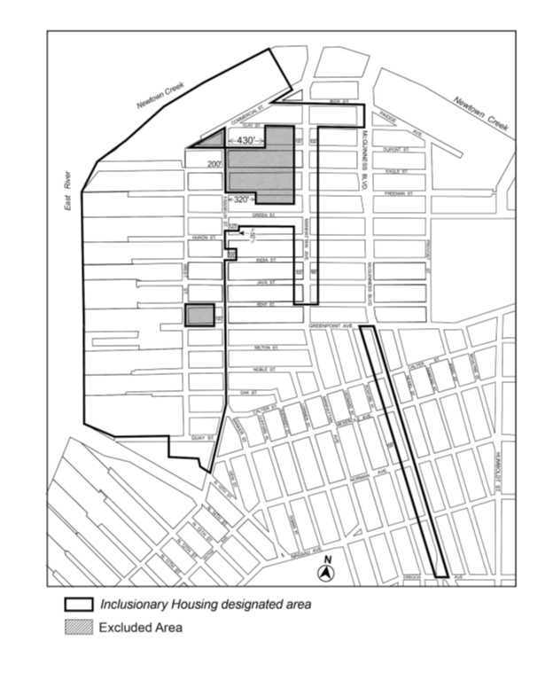

[PROPOSED MAP]

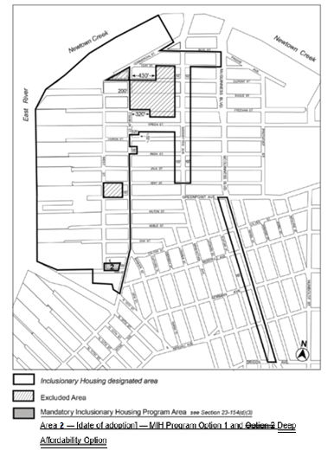

Portion of Community District 1, Brooklyn

* * *

Adopted.

Office of the City Clerk,}
The City of New York,} ss.:

I hereby certify that the foregoing is a true copy of a Resolution passed by The Council of The City of New York on ___ ______, 2021, on file in this office.

.....................................................
City Clerk, Clerk of The Council

