THE COUNCIL OF THE CITY OF NEW YORK
RESOLUTION NO. 1797

Resolution approving with modifications the decision of the City Planning Commission on Application No. N 210290 ZRR, for an amendment of the text of the Zoning Resolution (L.U. No. 843).

By Council Members Salamanca and Moya

WHEREAS, Richmond SI Owner, LLC, filed an application pursuant to Section 201 of the New York City Charter, for an amendment of the text of the Zoning Resolution of the City of New York, modifying Article XII, Chapter 8 (Special St. George District) and related Sections, and modifying APPENDIX F for the purpose of establishing a Mandatory Inclusionary Housing area, which in conjunction with the related actions would facilitate the development of a 592,014-square-foot mixed-use development with three mixed-use buildings, comprised of approximately 750 housing units, including 225 permanently affordable units, and 18,800 square feet of non-residential uses located on the ground floor and cellar in the St. George neighborhood of Staten Island, Community District 1 (ULURP No. N 210290 ZRR), (the “Application”);

WHEREAS, the City Planning Commission filed with the Council on September 10, 2021, its decision dated September 1, 2021 (the "Decision") on the Application;

WHEREAS, the Application is related to applications C 210289 ZMR (L.U. No. 842), a zoning map amendment (a) rezoning a R6 zoning district with a C2-2 overlay at a depth 100 feet within the SHPD to an R7-3 zoning district with a C2-4 commercial overlay at a depth of 185 feet and to be located within the SSGD; and (b) rezoning a R6 zoning district with a C2-2 overlay to a R6 zoning district with a C2-4 overlay and to be located within the SSGD; and C 210291 ZSR (L.U. No. 844), a special permit to modify bulk requirements within R7 districts and mandatory improvements of the SG;

WHEREAS, the Decision is subject to review and action by the Council pursuant to Section 197-d of the City Charter;

WHEREAS, upon due notice, the Council held a public hearing on the Decision and Application on September 24, 2021;

WHEREAS, the Council has considered the land use implications and other policy issues relating to the Decision and Application; and

WHEREAS, the Council has considered the relevant environmental issues, including the Positive Declaration, issued on October 16th, 2020 (CEQR No. 20DCP140R) and a Final Environmental Impact Statement (FEIS) for which a Notice of Completion was issued on August 20, 2021, which identified significant adverse impacts related to hazardous materials, noise, and air quality would be avoided through the placement of (E) designations (E-614) on the project sites. The proposed project, as analyzed in the FEIS, also identified significant adverse impacts with respect to open space (active), transportation (vehicular traffic), and construction (vehicular traffic, noise) and mitigation measures are included in the Restrictive Declaration.

RESOLVED:

Having considered the FEIS with respect to the Decision and Application, the Council finds that:

- The FEIS meets the requirements of 6 N.Y.C.R.R. Part 617;

- Consistent with social, economic and other essential considerations, from among the reasonable alternatives thereto, the action is one which minimizes or avoids adverse environmental impacts to the maximum extent practicable; and

- The adverse environmental impacts disclosed in the FEIS will be minimized or avoided to the maximum extent practicable by incorporating, as conditions to the approval, pursuant to the restrictive declaration attached as Exhibit A to City Planning Commission report for C 210291 ZSR, those project components related to environment and mitigation measures that were identified as practicable.

The Decision, together with the FEIS constitute the written statement of facts, and of social, economic and other factors and standards that form the basis of this determination, pursuant to 6 N.Y.C.R.R. §617.11(d).

Pursuant to Sections 197-d and 200 of the City Charter and on the basis of the Decision and Application, and based on the environmental determination and consideration described in the report, N 210290 ZRR, incorporated by reference herein, and the record before the Council, the Council approves the Decision of the City Planning Commission with the following modifications:

Matter underlined is new, to be added;
Matter struck out is to be deleted;
Matter within # # is defined in Section 12-10;
* * * indicates where unchanged text appears in the Zoning Resolution.
Matter double struck out is old, deleted by the City Council;
Matter double-underlined is new, added by the City Council.

* * *

ARTICLE II
RESIDENCE DISTRICT REGULATIONS

Chapter 1
Statement of Legislative Intent

* * *

21-10
PURPOSES OF SPECIFIC RESIDENCE DISTRICTS

* * *

21-15
R3-2, R4, R4B, R5, R6, R7, R8, R9 and R10 — General Residence Districts

These districts are designed to provide for all types of residential buildings, in order to permit a broad range of housing types, with appropriate standards for each district on density, open space, and spacing of buildings. However, R4B Districts are limited to single- or two-family dwellings, and zero lot line buildings are not permitted in R3-2, R4 (except R4-1 and R4B), and R5 (except R5B) Districts. The various districts are mapped in relation to a desirable future residential density pattern, with emphasis on accessibility to transportation facilities and to various community facilities, and upon the character of existing development. These districts also include community facilities and open uses which serve the residents of these districts or benefit from a residential environment.

R7-3 and R9-1 Districts may be mapped only as specified in this paragraph. Such districts may be mapped within the waterfront area and in the #Special Mixed Use Districts#. In addition, R7-3 Districts may be mapped in the #Special Long Island City Mixed Use District# and #Special St. George District#, and R9-1 Districts may be mapped in #Mandatory Inclusionary Housing areas#.

* * *
Chapter 3
Residential Bulk Regulations in Residence Districts

23-00
APPLICABILITY AND GENERAL PURPOSES

23-01
Applicability of This Chapter

* * *

23-011
Quality Housing Program
* * *

R6 R7 R8 R9 R10

(c) In the districts indicated without a letter suffix, the optional Quality Housing #bulk# regulations permitted as an alternative pursuant to paragraph (b) of this Section, shall not apply to:

(1) Article VII, Chapter 8 (Special Regulations applying to Large Scale Residential Developments) ,except that they may be permitted as an alternative to apply within #Large Scale Residential Developments# located:
(i) in C2-5 Districts mapped within R9-1 Districts in Community District 3 in the Borough of Manhattan.
(2) Special Purpose Districts
However, such optional Quality Housing #bulk# regulations are permitted as an alternative to apply in the following Special Purpose Districts:

* * *

Special Ocean Parkway District;

Special St. George District;

Special Transit Land Use District; or

Special Tribeca Mixed Use District.

* * *

ARTICLE XII
SPECIAL PURPOSE DISTRICTS

Chapter 8
Special St. George District

128-00
GENERAL PURPOSES

The “Special St. George District” established in this Resolution is designed to promote and protect public health, safety and general welfare. These general goals include among others, the following specific purposes:

(a) to build upon St. George’s existing strengths as a civic center, neighborhood and transit hub by providing rules that will bolster a thriving, pedestrian-friendly business and residence district;

(b) to establish zoning regulations that facilitate continuous ground floor retail and the critical mass needed to attract and sustain a broader mix of uses;

(c) to require a tall, slender building form that capitalizes on St. George’s hillside topography and maintains waterfront vistas;

(d) to encourage the reuse and reinvestment of vacant office buildings;

(e) to accommodate an appropriate level of off-street parking while reducing its visual impact; and

(f) to enhance neighborhood economic diversity by broadening the range of housing choices for residents at varied incomes; and

(g) to promote the most desirable use of land and building development in accordance with the District Plan for St. George and thus conserve the value of land and buildings and thereby protect the City’s tax revenues.

128-01
Definitions

Definitions specifically applicable to this Chapter are set forth in this Section and may modify definitions set forth in Section 12-10 (DEFINITIONS). Where matter in italics is defined both in Section 12-10 and in this Chapter, the definitions in this Chapter shall govern.
Commercial street

A “commercial street” shall be a #street#, or portion thereof, where special regulations pertaining to ground floor #uses# on #commercial streets#, pursuant to Section 128-11, apply to #zoning lots# fronting upon such #streets#. #Commercial streets# are designated on Map 2 in the Appendix to this Chapter.

* * *

128-056
Applicability of the Quality Housing Program

In C4-2 Districts, the optional Quality Housing #bulk# regulations permitted as an alternative pursuant to Section 23-011 (Quality Housing Program) shall not apply. In lieu thereof, the #bulk# regulations of this Chapter shall apply. However, where any of the Quality Housing Program elements set forth Article II, Chapter 8 (Quality Housing Program) are provided, the associated #floor area# exemption shall apply.

In C2-4 Districts mapped within R6 Districts, the optional Quality Housing #bulk# regulations permitted as an alternative pursuant to Section 23-011 shall apply.

In R7-3 Districts, the Quality Housing Program shall apply. For the purposes of applying such regulations, #buildings# constructed pursuant to the #bulk# regulations of this Chapter shall be considered #Quality Housing buildings#, and any #building# containing #residences# shall also comply with the requirements of Article II, Chapter 8.

For the purposes of applying the Quality Housing Program elements set forth in Article II, Chapter 8 to C2-4 Districts mapped within R6 Districts and to R7-3 Districts, the elements set forth in Sections 28-23 (Planting Areas) and 28-40 (Parking for Quality Housing) shall be superseded by the planting and parking location provisions of this Chapter.

* * *

128-20
FLOOR AREA, LOT COVERAGE AND YARD REGULATIONS

128-21
Maximum Floor Area Ratio

In C4-2 Districts within the Upland Subdistrict, the underlying #floor area ratio# and #open space# regulations shall not apply. In lieu thereof, the maximum #floor area ratio# for any #use#, separately or in combination, shall be 3.4, and no #floor area# bonuses shall apply, except that for #zoning lots# with less than 10,000 square feet of #lot area# without frontage on a #commercial street#, the maximum #floor area ratio# for any #use#, separately or in combination, shall be 2.2, and no #floor area# bonuses shall apply.

In R7-3 Districts, the maximum #floor area ratio# for any #use# within a #Mandatory Inclusionary Housing area# shall be 6.0.

128-22
Maximum Lot Coverage

In C4-2 Districts within the Upland Subdistrict and in R7-3 Districts, the underlying #open space ratio# provisions shall not apply. In lieu thereof, the maximum permitted #lot coverage# for a #residential building#, or portion thereof, shall be 70 percent for an #interior# or #through lot# and 100 percent for a #corner lot#.

* * *

128-30
HEIGHT AND SETBACK REGULATIONS

The provisions of this Section, inclusive, shall apply to all #buildings or other structures# within the Upland Subdistrict, except in C2-4 Districts mapped within R6 Districts, where the underlying height and setback regulations shall apply.

In C1-2 Districts mapped within R3-2 Districts, all #buildings or other structures# shall comply with the height and setback regulations of R4 Districts, except that the maximum perimeter wall height shall be 26 feet, and the #street wall# location provisions of Section 128-32 (Street Wall Location) shall apply.

The underlying height and setback regulations of C4-2 Districts within the Upland Subdistrict shall not apply. In lieu thereof, the height and setback regulations of this Section, inclusive, shall apply.
In R7-3 Districts, all #buildings or other structures# shall comply with the height and setback regulations of this Section, inclusive.

In the South and North Waterfront Subdistricts, the underlying height and setback regulations of Section 62-34 (Height and Setback Regulations on Waterfront Blocks) shall apply, except that:

(a) in the South Waterfront Subdistrict, rooftop regulations shall be as modified in Section 128-31 (Rooftop Regulations); and

(b) in the North Waterfront Subdistrict, #developments#, #enlargements#, alterations and changes of #use# permitted pursuant to Section 128-61 (Special Permit for North Waterfront Sites) shall instead be subject to the Proposed Plans, as set forth in Section 128-61, as approved pursuant to such special permit.

All heights shall be measured from the #base plane#, except that wherever a minimum or maximum base height is specified for #zoning lots# with multiple #street frontages#, such heights shall be determined separately for each #street# frontage, with each height measured from the final grade of the sidewalk fronting such #street wall#.

* * *
128-32
Street Wall Location
The following #street wall# regulations shall apply in C1-2 Districts mapped within R3-2 Districts and in C4-2 Districts within the Upland Subdistrict. In R7-3 Districts, no #street wall# location provisions shall apply.

(a) #Street walls# along #commercial streets#

* * *
128-33
Maximum Base Height
In C4-2 Districts within the Upland Subdistrict, the The maximum height of a #building or other structure# before setback shall be as specified on Map 3 (Minimum and Maximum Base Heights) in the Appendix to this Chapter. Where a maximum base height of 65 feet applies as shown on Map 3, such maximum base height shall be reduced to 40 feet for #zoning lots developed# or #enlarged# pursuant to the tower provisions of Section 128-35. When a #building# fronts on two intersecting #streets# for which different maximum base heights apply, the higher base height may wrap around to the #street# with the lower base height for a distance of up to 100 feet.

In R7-3 Districts, the maximum base height shall be 75 feet.

In C4-2 Districts within the Upland Subdistrict and in R7-3 Districts, all All portions of #buildings or other structures# above such maximum base heights shall provide a setback at least 10 feet in depth measured from any #street wall# facing a #wide street# and 15 feet in depth from any #street wall# facing a #narrow street#.

In C4-2 Districts within the Upland Subdistrict and in R7-3 Districts, dormers may exceed the maximum base height in accordance with the provisions of paragraph (c) of Section 23-621 (Permitted obstructions in certain districts). However, on any #zoning lot# that includes a tower #developed# or #enlarged# pursuant to Section 128-35, dormers shall not be permitted.

128-34
Maximum Building Height
In C4-2 Districts within the Upland Subdistrict, for #buildings# that are not #developed# or #enlarged# pursuant to the tower provisions of Section 128-35 (Towers), the maximum height of a #building or other structure# and the maximum number of #stories#, as applicable, shall be as set forth in Section 23-662 (Maximum height of buildings and setback regulations) for a residential equivalent of an R6 District. Separate maximum #building# heights are set forth within such Section for #developments# or #enlargements# with #qualifying ground floors# and for those with #non-qualifying ground floors#. However, on Bay Street where there is a maximum base height of 85 feet, the maximum height of a #building or other structure# also shall be 85 feet.

In C4-2 Districts within the Upland Subdistrict for #buildings# that are #developed# or #enlarged# pursuant to the tower provisions of Section 128-35, the maximum height of the tower portion of a #building# shall be 200 feet, and the height of all other portions of the #building# shall not exceed the applicable maximum base height. Where a maximum base height of 65 feet applies as shown on Map 3 in the Appendix to this Chapter, such maximum base height shall be reduced to 40 feet for #zoning lots developed# or #enlarged# pursuant to the tower provisions of Section 128-35.

In R7-3 Districts, the maximum height of a #building or other structure# shall be 185 feet or 18 #stories#, whichever is lower. The tower provisions of Section 128-35 shall not apply.

* * *

128-50
PARKING REGULATIONS

* * *

128-51
Required Off-street Parking and Loading

In the #Special St. George District#, the following parking and loading regulations shall apply:

(a) In C4-2 Districts, the following special regulations shall apply:

(a)(1) #Residential uses#

One off-street parking space shall be provided for each #dwelling unit# created after October 23, 2008, including any #dwelling units# within #buildings# converted pursuant to Article I, Chapter 5 (Residential Conversion Within Existing Buildings), except that the provisions of Section 25-25 (Modification of Requirements for Income-restricted Housing Units, Affordable Independent Residences for Seniors or Other Government-assisted Dwelling Units) shall apply to #income-restricted housing units#. However, where the total number of required spaces is five or fewer or, for #conversions#, where the total number of required spaces is 20 or fewer, no parking shall be required, except that such waiver provision shall not apply to any #zoning lot# subdivided after October 28, 2008. The provisions of Section 73-46 (Waiver of Requirements for Conversions) shall apply to #conversions# where more than 20 parking spaces are required.

(b)(2) #Commercial# #uses#

For #commercial# #uses#, the off-street parking and loading requirements of a C4-3 District shall apply, except that food stores with 2,000 or more square feet of #floor area# per establishment shall require one parking space per 400 square feet of #floor area# and, for places of assembly and hotels, the off-street parking and loading requirements of a C4-2 District shall apply.

(c)(3) #Community facility use#

For ambulatory diagnostic or treatment health care facilities listed in Use Group 4, the off-street parking requirements of a C4-3 District shall apply.

(b) In R7-3 Districts, the parking and loading regulations of an R7-2 District shall apply, except as modified by Sections 128-52 (Special Floor Area Regulations) through 128-56 (Curb Cuts on Commercial Streets).

(c) In C2-4 Districts mapped within R6 Districts, the underlying regulations shall apply, except as modified by Sections 128-52 through 128-56.

* * *

128-60
SPECIAL APPROVALS

The special permit for North Waterfront sites set forth in Section 128-61 is established in order to guide and encourage appropriate #use# and #development# in a unique location within the #Special St. George District# that serves as a gateway between Staten Island and Manhattan for both visitors and daily commuters. Redevelopment of the North Waterfront sites pursuant to this special permit provides an appropriate means to address the special characteristics of these sites, while accommodating their continuing transportation function, as part of their transformation into a regional destination that will contribute to the revitalization of the #Special St. George District# and surrounding area.

The special permit for #buildings# in R7-3 Districts set forth in Section 128-62 is established to allow modification of #bulk# regulations and mandatory improvements, except #floor area ratio# provisions, in order to encourage better site planning, and streetscapes that are consistent with the goals of the Special District.

* * *

128-62
Special Permit for Buildings in R7-3 Districts

For any #zoning lot# in an R7-3 District, the City Planning Commission may permit modification of #bulk# regulations, except #floor area ratio# provisions, and modification of mandatory improvements, provided the Commission shall find that such modifications:

(a) will aid in achieving the general purposes and intent of the Special District;

(b) will enhance the distribution of #bulk# on the #zoning lot#;

(c) will not unduly obstruct access to light and air from surrounding #streets# and properties; and

(d) will result in a better site plan and urban design relationship with adjacent #streets#, open areas, and the surrounding neighborhood.

The Commission may prescribe additional conditions and safeguards to minimize adverse effects on the character of the surrounding area.

Appendix – Special St. George District Plan

[ALL PROPOSED MAPS BELOW TO BE REPLACED
BY COUNCIL-MODIFIED MAPS]

Map 1 – Special St. George District and Subdistricts [date of adoption]

[EXISTING MAP]
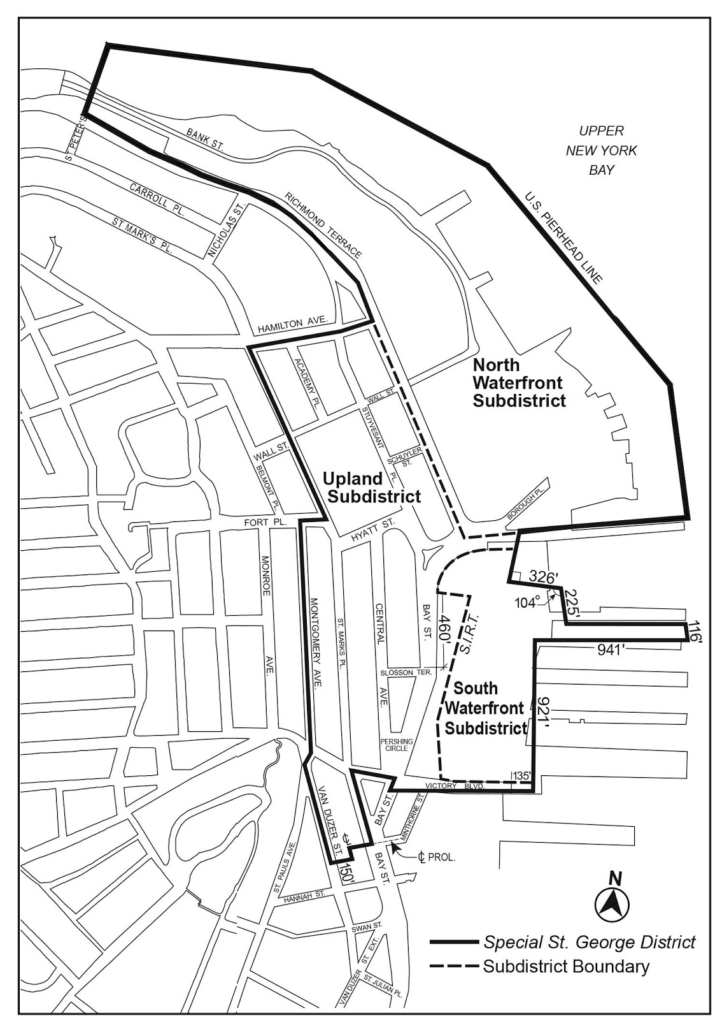

[PROPOSED MAP]
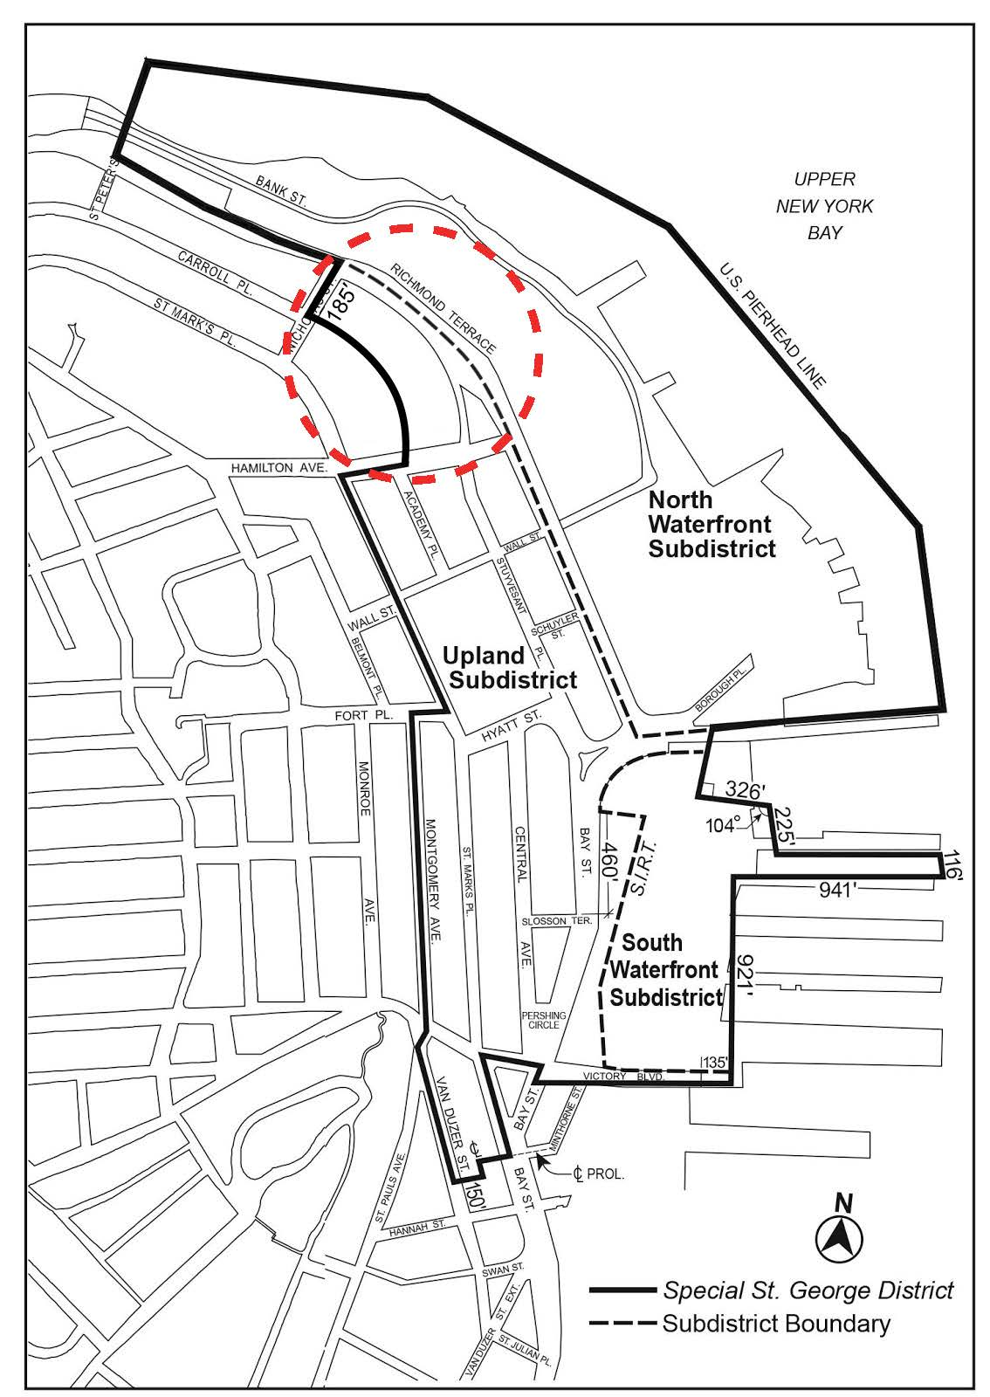

[Council Modified Map]

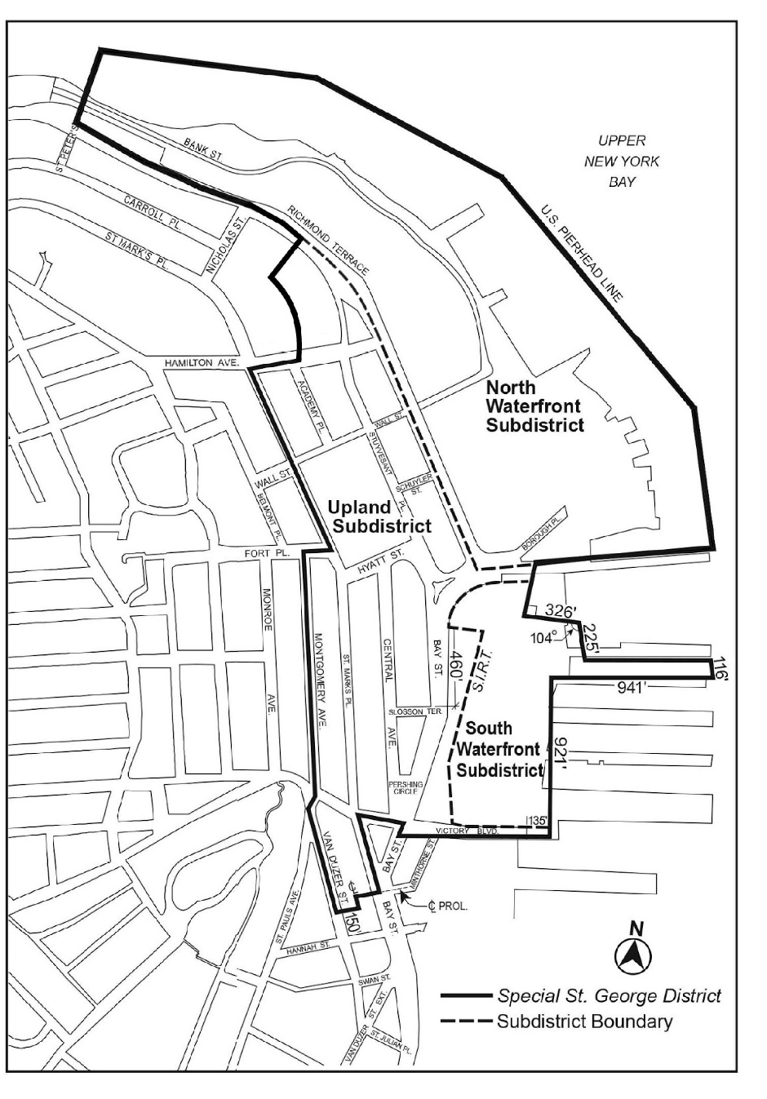

Map 2 – Commercial Streets [date of adoption]

[EXISTING MAP]
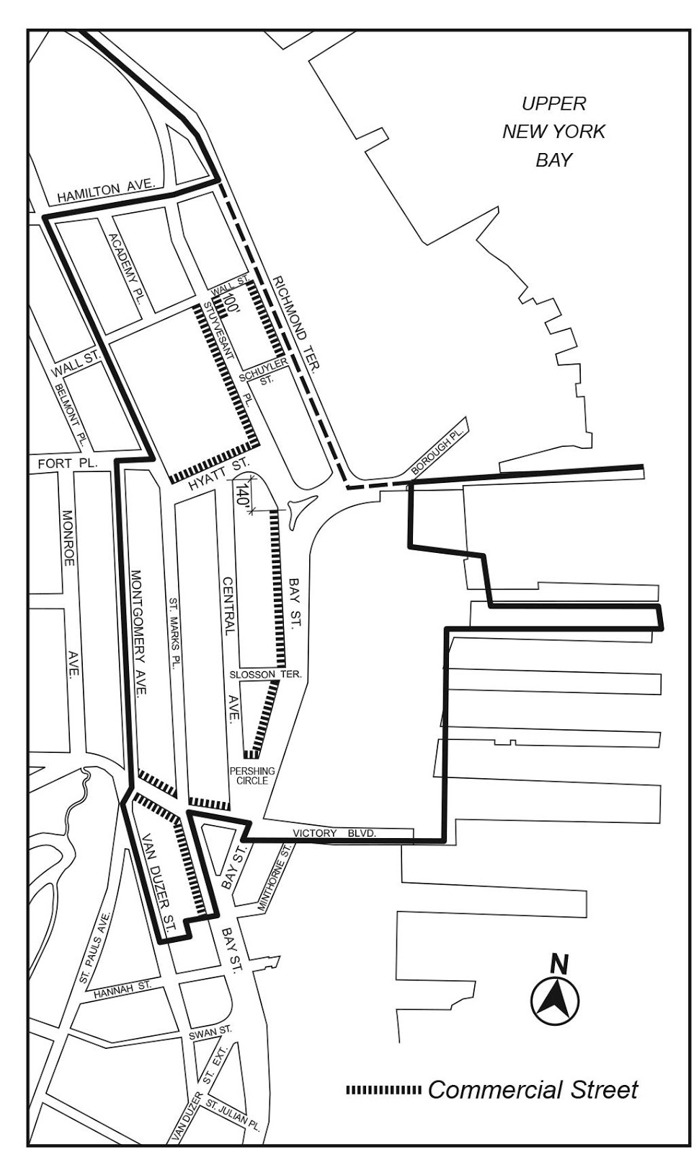

[PROPOSED MAP]
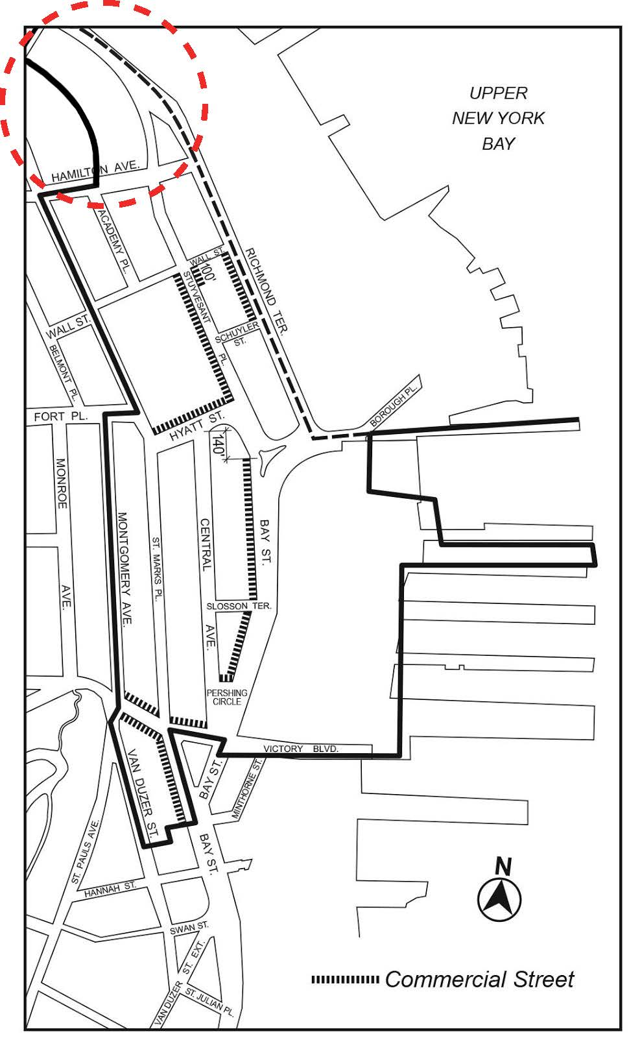

[Council Modified Map]

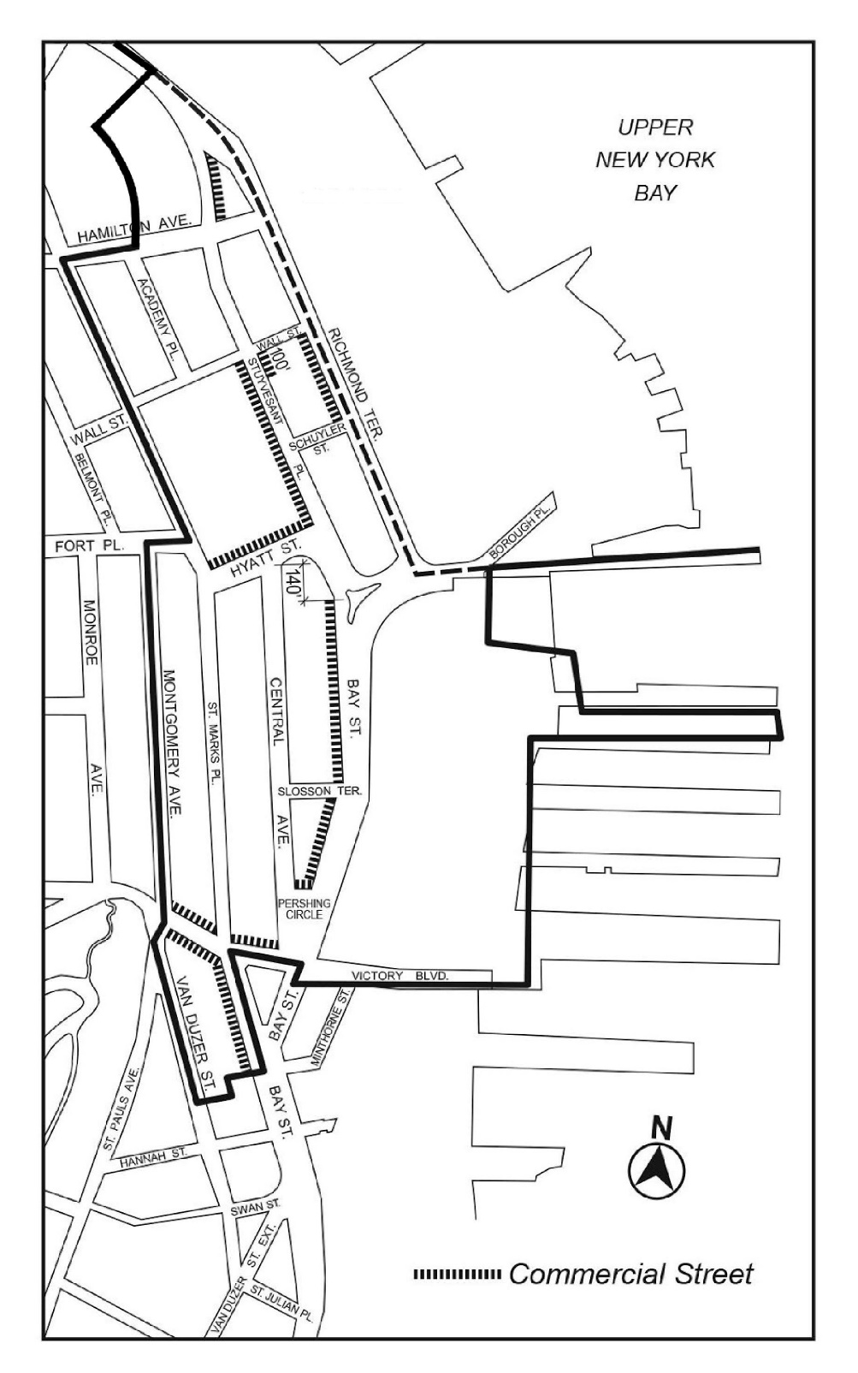

Map 3 –Minimum and Maximum Base Heights [date of adoption]

[EXISTING MAP]

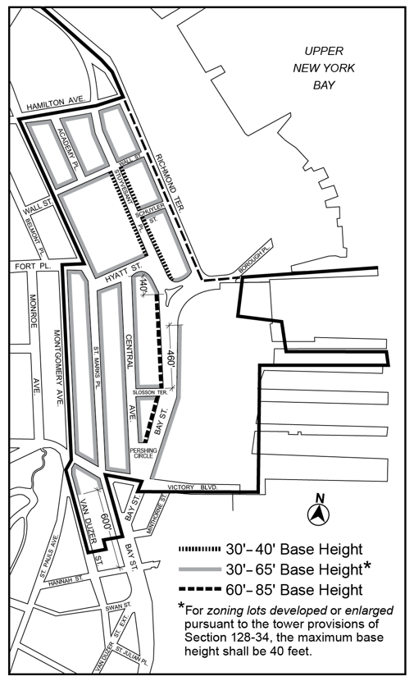

[PROPOSED MAP]
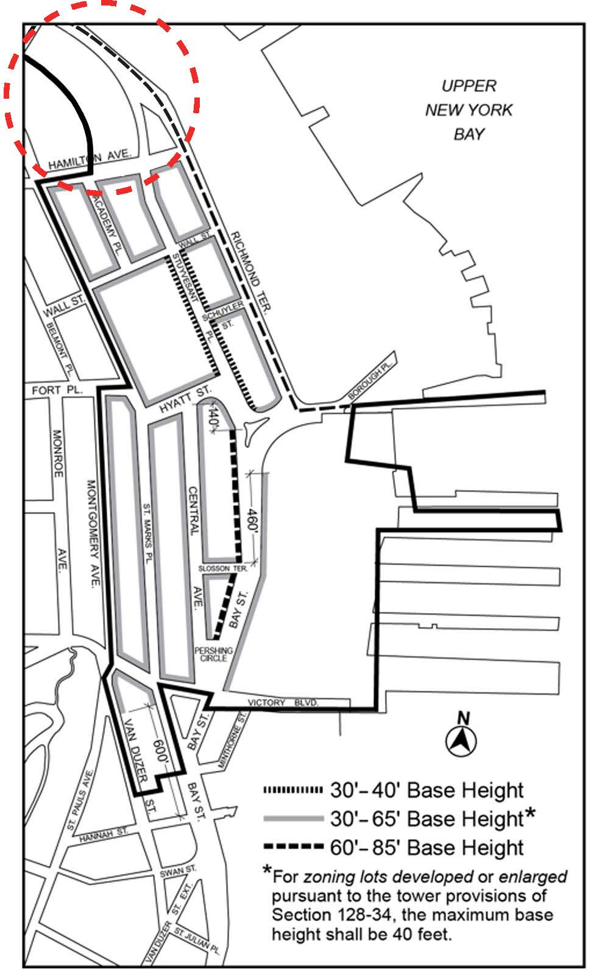

[Council Modified Map]

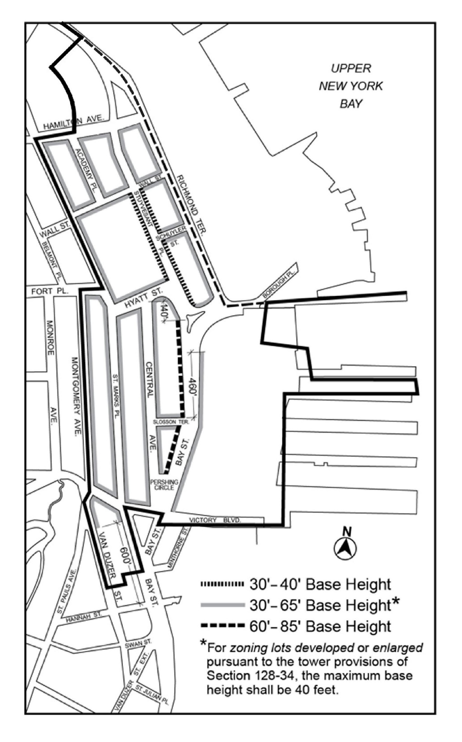

Map 4 – Tower Restriction Areas [date of adoption]

[EXISTING MAP]

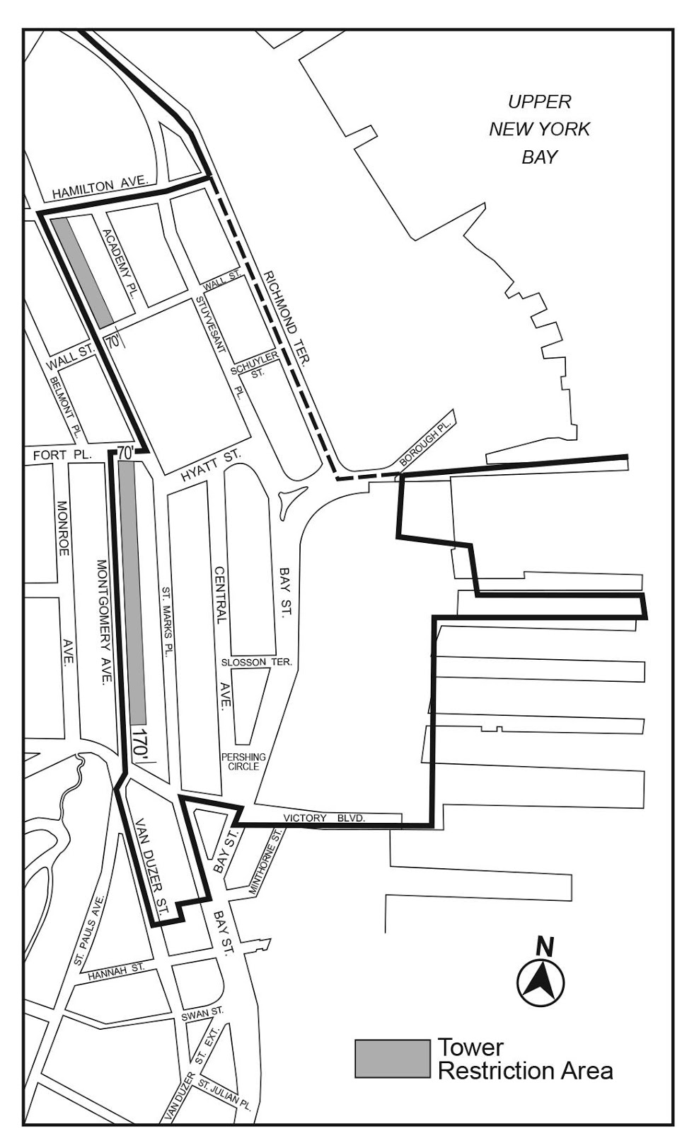
[PROPOSED MAP]
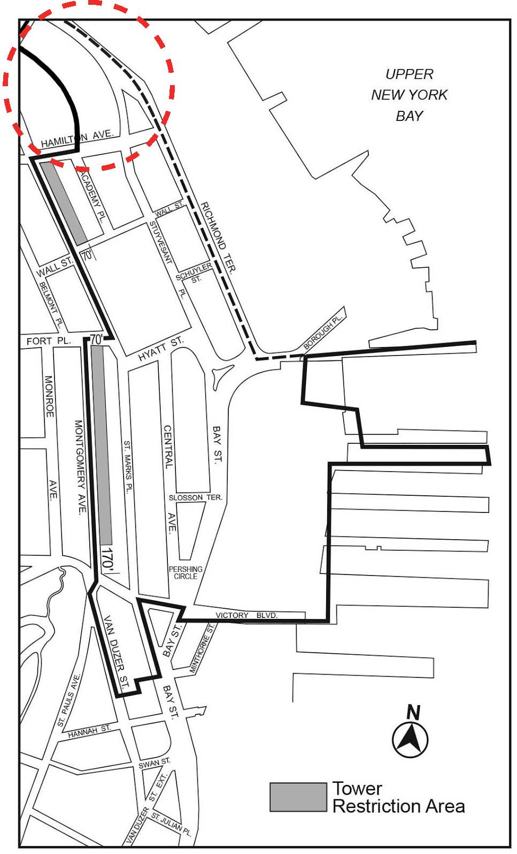

[Council Modified Map]

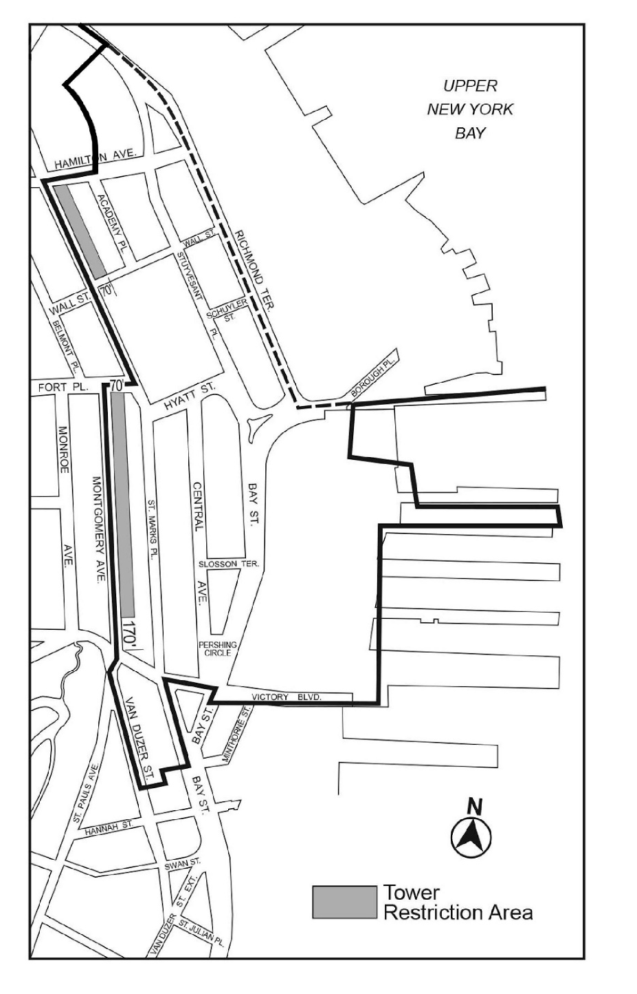

Map 5 – Visual Corridors and Parcels [date of adoption]

[EXISTING MAP]
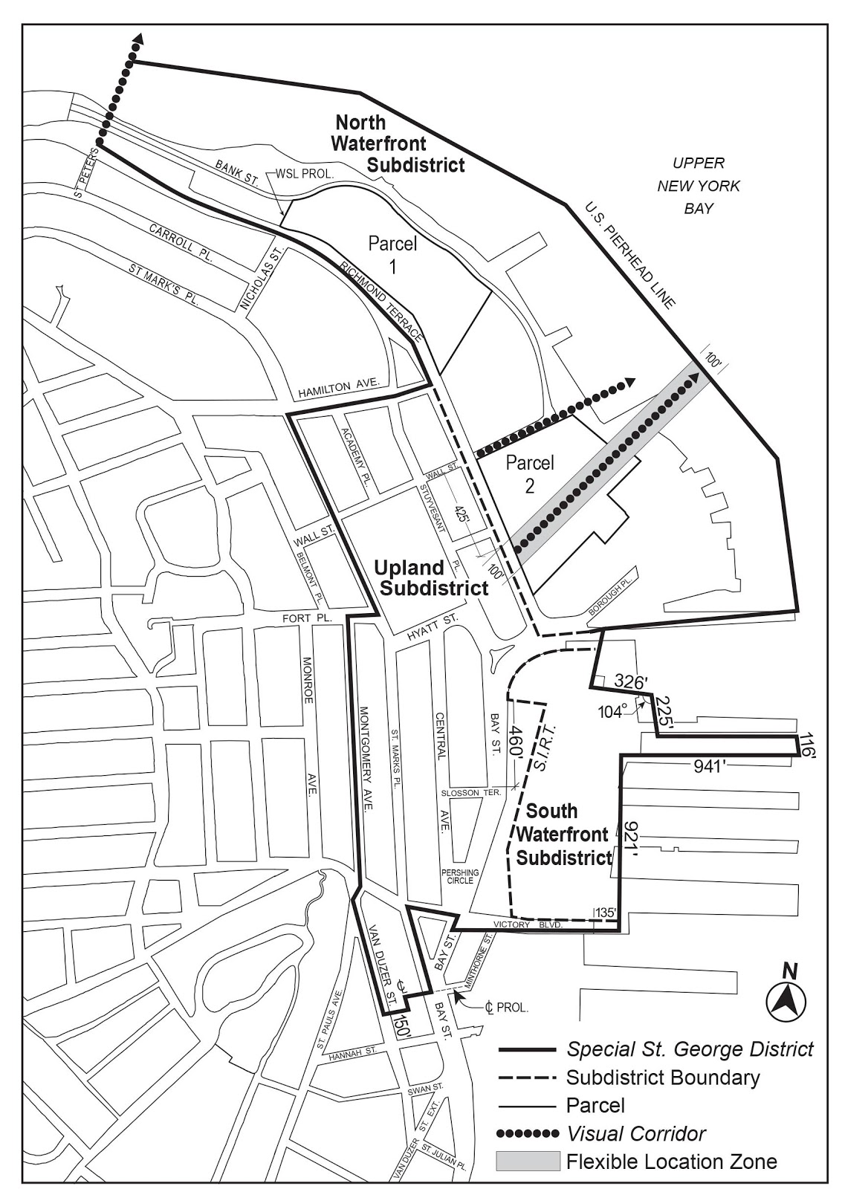
[PROPOSED MAP]
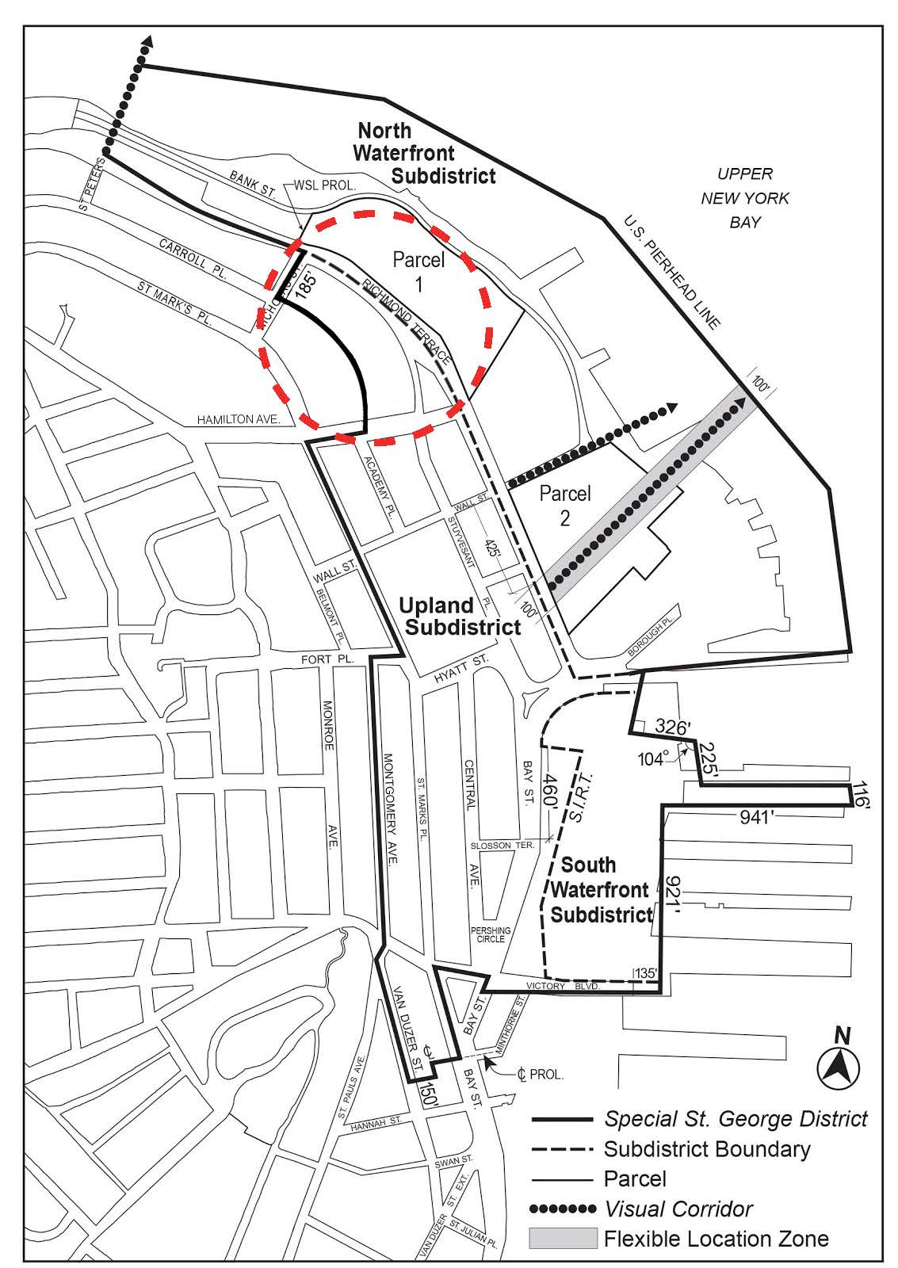

[Council Modified Map]

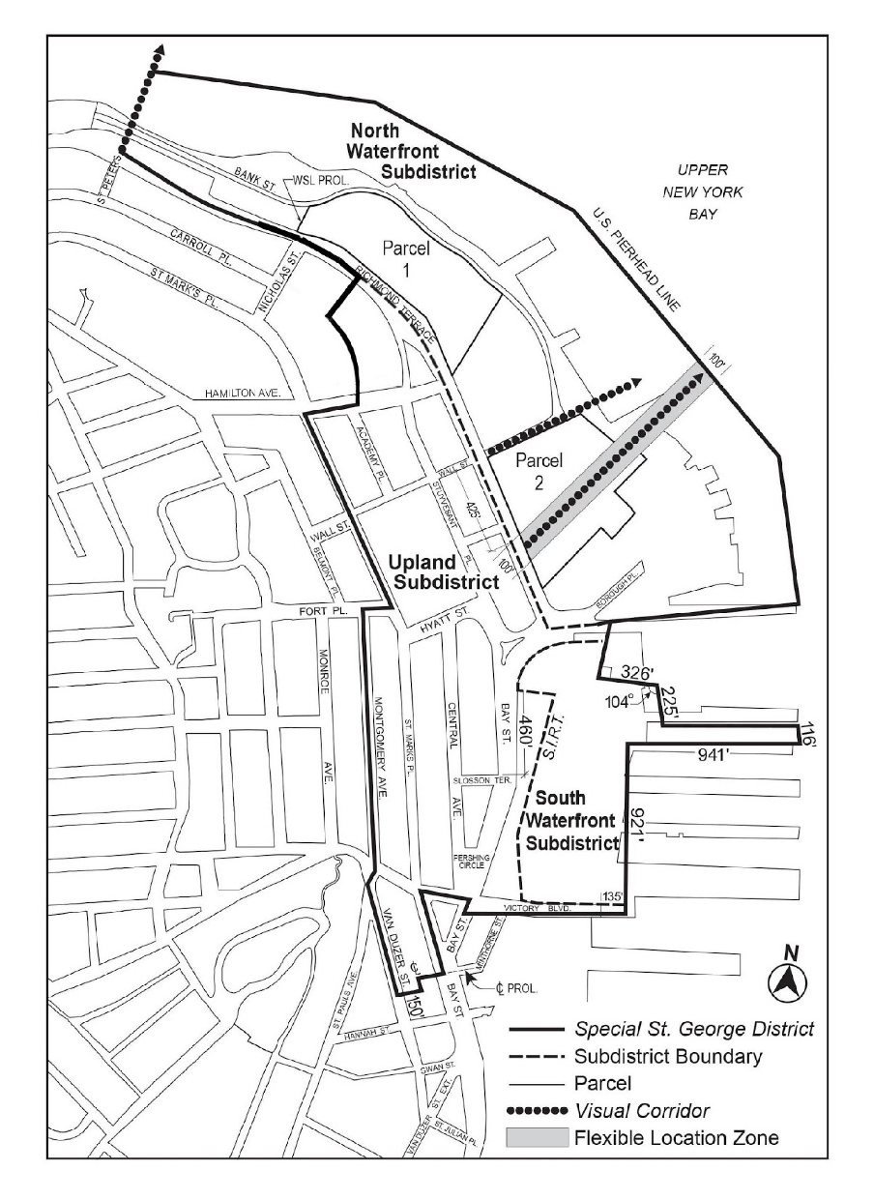

* * *

APPENDIX F

Inclusionary Housing Designated Areas and Mandatory Inclusionary Housing Areas

* * *

STATEN ISLAND

Staten Island Community District 1

* * *

Map 3 – [date of adoption]

[PROPOSED MAP]

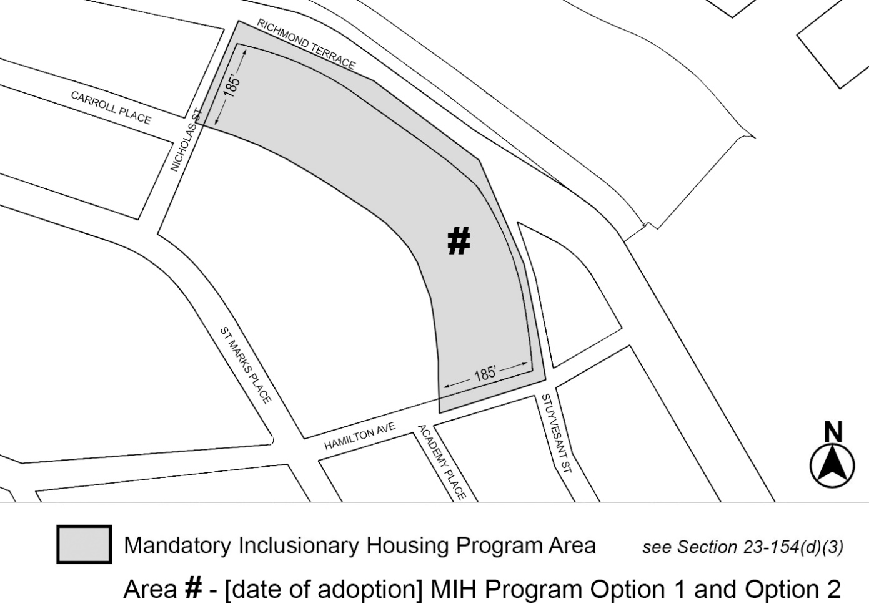

[Council Modified Map]

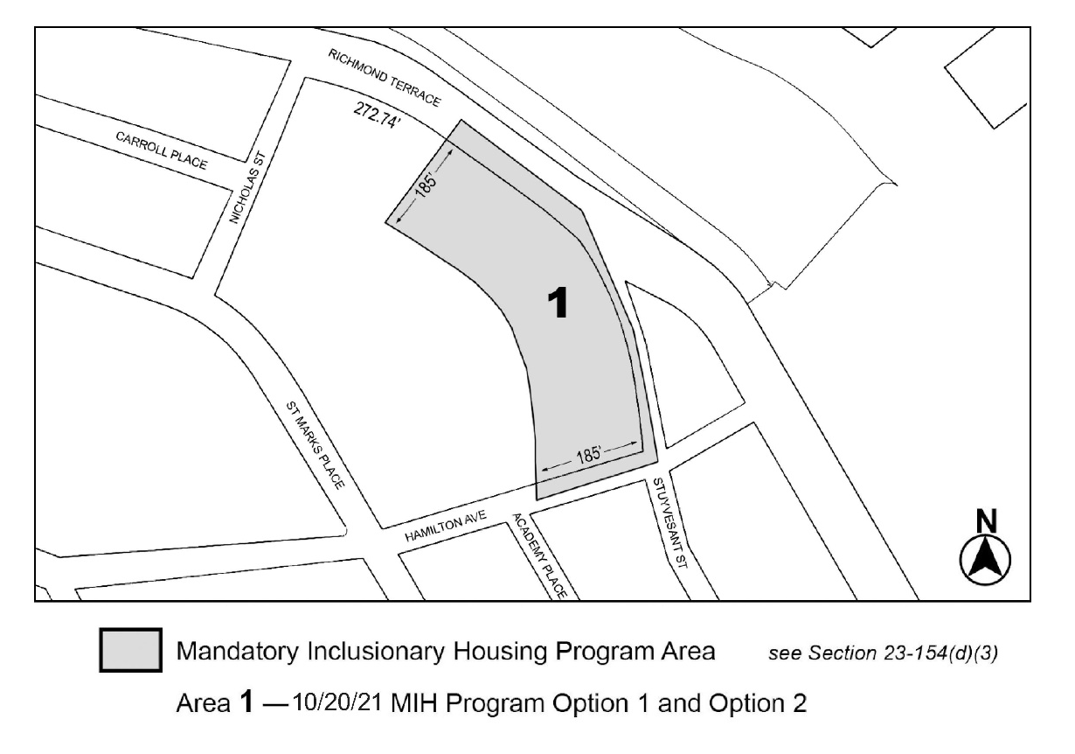
260’

* * *

Adopted.

Office of the City Clerk,}
The City of New York,} ss.:
I hereby certify that the foregoing is a true copy of a Resolution passed by The Council of The City of New York on November 10, 2021, on file in this office.

.....................................................
City Clerk, Clerk of The Council

