THE COUNCIL OF THE CITY OF NEW YORK
RESOLUTION NO. 1642

Resolution approving the decision of the City Planning Commission on Application No. N 170030 ZRK, for an amendment of the Zoning Resolution of the City of New York, modifying Appendix F, for the purpose of establishing a Mandatory Inclusionary Housing area, within Community District 2, Borough of Brooklyn (L.U. No. 731).

By Council Members Greenfield and Richards

WHEREAS, the City Planning Commission filed with the Council on July 28, 2017 its decision dated July 26, 2017 (the "Decision"), pursuant to Section 201 of the New York City Charter, regarding an application submitted by the Institute for Community Living, for an amendment to the text of the Zoning Resolution of the City of New York, modifying Appendix F, for the purpose of establishing a Mandatory Inclusionary Housing area on the northeast corner of the intersection of Schermerhorn Street and Nevins Street (Block 172, Lot 37, part of Lots 43, 44, 45). This amendment in conjunction with the related action would facilitate the enlargement of an existing building to a 10-story, 95-012 square foot building with approximately 128 units of affordable and supportive housing in the Downtown neighborhood of Brooklyn Community District 2, (Application No. N 170030 ZRK), Community District 2, Borough of Brooklyn (the "Application");

WHEREAS, the Application is related to application C 170029 ZMK (L.U. No. 730), a zoning map amendment to change a C6-1 district to a C6-4 district;

WHEREAS, the Decision is subject to review and action by the Council pursuant to Section 197-d(b)(1) of the City Charter;
WHEREAS, upon due notice, the Council held a public hearing on the Decision and Application on August 21, 2017;

WHEREAS, the Council has considered the land use implications and other policy issues relating to the Decision and Application; and

WHEREAS, the Council has considered the relevant environmental issues, including the negative declaration issued April 3, 2017 (CEQR No. 17DCP117K), which includes (E) designations to avoid the potential for significant adverse impacts related to hazardous materials, air quality and noise (E-421), (the “Negative Declaration”);

RESOLVED:

The Council finds that the action described herein would have no significant impact on the environment as set forth in the Negative Declaration.

Pursuant to Sections 197-d and 200 of the City Charter and on the basis of the Decision and Application, and based on the environmental determination and consideration described in the report, N 170030 ZRK, incorporated by reference herein, the Council approves the Decision.

Matter underlined is new, to be added;
Matter struck out is to be deleted;
Matter within # # is defined in Section 12-10;
* * * indicates where unchanged text appears in the Zoning Resolution

ARTICLE X
SPECIAL PURPOSE DISTRICTS

Chapter 1
Special Downtown Brooklyn District

* * *

101-02
General Provisions

* * *

101-021
Applicability of Inclusionary Housing program

In #Mandatory Inclusionary Housing areas#, as specified in APPENDIX F of this Resolution, the provisions of Sections 23-154 (Inclusionary Housing) and 23-90 (INCLUSIONARY HOUSING), shall apply, except as superseded, supplemented or modified by the provisions of this Chapter.

* * *

APPENDIX F
Inclusionary Housing Designated Areas and Mandatory Inclusionary Housing Areas

* * *

BROOKLYN
* * *

Brooklyn Community District 2

* * *

In portions of the #Special Downtown Brooklyn District# in the R6B and C6-4 (R10 equivalent) Districts within the areas shown on the following Map 6:

Map 6 - [date of adoption]


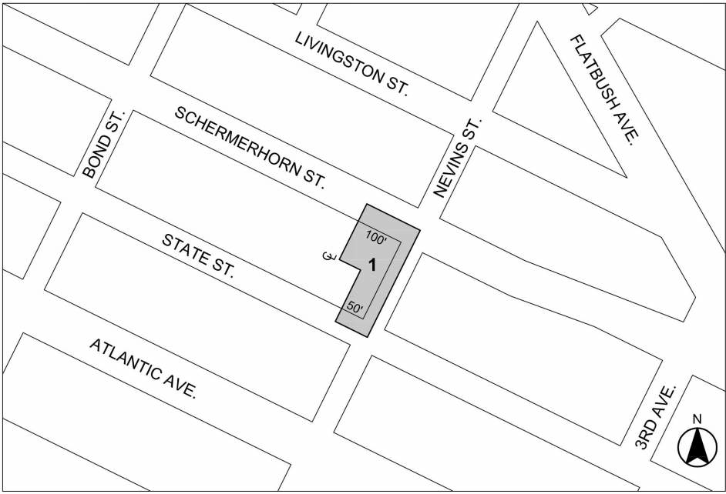
[PROPOSED MAP]
Mandatory Inclusionary Housing area see Section 23-154(d)(3)
Area 1 [date of adoption] - MIH Program Option 1 and Option 2

Portion of Community District 2, Brooklyn

* * *

Adopted.

Office of the City Clerk, }
The City of New York, } ss.:

I hereby certify that the foregoing is a true copy of a Resolution passed by The Council of The City of New York on September 7, 2017, on file in this office.

.....…….........................................
City Clerk, Clerk of The Council

