Staff: Committee on Technology
Irene Byhovsky, Legislative Counsel
Charles Kim, Legislative Policy Analyst
Florentine Kabore, Finance Analyst
Nicholas Montalbano, Data Analyst

Subcommittee on Zoning & Franchises
Angelina Martinez-Rubio, Subcommittee Counsel
Kaitlin Greer, Legislative Coordinator



THE COUNCIL OF THE CITY OF NEW YORK

Briefing Paper and Committee Report of the
Land Use and Infrastructure Divisions
Andrea Vazquez, Legislative Director
Brad Reid, Deputy Director
Perris Straughter, Land Use Director

COMMITTEE ON TECHNOLOGY
Hon. Jennifer Gutiérrez, Chairperson

SUBCOMMITTEE ON ZONING AND FRANCHISES
Hon. Kevin C. Riley, Chairperson

September 19, 2022

Oversight: Broadband and Equal Access to the Internet in New York City

Int. 112 By Council Members Holden, Riley, Yeger, and Menin
Title: A Local Law to amend the New York city charter, in relation to establishing a cable franchise agreements website
Charter: Adds § 1077 to Chapter 48

Int. 241 By Council Members Gutiérrez, Hanif, Joseph, Brooks-Powers, Stevens, Menin, Williams, Schulman, Riley, Narcisse, Ung, Barron, Ossé, Ayala, Restler, Cabán, Abreu, Krishnan, Richardson Jordan, Nurse, and Won
Title: A Local Law to amend the administrative code of the city of New York, in relation to providing public school students with mobile hotspot devices
Administrative Code: Adds Title 34 (§§ 34-101, 34-102, 34-201)

Int. 440 By Council Members Won, Menin, Gutiérrez, Hanif, Brewer, Louis, Joseph, Ung, Nurse, Schulman, Velázquez, Krishnan, Sanchez, Abreu, and Restler
Title: A Local Law to amend the New York city charter, in relation to a program to provide public access to wireless networks
Charter: Amends Section 15

Int. 599 By Council Members Won, Gutiérrez, Menin, Cabán, Hanif, Marte, Yeger, and Nurse
Title: A Local Law to amend the New York city charter, in relation to information on affordable internet programs for students and families
Charter: Adds § 1077 to Chapter 48

- Introduction
On September 19, 2022, the Committee on Technology, chaired by Council Member Jennifer Gutiérrez, jointly with the Subcommittee on Zoning and Franchises, chaired by Council Member Kevin C. Riley, will hold an oversight hearing titled “Broadband and Equal Access to the Internet in New York City”. This hearing will discuss the further expansion of internet access for New York City (“NYC” or “the City”) residents, the current state of broadband access in NYC, and the status of the Internet Master Plan, which was introduced in January 2020. In addition to this oversight topic, the committees will hear the following bills: Int. No. 112, (Holden), in relation to establishing a cable franchise agreements website; Int. No. 241 (Gutiérrez), in relation to providing public school students with mobile hotspot devices; Int. No. 440 (Won), in relation to a program to provide public access to wireless networks; and Int. No. 599 (Won), in relation to information on affordable internet programs for students and families. Witnesses invited to testify include the Office of Innovation and Technology (“OTI”), existing franchisees, industry representatives, advocates, and members of the public.
- Background
On January 7, 2020, then-Mayor Bill de Blasio and the Mayor’s Office of the Chief Technology Officer (“MOCTO”) announced the release of the New York City Internet Master Plan (“Internet Master Plan”), described as a roadmap for universal broadband in the City. Later that year, on October 13, 2020, the Committee on Technology jointly with the Subcommittee on Zoning and Franchises held an oversight hearing entitled Broadband and the Digital Divide, during which the Internet Master Plan was heavily discussed. Last year, the committee held an oversight hearing entitled Internet Master Plan One Year Later that further discussed the implementation of the plan. The Internet Master Plan was the outgrowth of prior efforts related to broadband in the City. Those efforts include the ‘NYC Connected’ Request for Information that was posted in 2017 to collect ideas for achieving universal broadband; the establishment of the Broadband City Assets Task Force in August 2018 to coordinate the use of City assets for broadband infrastructure deployment; and in 2018, several interviews and focus groups with 28 organizations and City agencies to better understand how residents use the internet.
The Internet Master Plan’s guiding principles are anchored in five areas: equity, performance, affordability, privacy, and choice, all of which are meant to serve as measures for success and design parameters with regards to the Mayoral Administration’s (“Administration”) relationship and approach to broadband infrastructure and services. The plan itself seeks to establish a network of multiple operators sharing “open access” or “neutral host” fiber optic infrastructure that can be used to lower costs, increase competition, and incentivize private-sector investments. According to the Internet Master Plan, the infrastructure would be built out and maintained through a series of public-private partnerships, with partners sought out using a Request for Proposals (“RFP”) dubbed the Universal Solicitation for Broadband (“USB”). The Administration also had plans to utilize several technologies across the three types of broadband connections such as fiber optic cable, mesh Wi-Fi, and 5G mobile connectivity to ensure a broadband network that is as expansive as possible.
  - Phases of Implementation of the Internet Master Plan
According to the Internet Master Plan, the City committed to four phases of actions that applied to an initial “Internet Action Plan Timeline” as follows: Coordinate City Processes, Optimize Public Assets, Partner on Infrastructure, and Enable Service Delivery.
Coordinate City Processes entails building on interagency contributions to maintain the consistency and clarity of City policies as broadband deployment increases;
Optimize Public Assets refers to how the City will invite proposals for the coordinated use of City-owned assets and look to maximize public benefit while also prioritizing approaches that allow for multiple operators to use an asset;
Partner on Infrastructure refers to the City investing in new infrastructure which can be shared by multiple broadband operators; and
Enable Service Delivery entails the City promoting the use of shared infrastructure so that broadband operators can reach more areas with more services.
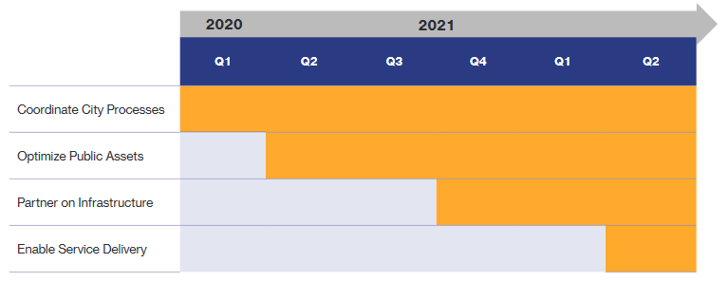
Figure 1, Internet Action Plan Timeline (Long description: Horizontal bar graph with each bar showing the intended start time of the initial four phases of the implementation of the Internet Action Plan Timeline, with an arrow pointing right on the top of the graph with the years 2020 and 2021 inlaid, implying that these four phases would continue until their completion after their start time. At the top of the graph and below the arrow are the labels Q1, Q2, Q3, and Q4, then Q1, and Q2 again, to indicate the different quarters of the two years. At the left of the graph are the labels for each bar, starting from the top: Coordinate City Processes, Optimize Public Assets, Partner on Infrastructure, and Enable Service Delivery. Each bar is segmented to align with the quarter in which that initial phase is supposed to start.)

According to the graph of the timeline provided in the Internet Master Plan (see Fig. 1), the steps of each action phase would commence in separate quarters of the year: “Coordinate City Processes” starting in the first quarter (“Q1”) of 2020; “Optimize Public Assets” starting in Q2 of 2020; “Partner on Infrastructure” beginning in Q4 of 2020; and the final step, “Enable Service Delivery” starting in Q2 of 2021.
The Internet Master Plan also has a broader roll-out plan containing four phases through which the City planned to take action to achieve universal broadband:
        - Introduce New Role for City Government: Wherein the City identifies priorities for new public and private investment in broadband infrastructure, invites proposals for the coordinated use of City assets, and mobilizes investment in new infrastructure.
        - Establish Partnerships for New Broadband Infrastructure and Service: Wherein the City reviews responses to the USB, awards public-private partnership agreements, coordinates across participating agencies, and provides oversight and data management for the launch of new services.
        - Expand Service to More New Yorkers: Wherein the City uses the infrastructure and assets from previously realized Internet Master Plan projects and partnerships to leverage more investment, solicitations, and proposals for the sake of more broadband service options.
        - Ensure All New Yorkers Benefit from Connectivity: Wherein the City considers measures and subsequently takes steps to ensure that no New Yorker is left out of improvements and equitable use of broadband connectivity.
In MOCTO testimony at an October 2020 hearing of the committees, the agency stated their opinion that the “Internet Master Plan is the most ambitious plan for citywide broadband in the nation,” which is “projected to generate an increase in $142 billion in gross city product and 165,000 jobs by 2045.” In March 2021, the City released its ‘Universal Solicitation for Broadband’ Request for Proposals. The RFP invites companies large and small to propose solutions to address the then existing system as described in the Internet Master Plan. Specifically, the City sought proposals for: new broadband infrastructure, such as fiber and conduit; asset managers to make that infrastructure broadly available; new affordable internet service options that meet the City’s Broadband Principles. According to April 2021 testimony before the Committee on Technology, MOCTO “received significant interest at the pre-proposal conference, more than 200 participants, and [were] looking forward to receiving proposals at the end of this month. In May [2021], the City [planned] to review the proposals, begin negotiations, and proceed with the process of licensing of City assets.” MOCTO has created a digital tool to help the RFP Review Committee visualize the geographic and neighborhood impacts of proposals and support its analysis and decision-making.
  - Data on the Digital Divide
Adoption of broadband internet is not evenly distributed across the City, and one of the goals of the Internet Master Plan was to bring internet access to areas where many residents are without an internet connection. According to data collected by the United States Census, in 2021, 8.1% of City households did not have access to any internet, 24.5% of households lacked access to broadband such as cable, fiber optic, or DSL, and 12.8% of households only had a cellular data plan and no other type of internet connection. This is compared to 13.2%, 28.3%, and 11.1%, respectively, for the American Community Survey’s (ACS) 2020 5-year estimates (2016-2020).
A high-speed broadband connection is necessary for many remote learning and remote work tasks. Having only a smartphone to connect to the internet to do schoolwork or to work remotely puts those users at a disadvantage, because it is often difficult to read tasks and assignments on a small screen or type out reports on a small keyboard. These users may also run into data overage charges if they use their smartphones for data-heavy applications such as video conferencing, and data plans might have insufficient capacity.
Students without home internet access or devices to connect to the internet struggle to complete their homework. They have had to sit outside school buildings, come home late at night from public libraries, or spend money on food at noisy fast-food restaurants in order to connect to the internet. Students have anecdotally reported having difficulty completing assignments because they could not connect to the internet or because the environment was not conducive to studying. Even after the NYC Department of Education distributed internet-connected iPads for students to use for remote learning, between 11% and 13% of students in each borough lacked access to the internet in fall 2020. Even with an internet connection at home, students were not always able to connect—between 10% and 17% of students in each borough lacked a device to connect to the internet in fall 2020.
In order to reliably analyze internet and broadband access at a more granular level, the City Council’s Data Team used the ACS 2020 5-year estimates for geographic and demographic analysis. According to the analyses, the five community districts with the highest percentage of households that lack a broadband subscription are in some of the lowest-income areas of the City. In addition, many households do not have a device that can connect to the internet or a sufficient number of devices for all household members to simultaneously use for work and school work.

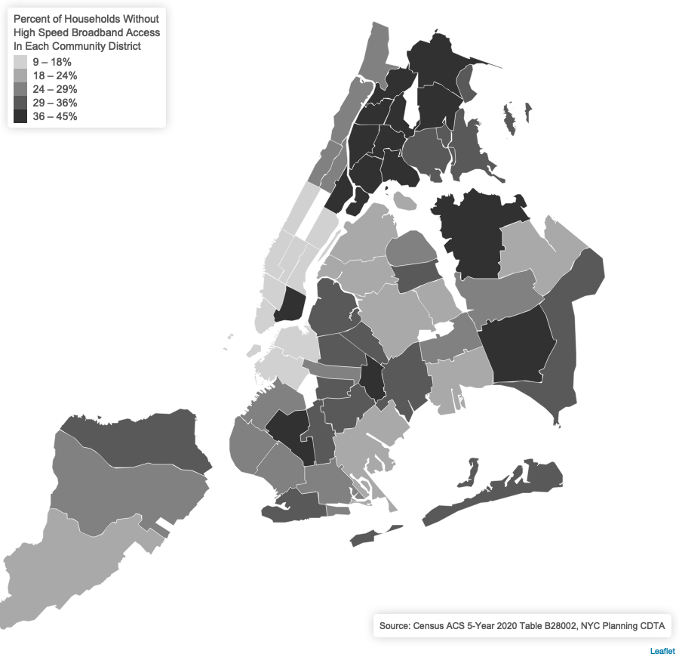

Figure 2, Percentage of Households Without High-Speed Broadband Access in Each Community District (Long description: A map of all 59 community districts in New York city that shows the share of residents without broadband subscriptions in each community district. Each community district is color-coded according to the percentage of broadband subscribers in each district. The lightest-colored districts represent those where 9-18% of households do not have broadband subscriptions. The darkest-colored districts represent those where 36-45% of households do not have broadband subscriptions. The data used represent a five-year average for 2016-2020.)
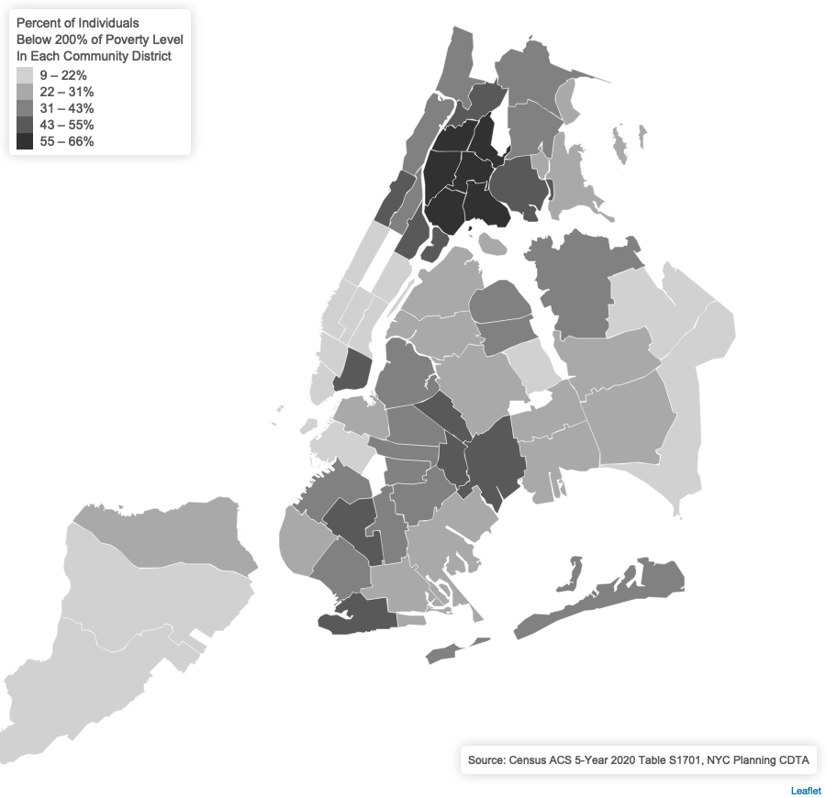
Figure 3, Percentage of Individuals Below 200% of Federal Poverty Level in Each Community District (Long description: A map of all 59 community districts in New York city that shows the share of individuals with incomes below 200% of the Federal Poverty Level in each community district. Each community district is color-coded according to the percentage of individuals with incomes below 200% of the Federal Poverty Level in each district. The lightest-colored districts represent those where 9-22% of individuals have incomes below 200% of the Federal Poverty Level. The darkest-colored districts represent those where 55-66% of individuals have incomes below 200% of the Federal Poverty Level. The data used represent a five-year average for 2016-2020.)
Bronx Community District 1 (Melrose-Mott Haven-Port Morris), Brooklyn Community District 12 (Borough Park-Kensington), Manhattan Community District 11 (East Harlem), Bronx Community District 6 (Tremont-Belmont-West Farms), Bronx Community District 2 (Longwood-Hunts Point), and Queens Community District 12 (Jamaica-St. Albans-Hollis) have the highest percentages citywide of residents without a broadband subscription (44%, 42%, 41%, 41%, 41%, and 41% respectively as of the ACS 2020 5-year estimates). As of 2020, in all of the community districts listed above (with the exception of Queens Community District 12), more than half of all residents have incomes below 200% of the federal poverty line.
Who has access to broadband is also unequally distributed across communities throughout the City. Low-income, senior citizen (65+), black, and Hispanic New Yorkers are less likely to have a broadband internet connection than New Yorkers overall. According to the ACS 2020 5-year estimates, under one third (28%) of New Yorkers lack a broadband internet connection. That share rises to over a third for black and Hispanic residents (35% and 36%) and nearly half (45%) of both low-income and senior citizen residents.
This lack of connectivity is due to many factors, but affordability is the biggest barrier to service for many residents without an internet connection. Most areas of the City have wiring for at least one internet service provider, and many have wiring for more than one provider.
  - Previous Hearings on Internet Master Plan and Digital Divide
The Committee on Technology has, in recent years, held two oversight hearings on the Internet Master Plan and the Digital Divide. The first was held jointly with the Subcommittee on Zoning and Franchises on October 13, 2020. In attendance were John Paul Farmer, Chief Technology Officer, MOCTO; Michael Pastor, Department of Information Technology and Telecommunications (“DoITT”); and representatives from Charter/Spectrum, Altice USA, Verizon, Starry Internet, Brooklyn Fiber, NYCLU, Local 3 IBEW AFL-CIO, NYC-DSA Tech Action Working Group, New York City Bar Association, LiveOn New York, Celina Trowell, Vocal New York, AARP New York, NYC Mesh, BetaNYC, Advocates for Children of New York, Bay Ridge Center, The Code, and New York City Privacy.
The most recent oversight hearing of the Committee on Technology was held on April 14, 2021. Witnesses included John Paul Farmer, Chief Technology Officer, MOCTO, and representatives from Surveillance Technology Oversight Project (“S.T.O.P.”), Silicon Harlem, and Community Tech NY & Digital Equity Laboratory at The New School.Testimony submitted for the record came from Charter Communications (“Spectrum”); Altice USA, Inc.; and The Partnership for New York City. Testimony from the Administration cited the release of the “Citywide Universal Solicitation for Broadband Request for Proposals” as an advancement in the implementation of the Internet Master Plan, and mentioned ongoing communications with City agencies, industry partners, and community organizations to coordinate broadband programs.
- Updates Regarding the Internet Master Plan
In June 2020, MOCTO issued a Universal Solicitation for Broadband focusing on NYCHA (“Universal Solicitation for Broadband: NYCHA”), with the initial phase rolled out as the ‘NYCHA Rapid Response’ Request for Expressions of Interest (“RFEI”). The goal of this RFEI was to gather pilot projects and ready-to-deploy ideas which would serve to connect NYCHA buildings and their residents with free or reduced-cost internet, and had a rolling deadline for submissions between June 1 and June 30, 2020. Over 20 interested parties responded to this RFEI, including companies like Pilot Fiber, Altice, and Stealth Communications. Between June 2020 and July 2021, NYCHA selected six providers to offer broadband in NYCHA buildings (Starry, Sky Packets, Silicon Harlem, Flume, NYC Mesh, and Bloc Power).
The expansion of broadband to NYCHA buildings is underway. In September 2021, Starry Internet completed installation of in-unit broadband in Atlantic Terminal Houses in Brooklyn, Eugenia de Maria Hostos Houses in Manhattan, and the 272 Wyckoff Avenue building in Wyckoff Gardens. Residents were to sign up for Starry’s internet plan and use the Federal Communication Commission’s Emergency Broadband Benefit program, which covers up to $50 per month for broadband access for low-income people.
The NYCHA broadband expansion continued in April 2022, when Isaacs Houses and the Holmes Towers residents were connected with broadband. This broadband service was provided to residents with the aid of the federal $30 per month Affordable Connectivity Program subsidy.
On March 3, 2021, MOCTO, in partnership with the New York City Economic Development Corporation (“EDC”) and the New York City Department of Small Business Services (“SBS”), released its Universal Solicitation for Broadband Citywide RFP. This RFP was also released with a commitment by then-Mayor de Blasio of a $157 million capital investment. Completed responses to the RFP and any attachments were to be submitted to SBS by April 27, 2021.
The Internet Master Plan was an initiative championed by the de Blasio administration. The current administration of Mayor Eric Adams, has yet to clarify its position on the continuation of the Internet Master Plan; that is, whether it will be continuing the initiative in its entirety or whether it will be officially continuing with broadband connectivity expansion in a different capacity. On June 1, 2022, the news outlet Gothamist reported that an official OTI spokesperson stated that the broadband policy for the City would focus on “more near-term solutions,” while the Internet Master Plan and its related initiatives continues to be reviewed, and, as of the date of the article, the $157 million of capital investment committed to by the de Blasio Administration had yet to be spent.
Additionally, and outside of the planning processes of the Internet Master Plan, at a March 2022 preliminary budget hearing for the Committee on Technology, Michael McGrath, the Chief Operating Officer of OTI, reported that as of March 2022, wireless internet networks had been installed in all homeless shelters that serve families with children.
- Funding for Broadband
The City’s existing broadband infrastructure has mostly been built out using private funds, through a franchise process. While the Internet Master Plan anticipates partnership with private entities to expand broadband access under its USB model, funding for broadband, broadband affordability, and its requisite projects have come from and are set to arrive from a variety of additional streams, including from the federal, state, and local levels.
  - Federal Programs
The FCC established The Emergency Broadband Benefit Program in the last week of February 2021, involving $3.2 billion of funding available for internet service providers to provide discounted broadband services to qualifying households. The Emergency Broadband Benefit program was replaced by the Affordable Connectivity Program at the end of December 2021 and will continue to cover up to $30 per month for broadband plan costs. The Affordable Connectivity Program is supported by amendments and appropriations from the Infrastructure Investment and Jobs Act (“IIJA”), signed into law on November 15, 2021, which includes a provision of $14.25 billion for low-income broadband affordability. On March 11, 2021, the American Rescue Plan Act was also signed into law; it included $10 billion for state-level broadband and infrastructure projects and $7.1 billion for the Emergency Connectivity Fund.
Additional broadband funding was provided through the IIJA’s specific $65 billion allocation to support buildout of broadband networks and increased broadband access. The IIJA’s $42 billion Broadband Equity and Deployment Program provides grants to states, which can make subgrants for broadband deployment programs. These subgrants are intended to bring broadband to underserved and low-income communities and includes minimum upload and download speeds for that broadband.
  - State Programs
At the state level, New York State had the New NY Broadband Program, which committed $500 million in funding in 2015 for high-speed internet access statewide. Round III of New NY Broadband Program funding was completed in 2018. Building on the progress of the New NY Broadband Program, the New York State Legislature passed the Working to Implement Reliable and Equitable Deployment of Broadband Act (“WIRED Broadband Act”) as part of the New York State budget for Fiscal Year 2022-2023. This budget also appropriates $300 million in New York State funds to be added to $1.15 billion in federal funds for the purpose of broadband deployment and expansion. The WIRED Broadband Act established a new program to oversee this total of $1.45 billion in federal and New York State broadband funding, known as ConnectALL, involving management of fiber deployment, municipal assistance, innovation grants, and digital equity grants throughout New York State.
  - City Programs
The City launched the Internet Master Plan in January 2020 with an announcement claiming an initial $70 million investment from its own funds. Then, in July 2020, the City pledged another $157 million in capital investment emergency funding to support the City’s broadband expansion projects for low-income New Yorkers.
- Other City Franchises and Initiatives
OTI has an “Information Services Franchises” webpage that lists the current franchisees that have been awarded contracts to provide information services in the City; the franchises are defined as “high-speed voice and data franchises provided via city streets” that “are not cable television, public pay telephones, or mobile telecommunications services” and “include data transmission services used by businesses and residents.” In addition, the OTI website has a dedicated “Broadband” webpage that hosts information on its current programs related to broadband expansion and access. Among those programs are the following:
LinkNYC, described as the “City’s free outdoor Wi-Fi network”, in which, pursuant to a franchise, public payphones were replaced with LinkNYC kiosks that broadcast free public Wi-Fi;
Parks Wi-Fi, the City’s public Wi-Fi service in NYC Parks;
NYC Connected Communities, OTI’s long-term, large-scale digital inclusion initiative in collaboration with NYC Parks, the Department for the Aging (“DFTA”), NYCHA, and the New York, Brooklyn, and Queens Public Library systems, providing digital resources and training at public sites, including:
Parks and Recreation Centers, where the Department of Parks and Recreation oversees Computer Resource Centers that offer digital literacy classes and computers;
Senior Centers, where seniors can use computers and access the internet in DFTA senior centers and the Senior Planet Exploration Center;
NYCHA Community Computer Centers, which provide internet, printing, and computer access at certain NYCHA locations; and the
NYCHA Digital Van, a project that offers Wi-Fi, laptops, and printers in vans traveling around the city to serve NYCHA community members.
- Issues Related to Broadband Access in NYC
While broadband “availability” refers to a geographic area that has been wired for service, broadband “access” is a different matter as it refers to whether a household has a subscription for internet services, including cellular service. A September 2021 report issued by New York State Comptroller Thomas P. DiNapoli found that as of 2019, although most of NYC was geographically wired and thus had broadband services available (with just 31,000 people not having broadband available), more than 513,800 City households did not have broadband access in their homes. The Comptroller’s report cited a survey to argue that the key obstacle to broadband access is affordability, as those without a home broadband connection are mostly unable to justify the cost of a monthly broadband subscription on top of their more pressing expenses.
- Legislative Analysis and Legislation
  - Analysis of Int. 112-2022
Int. 112 would require DOITT to create and maintain an online portal containing information related to franchise agreements for the provision of cable television services. DOITT would be required to update information contained in the portal every year.
The bill would take effect 120 days after becoming law.
  - Analysis of Int. 241-2022
Int. 241 would require DOITT, in consultation with the Department of Education (“DOE”), to purchase and distribute mobile hotspot devices to all City public school students. The COVID-19 pandemic and the introduction of remote learning shined a light on the inequity of all students’ ability to connect to the internet at home to facilitate their remote learning. This bill would ensure all students can continue to receive the free public education they are entitled to under the law even when physical school buildings are closed for any part of the academic year.
The bill would take effect 180 days after becoming law.
  - Analysis of Int. 440-2022
Int. 440 would require the Office of Operations (“OPS”), the Office of Cyber Command (“NYC3”) and DOITT to establish a program for City agencies to provide access to municipal Wi-Fi networks to the public. OPS, NYC3 and DOITT would be required to submit a report identifying the City agencies that are able to provide public access to existing wireless networks being used by such agencies. City agencies identified in the report would be required to submit a plan to OPS, NYC3 and DOITT to provide public access to secure wireless networks. Subsequently, such City agencies would be required to implement such plans to provide public access to Wi-Fi, and set up a publicly accessible space for individuals to access such Wi-Fi. Finally, the bill would disclaim any liability on the part of the City for any damages incurred though the use of Wi-Fi provided pursuant to the bill.
The bill would take effect 30 days after becoming law.
  - Analysis of Int. 599-2022
Int. 599 would require DOITT to develop written materials containing information on affordable internet programs available to students and families in the City. DOITT would be required to provide such written materials to DOE to be distributed to students at every school at the beginning of each academic year. DOITT, in coordination with DOE, would be required to provide assistance with applying for affordable internet programs at every school. DOITT would be required to post the information contained in the written materials on its website. DOITT would also be required to annually report on the distribution of the written materials and assistance provided to families at every school, including any issues with such distribution or assistance.
The bill would take effect 30 days after becoming law.
- Conclusion
The Committees look forward to receiving testimony from the Administration, advocacy groups, internet service providers, academics, and other interested members of the public on the present challenges involved with and status of broadband connectivity for New Yorkers, as well as on efforts and possibilities of efforts to expand broadband access throughout the City.
Int. No. 112
By Council Members Holden, Riley, Yeger and Menin

A Local Law to amend the New York city charter, in relation to establishing a cable franchise agreements website

Be it enacted by the Council as follows:
Section 1. Chapter 48 of the New York city charter is amended by adding a new section 1077 to read as follows:
§ 1077. Cable franchise agreements website. a. The commissioner of information technology and telecommunications shall create and maintain an online portal containing information related to each franchise agreement for the provision of cable television services. Such portal shall include data on the non-confidential information maintained in connection with each such franchise agreement, including, but not limited to, the following:
1. The best available data on rates for any broadband internet services offered by franchisees, disaggregated by broadband technology, speed, and zip code. Such data shall be updated annually;
2. An interactive map of the geographical coverage areas for each such franchise agreement; and
3. A copy of all such franchise agreements signed on or after 2006, in a searchable, machine readable format.
§ 2. This local law takes effect 120 days after it becomes law.
Session 12
NC
LS #5510
2/14/22

Session 11
IB
LS #16667
Int. 2214-2021
[This page intentionally left blank]

Int. No. 241

By Council Members Gutiérrez, Hanif, Joseph, Brooks-Powers, Stevens, Menin, Williams, Schulman, Riley, Narcisse, Ung, Barron, Ossé, Ayala, Restler, Cabán, Abreu, Krishnan, Richardson Jordan, Nurse and Won

A Local Law to amend the administrative code of the city of New York, in relation to providing public school students with mobile hotspot devices

Be it enacted by the Council as follows:

Section 1. The administrative code of the city of New York is amended by adding a new title 34 to read as follows:
TITLE 34
DEPARTMENT OF INFORMATION TECHNOLOGY AND TELECOMMUNICATIONS
CHAPTER 1
GENERAL PROVISIONS
§ 34-101 Definitions. As used in this title, the following terms have the following meanings:
Commissioner. The term “commissioner” means the commissioner of information technology and telecommunications.
Department. The term “department” means the department of information technology and telecommunications.
Mobile hotspot device. The term “mobile hotspot device” means an ad hoc wireless access point that is created by a dedicated hardware device.
Student. The term “student” means any pupil under the age of 21 as of September 1 of the academic period being reported, who does not have a high school diploma and who is enrolled in a district school within the city district, not including pre-kindergarten students.
§ 34-102 Mobile hotspot devices. In consultation with the department of education and any other agency the commissioner deems necessary, the department shall provide every student with a mobile hotspot device. Such distribution shall be subject to terms and conditions as determined by the commissioner in consultation with the department of education.
CHAPTER 2
REPORTING
§ 34-201 Reporting on mobile hotspot devices. a. On or before December 1, 2022, and annually thereafter, the department shall submit to the mayor and speaker of the council and post on the department’s website a mobile hotspot device report reflecting information from September 1 of the year in which the report is issued, which shall include, but not be limited to, the following:
1. The number of mobile hotspot devices in the custody of the department and the date on which the count was conducted;
2. The number and total cost of new mobile hotspot devices purchased by the department since the date of the last report submitted pursuant to this section. The department shall also list the reasons for the purchase of new mobile hotspot devices;
3. The number of mobile hotspot devices no longer in the custody of the department since the date of the last report submitted pursuant to this subdivision and the reason for such loss of custody;
4. The number of mobile hotspot devices loaned to the department of education; and
5. The annual cost to the department to maintain an inventory of mobile hotspot devices. Such cost shall be further disaggregated by repair cost and general maintenance cost.
b. On August 1, 2023, and annually thereafter, the department shall submit to the mayor and speaker of the council and post on the department’s website a mobile hotspot device report which shall include, but not be limited to, the following:
1. The number of mobile hotspot devices in the custody of the department and the date on which the count was conducted; and
2. The number of mobile hotspot devices returned by the department of education since the end of the academic year in the year which the report required pursuant to this subdivision is issued. If such number differs from the number in paragraph 4 of the report required pursuant to subdivision a of this section, a detailed explanation of why the numbers differ.
c. The reports required pursuant to this section shall be archived for three years on the department’s website and shall remain publicly available.
§ 2. This local law takes effect 180 days after it becomes law.
Session 12
MHL
LS #8575
04/15/22
Session 11
MMB
LS#14,453
Int. 2075-2020

[This page intentionally left blank]

Int. No. 440

By Council Members Won, Menin, Gutiérrez, Hanif, Brewer, Louis, Joseph, Ung, Nurse, Schulman, Velázquez, Krishnan, Sanchez, Abreu and Restler

A Local Law to amend the New York city charter, in relation to a program to provide public access to wireless networks

Be it enacted by the Council as follows:

Section 1. Section 15 of the New York city charter, as amended by local law number 14 for the year 2022, is amended by adding a new subdivision l to read as follows:
l. 1. The office of operations shall coordinate with the department of citywide administrative services, the office of cyber command and the department of information technology and telecommunications to establish a program whereby city agencies provide wireless network access for the public to utilize the internet.
2. No later than October 1, 2022, and annually thereafter, the office of operations shall coordinate with the department of citywide administrative services, the office of cyber command and the department of information technology and telecommunications, to submit a report to the mayor and the speaker of the council on wireless networks used by city agencies. Such report shall include, but need not be limited to, the following information:
(a) A list of the city agencies that are capable of providing secure wireless network access to the public, according to the most recent wireless network security standards established by the office of cyber command;
(b) A list of the city agencies that are capable of providing secure wireless network access to the public, according to the most recent wireless network security standards established by the office of cyber command, and are able to provide space in a publicly accessible area for individuals to use such secure wireless network access;
(c) The locations of the buildings or areas where such space in a publicly accessible area can be provided; and
(d) Any updates to wireless network security standards established by the office of cyber command.
3. No later than December 1, 2022, and annually thereafter, each agency that has been identified as capable of providing secure wireless network access to the public, and is able to provide space in a publicly accessible area for individuals to use such secure wireless network access pursuant to subparagraph (b) of paragraph 2, shall submit a plan to the office of operations to provide public access to such agency’s secure wireless network. Such plan shall include the following information:
(a) At least one location in a publicly accessible area that can be used by individuals to access the agency’s secure wireless network;
(b) The steps the agency will take to ensure the wireless network connection is secure and accessible;
(c) Any changes or updates that have been or will be made to the agency’s wireless network that could impact its security or accessibility; and
(d) Any obstacles to providing public access to the wireless network used by the agency.
4. The office of operations, in coordination with the department of citywide administrative services, the office of cyber command and the department of information technology and telecommunications, shall review each plan submitted by an agency, and shall submit a finalized plan to each such agency including any modifications that such offices or department deems necessary. No later than 60 days after receiving such a finalized plan, each agency shall implement such plan to provide wireless network access to the public.
5. Each agency that has been identified as capable of providing secure wireless network access to the public, and is able to provide space in a publicly accessible area for individuals to use such secure wireless network access pursuant to subparagraph (b) of paragraph 2, shall provide public access to such agency wireless network, free of charge, provided that such network meets the most recent wireless security standards established by the office of cyber command. Each agency shall make such space available for public use in accordance with the rules promulgated by the office of operations.
6. The following information shall be posted to the office of operations website and on the city’s official website:
(a) A list of the locations of city agencies that provide wireless network access to the public;
(b) Information on how to properly and safely connect to a secure wireless network;
(c) Information on how to address common technical issues that may arise when trying to connect to a wireless network; and
(d) Rules and regulations for individuals to connect to a wireless network provided by an agency.
7. The city shall not be liable for any damages resulting from connection to any agency’s wireless network, including, but not limited to, damage to equipment, breach of security, or loss of data.
§ 2. This local law takes effect 30 days after it becomes law, except that the director of the office of operations shall take such actions as are necessary to implement this local law, including the promulgation of rules, before such date.
JEF
LS#6821/6858
4/14/22 10:45 am

[This page intentionally left blank]

Int. No. 599

By Council Members Won, Gutiérrez, Menin, Cabán, Hanif, Marte, Yeger and Nurse

A Local Law to amend the New York city charter, in relation to information on affordable internet programs for students and families

Be it enacted by the Council as follows

Section 1. Chapter 48 of the New York city charter is amended by adding a new section 1077 to read as follows:
§ 1077. Affordable internet programs for students and families. a. Definitions. As used in this section, the following terms have the following meanings:
Affordable internet program. The term “affordable internet program” means a program that provides discounts to households to help pay for broadband internet service or internet connected devices.
Department. The term “department” means the department of information technology and telecommunications.
School. The term “school” means a school of the city school district of the city of New York.
b. No later than August 1, 2023, and annually thereafter, the department shall develop written materials containing information about the availability of affordable internet programs for students and families. Such materials shall include, but need not be limited to, the following information:
1. Descriptions of affordable internet programs available to students and families;
2. Eligibility for such affordable internet programs; and
3. Instructions on how to apply for such affordable internet programs.
c. The department shall provide the materials required by subdivision b of this section to the department of education for distribution to each school, to be shared with every student of each such school at the beginning of each academic year. The department of education shall ensure that such materials are provided in hard copy to all schools in sufficient quantity to satisfy the requirements of this section.
d. The department shall provide assistance with applying for affordable internet programs at each school, with permission from and in coordination with the department of education.
e. The department shall post on its website the information about affordable internet programs required by subdivision b of this section, including links to websites that allow individuals to apply for each affordable internet program.
f. No later than August 1, 2024, and annually thereafter, the department shall submit to the mayor and the speaker of the council a report on the distribution of materials about affordable internet programs and the assistance provided with applying for affordable internet programs as required by this section. The report shall include, but need not be limited to, the following information for the previous academic year:
1. The total number of schools that provided such materials to students;
2. The total number of schools that did not provide such materials to students, if any;
3. The total number of individuals at each school who sought assistance with applying for affordable internet programs; and
4. Any issues with providing such materials to students or assisting individuals with applying for affordable internet programs.
§ 2. This local law takes effect 30 days after it becomes law.
JEF
LS # 6824
7/7/2022 12:06pm

New York City Press Office, De Blasio Administration Releases Internet Master Plan For City’s Broadband Future, Jan 7, 2020, https://www1.nyc.gov/office-of-the-mayor/news/010-20/de-blasio-administration-releases-internet-master-plan-city-s-broadband-future.
MOCTO, NYC Internet Master Plan, Jan 7, 2020, p. 3-4, https://www1.nyc.gov/assets/cto/downloads/internet-master-plan/NYC_IMP_1.7.20_FINAL-2.pdf.
MOCTO, NYC Internet Master Plan Executive Summary, Jan 7, 2020, p. i, https://www1.nyc.gov/assets/cto/downloads/internet-master-plan/NYC_IMP_ExecSummary_1.7.20_FINAL.pdf.
MOCTO, NYC Internet Master Plan, Jan 7, 2020, p. iv, https://www1.nyc.gov/assets/cto/downloads/internet-master-plan/NYC_IMP_1.7.20_FINAL-2.pdf.
Id at 57.
Wired, fixed wireless access, and mobile wireless.
Supra note 4 at 41.
Id at vi.
Id at 56.
Id at 57.
Id at 57.
Id.
Id at 61.
Id at 62.
Id at 62.
MOCTO Testimony before New York City Council Committees on Technology and Land Use, Oct 13, 2020, p.1.
MOCTO Testimony before New York City Council Committees on Technology and Land Use, Oct 13, 2020, p.2.
MOCTO Testimony before New York City Council Committees on Technology, April 2021, p.2.
MOCTO Testimony before New York City Council Committees on Technology, April 2021, p.2.
MOCTO Testimony before New York City Council Committees on Technology, April 2021, p.2.
“Broadband” includes cable, fiber optic, or DSL internet service.
American Community Survey, 2021 1-Year Estimates, Table B28002, “Presence and Types of Internet Subscriptions in Household,” U.S. Census Bureau, https://www.census.gov/programs-surveys/acs/data.html.
American Community Survey, 2020 5-Year Estimates, Table B28002, “Presence and Types of Internet Subscriptions in Household,” U.S. Census Bureau, https://www.census.gov/programs-surveys/acs/data.html.
Cecilia Kang, Bridging a Digital Divide That Leaves Schoolchildren Behind, New York Times, Feb 22, 2016, https://www.nytimes.com/2016/02/23/technology/fcc-internet-access-school.html.
New York State Education Department survey conducted in fall 2020 about student access to devices and internet obtained by the NYCLU via a Freedom of Information Law request. https://github.com/new-york-civil-liberties-union/NYSED-Remote-Learning-Survey.
Ibid.
The geographic analysis is done by aggregating census tracts to the Community District Tabulation Area. The demographic analysis is done using the ACS Public Use Microdata Sample (PUMS) data. Both use the ACS 2020 5-year estimates for increased statistical reliability. Full details on the analysis can be found here: https://github.com/NewYorkCityCouncil/tech_broadband_sept2022.
American Community Survey, 2020 5-Year Estimates, Table B28002, “Presence and Types of Internet Subscriptions in Household,” U.S. Census Bureau, https://www.census.gov/programs-surveys/acs/data.html; American Community Survey, 2020 5-Year Estimates, Table S1701, “Poverty Status in the Past 12 Months,” U.S. Census Bureau, https://www.census.gov/programs-surveys/acs/data.html.
American Community Survey, 2020 5-year Estimates, Public Use Microdata Sample (PUMS), U.S. Census Bureau, https://www.census.gov/programs-surveys/acs/microdata.html.
Pew Charitable Trusts, How Can the United States Address Broadband Affordability?, Pew Charitable Trusts, Apr 29, 2022, https://www.pewtrusts.org/en/research-and-analysis/articles/2022/04/29/how-can-the-united-states-address-broadband-affordability.
New York State, New York State PSC Broadband Map, accessed Sep 2022, https://mapmybroadband.dps.ny.gov/explore?address=New%20York; Federal Communications Commission, Fixed Broadband Deployment: Location Summary, accessed Sep 2022, https://broadbandmap.fcc.gov/#.
The New York City Council, Oversight – Internet Master Plan One Year Later, City of New York, https://legistar.council.nyc.gov/LegislationDetail.aspx?ID=4893960&GUID=FA73702A-477A-49B7-9E63-D2EB1D9B9192&Options=&Search=.
NYC Office of the Mayor, Mayor de Blasio and Taskforce on Racial Inclusion and Equity Announce Accelerated Internet Master Plan to Support Communities Hardest-Hit by COVID-19, City of New York, Jul 7, 2020, https://www1.nyc.gov/office-of-the-mayor/news/499-20/mayor-de-blasio-taskforce-racial-inclusion-equity-accelerated-internet-master. The original webpage hosting the “Universal Solicitation for Broadband: NYCHA” project and details has been decommissioned, and cannot be opened without an archiving tool: https://web.archive.org/web/20211216231848/https://www1.nyc.gov/assets/cto/#/projects-all/universal%20solicitation.
Id.
NYC EDC, Interested Subcontractors and Suppliers; Procurement Opportunity: Universal Solicitation for Broadband in NYCHA Residences RFEI, City of New York, https://edc.nyc/contracts/1472.
NYC Office of the Mayor, Recovery for All of Us: New York City Announces Free and Low-Cost Broadband Access for 13 NYCHA Developments, Serving Up to 30,000 Residents, City Of New York, May 6, 2021, https://www1.nyc.gov/office-of-the-mayor/news/338-21/recovery-all-us-new-york-city-free-low-cost-broadband-access-13-nycha; NYC Office of the Mayor, Mayor de Blasio Announces Low-Cost Broadband Access for Another 10,000 NYCHA Residents in the Bronx, City Of New York, Jul 27, 2021, https://www1.nyc.gov/office-of-the-mayor/news/525-21/mayor-de-blasio-low-cost-broadband-access-another-10-000-nycha-residents-the-bronx.
New York City Housing Authority, NYCHA Celebrates Major Completion of In-Unit Service Installation Under the City’s Internet Master Plan for Universal Broadband with Back-to-School Event, City Of New York, Sep 3, 2021, https://www1.nyc.gov/site/nycha/about/press/pr-2021/pr-20210903.page.
Nick Garber, UES NYCHA Residents Get Free Broadband Internet Through New Program, Patch, Apr 28, 2022, https://patch.com/new-york/upper-east-side-nyc/ues-nycha-residents-get-free-broadband-internet-through-new-program.
Id.
NYC Small Business Services, Request for Proposals Broadband NYC PIN: 80121P0001, City Of New York, https://www1.nyc.gov/site/sbs/about/rfp-80121p0001-broadband.page; NYC Citywide Administrative Services, Correction: Universal Solicitation For Broadband, City of New York, https://a856-cityrecord.nyc.gov/RequestDetail/20210208103.
Id.
Id.
Jaclyn Jeffrey-Wilensky, NYC’s plan for public internet paused under Mayor Adams, Gothamist, Jun 1, 2022, https://gothamist.com/news/nycs-plan-for-public-internet-paused-under-mayor-adams?mc_cid=9424e1bd82.
MOCTO Testimony before New York City Council Committees on Technology and Land Use, March 23, 2022, p. 167.
Department of Information Technology and Telecommunications, Broadband Deployment, City Of New York, https://www1.nyc.gov/site/doitt/initiatives/broadband-deployment.page.
Todd Wetherington, FCC to Provide Internet, Discounts for Low-Income Households, GovTech, Mar 11, 2021, https://www.govtech.com/network/FCC-to-Provide-Internet-Discounts-for-Low-Income-Households.html; Federal Communications Commission, Emergency Broadband Benefit, FCC, Feb 26, 2021, https://www.fcc.gov/broadbandbenefit.
Federal Communications Commission, Emergency Broadband Benefit, FCC, accessed September 2022, https://www.fcc.gov/broadbandbenefit.
The White House, President Biden’s Bipartisan Infrastructure Law, The White House, https://www.whitehouse.gov/bipartisan-infrastructure-law/; National Consumer Law Center, Key Broadband Affordability Wins in Biden’s Infrastructure Bill, NCLC, Nov 8, 2021, https://www.nclc.org/media-center/key-broadband-affordability-wins-in-bidens-infrastructure-bill.html.
National Association of Telecommunications Officers and Advisors, American Rescue Plan Act Includes Billions for Local Government, NATOA, Mar 11, 2021, https://www.natoa.org/news/american-rescue-plan-act-includes-billions-for-local-government.
See Fact Sheet: The Bipartisan Infrastructure Deal, The White House, Nov 6, 2021, https://www.whitehouse.gov/briefing-room/statements-releases/2021/11/06/fact-sheet-the-bipartisan-infrastructure-deal/.
New York State, Broadband for All, State of New York, https://www.ny.gov/programs/broadband-all.
Id.
Sean M. Ryan, Senator Sean Ryan Announces State Budget Includes Major Broadband Funding, Labor Standards For Broadband Projects, The New York State Senate, Apr 8, 2022, https://www.nysenate.gov/newsroom/press-releases/sean-m-ryan/senator-sean-ryan-announces-state-budget-includes-major.
Id.
Id.
Ryan Johnston, NYC Asks Companies to Expand Broadband Across the City, StateScoop, Mar 3, 2021, https://statescoop.com/new-york-city-rfp-broadband-expansion/; Colin Wood, New York City Unveils ‘Internet Master Plan’ for Universal Broadband Access, StateScoop, Jan 7, 2020, https://statescoop.com/new-york-city-internet-master-plan-universal-access-john-paul-farmer/.
Id.
NYC Office of Technology and Innovation, Information Services Franchises, City of New York, accessed Sep 15, 2022, https://www1.nyc.gov/content/oti/pages/franchises/information-services-franchises.
NYC Office of Technology and Innovation, Broadband, City of New York, https://www1.nyc.gov/content/oti/pages/broadband.
NYC Office of Technology and Innovation, Information Services Franchises, City of New York, accessed Sep 15, 2022, https://www1.nyc.gov/content/oti/pages/franchises/information-services-franchises.
NYS Comptroller Thomas P. DiNapoli, DiNapoli: Over One Million New Yorker Households Are Not Connected to Broadband, Office of the New York State Comptroller, Sep 14, 2021, https://www.osc.state.ny.us/press/releases/2021/09/dinapoli-over-one-million-new-yorker-households-are-not-connected-broadband.
NYS Comptroller Thomas P. DiNapoli, Availability, Access, and Affordability: Understanding Broadband Challenges in New York State, Office of the New York State Comptroller, Sep 2021, https://www.osc.state.ny.us/files/reports/pdf/broadband-availability.pdf.
Id.

