Staff: Committee on Sanitation & Solid Waste Management
Morganne Barrett, Legislative Counsel
Ricky Chawla, Senior Legislative Policy Analyst
Tanveer Singh, Financial Analyst
Brooke Frye, Senior Data Scientist
Reese Hirota, Data Scientist

Staff: Committee on Health
Christopher Pepe, Senior Legislative Counsel
Sara Sucher, Legislative Counsel
Mahnoor Butt, Policy Analyst
Danielle Glants, Financial Analyst
Julia Fredenburg, Senior Data Analyst
Anne Driscoll, Data Analyst



The Council of the City of New York

Briefing Paper of the Legislative Division
Andrea Vazquez, Legislative Director
Brad Reid, Deputy Director, Infrastructure
Smita Deshmukh, Deputy Director, Human Services

Committee on Sanitation & Solid Waste Management
Hon. Sandy Nurse, Chair

Committee on Health
Hon. Lynn Schulman, Chair

December 7, 2023

Oversight: Rat Mitigation and Public Health

- Introduction

On December 7, 2023, the Committee on Sanitation and Solid Waste Management (the Sanitation Committee), chaired by Council Member Sandy Nurse, and the Committee on Health (the Health Committee), chaired by Council Member Lynn Schulman, will hold a joint oversight hearing on Rat Mitigation and Public Health in New York City (NYC). Witnesses invited to testify include representatives of the New York City (City) Department of Health and Mental Hygiene (DOHMH), the City Department of Sanitation (DSNY), and the City Department of Buildings (DOB), as well as environmental and health advocates, and other interested members of the public. In October 2022, the Committee on Sanitation and Solid Waste Management held a hearing focused on the NYC rodent population and heard testimony on a package of legislation known as the “Rat Action Plan.” This legislation, among other things, led to the designation of DOHMH’s rat mitigation zones, and established new rat-related construction permit requirements.
- Background
The rat species most commonly encountered in NYC is the brown rat, Rattus norvegicus. Brown rats average approximately 16 inches in size, with average adults weighing between .5 and 1 pound. Females are capable of reproducing at 4 months of age, and can produce 7 litters of pups a year, with an average litter containing 8 pups. The brown rat’s gestation period lasts approximately 3 weeks, and pups can nurse for 3 to 4 weeks before venturing outside of the nest for other food sources. While breeding activity can occur all year, it peaks during the warmer months. The average lifespan of a brown rat in the wild is estimated at 1 to 2 years, though captive individuals have been known to live up to 4 years. Brown rats are omnivorous foragers that can subsist on a variety of plant material and animal protein, and have been known to catch fish, lizards, other rodents, and birds, and raid bird nests for eggs.
Genetic analysis suggests that the NYC brown rat population originated in Western Europe, and arrived in NYC between 1750 and 1780 as a result of ship travel associated with British colonial efforts. Brown rats are nocturnal mammals that live in social colonies of related individuals, typically in underground burrows. They tend to remain close to their home burrows or nesting sites, rarely traveling further than approximately 500 feet from home during the course of their everyday lives, while rats in dense urban areas may be restricted to ranges closer to 100 feet due to competition with and territorial aggression from neighboring colonies. Changes in availability of resources, disruption of nesting sites, and mate-seeking behavior can all lead brown rats to travel much longer distances from their home burrows, though gene flow tracking of NYC rat populations suggest they rarely travel further than 1400 meters, or approximately 4600 feet. While accurately estimating NYC’s brown rat population can be challenging, a 2014 statistical analysis estimated approximately 2 million rats across NYC, and in August 2023, local NYC pest control company M&M Pest control released a study claiming that an estimated 3 million rats now inhabit NYC.
Rats are a prolific part of NYC living, due in large part to humans which provide the rats’ food and habitat. Despite the horror that rats universally elicit and the fact that other animals such as mice, rabbits, and birds can be also vectors for disease and pathogens, rats continue to survive and serve as a “symptom and symbol” of poor urban sanitation conditions and management practices.

Rat-Associated Health Risks

According to the U.S. Centers for Disease Control and Prevention (CDC), rodents —such as rats, mice, squirrels, woodchucks, and chipmunks—carry diseases that can spread directly to humans, either through the handling of such rodents; contact with rodent feces, urine, or saliva (i.e., by breathing in air and eating food that is contaminated with rodent waste); or rodent bites. Certain diseases can also spread from rodents to humans through indirect contact, such as when humans are bitten by ticks, mites, fleas, or mosquitoes that have fed on infected rodents. The CDC states that rodent infestations in and around the home are the main reason disease spreads from rodents to people. In NYC, DOHMH has identified rats as the main source of bacteria responsible for leptospirosis, a disease that in 2021 caused 15 reported cases, including 1 death.
A 2014 study by Columbia University’s Mailman School of Public Health on trapped rats in NYC identified bacterial pathogens like E. coli, Salmonella, C. difficile, and Seoul Hantavirus, which are capable of causing mild to life-threatening symptoms in humans. A 2023 study found that wild rats in NYC were exposed to and susceptible to infection by variants of SARS-CoV-2, including the Alpha, Delta, and Omicron variants. While the CDC assessed the risk of animals transmitting COVID-19 to humans as “low,” the findings may suggest that continuous and vigilant monitoring of rats will help identify new virus strains that could pose public health risks, and thus mitigate any potential threats associated with such strains.

Rodenticide-Associated Health Risks
Rodent poison, or rodenticide, are pesticides used to control rodents. Rodenticides have the same effect when eaten by any mammal, and can also affect birds. They are typically formulated as baits designed to attract animals, and include flavorings such as fish oil, molasses, or peanut butter. Poisons used in rodenticides are classified into anticoagulants and non-anticoagulants. All anticoagulants interfere with blood clotting, and death may result from excessive bleeding. Non-anticoagulant rodenticides trigger various life-threatening symptoms in rats, such as respiratory distress, uncontrollable muscle contractions, and convulsions.
Rodenticide poisoning can occur in humans if directly ingested, and rarely by inhalation or transcutaneous (skin) exposure. Children, especially those under 6 years old, are at high risk of unintentional poisoning through oral ingestion, which can cause severe gastrointestinal symptoms and, in extreme cases, fatalities. According to some estimates, over 10,000 children in the United States suffer from rat poison-related health issues annually. To minimize the possibility of children (and pets) being exposed to rodenticides, the United States Environmental Protection Agency (EPA) now requires all rodenticide consumer products to be sold with bait stations that securely contain the poison and are resistant to tampering and weathering. In November 2022, the EPA issued proposed interim decisions for 11 rodenticides undergoing registration review, and proposed additional mitigation measures based on findings in the 2020 draft human health and ecological risk assessments aimed at protecting public health and mitigating ecological risk to non-target organisms as a result of rodenticide use.

Environmental Concerns with Rodenticides
Rat poison can enter the environment through multiple vectors. Because bait poisons must be ingested to work, manufacturers include ingredients such as molasses, fish oil, and peanut butter to make baits palatable. When baits are placed in unsecured traps or scattered, non-targets including children, pets, and unintended wildlife may access and consume the baits. Animals sickened by rat poison do not necessarily die immediately, and may wander in a disoriented state, significantly increasing the likelihood that they will be predated on. Rats that develop a resistance to poisons can also build up these toxins in their bodies in a process known as bio-accumulation, and poison predators that feed on them. This can be of particular concern to local red tailed hawks and peregrine falcons, as according to the Audubon Society of New York, anticoagulant rodenticides were detected in 84% of dead birds of prey found in NYC. Another study revealed that 68% of red-tailed hawks found across New York State have anticoagulant rodenticide toxins in their systems. This data suggests widespread poisoning of New York State raptors, raising concerns about the use and unintended consequences of rodenticides in urban environments, including how these substances can negatively affect the survival of ecologically important native species.

Integrated Pest Management
As awareness of the potential negative health and environmental consequences of rodenticides use has increased, modern rat control strategies have shifted away from the poison-based approach to a more holistic approach that focuses on pest prevention, known as integrated pest management or IPM. Under the IPM framework, the most effective and least risky approaches are prioritized, with due consideration of the risks to the person administering pest control measures, building residents, and the environment. In the context of rats, this means strategies to exclude them from interior spaces and reduce their access to resources like nesting sites, food, and water, as well as deploying non-toxic strategies such as trapping or physical removal before resorting to the use of rodenticides. A recent rat eradication effort on Manhattan’s East 86th street corridor that used carbon monoxide generated by portable motors to gas active burrows, saw a near 100% rate of success in eliminating rats from every location treated.
Contraceptive use has also been posited as a potential means of controlling and mitigating rat infestations while avoiding the ethical concerns related to the use of poisons that cause slow and agonizing deaths, and those related to the unnecessary killing of animals in general. In 2013, New York City’s Metropolitan Transit Authority engaged in a pilot program trialing the contraceptive bait Contrapest in the New York City subway system, where it was reportedly able to reduce the number of rats in the trial area by nearly 50% within 3 months. According to the manufacturer, the active ingredients in Contrapest, 4-vinylcyclohexene diepoxide (VCD) and triptolide, are designed to induce menopause in female rats, and reduce the production of sperm cells in male rats, and are delivered via a calorie dense liquid bait, high in fat and sugar, and designed to be highly palatable to rats. The liquid is held within feeding stations designed to exclude non target species, then ideally placed along known feeding routes and close to nesting sites. The manufacturer claims that VCD and triptolide are quickly metabolized by the rats, and do not bio-accumulate in their organs, thus reducing the likelihood of causing fertility issues in predator species that may feed on rats that have consumed the product. In 2018, the de Blasio administration announced that it would begin testing the use of Contrapest in selected residential buildings around the city. The results of these trials are unclear. Washington, D.C. began trialing the use of Contrapest in 2018, which, according to the manufacturer, resulted in a 90% reduction in rat populations across the testing areas, though independent verification for these claims could not be found.
Under IPM, excluding rats from interior spaces generally involves thoroughly inspecting building exteriors and interior spaces for gaps, cracks, and holes, particularly around plumbing and wires, and filling them securely with rodent-proof materials. The use of door sweeps is also recommended to exclude rats capable of squeezing through narrow openings. Exterior spaces are kept free of clutter that may provide rats with cover, including overgrown or unkempt vegetation that can make burrows harder to identify and remediate. Care is also taken to ensure that rats do not have access to consistent sources of water and food, as they prefer to make their home nests close to these resources. If a colony of rats is eradicated, but the conditions that attracted them in the first place are not remediated, there is a high likelihood that another population will establish itself.

The City’s Spending on Rat Mitigation

According to budget data from the City’s budget for Fiscal Year (FY) 24, a total of $3.5 million in FY23, $7.5 million in FY24, $2.4 million in FY25 and FY26 has been allocated for Rat Mitigation Programs. These allocations are routed to a variety of agencies, including: the City Department of Education, DOHMH, DSNY, and the City Department of Parks and Recreation (DPR). The two largest allocations for rat mitigation are $4.8 million in FY23 for the Containerization Study and Rat Resistant Receptacles and $3.1 million in FY23, reducing year-over-year to $2.3 million in FY26, for the Neighborhood Rat Reduction Plan expansion to Harlem. No funding for rat mitigation was added prior to FY23, and no new funding was included with the release of the FY24 November Plan.

The Department of Health and Mental Hygiene’s Role in Rat Mitigation

In NYC, rodent control is conducted by the Office of Pest Control of the Bureau of Veterinary and Pest Control Services within the Division of Environmental Health at DOHMH. Through this office, DOHMH conducts rat inspections, records data, conducts public education efforts, including community outreach and professional trainings, and runs multiagency efforts to curb rat infestation in NYC.
One of DOHMH's main rat mitigation operations is the Rat Indexing program, which started in 2015. This initiative operates on the understanding that rats often occupy entire blocks or larger areas rather than a single property or lot. According to DOHMH, with Rat Indexing, DOHMH inspects all properties within specific zones, looking for signs of rat activity and conditions that attract rats. The agencies’ stated goal through Rat Indexing is to map areas with a strong rat presence, enabling targeted action to address the issue more effectively. Inspections may be conducted in response to either a 311 complaint or through a proactive inspection by the neighborhood indexing program. During each inspection, trained inspectors look for signs of rodent activity such as tracks, droppings, burrows, gnawing, and live or dead rats. Properties are labeled based on their inspection results, guiding subsequent actions. If rat issues persist, a property owner could receive directives from DOHMH for necessary actions.
Continual inspections and data analysis could support DOHMH in its effort to pinpoint hotspots and apply targeted efforts for more efficient rat control. Inspection records are publicly accessible through the Rat Information Portal, a web-based tool, which allows a user to search specific areas through unique property IDs (Borough-Block-Lot [BBL]), including those without street addresses like parks or vacant lots. Citywide, 311 complaints for rats follow seasonal trends, peaking in the summer with approximately 150 to 200 complaints a day. (See Figure 1)
Figure 1: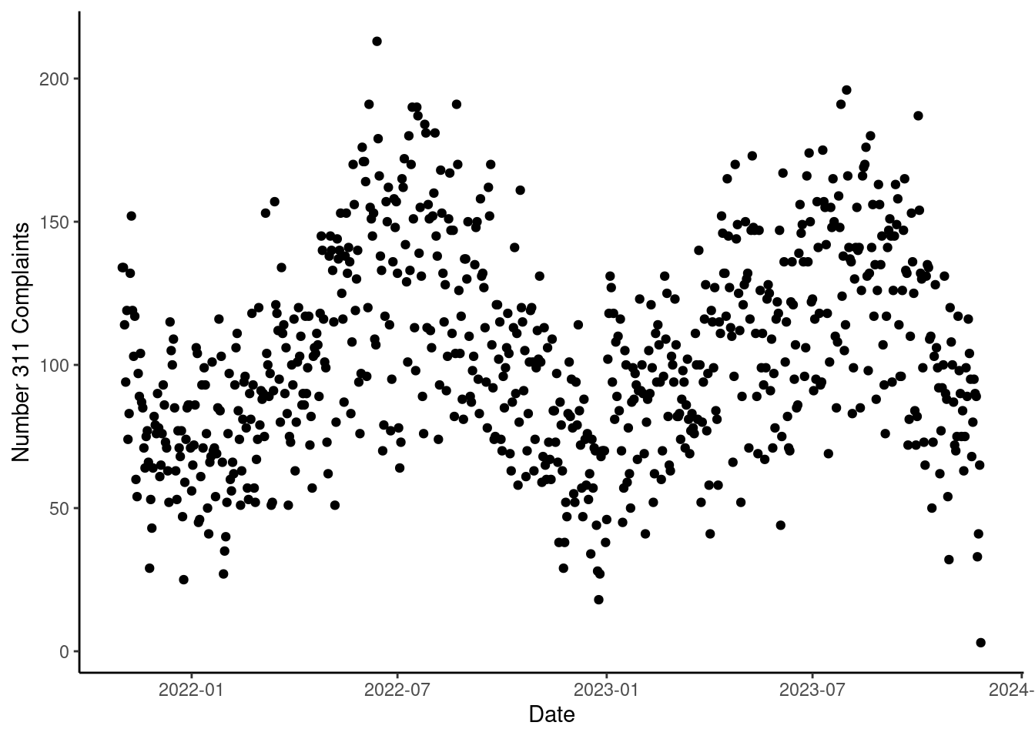
A graph showing 311 rat complaints between November of 2021, and November of 2023. Complaint volume shows a seasonal pattern, with complaints peaking in the summers, with between 150 and 200 311 complaints per day.

To raise public awareness and provide education, DOHMH conducts free training sessions through its “Rat Academy” program, which aims to equip individuals and professionals with essential knowledge on rat prevention and management. This initiative offers two distinct courses: community training and pest control professional training. Community training offers a comprehensive two-hour session and is open to anyone interested in understanding rat management. Trainings cover topics such as rat biology, behavior, habitats, and effective control methods, and provides participants with practical tips to prevent rat infestations in their homes, buildings, and neighborhoods. Sessions are typically hosted and sponsored by community partners or elected officials. DOHMH encourages public participation; anyone can sign up for a community training by contacting ratportal@health.nyc.gov or by calling 311. The second type of Rat Academy, pest control professionals training, is an intensive three-day advanced course designed for pest control experts. This in-depth program delves deeper into rat biology, behavior, site-specific responses, strategies, and effective communication skills for engaging with the public. Participants engage in fieldwork, including site inspections. Offered biannually, attendees are required to complete all three days and all assigned tasks, and must pass a final exam in order to receive a certificate of completion and continuing education credits.
Additionally, in 2017, DOHMH launched the Neighborhood Rat Reduction Initiative in collaboration with DSNY, DPR, DOE, and the NYC Housing Authority, to improve neighborhood sanitation by eliminating the food, water, and habitat that rats need to survive. This program focuses on “Rat Mitigation Zones” (RMZs), which are areas associated with high levels of rat activity.
From November 2021 to the present, the number of citywide rat inspections resulting in a passing score has declined: the average number of passed inspections in November, 2022, was 625/day and in November, 2023, the average was 500/day. (See Figure 2) Over the same timeframe, metrics for rat activity detected, clean up work done, bait application actions taken, and stoppage actions have remained relatively constant.
Figure 2:
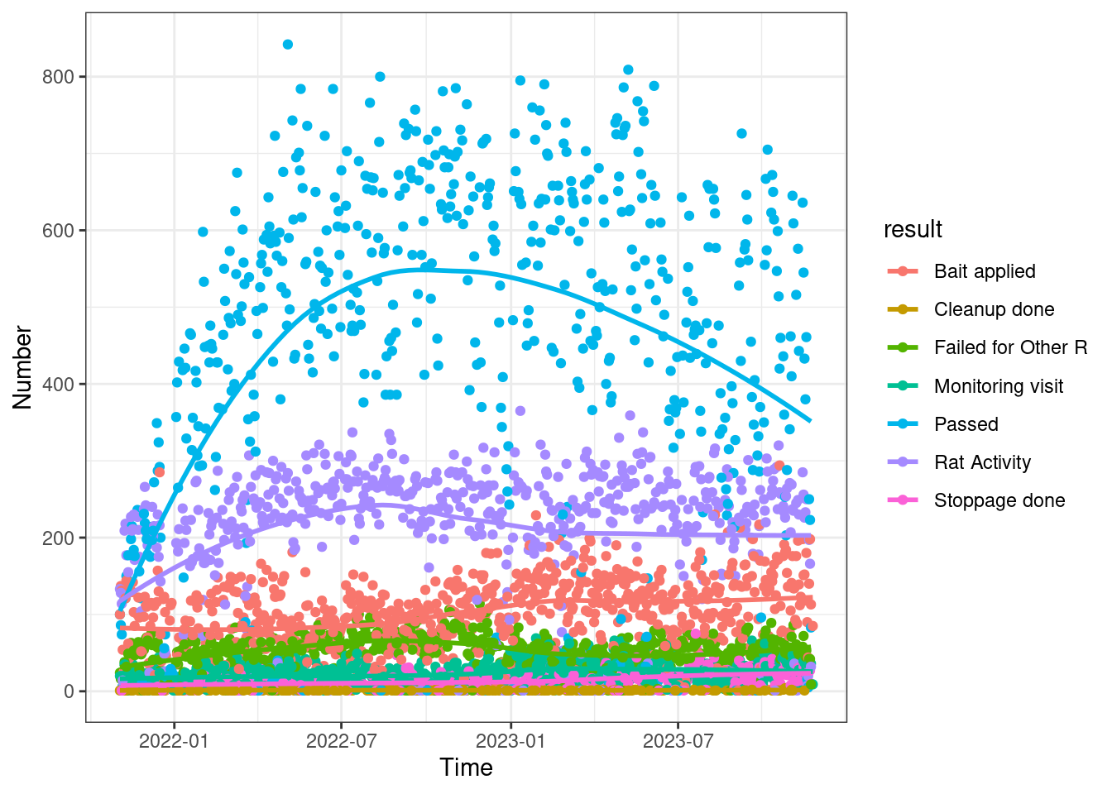
Graph showing the results of citywide rat inspections between November 2021 and November of 2023.

The Department of Sanitation’s Role in Rat Mitigation

In addition to its collaborative work with DOHMH, DSNY has recently launched several of its own initiatives to “beat the rats,” including waste containerization. Containerization in NYC is the storage of waste in sealed, rodent-proof receptacles rather than plastic bags placed directly on the curb. Containerization is intended to cut off rats’ preferred food supply, thereby limiting their ability to reproduce. Beginning in fall 2024, residential buildings with 9 or fewer units will be required to place trash in containers with secure lids at the curb for collection. DSNY has requested vendor proposals to produce an official City bin which can be used by owners of buildings with 9 or fewer units. Official bins are scheduled to be available in fall 2024 and such buildings will be required to purchase and use them starting in summer 2026.
To advance a waste containerization plan for residential buildings with 10 or more units, DSNY began a 12-month containerization pilot in August 2023 in Manhattan’s Hamilton Heights neighborhood. Several dozen shared wheeled containers were placed in the roadway along the curb at six shared locations in the neighborhood, where refuse and recycling collection is carried out by DSNY’s retrofitted trucks 6 times per week. Another containerization pilot program also began at 14 West Harlem schools earlier this year.
Some New Yorkers may also elect to participate in DSNY’s Clean Curbs program. Approved participants must purchase, install, and maintain sealed, rodent-proof containers. DSNY and the City Department of Transportation (DOT) review and approve participants’ proposed container locations, and adjacent property owners and Community Board(s) are notified before container installation. DSNY has also installed stationary steel containers on City streets in the parking lane, to service various Business Improvement Districts.
In addition to containerizing commercial and residential waste, DSNY corner litter baskets were redesigned, resulting in a TIME Best Inventions of 2023 designation. Traditional wire mesh litter baskets will be progressively replaced by the “Better Bin,” which has a “modular” design that is rat resistant, holds greater volume, and keeps trash away from the ground. DSNY also began implementing its expanded litter basket servicing plan in 2022 and saw a resultant 55% reduction in litter basket complaints.
In addition to containerization, DSNY adjusted the time of day at which trash may be left outside for collection. Prior to 8:00 p.m., residential buildings may not place bags of waste directly on the curb unless it is in a securely-lidded container of 55 gallons or less, in which case it may be placed at the curb after 6:00 p.m. If a building has 9 or more residential units, the property owner may opt in each January to set their waste on the curb at 4:00-7:00 a.m., instead. Food-related businesses and chain stores may place waste, including refuse and organic waste, at the curb 1 hour before closing and must use rigid containers with secure lids. On October 24, 2023, DSNY held a public hearing on its proposed rule expanding this requirement to all commercial establishments citywide. Until the proposed rule takes effect, any other business must either follow the same rule, or place their bagged waste at the curb no earlier than 8:00 p.m. Commercial waste containers must be stored indoors if space is available, or outdoors within three feet of the building. These rules do not apply to other recyclables such as metal, glass, plastic, or paper, or to businesses that have waste collected from a loading dock.
In addition to containerization and setout times, Local Law 146 of 2013 was adopted with the intention to mitigate wild rat populations by requiring businesses to separate organic waste and place it in a separate container with a latching lid. Food waste in particular represents a large source of food for rodents. In accordance with Local Law 85 of 2023, DSNY adopted a rule on October 21, 2023, making mandatory the separation of residential organic waste (“curbside composting”). DSNY has announced that it will progressively rollout curbside composting in each borough; service is reportedly currently available to all Queens and Brooklyn residents and will expand to Bronx and Staten Island on March 25, 2024, and to Manhattan on October 7, 2024. According to DSNY, these new rules will move millions of pounds of trash per day from City curbs, which “will meaningfully limit potential food sources for vermin while also helping to keep our sidewalks free of unattractive piles of black bags.” On July 25, 2023, DSNY announced that, “following changes to setout times, 311 rat activity complaints across the city “decreased by 20 percent from May to mid-July 2023,” compared to the same period in 2022, and in the City’s four rat mitigation zones, “complaints decreased by more than 45 percent.”

Rat complaints by Council District
Between November 2021 and November 2023, the Council Districts with the highest increase in complaints, adjusted for population (number complaints/population of CD), were Council District 4, which showed a +51% increase in complaint volume, Council District 19, which showed a +43% increase in complaint volume, and Council District 34, which showed a +41% increase in complaint volume. Council Districts 23 and 24 saw the greatest reduction in complaint volume over the same timeframe, declining by more than 25% in each district, followed by Council Districts 7 and 16, which saw reductions over 15% in complaint volume.

Figure 3:
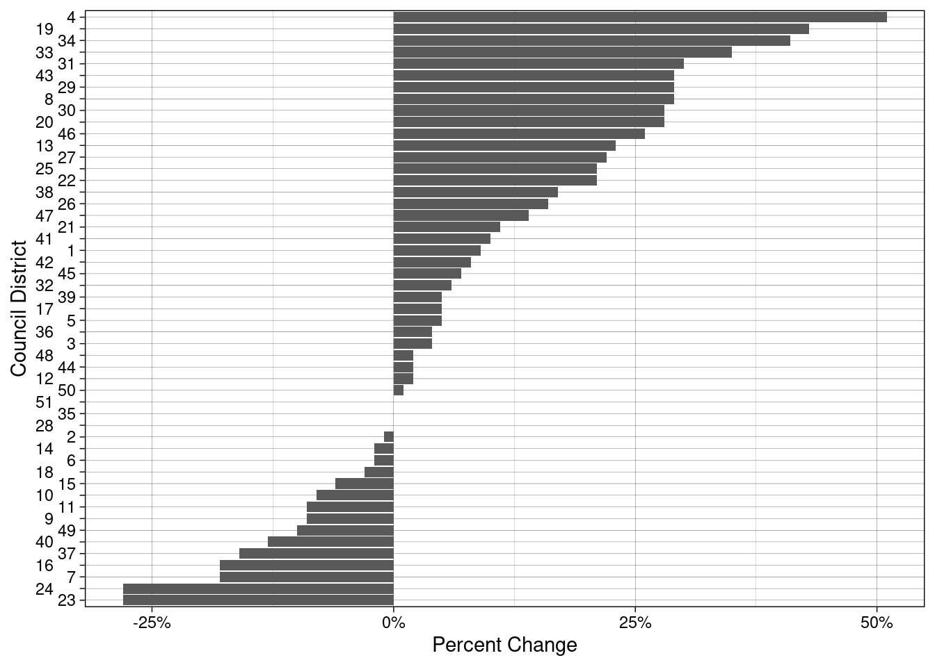
Bar graph showing percent change in 311 rat complaints, adjusted for population (number complaints/population of CD).

In most Council Districts, the mean average time to respond to 311 rat complaints since November, 2022, was less than 1 day, though in certain Council Districts, response times were longer. Council District 20 reported the longest average response time, with the mean response time of 5 days, double the length of time of the Council District with the second highest average response time, District 40, where the mean response time is 2.5 days.
Figure 4:
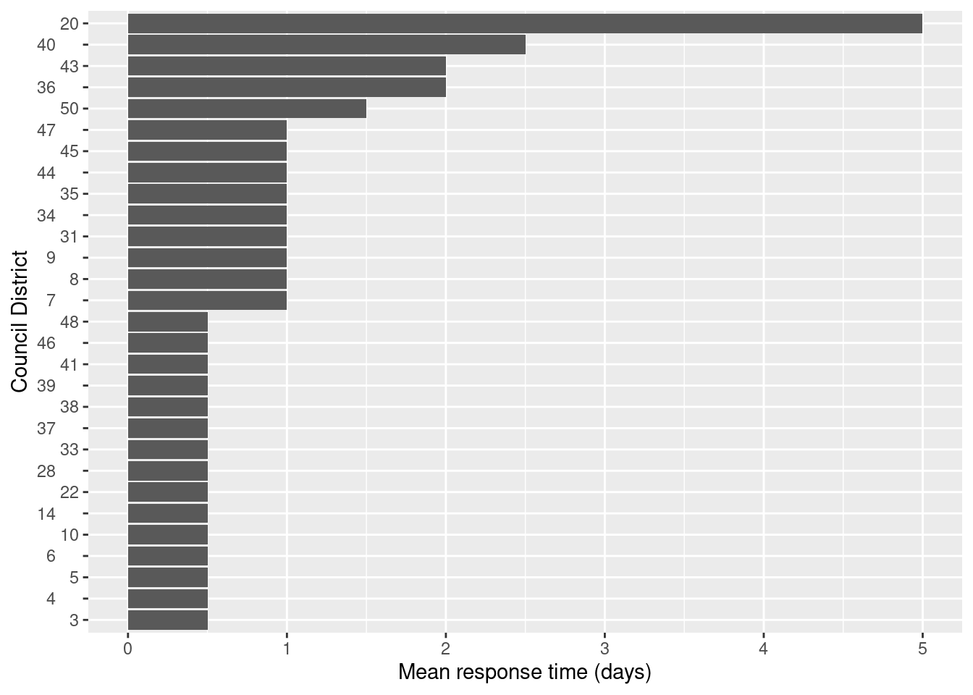
Bar graph showing the mean average time to respond to 311 rat complaints since November, 2022.

Public Housing Infrastructure Improvements

Public housing presents another opportunity for DSNY engagement in its “war on rats.” The NYC Housing Authority (NYCHA) provides housing to 1 in 17 New Yorkers, making NYCHA developments a significant part of the City’s waste production and recent operational changes in collection and handling. DSNY’s 2017 Waste Characterization Study found that the composition of waste at NYCHA developments generally mirrors Citywide trends, with approximately 33% of NYCHA’s refuse recyclable in DSNY’s curbside collections, and about 32% comprised of compostable organics. The study found that approximately 47,408 tons of recyclables are disposed of in NYCHA’s containerized waste each year, presenting a significant opportunity to increase diversion for beneficial reuse.
On January 31, 2019, the United States Department of Housing and Urban Development (HUD), NYCHA, and the City entered into an agreement to address issues relating to physical conditions at NYCHA (HUD Agreement). The agreement, which is overseen by a federal monitor, requires NYCHA to prepare “Action Plans” and to achieve a 50% reduction of its rat population, 40% reduction of its mice population, a 40% reduction of its roach population, and a percentage reduction (to be determined by the Monitor) of its bedbug population. NYCHA has been criticized for failing to meet these goals, and an expert hired by the federal monitor has criticized the way in which NYCHA counts the number of rats on its properties and the resultant claims by the agency about its reduction in rat populations. The Monitor suggested in 2022 that the level of infestation on NYCHA properties is growing again.
The NYCHA Pest/Waste Management Action Plan specifically requires response to a pest complaint, and that the property owner inspect and treat the complaining unit and the adjacent units when there is an infestation. For pests such as rats, the plan calls for NYCHA to respond within 24 hours if a rat is inside an apartment, and while complaints about interior conditions are prioritized, the average overall response time is approximately 4.6 days. Inspectors “use pesticides only when signs of pests are present, and instead focus on addressing the underlying causes of a pest problem, such as trash disposals, leaks and holes.” NYCHA’s Neighborhood Rat Reduction Program (NRR) includes 103 of NYCHA’s properties with the most problematic rat concerns and provides preventative inspections to identify infestations early.
The NYCHA Sustainability Agenda, released in 2021, commits to “re-envision waste management and recycling at NYCHA.” To advance its waste goals and as part of its “Clean Curbs for All” initiative with DSNY, NYCHA reports that it is piloting mechanical waste collection at select curbside locations, designing and installing over 20 centralized waste yards citywide, retrofitting Polo Grounds Towers with a pneumatic waste collection system, expanding on-site organics collection and processing to Polo Grounds Towers and Patterson Houses, establishing new in-building organics collection at College Point and Leavitt in Queens, and using SmartBins for organics collection bins at over 29 NYCHA sites. NYCHA’s other infrastructure improvements include installation of metal door sweeping attachments, which prevent rats from entering trash compactor rooms, wire coverings on basement window wells, sealing up cracked sidewalks, adding snap traps, hiring more pest control personnel, and making waste containers more rat-proof. Former Mayor Bill de Blasio’s administration also spent tens of millions of dollars to reduce the rat population, including by replacing the dirt floors in some public housing buildings’ basements with concrete flooring, however, “dozens of these dirt floors remain uncapped” and some basements which are on queue could be waiting until 2028 to be finished.
NYCHA launched a waste management initiative in 2020 called, “Campaign for Clean NYCHA” with the goal of promoting best practices for a pest free environment and to better engage residents in proper waste management. NYCHA also launched a website for pest extermination services and provided materials including notices, FAQs, and building flyers. DSNY reports that it offers Clean Buildings trainings for NYCHA staff, and increased the number of bulk container dump tickets it provides to NYCHA.

Rat Mitigation Education

To inform business owners on how to comply with updated regulations, DSNY hosted several remote trainings in 2023 regarding proper waste disposal and rodent mitigation. In an effort to achieve zero waste in City schools, DSNY also provided training at 325 Bronx schools on proper refuse and organics separation. In August 2023, BUFNY II, a 96-unit affordable housing community in Harlem, the Harlem Street Tenants Association, and DSNY partnered to host the City’s first ever “Anti-Rat Day of Action,” which included community resources on caring for street trees which can be a safe harbor for rats, waste and litter management, and other rodent mitigation education. The Adams administration announced that it will expand the Anti-Rat Days of Action to each borough.

Department of Buildings’ Role in Rat Mitigation
Local Law 109 of 2022 requires that, prior to issuance of certain construction permits by DOB, the permit applicant must certify that a licensed exterminator was retained to effectively treat the premises for rodent extermination. The Council adopted this law to address the reality that “[c]onstruction projects can dig up and disturb underground rat colonies, sending the rodents scurrying” into neighboring buildings and other community space as well as create new harborage space for rats. Permits for the following work are affected: construction involving 50% or more of a building’s floor area; vertical or horizontal enlargement increasing the building floor area by more than 25%; demolition of more than 50% of a building’s floor area; and full demolition of a building. The DOB requires a permit applicant to provide a pre-demolition rodent extermination certificate before DOB will issue a demolition permit. DOHMH’s Office of Pest Control oversees rodent baiting, and typically issues a certificate stating that the building has been inspected and baited appropriately, however since the COVID-19 outbreak, the Office has instituted a self-certification program. Additionally, the NYC Building Code requires rodent-proofing design and construction, including that any openings on exterior or underground walls, any ventilation openings for exposed pipes, wires, and conduits, and any openings near cellar floors or around electric cables be closed with a material designed to prevent rodents from passing through.

- Conclusion
At this hearing, the Committee intends to hear updates from DOHMH, DSNY, and DOB on their respective and collaborative efforts to address public health risks related to the City’s wild rat population and the consequences of City rat mitigation strategies.

Local Law (L.L.) 110/2022, available at: https://legistar.council.nyc.gov/LegislationDetail.aspx?ID=5668976&GUID=6B184A43-A50E-4BE1-A088-2FD5788E1266&Options=ID|Text|&Search=459 ; L.L. 109/2022, available at: https://legistar.council.nyc.gov/LegislationDetail.aspx?ID=5663466&GUID=85217DF4-CDC8-4C74-A918-334EF9BE122B&Options=ID|Text|&Search=442.
Carl Zimmer. “How The Brown Rat Conquered New York City (And Every Other One, Too). New York Times. October 27, 2016. https://www.nytimes.com/2016/10/28/science/brown-rat-new-york-city.html
Norway Rat. Smithsonian National Zoo. https://nationalzoo.si.edu/animals/norway-rat
Id.
Id.
Id.
Id.
Matthew Combs et al. Spatial population genomics of the brown rat (Rattus norvegicus) in New York City. Molecular Ecology. November 2017.
Id.
Id.
Auerbach, J. (2014), Does New York City really have as many rats as people?. Significance, 11: 22-27, https://doi.org/10.1111/j.1740-9713.2014.00764.x
MM Pest Control. There are now 3 million rats in NYC, a 50% increase since 2010. https://mandmpestcontrol.com/there-are-now-3-million-rats-in-new-york-city-study/
Ina Jane Wundram and R. Barry Ruback, Urban Rats: Symbol, Symptom, and Symbiosis (1986); see also, Diseases from rodents, pocket pets and rabbits, King County Washington (last accessed Nov. 21, 2023), available at: https://kingcounty.gov/en/legacy/depts/health/communicable-diseases/zoonotic/facts-resources/diseases-by-animal/pocket-pets
CDC, How to Control Wild Rodent Infestations, https://www.cdc.gov/healthypets/pets/wildlife/rodent-control.html#:~:text=Rats%20and%20mice%20are%20known,waste)%3B%20or%20rodent%20bites. It should be noted that rats are no more likely to be the source of a new human disease than other animals. Urban-adapted mammals, such as rats, have more documented parasites, but new research suggests that this is not due to extended historical contact with humans but rather due to sampling bias arising from their proximity to humans. Gregory F. Albery et al., Urban-adapted mammal species have more known pathogens, Nature (2022), https://www.nature.com/articles/s41559-022-01723-0.
CDC, How to Control Wild Rodent Infestations, https://www.cdc.gov/healthypets/pets/wildlife/rodent-control.html#:~:text=Rats%20and%20mice%20are%20known,waste)%3B%20or%20rodent%20bites. Diseases that can spread from rodents to people include Hantavirus, Hantavirus Pulmonary Syndrome, Hemorrhagic Fever with Renal Syndrome, Lassa Fever, Leptospirosis, Lujo Hemorrhagic Fever, Omsk Hemorrhagiv Fever, Rat-Bite Fever, Salmonellosis, Sylvatic Typhus, and others. Id. Diseases that can spread through indirect contact include Anaplasmosis, Colorado tick fever, Flea-borne Typhus, Lyme Disease, and others. Id.
Id.
N.Y.C. Dep’t of Health & Mental Hygiene, Lower Your Risk of Leptospirosis In the Home and Workplace In New York City, https://www.nyc.gov/assets/doh/downloads/pdf/zoo/lower-your-risk-of-leptospirosis.pdf.
Paluch, Gabrielle, New York reports a record 15 leptospirosis cases in 2021, as vermin complaints flood in (Business Insider, Oct. 16, 2021), https://www.businessinsider.com/new-york-reports-a-record-15-cases-of-a-rare-rat-linked-disease-2021-10#:~:text=New%20York%20reports%20a%20record%2015%20leptospirosis%20cases%20in,as%20vermin%20complaints%20flood%20in&text=New%20York%20has%20recorded%2015,people%20infected%20were%20experiencing%20homelessness. Leptospirosis, transmitted by leptospira bacteria in infected animals’ urine, can lead to severe kidney and liver failure or manifest without symptoms.
Columbia Mailman School of Public Health, Rats of New York and the Diseases They Carry (Oct. 10, 2014), https://www.publichealth.columbia.edu/news/rats-new-york-diseases-they-carry
Shah, Simmone, New York City Rats Carry COVID-19, Study Finds (TIME, Mar. 10, 2023, 1:50 PM), https://time.com/6261908/new-york-city-rats-covid-19/.
Id.
Rodenticides, U.S. EPA, https://www.epa.gov/rodenticides/rodent-control-pesticide-safety-review#:~:text=Rodenticides%20are%20used%20to%20control,serious%20risk%20to%20public%20health.
Rodenticides, National Pesticide Information Center, http://npic.orst.edu/factsheets/rodenticides.html#:~:text=Most%20rodenticides%20are%20also%20toxic,or%20if%20skin%20contact%20occurs.&text=Strychnine%2C%20cholecalciferol%2C%20and%20zinc%20phosphide,in%20toxicity%20upon%20skin%20contact.
Id.
Rodenticides, U.S. EPA, https://www.epa.gov/rodenticides/rodent-control-pesticide-safety-review#:~:text=Rodenticides%20are%20used%20to%20control,serious%20risk%20to%20public%20health. There are 11 rodenticide active ingredients that can be divided into 3 categories: first-generation anticoagulants, second-generation anticoagulants, and non-anticoagulants. Second-generation anticoagulants are especially hazardous as they are highly toxic and persist in body tissues for a long time. Second-generation anticoagulants are more likely to be toxic in a single feeding than earlier products, but since time-to-death is several days, rodents can feed multiple times before death, leading to carcasses containing residues that may be many times the lethal dose. Id.
Id.
Id.
What You Need to Know About Rodenticides and Safety (int-enviroguard.com) Carol D’Silva & Bhuvana Krishna, Rodenticide Poisoning, NIH, https://www.ncbi.nlm.nih.gov/pmc/articles/PMC6996659/#:~:text=Routes%20of%20Exposure,accidental%20ingestion%20is%20more%20common.
Rat Poisons Endanger 10,000 Children Every Year in the U.S. | Scientific American
Id.
Rodenticides, U.S. EPA, https://www.epa.gov/rodenticides/rodent-control-pesticide-safety-review#:~:text=Rodenticides%20are%20used%20to%20control,serious%20risk%20to%20public%20health.
Id. For example, the EPA is proposing to prohibit refillable bait stations for consumer-sized products and prohibiting consumer-sized zinc phosphide products. Id.
National Pesticide Information Center. Rodenticides, available at: http://npic.orst.edu/factsheets/rodenticides.html.
Id.
Id.
Id.
Rodenticide and birds of prey. Audubon Society of New York City.
Rodenticide poisoningwidespread among state’s red-tailed hawks, Cornell College of Veterinary Medicine (July 7, 2022), available at: https://www.vet.cornell.edu/news/20220707/rodenticide-poisoning-widespread-among-state-s-red-tailed-hawks#:~:text=The%20paper%2C%20published%20May%2012,problem%20is%2C%E2%80%9D%20says%20Dr.
Id.
United States Environmental Protection Agency. Introduction to Integrated Pest Management. https://www.epa.gov/ipm/introduction-integrated-pest-management.
Id.
Id.; see also, NYC Admin. Code § 27- 2017.8 (integrated pest management practices).
Sophia Chang. A new tactic killed ‘nearly 100%’ of rats on this Upper East Side street. Gothamist. 10/30/23 https://gothamist.com/news/a-new-tactic-killed-nearly-100-of-rats-on-an-upper-east-side-street.
Lisa Abend. Rat Infestations are a Global Problem. Is Birth Control The Solution? Time Magazine. March 27, 2023. https://time.com/6264623/rat-birth-control-poison-contrapest/
Alice Klein. Menopause causing bait is curbing rat populations in New York. The New Scientist. May 5, 2017. https://www.newscientist.com/article/2130114-menopause-causing-bait-is-curbing-rat-populations-in-new-york/
Contrapest Technical User Bulletin. https://cdn.shopify.com/s/files/1/0255/4986/5032/files/ContraPest_Technical_Use_Bulletin_794652f5-284d-431a-995a-229d38cb0dd1.pdf?v=1653696947
Id.
Id.
Megan Molteni. NYC’s newest weapon against the rats? Sterilization. Wired Magazine. February 23, 2017. https://www.wired.com/2017/04/nycs-newest-weapon-rats-sterilization/
Senestech launches successful campaign in Nation’s capital. https://cdn.shopify.com/s/files/1/0255/4986/5032/files/DC-CASE-STUDY_NEW-BRAND_WEB2.pdf?v=1653689936
Ecolab. Exclusion, a cornerstone of integrated pest management. https://www.ecolab.com/articles/2019/07/exclusion-a-cornerstone-of-ipm.
Id.
Id.
Id.
Id.
City of New York Adopted Budget Fiscal Year 2024, available at: https://www.nyc.gov/assets/omb/downloads/pdf/erc6-23.pdf.
Rodent Control Program Assessment, CDC (July 2015), available at: https://www.cdc.gov/nceh/ehs/docs/vector-profiles/nyc-ny.pdf
N.Y.C. Dep’t of Health & Mental Hygiene, Rats, https://www.nyc.gov/site/doh/health/health-topics/rats.page#:~:text=Rat%20Indexing%3A%20The%20Health%20Department,maps%20showing%20local%20hot%20spots.
N,YC. Dep’t of Health & Mental Hygiene, Rat Indexing, https://www.nyc.gov/site/doh/health/health-topics/rat-maps-and-data-rat-indexing.page.
Id.
Id.
Id.
Id.
N.Y.C. Dep’t of Health & Mental Hygiene, Rat Information Portal, https://a816-dohbesp.nyc.gov/IndicatorPublic/Rats/.
Id.
Id.
Id.
Id.
See Fig. 1
Based on 311 data obtained from the NYC Open Data Portal
Rat Prevention: Training (Rat Academy), NYC-DOHMH (last accessed Nov. 9, 2023), available at: https://www.nyc.gov/site/doh/services/rats-control-training.page.
Id.
Id.
Id.
Id.
Rat Prevention: Training (Rat Academy), NYC-DOHMH (last accessed Nov. 9, 2023), available at: https://www.nyc.gov/site/doh/services/rats-control-training.page
Id.
Id.
Id.
Id.
N.Y.C. Dep’t of Health & Mental Hygiene, Rat Mitigation Zones, https://a816-dohbesp.nyc.gov/IndicatorPublic/beta/key-topics/pests/rat-mitigation-zones/
Id.
See Figure 2
Id.
Based on 311 data obtained from NYC Open Data Portal
Our Work, DSNY (last accessed Nov. 9, 2023), available at: https://www.nyc.gov/assets/dsny/site/our-work.
Use Bins, DSNY (last accessed Nov. 9, 2023), available at: https://www.nyc.gov/assets/dsny/site/resources/recycling-and-garbage-laws/use-bins.
Residential Waste Containerization, DSNY (last accessed Nov. 9, 2023), available at: https://www.nyc.gov/assets/dsny/site/resources/recycling-and-garbage-laws/use-bins/residential-containerization
Id.
Hamilton Heights Containerization Pilot, DSNY (last accessed Nov. 9, 2023), available at: https://www.nyc.gov/assets/dsny/site/our-work/hamilton-heights-bins
Kevin Duggan, Sanitation: Trash Containerization Can Be Done With a Historic Reuse of Parking; Pilot to Start This Fall, Streets Blog (May 3, 2023), available at: https://nyc.streetsblog.org/2023/05/03/sanitation-trash-containerization-can-be-done-with-a-historic-reuse-of-parking-pilot-to-start-uptown-this-fall.
Kathleen Culliton, Rats Expelled From Harlem Schools With New Trash Container Program, Patch (Aug. 16, 2023), available at: https://patch.com/new-york/harlem/rats-expelled-harlem-schools-new-trash-container-program; Sophia Chang, Giant trash bins land in Harlem: Will they fight rats or just take up parking?, Gothamist https://gothamist.com/news/giant-trash-bins-land-in-harlem-will-they-fight-rats-or-just-take-up-parking
Cole Rosengren, New York pursuing multiple options to containerize waste on 89% of streets, Waste Dive (Aug. 23, 2023), available at: https://www.wastedive.com/news/new-york-waste-containerization-dsny-adams-tisch-parking/689237/.
Clean Curbs, DSNY (last visited Aug. 29, 2023), available at: https://www.nyc.gov/assets/dsny/site/our-work/containerized-waste-rfei.
The Future of Trash Waste Containerization Models and Viability in New York City, DSNY (Apr. 2023), available at: https://dsny.cityofnewyork.us/wp-content/uploads/reports/future-of-trash-april-2023.pdf. ; see also, Maya Rajamani, 'We heard you': NYC rolls out new bins to curb trash, stymie rats, Spectrum News NY1 (Apr. 20, 2022), available at: https://ny1.com/nyc/all-boroughs/news/2022/04/20/nyc-rolls-out-sealed-bins-to-curb-trash--stymie-rats.
DSNY Litter Basket of the Future Named to TIME Best Inventions of 2023 List, DSNY (Oct. 26, 2023), available at: https://www.nyc.gov/assets/dsny/site/resources/press-releases/dsny-litter-basket-of-the-future-named-to-time-best-inventions-of-2023-list.
Id.; Better Bin, DSNY (last accessed Nov. 9, 2023), available at: https://www.nyc.gov/assets/dsny/site/our-work/better-bin.
Mayor Adams Consolidates Citywide Cleaning Functions to 'Get Stuff Clean,' Announces $14.5 Million in new Funding for Clean Streets and Parks, NYC Office of the Mayor (Nov. 10, 2022), available at: https://www.nyc.gov/office-of-the-mayor/news/824-22/mayor-adams-consolidates-citywide-cleaning-functions-get-stuff-clean-14-5-million#/0.
Mayor Adams, Sanitation Commissioner Tisch Announce Drastically Reduced Hours Trash Will sit on NYC Streets, NYC Press Office (Oct. 17, 2022), available at: https://www.nyc.gov/office-of-the-mayor/news/754-22/mayor-adams-sanitation-commissioner-tisch-drastically-reduced-hours-trash-will-sit-nyc#/0.
Setout Times, DSNY (last accessed Nov. 9, 2023), available at: https://www.nyc.gov/assets/dsny/site/services/collection-setout-times.
Id.
DSNY Proposed Further Amendment of Rule Relating to the Use of Certain Receptacles by Commercial Establishments, NYC Rules (last accessed Nov. 9, 2023), available at: https://rules.cityofnewyork.us/rule/dsny-proposed-further-amendment-of-rule-relating-to-the-use-of-certain-receptacles-by-commercial-establishments/#comments.
The Future of Trash Waste Containerization Models and Viability in New York City, DSNY (Apr. 2023), available at: https://dsny.cityofnewyork.us/wp-content/uploads/reports/future-of-trash-april-2023.pdf.
Commercial Waste Containerization, DSNY (last accessed Nov. 9, 2023), available at: https://www.nyc.gov/assets/dsny/site/resources/recycling-and-garbage-laws/use-bins/commercial-containerization.
Major Changes Coming to City Landscape; Food-Related Businesses Now Required to Use Lidded Containers to Keep the Rats OUT, DSNY (Aug. 1, 2023), available at: https://www.nyc.gov/assets/dsny/site/resources/press-releases/major-changes-coming-to-city-landscape-food-related-businesses-now-required-to-use-lidded-containers-to-keep-the-rats-out#:~:text=The%20second%20rule%2C%20starting%20September,the%20plan%20to%20containerize%20waste..
Commercial Waste Containerization, DSNY (last accessed Nov. 9, 2023), available at: https://www.nyc.gov/assets/dsny/site/resources/recycling-and-garbage-laws/use-bins/commercial-containerization.
https://dmna.ny.gov/foodservice/docs/Field_Sanitation_Team_Certification_Course/Instructor_Manual/L010LP_Rodent_Management_LP.pdf at section 10-4.
Requirement of Source Separation of Residential Organic Waste, NYC Rules (last accessed Nov. 9, 2023), available at: https://rules.cityofnewyork.us/rule/requirement-of-source-separation-of-residential-organic-waste/.
Curbside Composting, DSNY (last accessed Nov. 9, 2023), available at: https://www.nyc.gov/assets/dsny/site/services/food-scraps-and-yard-waste-page/composting-residents-organics.
Major Changes Coming to City Landscape; Food-Related Businesses Now Required to Use Lidded Containers to Keep the Rats OUT, DSNY (Aug. 1, 2023), available at: https://www.nyc.gov/assets/dsny/site/resources/press-releases/major-changes-coming-to-city-landscape-food-related-businesses-now-required-to-use-lidded-containers-to-keep-the-rats-out.
Opening Statement Of Madelynn Liguori Senior Counsel, Bureau Of Legal Affairs regarding Public Hearing On DSNY’s Proposed Rule Relating To The Use Of Certain Receptacles By A Chain Of Stores, DSNY (July 31, 2023), available at: https://dsny.cityofnewyork.us/wp-content/uploads/2023/08/Chain-of-Stores-Comments-Combined.pdf.
Dylan Shusterman, Changes to Trash Set-Out Times Show Early Positive Impact on Rat Activity, New York Law School City Land (July 31, 2023), available at: https://www.citylandnyc.org/changes-to-trash-set-out-times-show-early-positive-impact-on-rat-activity/.
See Fig. 3
Id.
Based on 311 data obtained from NYC Open Data Portal
See Fig. 4
Id.
Based on 311 data obtained from NYC Open Data Portal
NYCHA 2023 Fact Sheet, NYCHA (Apr. 2023), available at: https://www.nyc.gov/assets/nycha/downloads/pdf/NYCHA-Fact-Sheet-2023.pdf.
NYCHA Overview, DSNY (last accessed Nov. 9, 2023), available at: https://www.nyc.gov/assets/dsny/site/our-work/nycha.
Local Law 49. Review of Voluntary Recycling Incentive Pilot Programs for NYCHA. New York City Department of Sanitation. https://dsny.cityofnewyork.us/wp-content/uploads/2018/07/2018-06-LL49-Report_Final.pdf
Id.
United States Department of Housing and Urban Development, Agreement, (Jan. 31, 2019) available at https://www.hud.gov/sites/dfiles/PA/documents/HUD-NYCHA-Agreement013119.pdf.
Id. at 9.
Greg Smith, NYCHA’s Rodent Eviction Campaign Shows Tough Road Ahead for Rat Czar, The City (Apr. 24, 2023), available at: https://www.thecity.nyc/2023/04/24/rat-czar-nycha/.
Id.
Id.
United States Department of Housing and Urban Development, Agreement, at 9 (Jan. 31, 2019) available at https://www.hud.gov/sites/dfiles/PA/documents/HUD-NYCHA-Agreement013119.pdf.
Id. at 14; see also, NYCHA Pest/Waste Management Action Plan, at 9, available at: https://www.nyc.gov/assets/nycha/downloads/pdf/NYCHA-Pest-and-Waste-Management-Action-Plan-1.26.21.pdf.
Hearing Transcript (June 31, 2022), at 54, available at: https://legistar.council.nyc.gov/LegislationDetail.aspx?ID=5656540&GUID=72253CBB-0C65-45A8-A19A-AC0B93008128&Options=&Search=.
Greg Smith, NYCHA’s Rodent Eviction Campaign Shows Tough Road Ahead for Rat Czar, The City (Apr. 24, 2023), available at: https://www.thecity.nyc/2023/04/24/rat-czar-nycha/.
Pest Control at NYCHA, NYCHA (last accessed Nov. 21, 2023), available at: https://www.nyc.gov/site/nycha/residents/pest-control.page.
Id.
2023 Progress Report on NYCHA’s Sustainability Agenda, NYCHA (last accessed Nov. 9, 2023), available at: https://www.nyc.gov/site/nycha/about/sustainability-2023.page.
2023 Progress Report on NYCHA’s Sustainability Agenda, NYCHA (last accessed Nov. 9, 2023), available at: https://www.nyc.gov/site/nycha/about/sustainability-2023.page; see also, NYCHA Overview, DSNY (last accessed Nov. 9, 2023), available at: https://www.nyc.gov/assets/dsny/site/our-work/nycha.
Greg Smith, NYCHA’s Rodent Eviction Campaign Shows Tough Road Ahead for Rat Czar, The City (Apr. 24, 2023), available at: https://www.thecity.nyc/2023/04/24/rat-czar-nycha/.
United States Department of Housing and Urban Development, Agreement, at 27 (Jan. 31, 2019) available at https://www.hud.gov/sites/dfiles/PA/documents/HUD-NYCHA-Agreement013119.pdf; see also, Hearing Transcript (June 31, 2022), at 26, available at: https://legistar.council.nyc.gov/LegislationDetail.aspx?ID=5656540&GUID=72253CBB-0C65-45A8-A19A-AC0B93008128&Options=&Search=.
United States Department of Housing and Urban Development, Agreement, at 10 (Jan. 31, 2019) available at https://www.hud.gov/sites/dfiles/PA/documents/HUD-NYCHA-Agreement013119.pdf;
Camille Botello, Bronx businesses encouraged to attend DSNY rat mitigation trainings, Bronx Times (Sept. 7, 2023), available at: https://www.bxtimes.com/bronx-businesses-dsny-rat/; NYC Department of Sanitation Information Sessions on New Set-Out Rules for Commercial Trash, East Midtown Partnership (Mar. 10, 2023), available at: https://www.eastmidtown.org/news/article/nyc-department-sanitation-information-sessions-new-set-out-rules-commercial-trash/.
Camille Botello, Bronx DOE schools join city’s latest battle in the war against rats, Bronx Times (Mar. 7, 2023), available at: https://www.bxtimes.com/bronx-war-against-rats/.
BUFNYII, Affordable Housing Online (last accessed Nov. 9, 2023), available at: https://affordablehousingonline.com/housing-search/New-York/New-York-City/Bufny-II/10036124.
Arnold Davick, City hosts first ever Anti-Rat Day of Action, Spectrum News NY1 (Aug. 12, 2023), available at: https://ny1.com/nyc/all-boroughs/human-interest/2023/08/12/city-hosts-first-ever-anti-rat-day-of-action.
NYC to hold its first Anti-Rat Community Day of Action on August 12, ABC7 (July 26, 2023), available at: https://abc7ny.com/nyc-anti-rat-community-day-of-action-mayor-eric-adams/13551012/.
Moving the Needle on Rat Mitigation, NYC (last accessed Nov. 9, 2023), available at: https://www.nyc.gov/content/getstuffdone/pages/rat-mitigation.
Local Law 109 of 2022, available at: https://legistar.council.nyc.gov/LegislationDetail.aspx?ID=5663466&GUID=85217DF4-CDC8-4C74-A918-334EF9BE122B&Options=ID|Text|&Search=442 ; see also, Pre-Demolition Rodent Extermination Certificate, NYC DOHMH, available at: https://www.nyc.gov/assets/doh/downloads/pdf/pesticide/pre-demolition-rodent-extermination-certificate.pdf
Hearing Transcript, at 39-40 (June 21, 2022), available at: https://legistar.council.nyc.gov/LegislationDetail.aspx?ID=5663466&GUID=85217DF4-CDC8-4C74-A918-334EF9BE122B&Options=ID|Text|&Search=442; Nick Gallagher, Tour Guides Are Now Showing Off NYC Rat Havens During After-Hours Hang-Outs, The Messenger (Sept. 5, 2023), available at: https://themessenger.com/news/tour-guides-are-now-showing-off-nyc-rat-havens-during-after-hours-hang-outs
Service Notice: Local Law 109 of 2022: Rodent Abatement During Construction, NYC DOB, available at: https://www.nyc.gov/assets/buildings/pdf/ll109of22-sn.pdf.
Pre-Demolition Rodent Extermination Certificate, NYC DOHMH, available at: https://www.nyc.gov/assets/doh/downloads/pdf/pesticide/pre-demolition-rodent-extermination-certificate.pdf.
BC F102.1; BC F102.4.2

