THE COUNCIL OF THE CITY OF NEW YORK
RESOLUTION NO. 2113

Resolution approving the decision of the City Planning Commission on Application No. N 090335 ZRK, for an amendment of the Zoning Resolution of the City of New York, relating to Article II, Chapter 3 (Bulk regulations for Residential Buildings in Residence Districts), Section 23-90, inclusive, relating to the application of the Inclusionary Housing Program to proposed R7A districts, in the Borough of Brooklyn (L.U. No. 1148).

By Council Members Katz and Avella

WHEREAS, the City Planning Commission filed with the Council on June 23, 2009 its decision dated June 17, 2009 (the "Decision"), pursuant to Section 201 of the New York City Charter, regarding an application submitted by the Department of City Planning, for an amendment of the Zoning Resolution of the City of New York, relating to Article II, Chapter 3 (Bulk regulations for Residential Buildings in Residence Districts), Section 23-90, inclusive, relating to the application of the Inclusionary Housing Program to proposed R7A districts, (Application No. N 090335 ZRK), Community District 14, Borough of Brooklyn (the "Application");

WHEREAS, the Application is related to ULURP Application Number C 090336 ZMK (L.U. No. 1149), an amendment to the Zoning Map, Section Nos. 16d, 17b, 22c, & 23d, changing existing R3-1, R3-2, R4, R5, R6, R7-1, C4-2, C4-3, C1-3 and C2-3 Districts to R1-2, R3X, R4A, R5B, R5D, R6A, R6B, R7A, C4-4A and C4-2 Districts;
WHEREAS, the Decision is subject to review and action by the Council pursuant to Section 197-d(b)(1) of the City Charter;
WHEREAS, upon due notice, the Council held a public hearing on the Decision and Application on July 27, 2009;

WHEREAS, the Council has considered the land use implications and other policy issues relating to the Decision and Application; and

WHEREAS, the Council has considered the relevant environmental issues and the Negative Declaration issued on March 2, 2009, which included (E) designations for hazardous materials, air quality, and noise (CEQR No. 09DCP058K);

RESOLVED:

The Council finds that the action described herein will have no significant impact on the environment.

Pursuant to Sections 197-d and 200 of the City Charter and on the basis of the Decision and Application the Council approves the Decision.
The Zoning Resolution of the City of New York, effective as of December 15, 1961, and as subsequently amended, is further amended as follows:

Matter in underline is new, to be added;
Matter in strikeout is old, to be deleted;
Matter within # # is defined in Section 12-10;
* * * indicates where unchanged text appears in the Zoning Resolution

* * *
Article II: Residence District Regulations

Chapter 3
Bulk Regulations for Residential Buildings in Residence Districts

* * *

23-011
Quality Housing Program

- In R6A, R6B, R7A, R7B, R7D, R7X, R8A, R8B, R8X, R9A, R9X,R10A or R10X Districts, any #development# or #enlargement# shall comply with the applicable district #bulk# regulations as set forth in this Chapter and any #residential development#, #enlargement#, #extension# or conversion shall also comply with the requirements of Article II, Chapter 8 (Quality Housing Program). In R5D Districts, certain requirements of Article II, Chapter 8, shall apply as set forth in Section 28-01 (Applicability of this Chapter).

* * *

In the Borough of Brooklyn

Ocean Parkway Area
The area bounded by Church Avenue, Stratford Road, Beverley Road, Ocean Avenue, Foster Avenue and Coney Island Avenue.

Midwood Area
The area bounded by Avenue M, Ocean Avenue, Quentin Road, and a line midway between East 10th Street and Coney Island Avenue. The area bounded by Avenue M, Coney Island Avenue, Avenue P, Ocean Avenue, Quentin Road, and a line midway between East 10th Street and Coney Island Avenue.

* * *

23-144
In designated areas where the Inclusionary Housing Program is applicable
In #Inclusionary Housing designated areas#, as listed in the following table, the maximum permitted #floor area ratios# shall be as set forth in Section 23-942 (In Inclusionary Housing designated areas). The locations of such districts are specified in Section 23-922 (Inclusionary Housing designated areas).

Community District | Zoning District
Community District 1, Brooklyn | R6 R6A R6B R7A
Community District 2, Brooklyn | R7A
Community District 3, Brooklyn | R7D
Community District 7, Brooklyn | R8A
Community District 14, Brooklyn | R7A
Community District 3, Manhattan | R7A R8A R9A
Community District 6, Manhattan | R10
Community District 7, Manhattan | R9A
Community District 2, Queens | R7X

* * *

23-922
Inclusionary housing designated areas

The Inclusionary Housing Program shall apply in the following areas:

* * *

- In Community District 14, in the Borough of Brooklyn, in the R7A Districts within the areas shown on the following Maps X1, X2 and X3:

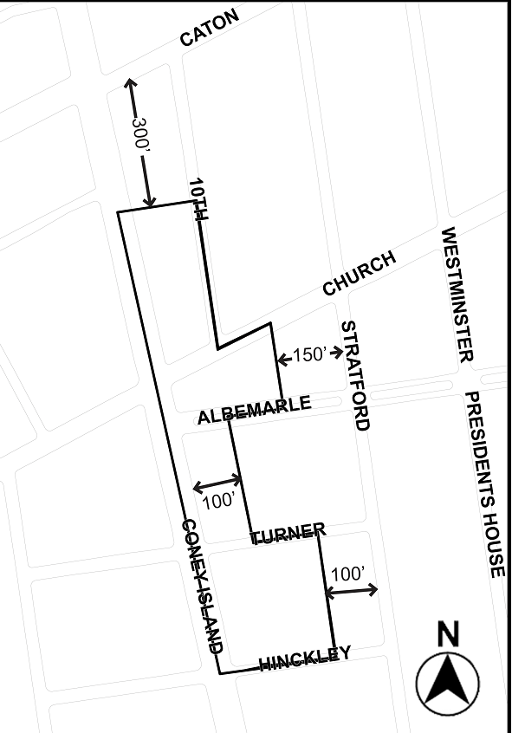

Map X1. Portion of Community District 14, Brooklyn

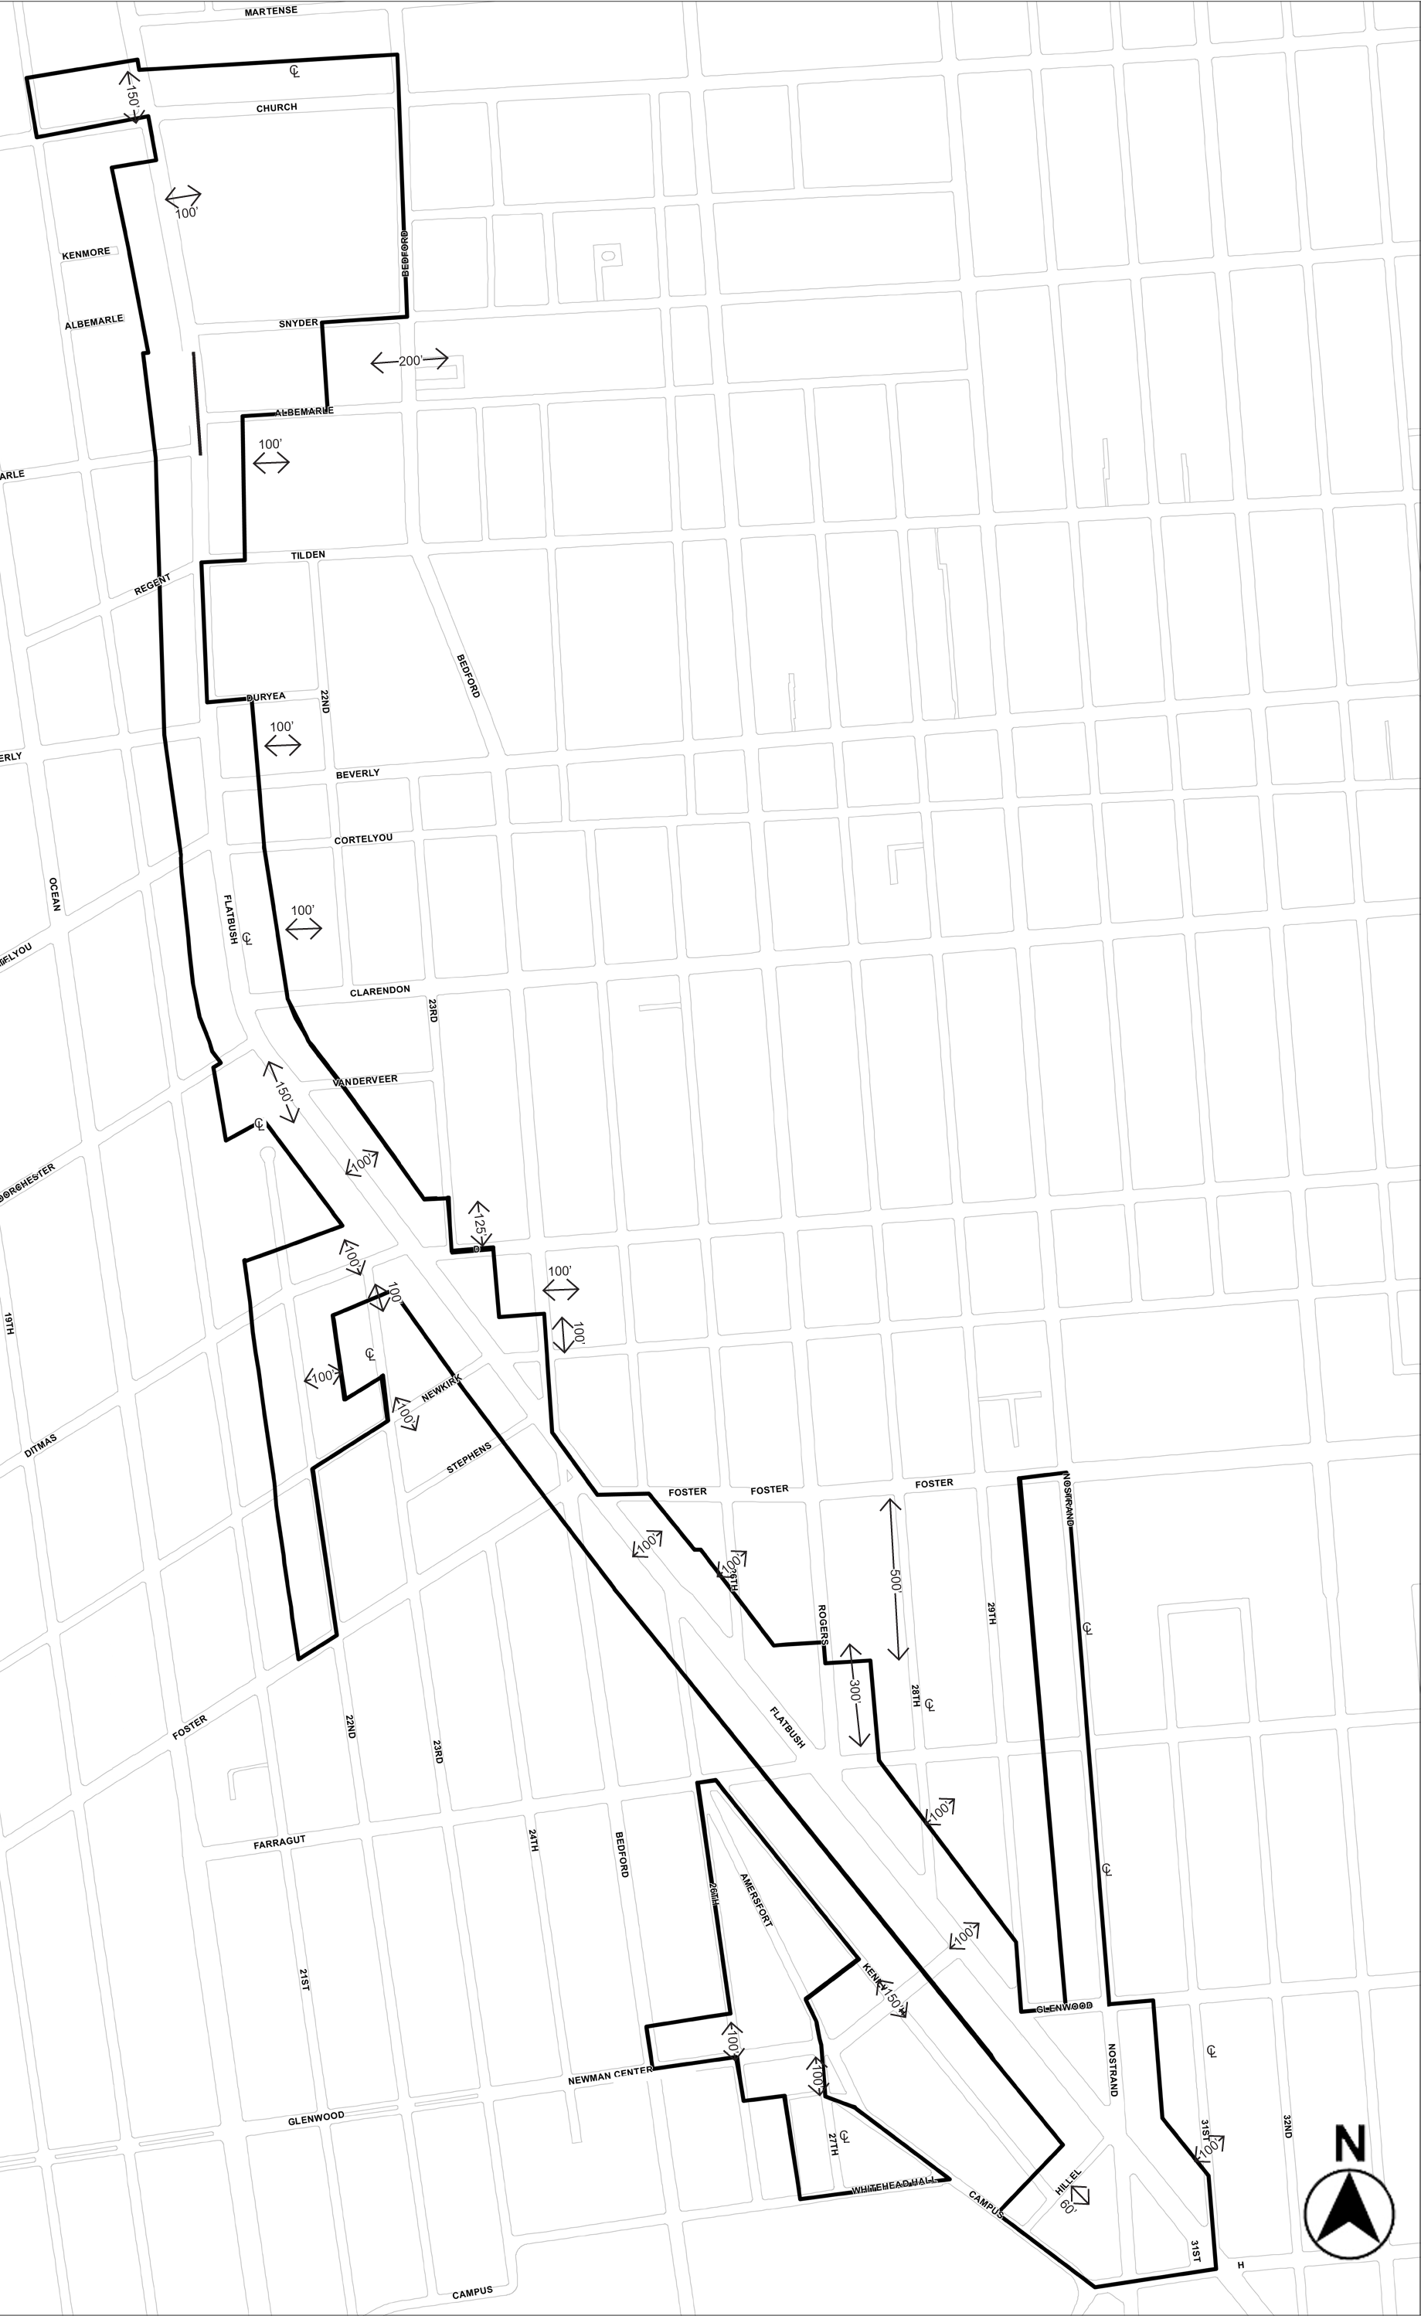

Map X2. Portion of Community District 14, Brooklyn

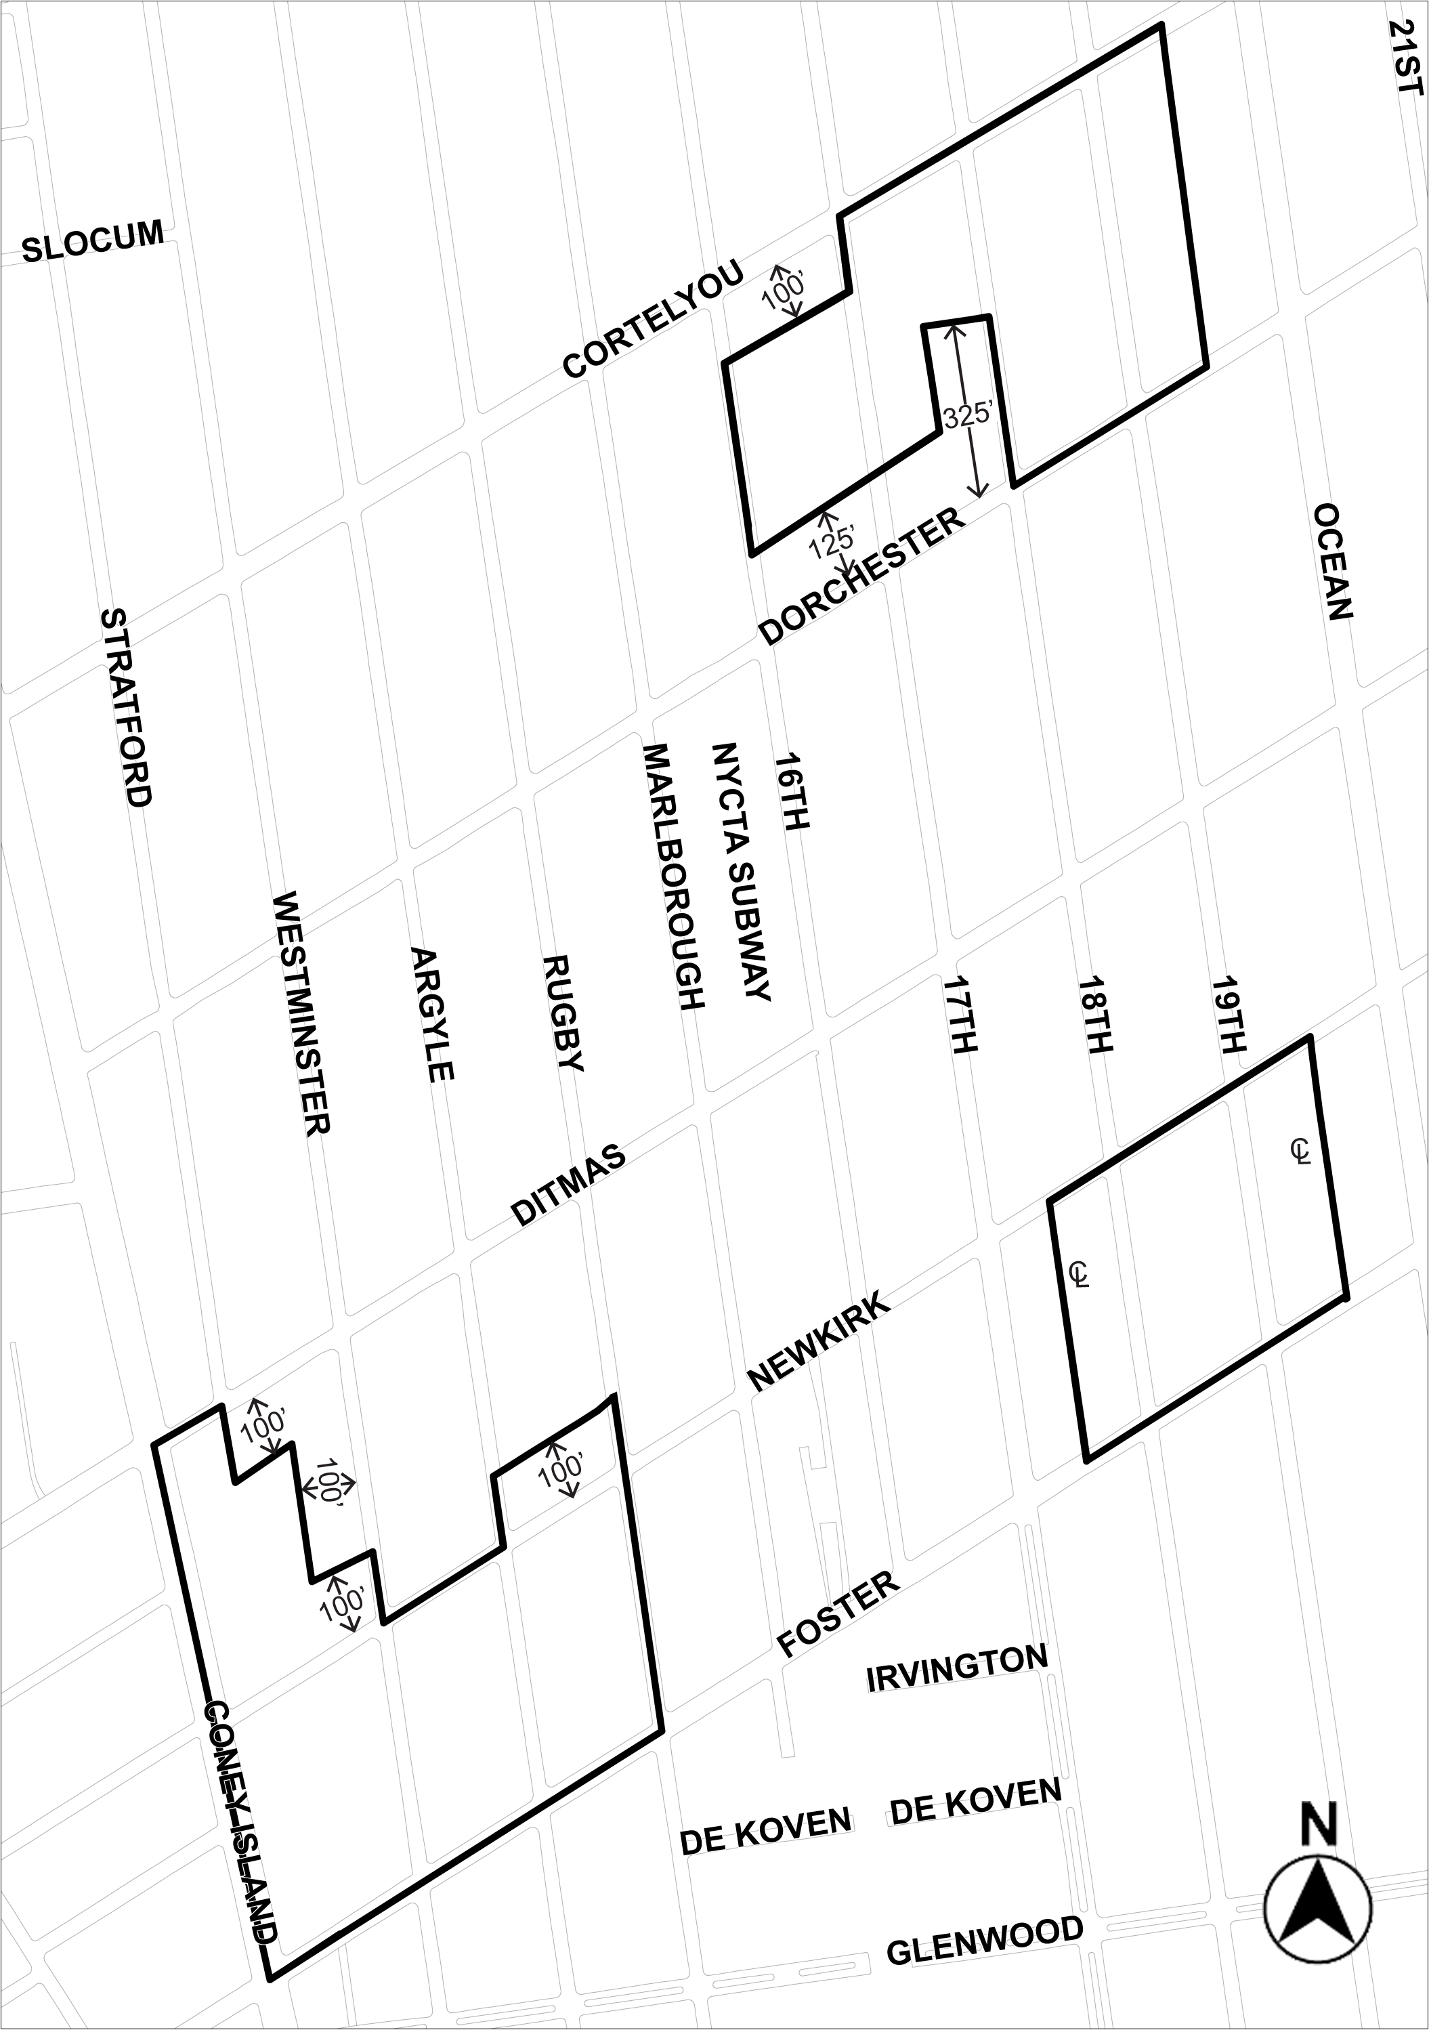

Map X3. Portion of Community District 14, Brooklyn

Adopted.

Office of the City Clerk, }
The City of New York, } ss.:

I hereby certify that the foregoing is a true copy of a Resolution passed by The Council of The City of New York on July 29, 2009, on file in this office.

...…….........................................
City Clerk, Clerk of The Council

