THE COUNCIL OF THE CITY OF NEW YORK
RESOLUTION NO. 20

Resolution approving the decision of the City Planning Commission on Application No. N 090176 ZRR, for an amendment of the Zoning Resolution of the City of New York, concerning the Special South Richmond Development District (Article X, Chapter 7) Appendix A, relating to the modification of arterial setback requirements in Community District 3, Borough of Staten Island (Preconsidered L.U. No. 2).

By Council Members Comrie and Weprin

WHEREAS, the City Planning Commission filed with the Council on January 8, 2010 its decision dated January 6, 2010 (the "Decision"), pursuant to Section 201 of the New York City Charter, regarding an application submitted by Brookside Amboy, LLC, for an amendment of the Zoning Resolution of the City of New York, concerning the Special South Richmond Development District (Article X, Chapter 7) Appendix A, relating to the modification of arterial setback requirements in Community District 3 (Application No. N 090176 ZRR), Borough of Staten Island (the "Application");

WHEREAS, the Decision is subject to review and action by the Council pursuant to Section 197-d(b)(1) of the City Charter;
WHEREAS, upon due notice, the Council held a public hearing on the Decision and Application on January 26, 2010;

WHEREAS, the Council has considered the land use implications and other policy issues relating to the Decision and Application; and

WHEREAS, the Council has considered the relevant environmental issues and the Conditional Negative Declaration, issued on December 2, 2009 (CEQR No. 09DCP22R);

RESOLVED:

The Council finds that the action described herein will have no significant effect on the environment subject to the following condition:

The applicant, Brookside Amboy LLC, incorporates an appropriate vapor barrier into the design plan of the proposed building as recommended by the Department of Environmental Protection.

Pursuant to Sections 197-d and 200 of the City Charter and on the basis of the Decision and Application, and based on the environmental determination and consideration described in this report, N 090176 ZRR, incorporated by reference herein, the Council approves the Decision.

The Zoning Resolution of the City of New York, effective as of December 15, 1961, and as subsequently amended, is further amended as follows:

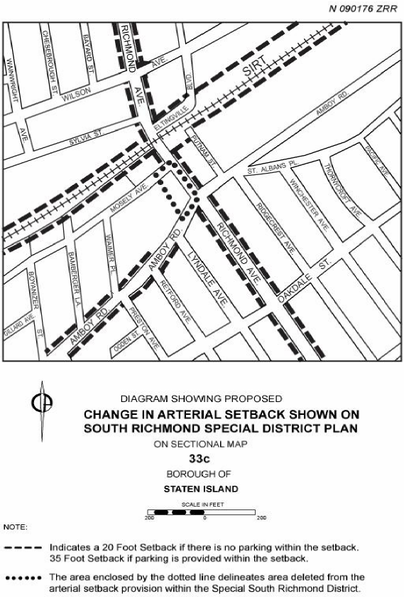

Adopted.

Office of the City Clerk, }
The City of New York, } ss.:

I hereby certify that the foregoing is a true copy of a Resolution passed by The Council of The City of New York on February 3, 2010, on file in this office.

...…….........................................
City Clerk, Clerk of The Council

